Intelligent E-Learning Repository System for Sharing Learning Resources

Ayidh Alanazi, Maysam Abbod
College of Engineering, Design and Physical Sciences
Brunel University London
United Kingdom
{ayidh.alanazi,Maysam.Abbod }@brunel.ac.uk
Abrar Ullah
School of Computer Science
University of Hertfordshire
United Kingdom
a.ullah3@herts.ac.uk

Abstract—The proliferation of Internet and technology triggered exponential growth in adoption of e-learning by many organizations worldwide. E-learning offers many benefits including ease of access, availability, re-usability and rich learning resources. With advances is technology, learning methods and objects have evolved from conventional text based content to multimedia and interactive knowledge objects. Learning objects can be useful for tutors and learners, however, there are some limitation to sharing of learning objects across many platforms to benefit respective learners. Learning objects are confined to resource owners and organizations. This study is part of an ongoing research to design a Unified E-learning Repository System (ULRS) for sharing learning objects from a centralized repository to benefit learners across many e-learning platforms. The authors have presented design of ULRS framework.
Keywords—Intelligent E-learning, Repository, Sharing Learning Resources

Introduction
E-learning is ‘‘the use of new multimedia technologies and the Internet to improve the quality of learning by facilitating access to resources and services as well as remote exchanges and collaboration. E-learning can take place totally online in virtual environments or in a mix of virtual and face-to-face environments; a mode entitled ‘blended learning’. E-learning has the potential to impact positively on education. It provides great opportunities for both educators and learners to enrich their educational experiences [1]. Individuals who were disadvantaged for geographic, physical or social circumstances have increasingly better educational chances via e-learning. Furthermore, e-learning supports synchronous and asynchronous communications in various formats ranging from text, voice and audio. In addition, supported by the openness and flexibility of the Internet, e-learning provides the teaching and learning transactions with unfathomable amounts of information independent of the pressure of time and the constraints of distance [1].
E-learning is generally defined as learning through electronic devices such as desktop / laptop computers, smart phones, CD / DVD players, etc.), which first appeared in the 80's as a competitor to traditional face-to-face [2]. The development of e-Learning in education continues to grow steadily [3]. In developing countries, such as Saudi Arabia, the most important tools of learning at anytime, anywhere concept still focused on a personal computer or PC [4], [5], [6]. Due to physical limitations of computer, students cannot access learning materials in a place or a location. In this case, mobile device is becoming popular among teenagers which can be fulfilled in the ubiquitous idea of learning [7]. Normally, we call e-learning with mobile device as mobile learning or m-Learning in short form. In the 90s, a new form of learning was revealed, namely, the mobile learning (m-Learning) [8]. Recently, many researchers have focused on m-learning and its environment, such as users’ acceptance in m-learning [9], [10], and setting the environment for m-Learning [11], [12].
Whilst E-Learning is rich with learning resources, there is a common issue in re-using and sharing learning resource across different learning environments. Learning resources are also known as learning objects, which are available in various forms in different learning management systems. In this study, we have presented a Unified E-Learning Repository System for sharing learning objects in Universities in Saudi Arabia. The ULRS has embedded with intelligent agents to search, access and use the shared learning objects.

Learning Objects
Learning resources in many forms are known as learning objects. Learning objects (LO) are known by various names and descriptions such as content objects, educational objects, information objects, , knowledge objects, intelligent objects, knowledge bits, learning components, reusable curriculum components, reusable information objects, reusable learning objects, testable reusable units of cognition, training components, nuggets, chunks and units of learning [13]. The ten most actively used LO tools available on the Internet include video sharing (for example, YouTube), podcasting (such as Audacity and iTunes), blogging (WordPress), presentation sharing (SlideShare), online office suites (Google Docs), bookmark sharing (Delicious), Wikis (PBworks), real-time communication (Skype and Twitter), social networking (Facebook and Twitter) as well as social media platforms which offer a cohesive approach to both formal and informal learning (Elgg). On the other hand, LOR can be compared to a “learning refinery” [1-4], [15], [16]. Marenco and Makevich start by defining the general meaning of the term “repository”, which obviously refers to space or a container where given items are collected and stored, and then they define LOR as “an organised content delivery mechanism for pieces of educational content” [17]. There are, however, more precise and specific definitions; for example, a definition which is suitable for an understanding of the tertiary level of education: A university-based institutional repository is a set of services that a university offers to members of its community for management and dissemination of digital materials created by institutions and its community members. It is most essentially an organizational commitment to the stewardship of these digital materials including long-term preservation where appropriate as well as organization and access or distribution. Lynch [18] also argued that LOR as an institutional repository, is not just a fixed collection of software and hardware, but rather a network whose installation requires attention to six different considerations such as the material, organisational, cultural, technical, infrastructural and the policy/political views. For example, when considering material views, issues such as academic papers, geospatial data, learning materials and research data will be the vital components to be included in the system. As for divisions and categorisation, Marenco and Makevich [17], have divided LORs into the following types:
- A general content repository: A platform that can be both educational and non-educational, such as YouTube and Screen Toaster.
- An online textbook repository: A refinery that provides textbooks for all levels and various courses, such as Connexions by Rice University.

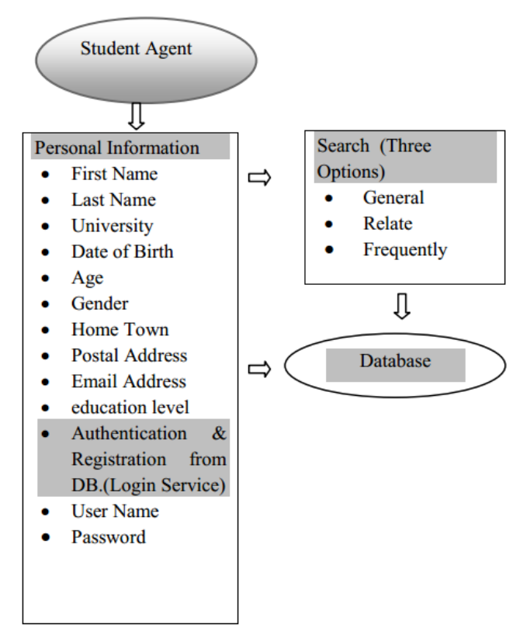

Figure 1. Student Agent Model

Fig 1. ULRS Framework
- A module repository: It offers pedagogical support through providing modules, such as MERLOT in California State University.
- A media-focused repository: this one contains various audio-visual items which are useful for study purposes as well as simulations which facilitates a glimpse of real-life training (Examples include iTunes by Apple and Intelecom Online). As for the advantages, Wiley has listed the following advantages of LORs, especially when utilised in institutions of higher education [19]:
- LORs are reusable, accessible and adaptable: They are easy to blend with other resources, in digital or in traditional forms.
- They are adaptable with regard to the demands of local curricula.
- They can be designed for use on different platforms;
- They are generally cost-effective.
Furthermore, LORs are highly versatile because they contain small portions of learning materials that can be updated in a straightforward manner. Consequently, learning processes which are based on LOR have become a new ‘school’, since LORs allow the possibility to create various learning and knowledge-seeking patterns. Even though it is not possible to fully equate LORs to conventional learning and teaching methods in all countries, they have been considered to sufficiently match an ideal conception of modern learning. In fact, there is one simple prerequisite for LOR-based learning: an Internet connection. That is why it is categorised the designations ‘online learning’ or ‘e-learning’.

Learning Objects Repositories
The published scholarship seem to agree that ‘learning object repositories’ are a set of large, interconnected databases which store, reproduce and deliver learning objects through the Internet. Prior to the emergence of this term, various other terms had been used to denote them such as ‘Learning Resource Bank’, ‘Knowledge Repositories’, ‘Digital Repositories’ and ‘Digital Libraries’ among many other terms that refer to the entities which provide the learner with information or learning resources in a digital environment. However, the term ‘Learning Object Repositories’ has been directly linked to e-learning and e-content objects that are used in accordance with specific teaching targets [20] [21].

Proposed Model
The aim of this study is to design a proposed model for intelligent E-learning repository management system based on an earlier paper (E-Learning Repository System for Sharing Learning Resources among Saudi Universities). The lecturers in Saudi universities have urgent need for e-learning materials on repository for enhanced E-learning experience in the Saudi Universities.

Unified e-Learning Repository System (ULRS)
This study proposes the Unified e-Learning Repository System (ULRS) for sharing learning objects across E-Learning systems. As shown in “Fig.1” the ULRS can be used for providing anytime availability of learning resources and minimizing the expensive groups required for maintenance moreover improving the usefulness.
The ULRS implements different groups with various permissions and access control. Teacher groups can be implemented to observe and review the learning materials, resources and feedback from learners to scrutinize their progress. In addition, the material can be updated on the basis of new introduction, development and more importantly from learner responses. Students or learner groups are the main users of the learning resources with read access. As a proof of concept, the ULRS has been developed and implemented in an online scenario. Teacher and learner are two specific roles to determine access and permissions to certain resources. Individual access is determined by the authentication system in place. There are three options to search learning resources in ULRS. Meta data or information about learning objects, users and their roles are stored in the database. The ULRS is powered with the following search agents:
- General search – The general search uses the exact search method for search of a keyword from the learning objects database on search text. General search provides search on learning object name, title, content type, and subject area filters.

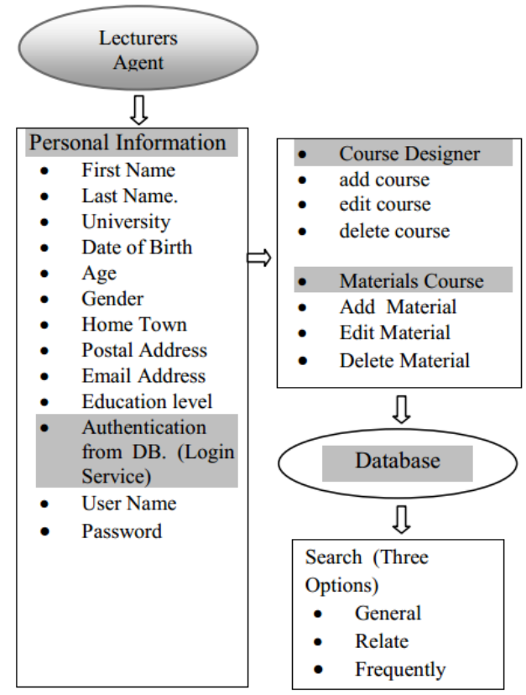

Figure 2. Teacher/Lecturer Agent Model

- Search using terms relate to the phrases you want to search for – This search performs a text based exact phrase search in the database using learning object name, title, content type and subject area filters.
- Search by frequency of search phrases – The search text is used to query the database. Results are presented based on the frequency of search text.

Features of ULRS
Features of the ULRS are described below.

Intelligent agents & web use: The introduction of advanced technologies such as web-based and intelligent agents can render the model lightweight and flexible, thus the intelligent E-learning system becomes a reality. This specific architecture has provided a flexible integration model where all the learning applications and components are freely connected and easily distributable over the Internet. In addition, the use of agents and intelligent content customization can be adapted for the various needs of individual learners. Although, we have not presented a complete Artificial Intelligence (AI) agents, however, search agents are inspired from AI applications.

Users (Student. Teacher/Lecturer, Administrator) Agent Design: The ULRS implements three main roles, defined as student, teacher and administrator. A user registers in the ULRS by adding details such as first name, surname, gender, address, email, date of birth, country and hometown and university. The users can update the registered details at any time, including his or her interest fields.

Users agent for profile management
The characteristics of the users’ profile agent include the following:
- Registration and login (Authentication Service) – New users can first register in e-learning system with their specific details. Registered students can login with a combination of user name and password.
- Users profile details – These can include the user’s first name, last name, date of birth, university, gender, age, address, email address and education level (to be selected from the options that are most recently achieved). Then, there is the most important selection of “subject of interest” as first preferred from available courses, with three different interests to define to insure adaptive e-learning.
- Profile management – the user can update his or her parameters and details anytime by logging into the system under the (my profile) tab.
- Search
Can be use general, search relate, frequently from database

Lecturers/Teachers Agent Design
The lecturers or teacher’s intelligent agent is used to handle all learning related contents and course resources.
The teacher is responsible for designing and developing courses topics, online learning content, and sample evaluation questions which the students can use to fill their respective fields of interest. The teacher is also responsible for:
- Adding or deleting courses of interest in relation to the topics.
- Building and managing sample questions addressed to the learners in order to test their knowledge of the topic they have chosen in the profile.

Design of the Lecturers/Teachers agent for profile management
When logged in with a lecturer or teacher account, the user has permissions to create, delete or update and course content. Moreover, lecturer has the same profile parameters and functions as the student profile.
- Login (Authentication Service) – The lecturer can log into the e-learning system with a user name and password.
- Lecturers profile details – These include first name, surname, date of birth, gender, age, postal address, hometown, email, education level (to be selected from the options most recently achieved).
- Profile management – the lecturer’s details and parameters can be updated anytime by using the correct login and authentication details.
- Course Designer – the lecturer has control over the course content resources. New course topics can be added, deleted or edited by the lecturers under (course designer) tab, thus enabling the management of interest topics for students.
- Materials Course –New Material course topics can be added, deleted or edited by the lecturers under (Material course)
- Search – Can be use general, search relate, frequently from database

Student Agent Design
The student is the target use of courses and learning objects. The student agent is responsible for access to course topics, online learning content, and evaluation questions in the relevant subject area.

Design of the Student agent for profile management
When logged in with a student account, the user has permissions to search, read and navigate through the course content. Moreover, student has the same profile parameters and functions as the lecturer profile.
- Login (Authentication Service) – A student can log into the e-learning system with a user name and password.
- Student’s profile details – These include first name, surname, date of birth, gender, age, postal address, hometown, email, education level, and enrolled courses.
- Profile management – the student’s details and parameters can be updated anytime by using the correct login and authentication details by individual user in the student role.
- Course Access – a student has access to the enrolled course and content resources. Access to course material, learning objects, assessment objects can be delegated by teacher or course administrator.
- Search – Can be use general, search relate, frequently from database

Administrator Agent Design
The administrator has a top level access create and assign roles to teacher and student user groups. The administrator has full control on access, permission, courses, course content, and user groups.

Design of the Administrator agent for profile management
When logged in with an admin account, the administrator has permissions to create, delete or update the course content. Moreover, administrator has the same profile parameters and functions like the student profile.
- Login (Authentication Service) – The administrator can log into the e-learning system with a user name and password.
- Users management –A user with administrator role can create, update and delete users. Administrator can create, update, delete and maintain the repository file tree structure.
- Course Designer – the administrator has control over creating new courses, updating, archiving and maintaining existing courses. New course topics can be added, deleted or edited by the administrator as well as lecturers under (course designer) tab, thus enabling the management of interest topics for students.
- Search – Can be use general, search relate, frequently from database

Conclusion
E-learning has been growing in popularity and use worldwide. Learning objects form an important part of the e-Learning pedagogy and architecture. To maximum the benefits of creating and sharing learning resources, it is eminent to have a centralized repository with defined access to all stakeholders. This study proposes the Unified e-Learning Repository System (ULRS) for sharing learning objects across e-Learning systems. The proposed design has been developed and deployed as a proof of concept. Future work will focus on evaluation of the proposed ULRS or learning objects repository.

References

[1] B. Holmes and J. Gardner. E-learning: concepts and practice. London: Sage, 2006.
[2] M. Abuhamdeh. “A hierarchical framework to quantitatively evaluate success factors of mobile learning.” Amman, Jordan: The University of Banking and Financial Sciences, 2010. Unpublished PhD Thesis
[3] K. Jairak, P. Praneetpolgrang and K. Mekhabunchakij. “An acceptance of mobile learning for higher education students in Thailand.” 2009. The 6th International Conference on eLearning for Knowledge-Based Society, Thailand.
[4] Y. Alshumaimeri and R. Alhassan. “Current availability and use of ICT among secondary EFL teachers in Saudi Arabia.” 2010. Global Learn Asia Pacific 2010 Conference on Learning and Technology, Penang, Malaysia.
[5] F. N. Al-Fahad. “Students’ attitudes and perceptions towards the effectiveness of mobile learning in King Saud University, Saudi Arabia.” The Turkish Online Journal of Educational Technology, 8 (2), 2009, 111-119.
[6] F. H. Chanchary and S. Islam. “Mobile learning in Saudi Arabia - prospects and challenges” 2011. International Arab Conference on Information Technology, Zarqa University, Jordan.
[7] A. Habboush, A. Nassuora and A. Hussein. “Acceptance of mobile learning by university students”. American Journal of Scientific Research. (22), 2011, 119-122.
[8] S. Wains and W. Mahmood. “Integrating m-Learning with e-learning.” 2008. The 9th ACM Special Interest Group for Information Technology Education (SIGITE’08), Ohio, USA.
[9] D. Phuangthong and S. Malisawan. “A study of behavioral intention for 3G mobile internet technology: Preliminary research on mobile learning.” 2005. presented at the Second International Conference on eLearning for Knowledge-Based
Society, Bangkok, Thailand.
[10] Z. Liu, G. Zhao, W. Zheng and J. Jin. “The research and exploration of mobile-learning based on Web 2.0.” 2008. International Symposium on Knowledge Acquisition and Modeling (KAM'08), Wuhan, China.
[11] P. Y. Chao and G. D. Chen, “Augmenting paper-based learning with mobile phones. in Interacting with Computers, 21, 2009, 173-185.
[12] R. Brown, H. Ryu, and D. Parsons. “Mobile helper for university students: a design for a mobile learning environment.” 2006. The 18th Australia conference on Computer-Human Interaction: Design: Activities, Artefacts and Environments, Sydney, Australia.
[13] Wikipedia. “King Khalid University (KKU) and e-Learning.” 2012 Available at: <http://en.wikipedia.org/wiki/King_Khalid_University>
[14] S. Downes. “Learning objects: Resources for distance education world-wide.” International Review of Research in Open and Distance Learning, 2001. Available at: <http://www.irrodl.org/index.php/irrodl/article/view/32.>
[15] S. Downes. “Design and reusability of learning objects in an academic context: a new economy of education?” USDLA Journal, 17(1), 2003. Available at: <http://www.usdla.org/html/journal/JAN03_Issue/article01.html.>
[16] S. Downes. “The rise of learning objects.” In International Journal of Instructional Technology and Distance Learning, 1(3), 2004. Available at: <http://www.itdl.org/Journal/Mar_04/editor.htm>
[17] A. Marenco and J. Makevich. “Using learning object repositories effectively in online courses.” 2009. Online Powerpoint presentation, available at: <http://www.slideshare.net/jmakevich/using-learning-object-repositories-effectively-in-online-courses.>
[18] C. Lynch. “Institutional repositories: Essential infrastructure for scholarship in the digital age.” ARL Bimonthly Report, 226. 2003, Online research article,
available at: <http://www.arl.org/storage/documents/publications/arl-br-226.pdf.>
[19] D. Wiley. “Connecting learning objects to instructional design theory: A definition, a metaphor, and a taxonomy.” The instructional use of learning objects. D. Wiley (Ed.), Bloomington, 2002. 3 – 24.
[20] R. Lehman. “Learning Object Repositories”, New Directions for Adult and Continuing Education. 113, Spring, 2007, 57-66
[21] I. MacLaren, “New trends in web-based learning: objects, repositories and learner engagement.” European Journal of Engineering Education, March 2004, 29(1), 65-71.

