Design of Smart Generation by Integrating Renewable Energy into Western Power Grid of Saudi Arabia

Fahad Aljahdali
College of Engineering and
Physical Sciences
Brunel University London
United Kingdom
Fahad.Aljahdali@brunel.ac.uk
Maysam Abbod
College of Engineering and
Physical Sciences
Brunel University London
United Kingdom
Maysam.Abbod@brunel.ac.uk

Abstract—Renewable energy sources are the answer to countless global issues for instance: the increasing risk of climate changes and global warming. Due to the promising benefits of integrating renewable energies based on generation such as: solar and wind sources the future energy markets are encouraged to invest in the available renewable systems. The Kingdom of Saudi Arabia is currently working to fulfil its 2030 vision, which one of the top priorities is investing in renewable energy resources. The western part of Saudi Electrical Company covers number of significant cities, characterised by harsh weather conditions: very high temperatures during the day and high level of humidity during the night time that force the consumers to use air conditioning on daily basis, hence high load, especially in the summer period. This research focuses on integrating renewable energy into transmission network of the western part, with the objective to minimize CO2 emission, through testing the grid load data with capacity of power stations and integrating solar panel and wind turbine platform.
Keywords— Integration of Renewable Energy, Load forecasting, Time series prediction

Introduction
The economic growth of modern societies mostly depends on energy supplies. Gas and oil, which is mostly produced by Saudi Arabia, generate 57% of the commercial energy supplies worldwide. The traditional, carbon- based sources of energy have caused devastating damage to the environment and human health so far. It is strongly affecting the climate change, which have gradually begun to be one of the biggest environmental problem worldwide. The traditional sources are not only harmful but also limited. The energy crisis an, the increasing cost of extracting oil and the alarming level of environmental pollution promote the development of non- polluting renewable energy sources and prioritize the concept of RE in the future energy planning. Energy obtained from renewable sources has the potential and capability to play a significant role to provide energy efficiency, and maintain the sustainability of global resources [13,19,14,15].
The area covered by WOA of SEC includes six major cities. Fig. 1 represents the main WOA network. It includes: two cities with holy mosques in Makkah and Medina; the major urban centre of western part of the country and second largest city in Saudi Arabia- Jeddah; another, after Jeddah, major city on red sea coast line Yanbu, other two cities are located on the coast line - Rabigh and Shoabah, and city in the mountains - Taif.
Figure 1: Western Saudi Arabia power grid.
The exploitation of solar and wind energy as an alternative source in Saudi Arabia has been considered, because of the long hours of sunshine and abundant amount of radiation. If the sun shines, there must be a wind. The wind is created because of the sun's uneven heating of the Earth (particularly sea). Wind and solar power are both waste-free and it do not consume any fuel [13,16].
In the first part of the work describes the load forecast data collected from Saudi Arabia Electricity Company and wind data from Jeddah Airport. In section III, the modelling method is explained and in section III the results of data modelling are presented. In part IV, more information is given about the obtained result, followed by discussion, and finally the conclusion is in section V.

Power Grid System Modelling
- Current State of the Grid
In this paper 380 kV Network including seven power stations with different capacities, located in seven different cities are being investigated: Jeddah, Rabigh, Yanbu and Shoiba, Makkah, Medina and Taif. The biggest stations are: Shoiba, Rabigh and Jeddah. Table I shows each power plant capacity with total fuel generation 19,933 MW which is the current situation without renewable energy.
Table I: Generation Units’ Capacities.
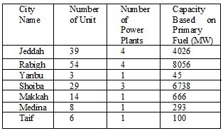
In this study four offshore farms (Rabigh and Shoiba) with capacity of 600 MW and two solar panel platforms (Medina), with a capacity of 45 WM each, has been injected into 380 kV transmission gird with total green power generation of 2,490 MW, which is approximately 12% of total fuel generation. The grid modelling and simulation has been implemented by using ETAP software. The aim of this study is to switch off number of fuel generation units and relay on renewable using a day ahead load forecasting based on the predicted load. In last study historical data has been obtained from Electrical Company form January 2010 to August 2016. It contained typically: weather conditions (temperature and humidity), date (time, day, month, year) and the load [1,2,3]. The developed models for forecasting the load conditions are based on two approaches: multivariate (MV) and time series (TS) prediction. The modelling is done using artificial neural networks (ANN) which is compared to linear regression (LR) models. The second approach is based on time series model using historical load conditions. The models are used to predict the grid loading according to the time of year and weather conditions. The prediction will be used to plan the operation of the power plant according the demand and the generated renewable energy [1,2].
B. Time Series Prediction
Time series is a sequence of vectors that depending on time, results in an output. It forecasts the future demand, based on the observation of historical data. The fundamental assumption of time series prediction is that the pattern observed in history will remain the same in the future [11]. Using historical data of a variable in a prediction model can provide a reasonable forecast accuracy [17]. Time series data is a large data set, that contains sequences of numeric values, obtained by repeated measurements of time. The values are measured at identical time intervals e.g. every hour, day, week or month. Time series prediction is applied when high prediction accuracy is needed, like the neural network support vector machine [12]. The ability of accurate load prediction helps the decision maker to plan and manage the demand response. Time series prediction gives the possibility to design smart energy generation system connected to renewable energy, such as solar and wind, mainly when the time series relates to electricity load forecasting. The exclusive advantage of time series for hourly forecasting is the ability to re-regulate the integration and production of the renewable energy into the system [4, 5, 6].
C. Load Forecasting
Recently, Load forecasting has become one of the major areas of research in Electrical engineering [14]. Electric companies need load forecasting models to predict the accurate amount of power to be delivered to consumer, hence find future demand of Electrical Load and control the supply and demand balance at various times of the day to achieve the best conditions of cost and safety [9]. Using historical data of a variable in a prediction model can provide a reasonable forecast accuracy. [17] Short Term Load Forecasting helps the power generation to cover the incoming demand and it plays a key role in achieving best economic results and reliable operation goals in electricity systems [7,10] Electrical power forecasting plays a significant role in the secure and economic operation of a power system, and the combined models can be utilized in other forecasting. With accurate forecast basic operating functions can be performed more efficiently [18].
D. Load Forecasting Data
The data obtained from Saudi Electrical Company represents the period from January 2010 to August 2016 and it is typically configured in eight indexes that represent: the time, date (day, month, year), day type (weekday or weekend), temperature, humidity and load. The data readings that have been collected are made mostly in 1-hour slots. At 13:00, when the temperature reaches the peak, the load reading is made every half an hour (13; 13.5; 14; 14.5; 15; 15.5). The following 3 readings are made at: 16, 17, and 18. Afterwards the readings are made every half an hour (18.5; 19; 19.5; 20; 20.5). Starting from 21 the next readings are taken hourly until 13:00 the following day. As seen on Fig. 2 and Fig. 3, the temperature and humidity level are the highest during the summer time, specifically, from April to August. This pattern remains the same in other years, taken under consideration in the obtained data.
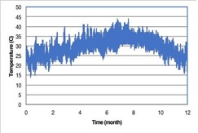
Figure 2: Temperature during 2016.
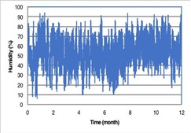
Figure 3: Humidity 2016.
Fig. 4 present the load is clearly the hot weather reflected on the higher of load consumption in the summer. Again, there is a noticeable difference between the load consumption in the summer and in the winter. The reason of this difference originates from the often use of air conditioning in the summer. The AC system is used regularly at homes and in public places
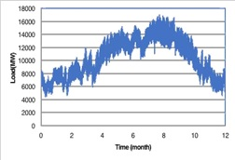
Figure 4: Load during 2016
D. Wind actual and forecasting Data
The wind data has been collected from Aviation dispatch from Jeddah Airport. It covers the period from 1 of May 2018 to 9th of May 2018. The weather report contains METAR data and Terminal Aerodrome Forecast (TAF) data. METAR is the actual weather report data measured in hourly readings and contain time, wind speed, gust and direction. TAF is a format for reporting weather forecast information. It covers wind speed, gust and expected time for weather change and generally apply to approximately 30 hours period ahead. [21]
Both the METAR’s and TAF’s radius covers the sea area, and in both cases the readings are reported in Zulu time. The METAR reading are done between 00:00 and 23:00 Zulu time which is 3:00-2:00 (the next day) local time in Saudi Arabia. Fig. 5 presents actual wind data speed history for 20 hours for 7th of May 2018. Table II presents TAF wind data forecast for one day before (6th May 2018). from 9:00 to 15:00 the wind speed is 33.33 km/h no gusting wind and from 15:00 to 9:00, the next day, the wind speed is 14.4 km/h with gusting wind 33.33 km/h. Table III is a TAF wind forecast for one day after the actual reading day (8th of May 2018). From 9:00 to 15:00 the wind speed is 11.11 km/h and gusting wind is 29.63 km/h. From 14:00 to 15:00 the gutting wind increases up to 33.33 km/h. From 16:00 to 9:00, the next day, wind speed 14.8 km/h and gusting wind 33.33 km/h. Fig. 6 presents 20 hours load history for one day (7th of May 2016).
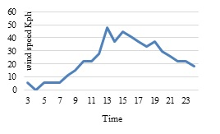
Figure 5: 20 hours actual wind speed.
Table II: Wind forecast TAF one day before the actual.
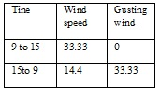
Table III: Wind forecast TAF one day after the actual.
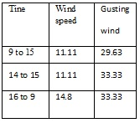
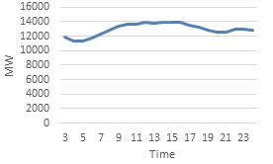
Figure 6: 20 hours- load Consumption
It can be seen clearly that the wind speed increasing time, typically from 12:00 to 20:00, is the same time when the load is increasing. This pattern remains the same taking under consideration other years. It is a very strong point regarding integrating the wind from into 380 kV network to minimise the fossil fuel to limit the CO2 emotion using green power.
The area covered by WOA of SEC is characterized by desert climate with extreme heat during day time. This harsh weather conditions force people living in the area to use air conditioning system regularly. When the temperature reaches its highest people turn up their air conditioning. It results in sudden increases of electricity demand and contributes to significant growth of Electrical Load consumption. Additionally, the consumption of energy varies, depending on the day and time and is strongly related to numerous aspects such as: school and work hours, prayer times, weekends, special events and holidays. The electrical load is influenced by people’s behaviour and life style.

Data Modelling
The gird data provided by SEC is Interconnected Summer Peak 2018 Base Case Final dated 07-11-2017. It has been put under prosses throw integrating the wind platforms and solar panels farms into transmission network 380 kV followed by running different power flow seiners by injecting the RW and testing the power plant generations units using ETAP Software [20]. Table IV explains the amount of elasticity generating based on different technologies (steam, cycle combined, gas). The primary fuel type Diesel and Crude used for Gas unit Heavy used for the steam unit.
Table IV: Generation units’ capacities
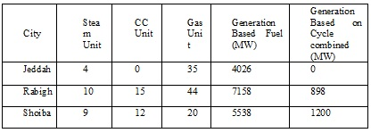
In all of the power flow ETAP modelling result PF configuration (Peak, Off peak, Peak with RW, Off peak with RW) is showing three biggest power stations in service (Jeddah, Rabigh, and Shoiba) with generation capacity 18820 MW, the other stations are off service with generation capacity 1098 MW and generation technology Gas (Yanbu, Makkah, Medina, and Taif).

Results and Discussion
In the first two cases, (Tables V and VI), the result contains all units in service, peak and off peak with different load flow including the capacity of generation. The main three power plants (Jeddah, Rabigh, and Shoiba) are always in service. In the second two cases, (Tables VII and VIII) the result shows 17 gas units (in Rabigh), out of service (with generation capacity 1008 MW) and substituted by RE, with the ability to get back in service to meet the demand within 20 minutes. This option is safer than other generation technologies such as steam.
ETAP simulation of the power flow is configured with different percentage of generation capacity, just nine units of steam in Rabigh station react. All the units in Rabigh, Shoiba and Jeddah run with full capacity, as seen in the four cases Tables V, VI, VII and VIII.
Table V: Case of peak from 13:00 to 21:00 next day, all units in service (MW).
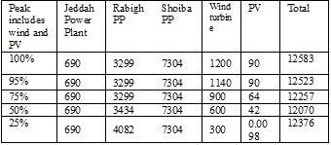
Table VI: Case of off peak from 21:00 to 13:00 next day, all units in services (MW).
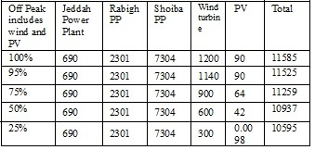
Table VII: Case of peak from 21:00 to 13:00 next day, 17 units of Gas out of service (MW).
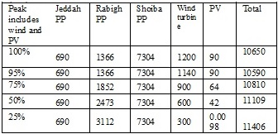
Table VIII: Case of off peak from 21:00 to 13:00 next day, 17 Gas units out of service (MW).
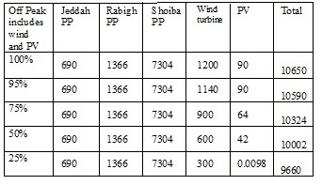

Conclusions
The work presented in this paper is based on real data collected form the Western side of Saudi Arabia, which can be generalised to other parts of the country for generating a general power system scheduling and optimisation with the inclusion of the renewable energy resources. The model can be generalised by utilisation of data from other parts of the power grid in order to predict power demands in different areas. This can be done using incremental learning such that the accumulated knowledge is incremented rather than discarded. The model can be integrated with the weather conditions in order to predict the power requirements with respect to the weather and the generated renewable energy for a particular day.

Acknowledgements
The authors would like to thank the Saudi Arabia Electrical Company and Flynas for providing the data used in this study.

References
- F. Aljahdali, and M. Abbod, “Design of smart energy generation and demand response system in Saudi Arabia,” Power Engineering Conf, UPEC2017, 2017.
- A.J. Al-Shareef, and M. Abbod, “Neural Network Complexity against Simplicity Electrical Load Forecast Case Study,” Power Engineering Conf, UPEC2005, 2005.
- I. Erlich, W. Winter, and A. Dittrich, “Advanced grid requirements for the integration of wind turbines into the German transmission system 2006,” Power Engineering Society General Meeting, 2006.
- G. Barta, G. Nagy, G. Papp, and G. Simon, “Forecasting framework for open access time series in energy,” IEEE Energy Conf. (ENERGYCON), pp. 1-6, 2016.
- I. P. Panapakidis and A. S. Dagoumas, “Day-ahead electricity price forecasting via the application of artificial neural network based models,” Applied Energy, vol. 172, no.1, pp.132-151, 2016.
- M. Emmanuel, R. Rayudu, and I. Welch, “Impacts of power factor control schemes in time series power flow analysis for centralized PV plant using wavelet variability model,” IEEE Transactions on Industrial Informatics, vol. 99, pp. 1-1, 2017.
- M. Shruthi, and S. Satyanarayana, “An overview of short term load forecasting in electrical power system using fuzzy controller,” IEEE Reliability, Infocom Technologies and Optimization (Trends and Future Directions) (ICRITO), pp. 296-300, 2016.
- L. M. Mordjaoui, and F. Laouafi, “An evaluation of conventional and computational intelligence methods for medium and long-term load forecasting in Algeria,” 2015 IEEE In Control, Engineering & Information Technology (CEIT) Conf, pp. 1-6.
- N. K. Singh, A. K. Singh, and M. Tripathy, “A Comparative Study of BPNN, RBFNN and ELMAN Neural Network for Short-Term Electric Load Forecasting: A Case Study of Delhi Region,” IEEE Conf. Publications, pp. 158-171, 2015.
- S. Valero, J. Aparicio, C. Senabre, M. Ortiz, J. Sancho, and A. Gabaldon, “Comparative analysis of Self Organizing Maps vs. multilayer perceptron neural networks for short-term load forecasting,” IEEE Modern Electric Power Systems (MEPS), pp. 1-5, 2010.
- B. Al-hnaity, "Financial engineering modelling using computational intelligent techniques: Financial time series prediction," PhD Thesis, Dept. Eng., Univ. Brunel, 2015.
- M. Xu, M. Han, and X. Wang, “Hierarchical neural networks for multivariate time series prediction”, IEEE Control Conf, pp. 6971-6976, 2016.
- M. AL-Oughain, “Renewable energies management strategy challenges in Arabian gulf counties,” PhD Thesis, Dept. Eng., Univ. Brunel, 2014.
- M. Prasun, and V. D. Gupta, “Prospects of wind energy in Chittagong,” IEEE International Conf. on Informatics, Electronics & Vision (ICIEV), pp. 753-758, 2012.
- J. J. Xueshan Han, J. Wang, X. Zhu, D. Sun, and Y. Ma, “Optimal power flow with transmission switching for power system with wind/photovoltaic generation,” IEEE Chinese Automation Congress (CAC), pp. 5802-5806, 2017.
- R. A. Shalwala, and J. A. M. Bleijs, “Impact of Grid-Connected PV systems on voltage regulation of a residential area network in Saudi Arabia,” IEEE 1st International nuclear and renewable energy Conference (INREC), pp. 1-5, 2010.
- T. Akin, B. M. Sanandaji, G. Chicco, V. Cocina, F. Spertino, O. Erdinc, N. G. Paterakis, and J. P. S. Catalao, “A short-term spatio-temporal approach for Photovoltaic power forecasting,” IEEE Power Systems Computation Conference (PSCC), pp. 1-7, 2016.
- A. J. Al-Shareef, E. A. Mohamed, and E. Al-Judaibi, “One hour ahead load forecasting using artificial neural network for the western area of Saudi Arabia,” International Journal of Electrical Systems Science and Engineering, vol. 1, no. 1, pp. 35-40, 2008.
- S. F. Hendrikus, D. Provenzano, and A. Hassan, “RES impact study. The northern region of KSA: First Step Toward Energy Diversification,” Saudi Arabia Smart Grid SASG, 2017.
- R. R. Waqfi, and N. Mutasim, “Impact of PV and wind penetration into a distribution network using ETAP,” 7th International Conf. on Modelling, Simulation and Applied Optimization (ICMSAO), pp. 1-5, 2017.
- J. Cunningham, M. Asencio, S. Lent, and C. Brinton, “The categorization of wind shift events using meta and personal weather station data,” Integrated Communications, Navigation and Surveillance Conf. (ICNS), pp. S3-1, 2014.

