Characterising Early Functional Recovery Trajectories of Chronic Critically Ill Patients: An Observational Cohort Study.
E.J. Corner^{1,2,5}, Z. Puthucheary3, A. Cakiroglu⁴, A. Sisson⁵, S.J. Brett^{6,7}
¹Brunel University London, London, United Kingdom, ²The Royal Brompton & Harefield NHS Foundation Trust, ³University College London, London, United Kingdom, ⁴Francis Crick Institute, London, United Kingdom, ⁵Chelsea and Westminster NHS Foundation Trust, ⁶Imperial College London, London, United Kingdom, ⁷Imperial College Healthcare Trust, London, United Kingdom.

Rationale: Around 20% of patients in the Intensive Care Unit (ICU) will develop ‘chronic critical illness’ (CCI) requiring a protracted ICU stay. Little is known about the functional recovery of these patients whilst in the ICU.
The Chelsea Critical Care Physical Assessment (CPAx) score as a validated 50-point scale recorded daily to allow monitoring of function in the ICU. This means that the CPAx can provide individual recovery trajectories for each patient, therefore could be used to investigate the functional recovery trajectories and characteristics of patients with CCI.
Aims
1. Examine functional recovery trajectories in patients with CCI using the CPAx.
2. Characterise the subgroups of patients with differing functional trajectories.
Methods:
Participants: Patients admitted to the ICU at a London Teaching Hospital from 10/05/2010 to 19/09/2017 with a length of stay of ≥10 days and ≥4 completed CPAx scores.
Data collection: A report was generated from the ICU database with daily CPAx scores for each patient and the following demographics: age, gender, diagnosis, Acute Physiology and Chronic Health Evaluation II score (APACHE II), mortality outcome i.e. dead or alive, days of advanced respiratory support, and length of stay (LOS) on ICU and hospital
Data analysis: The total CPAx score for each patient for the first 10 days of ICU was analysed to identify clusters of longitudinal trajectories. Demographic data was analysed using descriptive statistics to identify the incidence of CCI and to characterise the clusters. Chi-squared and independent t-tests (alpha .05) were used to analysis categorical and ratio data.
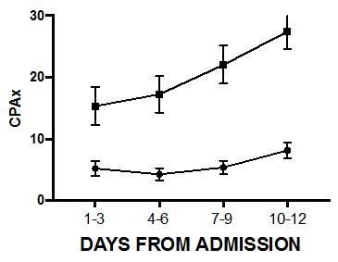
Results: 1,899 patients were admitted during this period; 373 (20%) patients fit the criteria for CCI. Two common recovery trajectories were identified in 252 patients; Cluster 1 (n=70) showed a large improvement in physical function; Cluster 2 (n=182) showed minimal improvement (figure 1). Cluster 2 was associated: increased age (p=0.005), longer ICU LOS (p<0.01) and hospital LOS (p=0.02), and a longer duration of advanced respiratory support (p<.01). There was a non-significant trend towards greater mortality in ICU (p=0.07), no difference in overall hospital mortality (p=0.54), APACHE II score (p=0.65) or gender (p=.75).
Conclusions: Patients with CCI represent a heterogeneous group that may be categorised using the CPAx into two distinct clusters that recover at different rates. The CPAx may be a useful tool to

(Funding: Brunel University London)

