ON-DEMAND HD VIDEO USING JINI BASED GRID

Simon Kent, Peter Broadbent, Nigel Warren, Stephen R. Gulliver

Department of Information Systems and Computing
Brunel University, United Kingdom.
{Simon.Kent; Peter.Broadbent; Nigel.Warren; Stephen.Gulliver}@brunel.ac.uk

ABSTRACT
This research establishes the feasibility of using a network centric technology, Jini, to provide a grid framework on which to perform parallel video encoding. A solution was implemented using Jini and obtained real-time on demand encoding of a 480 HD video stream. Further, a projection is made concerning the encoding of 1080 HD video in real-time, as the current grid was not powerful enough to achieve this above 15fps. The research found that Jini is able to provide a number of tools and services highly applicable in a grid environment. It is also suitable in terms of performance and responds well to a varying number of grid nodes. The main performance limiter was found to be the network bandwidth allocation, which when loaded with a large number of grid nodes was unable to handle the traffic.

1. INTRODUCTION
Low specification devices are not capable of playing media destined for high-end systems, such as full HD (High Definition) video, largely due to network bandwidth and processing restrictions. Currently video is encoded at different resolutions, with the user selecting the most appropriate option for their device. This requires a given video clip to be encoded many times, sometimes being re-encoded as new video formats and hardware capabilities become available. Sadly, however, pre-encoding video does not allow either dynamic video streaming or real-time encoding. Previous research has utilised a number of networked computers to perform real-time parallel video encoding [1], [11], [12]. Whilst these parallel encoders are very efficient at encoding, the quality of the encoded video is limited by the resolution at which it was encoded.
The clear solution is to perform on-demand encoding of video, as the user requests it. This suits any number of devices as the output specifically matches the user’s requirements, from mobile phones through to full HD. However, due to the computational resources needed for real-time encoding, either a very powerful multi processor machine would be required, or multiple networked computers. The latter option is more readily available, is more scalable, is more fault-tolerant and requires less initial financial burden for commercial users. Accordingly, this research proposes a client / grid approach, in which the grid can upwardly or downwardly scale the original source video and send the scaled video to the client upon demand.

2. HD USING JINI BASED GIRD
Video streams are structured in such a way that they can be segmented and encoded in a non-sequential and non-temporal manner, allowing each segment to be processed independent from each another. Accordingly, a scalable solution for providing increased computational power can be achieved by using multiple networked computers, known as a grid or cluster. Grid computing is the process of utilising multiple networked computers to perform a task. This involves the coordination and sharing of resources across locally or remotely dispersed computers to provide increased computational power. There are limited restrictions on the requirements for each computer, thereby enabling the use of legacy systems and reducing the subsequent financial demands placed by other high-performance computing solutions, such as parallel computers.
Jini is an open architecture from Sun Microsystems Inc. based on Java that allows developers to focus on developing services from a network point of view, commonly known as SOA (Service Oriented Architecture). Jini has been used for a variety of tasks, from mobile devices and peer-to-peer computing to constructing a grid environment from Jini [6], [8], [9], [13]. There are number of services provided by Jini. The services applicable in this research include the ‘Lookup Service’ and the ‘JavaSpace Service’. Jini’s goals directly correlate to the goals of grid-based systems, such as spontaneous networking including plug-and-work, robustness in terms of failure and scalability [2], [3], [10]. In addition, Java provides features - including the ability to dynamically download executable code, Java security mechanism and a homogeneous execution platform - which provides a highly dynamic network of services which are scalable, flexible, and adaptive to change. Jini was combined with Java Media Framework (JMF), as JMF allows encoding and decoding of a number of audio / video formats, based on a mix of hardware platforms.

2.1. Video Stream Segmentation
There are several methods that can be used to segment a video stream to facilitate parallel encoding. In preliminary tests, grid nodes adequately scaled individual frames, so there is no need to segment data at the macroblock level. Frame level segmentation therefore becomes the smallest independent data segment. The use of GOPs (Group of Pictures) was considered [4], yet was avoided to prevent future resource complexity. This alleviates complexities, as well as any frame duplication, but increases the number of requests from the JavaSpace to obtain the required set of frames.
In practise the system sequentially traverses the stream and performs frame level segmentation, writing each frame to the JavaSpace in the form of a Java BufferedImage. As a BufferedImage is not serialisable, it is converted into a byte stream and then written to the JavaSpace, contained in a SourceFrameEntry. Once all the required frames have been successfully written to the JavaSpace, the transaction is committed and the frames become available for processing.

2.2. Node Processing
This refers to the processing that each node on the grid needs to perform in order to encode the video. As the segmentation will be done at the frame level, the simplest method of processing is on each individual frame. Nodes can request a single frame at a time, perform the processing, and then write the processed frame to the JavaSpace. Although minimising the benefits of predictive frames, this facilitates the grid processing power and aids the speed of decoding.

2.3. Video Stream Concatenation
Once encoded frames become available on the JavaSpace, the client application starts reading the frames and outputting the resultant video stream. The application consists of two threads, one to read from the JavaSpace and the other to output the video stream. The stream is output directly on screen through the JMF interface and output to a file on the local machine. To facilitate with the analysis of the system, the client waits until all the frames have been encoded before it starts to read them.
The chosen file format was MJPEG, as this allows easy integration of the frames into a stream. It is also suitable in terms of performance; a full HD MJPEG stream can be constructed from retrieving frames from the JavaSpace in at least double the source frame rate (tested at twenty five frames per second). Using JMF allows the constructed video stream to be streamed over an RTSP (Real-Time Streaming Protocol) link to a client should they not have access to the JavaSpace.

3. ANALYSIS
To assess the feasibility of the implemented system a number of measures were defined. These are: i) Video Stream to JavaSpace - a useful measurement for real-time processing; ii) Node Processing - to circumvent the absence of a global clock on all the nodes; iii) Quality – where we use PSNR (Peak Signal-to-noise ratio) to objectively compare the original source frame against the encoded frame, thus providing a numerical comparison. Although not perceptually ideal, PSNR facilitates simple automatic objective comparison; iv) Client presentation – to ensure the video stream played back to the user is at the same rate at which the stream was encoded; v) Network Load.
The system was tested using two identical HD video streams, one stream conforming to the 480p HD standard at a resolution of 848x480 pixels, the second conforming to the 1080p HD standard at a resolution of 1920x1080 pixels. Both streams are twenty four bit colour streams running at twenty five frames per second, neither contained sound. The streams contain a variety of motion, complete black screens and complete white screens.
Forty two machines were used in total, one to hold the JavaSpace and Transaction services, one for a client machine and up to forty machines for node processing. The client machine is used for the analysis applications. The machine running the JavaSpace also recorded all traffic on the network to ascertain the network load using a network protocol analyser (Wireshark1). All machines have Pentium 4 2.8GHz processors with 512MB of RAM and a 100Mbit Ethernet connection. All machines were running Windows XP.

3.1. Encoding 480p HD
The analysis was performed on a varying number of nodes to be able to measure the differences on performance, overhead and the network load. All encoding for the 480p stream used a sample of five hundred frames, the JavaSpace and the Transaction services were restarted after each analysis run to ensure a common starting point was obtained. As the PSNR measurement has the restriction that the images need to be the same size, the nodes scaled each frame to its original size. The frames were compressed for maximum quality, as this places the greatest amount of traffic on the network and the JavaSpace and takes the longest amount of processing time. The average encoding time for varying amounts of nodes is presented in Fig. 1.

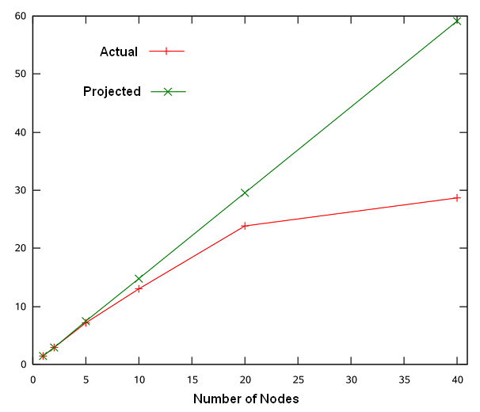
Fig. 1: Average frame encoding time for 480p

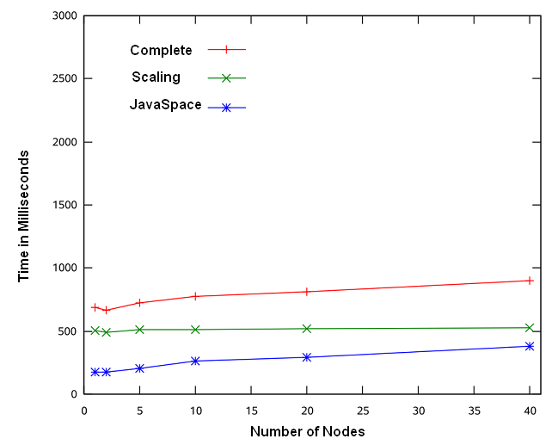
Fig. 2: Average frame encoding overhead for 480p

The projected encoding time is based on the performance of a single node and then multiplied for the corresponding number of nodes. The values presented in Fig. 1 were taken from the client machine, so they represent the moment the frames became available to the client and include all overhead. The actual encoding time quite closely matches the projected time up until twenty nodes, using forty nodes does not increase the performance dramatically. There does not appear to be a marked increase in overhead due to the JavaSpace, presented in Fig. 2, but these values represents the average overhead of all the frames.
The specific overhead of using forty nodes is detailed in Fig. 2 which shows at times the overhead is more than the actual time to scale the frame and on average takes only slightly less time than the encoding of each frame. For a single node the average overhead is 35% of the scaling time, for forty nodes this value is 72%. A very high overhead also occurs at the start of the encoding. In trying to achieve real-time encoding and limit the playback delay for the client, every empty frame that needs to be encoded is committed to the JavaSpace immediately, thereby becoming available for the nodes on the grid. Once the client has placed all the frames required for encoding on the JavaSpace, the overhead decreases – equivalent to real-time processing. This is most apparent in Fig. 3.
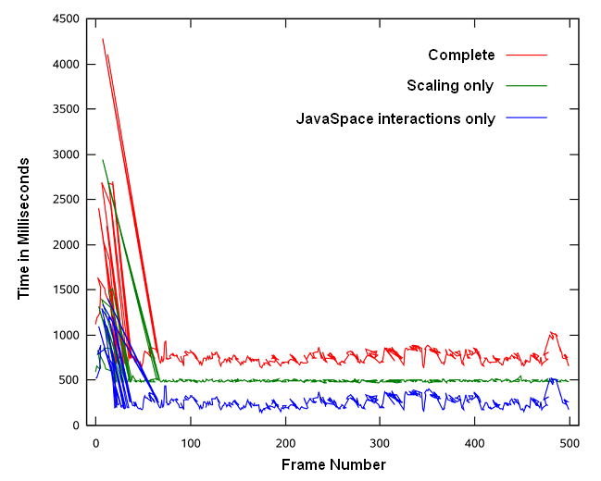
Fig. 3: 480p frame encoding overhead for twenty nodes

Using twenty nodes falls just short of real-time encoding at twenty four frames per second. If more network bandwidth were available and less congestion occurred; or the frames were packaged into groups of frames and only transferred to the JavaSpace when all the frames were encoded, real-time encoding should be achieved with a minimum of twenty five nodes.

3.2. Encoding 1080p HD
The same configuration was used as in the 480p encoding, but the video stream sample was one hundred frames due to the increased frame size. Whilst the encoding speed achieved, Fig. 4, is much lower than the 480p video stream, the relation to the projected encoding time is more closely matched. The overhead on the frames now becomes smaller relative to the encoding time, shown in Fig. 5. For a single node the overhead is 26% of the scaling time, for forty nodes this figure rises to 38%.
Using forty nodes results in fifteen frames per second, with an overhead less than half the encoding time. To achieve real-time encoding, assuming the overhead can be maintained at 38% means approximately sixty nodes will be needed. Although the encoding time of each node is relatively consistent, there are peaks in the frame encoding time which directly relate to the number of nodes, most apparent in Fig. 6.
These values are measured as the difference in time between successive encoded frames when they become available on the JavaSpace to a client. One of the reasons for this is the length of time it takes to encode each frame. When encoding starts on the first frame, we can assume a difference of zero occurs when the node requests the frame. The second requesting node has to wait for the JavaSpace to complete the operation of the first node before it can retrieve it’s frame and start encoding the frame; and so forth for all the requesting nodes. As the time taken to encode a frame is relatively small, this has the effect of the nodes all completing encoding very close to each other. This in turn means once the last node has finished encoding and written the frame to the JavaSpace, there is a gap between the first node returning its second encoded frame. Looking at the results from using two nodes through to forty nodes, the peaks consistently decrease when the
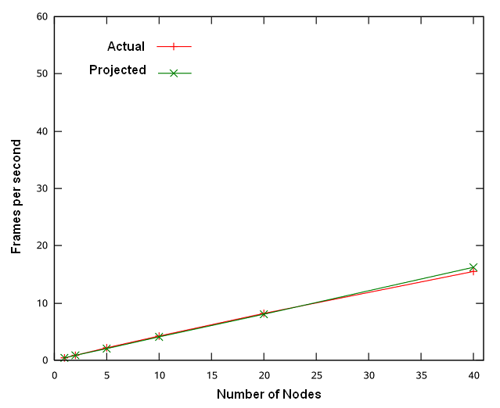
Fig. 4: Average frame encoding time for 1080p
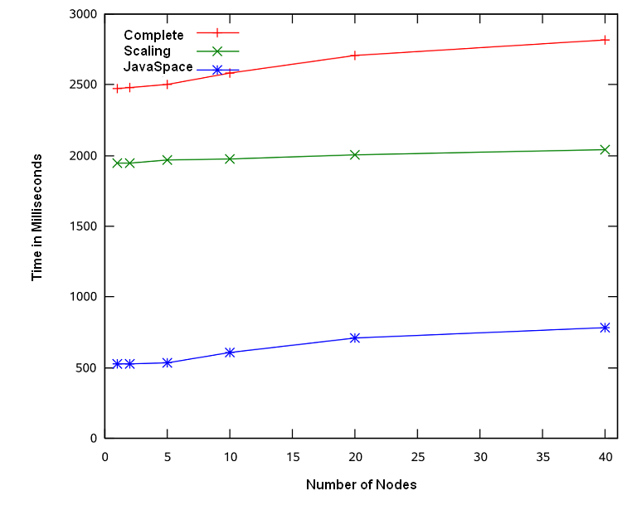
Fig. 5: Average frame encoding overhead for 1080p

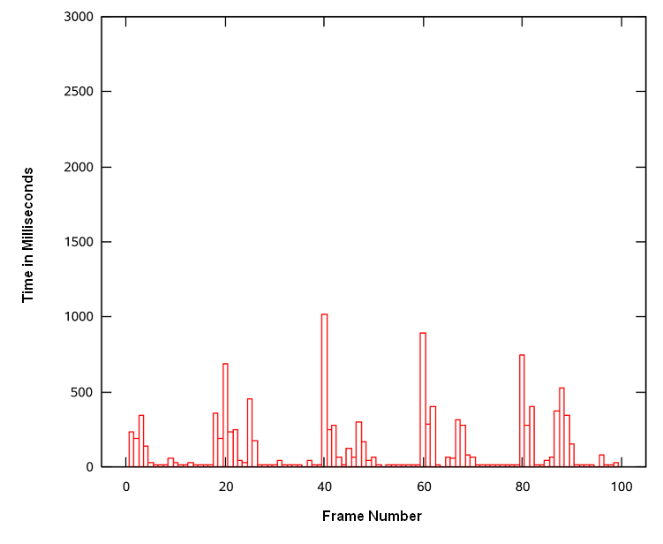
Fig. 6: 1080p frame encoding time for twenty nodes
number of nodes increases. This average decrease is roughly halved when the number of nodes is doubled, to eliminate the peaks altogether would require more available nodes on the grid. PSNR for 480p and 1080p are consistent, independent of the number of nodes.
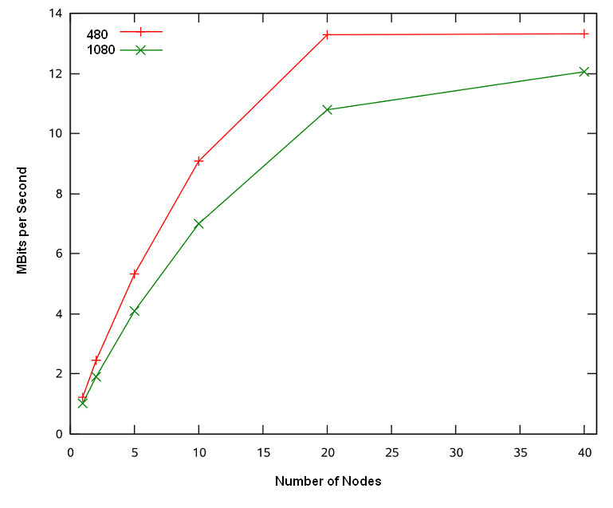
Fig. 7: Network load for 480p and 1080p
The network bandwidth was found to be the main bottleneck of the system when encoding 480p HD, yet thankfully the average bandwidth requirement was not an issue (see Fig. 7).

The results obtained from the analysis can be summarised as follows:
• Real-time on demand encoding was achieved and exceeded for a 480p HD video stream using forty nodes.
• Real-time on demand encoding is projected to be achieved for a 1080p HD video stream using sixty machines, assuming network bandwidth allocation. Using only forty machines, fifteen frames per second was achieved – a perceptually acceptable frame rate for most visual information processing [5].
• The network bandwidth was found to be the main bottleneck of the system when encoding 480p HD even though the average bandwidth requirement was not an issue. It was not an issue for 1080p HD owing to the increased encoding time of each frame (see Fig. 7).
• A consistent level of quality was maintained using a varying number of nodes.
4. CONCLUSION
The overall aim of this research was to evaluate the feasibility of a Jini based grid architecture for real-time on demand, variable resolution video encoding. The system and its assessment provided evidence of being able to encode video on demand in real-time on a Jini based grid, thereby establishing its feasibility. In addition, the network and service oriented Jini system responds to the larger goal of providing a working scalable multiplatform grid solution to real-time on demand encoding of HD quality video at varying resolutions.
Digital video resolution has increased tremendously with the popularity of online and digital media. Codecs such as MPEG-4 AVC have been implemented to respond to this demand, by obtaining greater compression but requiring increased computational resources to do so. Most current desktop hardware is incapable of encoding very high quality video at real-time, requiring specialised and often very expensive hardware to do this. A grid provides access to an increased amount of computational power. By using the network and service oriented Jini, the grid can be designed in such as way so it is resilient to failure.
5. REFERENCES
- S.M. Akramullah, I. Ahmad, M.L. Liou, (1997) Performance of software-based MPEG-2 video encoder on parallel anddistributed systems. IEEE Transactions on Circuits and Systems for Video Technology,
Vol. 7 (4), Aug 1997, pp. 687 – 695
- K. Arnold, (1999) The Jini architecture: dynamic services in a flexible network. 36th ACM/IEEE Conference on Design Automation (New Orleans, Louisiana, United States, June 21 - 25, 1999). M. J. Irwin, Ed. DAC '99. ACM Press, New York, NY, pp. 157-162.
- M. Baker, and G. Smith, (2001). Jini Meets the Grid, International Conference on Parallel Processing Workshops (ICPPW'01), 2001. pp. 0193
- H. Wu, M. Claypool, and R. Kinicki, 2006. Guidelines for selecting practical MPEG group of pictures. In Proceedings of the 24th IASTED international Conference on internet and Multimedia Systems and Applications (Innsbruck, Austria, February 13 - 15, 2006). A. C. Boucouvalas, Ed. International Association Of Science And Technology For Development. ACTA Press, Anaheim, CA, 61-66.
- S. R. Gulliver, G. Ghinea, (2004). Stars in their eyes: What eye-tracking reveals about multimedia perceptual quality. IEEE Transactions on System, Man, and Cybernetics, Part A: Systems and Humans, Vol. 34 (4), pp.472-482.
- P. Hui, O. Chau, X. Liu, and V.O.K, L. (2004). A peer-to-peer Jini architecture for pervasive multimedia. Vehicular Technology Conference, (26-29 Sept. 2004) VTC2004-Fall. 2004 . Vol. 5, pp. 3160 – 3164
- Z. Juhasz, A. Andics, S. Pota, (2002) JM: A Jini Framework for Global Computing. 2nd International Workshop on Global and Peer-to-Peer Computing on Large Scale Distributed Systems at IEEE International Symposium on Cluster Computing and the Grid (CCGrid '2002), Berlin, Germany. (2002), pp. 395-400
- Z. Juhasz, K. Kuntner, M. Magyarodi, G. Major, and S. Pota, (2003a). Jgrid design document ikta-5 089/2002. University of Veszprem, Hungary.
- Z. Juhasz, K. Kuntner, M. Magyarodi, G. Major, and S. Pota, (2003b). Jgrid requirements document ikta-5 089/2002. University of Veszprem, Hungary.
- Q. H. Mahmoud, (2000). Using Jini for High-Performance Network Computing. International Conference on Parallel Computing in Electrical Engineering (August 27 - 30, 2000). PARELEC. IEEE Computer Society, Washington, DC, pp. 244.
- J. Nang and K Junwha, (1997). An Effective Parallelizing Scheme of MPEG-1 Video Encoding on Ethernet-Connected Workstations, Advances in Parallel and Distributed Computing Conference (APDC '97), apdc, pp. 4.
- A. Rodriguez, A. Gonzalez, and M. P. Malumbres, (2004) Performance Evaluation of Parallel MPEG-4 Video Coding Algorithms on Clusters of Workstations. Parallel Computing in Electrical Engineering, international Conference on (Parelec'04: September 07 - 10, 2004). PARELEC. IEEE Computer Society, Washington, DC, pp. 354-357.
- I. Sutedja, N. Vun, H. W. Jing, and A. Fasbender, (2001). Applications of jini technology in wireless mobile computing environment. TENCON 2000. Vol. 2, pp. 207 - 212

