A potential anti-coagulant role of complement factor H

Janez Ferluga^{1,2}, Uday Kishore², Robert. B. Sim^{1, 3*}

¹Department of Biochemistry, University of Oxford, South Parks Road, Oxford OX1 3QU, UK
²Centre for Infection, Immunity and Disease Mechanisms, Biosciences, Heinz Wolff Building, Brunel University, London UB8 3PH, UK
³Department of Pharmacology, University of Oxford, Mansfield Road, Oxford OX1 3QT, UK

*Corresponding author: Dr. R. B. Sim, Department of Pharmacology, University of Oxford, Mansfield Road, Oxford OX1 3QT, UK (bob.sim@bioch.ox.ac.uk)

Key words: Factor H; complement; coagulation; anti-phospholipid syndrome

Abstract
Anti-phospholipid syndrome (APS) is a complex autoimmune disease, associated with recurrent venous and arterial thrombosis in various tissues. APS is associated with specific antibodies against plasma beta-2 glycoprotein 1 (β2-GP1), and these antibodies react with β2-GP1 bound to negatively charged phospholipids (e.g. cardiolipin) on cell membranes. Some APS patients also have autoantibodies to complement factor H (FH), a homologue of β2-GP1, which also binds to anionic phospholipids. β2-GP1 has earlier been shown to inhibit the intrinsic (contact) activated blood coagulation pathway, promoted by anionic phospholipids. Here we examine whether FH could have similar anti-thrombotic properties. In vitro experiments with surface-bound phospholipids and human plasma, in the presence of FH, confirm this hitherto unreported property of FH.

Abbreviations: APS, anti-phospholipid syndrome; β2-GP1: beta 2-glycoprotein 1; FH: factor H; SLE: systemic lupus erythematosus; CCP: complement control protein; CL: cardiolipin; PS: phosphatidylserine; aPL: anti-phospholipid autoantibodies

Introduction
Anti-phospholipid syndrome (APS), also called Hughes syndrome, is a heterogeneous, yet distinct autoimmune disease, which is characterised by recurrent systemic thrombosis, appearing as deep venous thrombosis, pulmonary embolism, or as arterial cerebral thrombosis associated with ischemic stroke and myelitis, and by thrombocytopenia. In pregnancies there are also recurrent spontaneous abortions (Hughes, 1983; de Laat, et al., 2009a). APS can occur as a primary disease, or in association with other diseases such as systemic lupus erythematosus (SLE). As first defined, APS appeared to be mediated by autoantibodies against negatively charged phospholipids and sulfatides, including cardiolipin (CL), phosphatidylserine (PS), and by lupus anticoagulant (LA) reagent antibodies (Hughes, 1983; Miyakis, et al., 2006). However, the pathogenic anti-phospholipid autoantibodies (aPL) have been found to be mainly directed against proteins such as β2-GP1, but only when these proteins are bound to cell membrane or solid-phase anionic pro-coagulant phospholipids (Schousboe, 1985; McNeil, et al., 1990; Guerin, et al., 1997; Arvieux, et al., 1999; Tripodi, et al., 2011). The aPL targets may include coagulation proteins, vascular endothelial cells and platelets, normally protected from exerting a thrombotic effect by β2-GP1 (Vazquez-Mellado, et al., 1994; de Groot and Urbanus, 2012a). The anionic phospholipids, exposed due to injury or infection, may trigger in genetically susceptible people an APS episode, by activating the FXII (Hageman) contact phase of the intrinsic blood coagulation pathway (Schousboe, 1985; Rojkjaer and Schousboe, 1997). Extrinsic tissue factor TF/FVII complex and the common blood-coagulation pathway may also become involved (Nimpf, et al., 1986). Unlike the APS autoantibodies directed against the cardiolipin/cofactor complex, anti-cardiolipin antibodies, which occur in syphilis, may directly bind to phospholipids. These antibodies are not considered to predispose to APS (Hughes, 1983; Matsuura, et al., 1990; de Groot, et al., 2012b). In normal people, i.e. those without an increased risk for the disease, as estimated by its lack of history and of persistence of pathogenic autoantibodies such as of LA, anti-cardiolipin and of anti-β2GP1 (Amaral, et al., 2010), natural autoantibodies with a low affinity for β2-GP1 have been detected, apparently of unclear function (de Groot and Urbanus, 2012a).
FH is a homologue of β2-GP1 which prompted us to investigate common properties. We detected specific IgG autoantibodies against FH in in a number of APS patients, suggesting their contributory role in this thrombophilia (Guerin, et al., 1997; 1998; Ferluga, et al., 1998). A FH anti-thrombotic role in APS would be consistent with observations on the relative deficiency of this fully functional regulator associated with the atypical haemolytic uremic syndrome (aHUS). aHUS is characterised by complement dysregulation and thrombotic microangiopathy (Rodrigues de Cordoba, et al., 2004; Licht, et al., 2005; Hakobyan, et al., 2010; Meri, 2013). Autoantibodies to FH have been found in several diseases, including aHUS and SLE, and confirmed in thrombotic patients having also LA antibodies, a marker for APS (Guerin, et al., 1998; Meri, 2013; Zadura, et al., 2012).

β2-GP1 (Apolipoprotein H) is an abundant plasma protein, partially associated with lipoprotein fractions, and is composed of 5 complement control protein (CCP) modules/domains (Steinkasserer, et al., 1991). β2-GP1 does not possess the complement regulatory activities of FH (i.e. decay-acceleration and factor I-cofactor activity (Puurunen, et al., 1995).
However, a complement regulatory role for β2-GP1, connected with that of FH, has been suggested recently. Gropp, et al. (2011) reported that β2-GP1, when bound to an anionic phospholipid surface, can bind unactivated C3, and make it susceptible to the action of FH and factor I.
Previously, β2-GP1 was found to inhibit the anionic phospholipid contact activation of blood coagulation (Schousboe, 1985), platelet prothrombinase activity (Nimpf, et al., 1986; Vazquez-Mellado, et al., 1994), and ADP induced platelet aggregation (Nimpf, et al., 1987). In 90% of the population, β2-GP1 is found at 150-300 μg/ml in plasma (Schousboe, 1988). β2-GP1 circulates as a closed, seemingly inert form (de Groot and Urbanus, 2012a). However, it acquires a stretched conformation upon binding via its CCP5 C-terminus domain containing the highly positive amino acid -KNKEKK- motif, binding to anionic phospholipids (Kertesz, et al., 1995; Steinkasserer, et al., 1991). It may thus expose the hidden antigenic epitopes located on the N-terminus in the first CCP module, so as to interact with pathogenic antibodies (Musial, 2012; de Laat, et al., 2009a). Several heterogeneous β2-GP1 conformational epitopes in the first CCP region are recognised specifically by the APS antibodies (Guerin, et al., 1997; 2000). According to a pathogenesis model, the antibody/β2-GP1 complex may be taken up by a range of cellular receptors, upon removing β2-GP1 from anionic phospholipids, thereby activating endothelial cells and platelets, and exposing the phospholipids for thrombus formation (Tripodi, et al., 2011; de Groot and Urbanus, 2012a).
Complement FH (155 kDa) is a versatile plasma glycoprotein of variable concentration range with mean concentration around 220-240 µg/ml. FH is made of 20 CCP modules and is encoded within the chromosome 1q32 cluster of Regulator of Complement Activation (RCA) genes, together with membrane bound regulators such as the decay accelerating factor (DAF), CR1, CR2, the membrane cofactor protein (MCP), C4 binding protein (C4bp), FH related proteins FHR 1-5. FH has an alternatively-spliced form, FHL-1, which consists of the first 7 CCPs of FH followed by the unique tetrapeptide sequence SFTL (Ripoche, et al., 1988). For their alternative pathway regulation, FH and some of these other RCA cluster proteins share C3bBb decay accelerant property, by dissociating C3 and C5 convertases C3bBb and C3b₂Bb, through binding to C3b (Ripoche, et al., 1988). When bound to cell surfaces, FH protects cell and tissues from auto-complement attack. The CCP18-20 and CCP 6-7 modules of FH bind to cell polyanions such as glycosaminoglycans (GAGs), enhancing its binding to C3b, already covalently bound to the membrane (Clark, et al., 2006).
In addition to β2-GP1, FH as well as CR1 and C4bp, have been found to be distinct targets of autoantibodies associated with APS. As in the case of β2-GP1, the FH antigenic epitopes were recognised by distinct autoantibodies only when bound to a solid surface, possibly exposing the specific pathogenic epitopes. β2-GP1 and FH competed for binding to anionic phospholipids (Kertesz, et al., 1995; Guerin, et al., 1998; Ferluga, et al., 1998; Tan, et al., 2010). Thrombotic patient antibodies recognised C4bp epitopes when in combination with CL (Arvieux, et al., 1999). C4bp is involved in coagulation regulation, by complexing protein S, a cofactor of anti-coagulant activated protein C (Guerin, et al., 1988; Dahlback, 2011).
Here, we report that FH, like β2-GP1, also inhibits the anionic phospholipid activated Hageman factor XII contact coagulation pathway.

Materials and Methods
Proteins

FH was prepared as indicated in study by Sim, et al. (1993). β2-GP1 was prepared as described by Williams and Sim, (1993). α₂M was purified as described previously (Harpel, 1976). CL, PS, PA and APTT were purchased from Sigma Aldrich. The activated partial thromboplastin time (APTT) coagulation test reagent contains rabbit brain cephalin dissolved in buffered 0.1 mM ellagic acid. The chromogenic substrate H-D-Pro-Phe-Arg-pNA (S-2302TM) was from Chromogenix AB. Human IgG was made by triple Na2SO4 precipitation from human serum (Johnstone and Thorpe, 1996).
Amidolytic reaction and tests
The previously published procedures for β2-GP1 inhibition testing of Hageman factor system, activated on contact with phosholipids in human plasma, were adapted (Schousboe, 1985, 1988). Kallikrein amidolytic activity generated in human phospholipid coated microtitre plates, was measured by the chromogenic substrate S-2302TM hydrolysis. The rate of formation of the cleaved yellow product, p-nitroaniline (pNA) was read at 405 nm.
To obtain human plasma, blood was drawn with a syringe, containing 25 mM EDTA at pH 7.5, to a dilution of about 2.5 mM EDTA. After centrifugation at 10,000 g for 10 minutes, the plasma was aliquoted into small tubes and stored at -70⁰C.
Microtitre plates (Falcon, flexible and of low adsorbance capacity, with slightly narrowing conical flat bottom wells) were coated with 50 µl/well of 50 µg/ml negatively charged phospholipid ethanol solution, and the plates dried overnight in an air stream. In the tests, 50 mM Tris-HCl, 12 mM NaCl buffer, pH 7.8 was used (assay buffer). The indicated amounts of FH and of other proteins, dialysed against the above buffer, were added to the wells and supplemented with the buffer up to 55 µl volume, and incubated at 37º C for 20-40 minutes. Then 20 µl of plasma diluted 1 to 10 with the assay buffer was added, and the mixture incubated for 2-3 minutes at 37º C, followed by the addition of 15-20 μl of 1/5 assay buffer diluted 1.2 mM S-2302. The amidolytic reaction was stopped after 2-3 minutes with the addition of 20 µl 25 % acetic acid, and the p-nitroaniline absorbance measured. In some cases the amidolytic reaction was continued and read in a few one minute intervals. As a control, assay buffer and the S-2302 were added to untreated wells. The background amidolysis level was found to be almost equal, or slightly higher, to that with the neutral phosphotidycholine (PC) coated wells shown in Fig. 2.
The APTT test reagent was also examined for its potential inhibition by FH. The commercial APTT solution, diluted 1/10 in assay buffer, was added in 10ul – 20ul volumes to the non-coated wells together with the examined proteins, the volume adjusted with assay buffer, incubated at 37º C, and the test continued as above. Preliminary tests indicated an APTT concentration balance against FH inhibition of contact activation (not shown).
Studies with purified Hageman components, and with whole human plasma, at physiological ionic strength, indicated a requirement for Zinc ²⁺ ions and of HMW kininogen, for optimal contact activation by anionic inositol-phospholipid vesicles. Ca²⁺ ions are not needed in Hageman factor phase (Schousboe, 1990).

Results
As shown in Figure 1, the surface bound anionic phospholipids cardiolipin (CL), phosphatidylserine (PS), phosphatidic acid (PA), as well as APTT, promoted in human plasma the contact activation of Hageman factor system, as read by an arbitrary amidolytic activity increase as previously found (Schousboe, 1985). To see whether FH may inhibit such activation, three separate tests were performed (Figure 2). FH lowered the extent of contact activation by CL, PS and apparently completely inhibited activation by the APTT reagent. The neutral PC is ineffective in activation. The inhibitory activity of FH and β2-GP1 on the PS activation of the FXII system were compared, and FH appeared to be considerably more effective (Figure 3). Similarly, in the test with APTT reagent plasma activation, the β2GP1 inhibition was weaker than that of FH (Figure 4). A further dose-dependent inhibition by FH is shown in fig 5.
Other proteins which bind anionic phospholipids may also be expected to show inhibitory effects in this test system. Weak inhibitory effects of α2macroglobulin (α2M) (Fig 6) and normal human IgG (Figs 7 and 8) were detected. α₂M is an ancient regulator of many physiologic processes, including inhibition of thrombin, plasmin and kallikrein (Rehman, et al., 2013). α₂M adheres to anionic phospholipids as does a small proportion of normal IgG (Tan, et al., 2010; Ferluga, et al., 1988).

Discussion
Complement FH showed an inhibitory effect on the Hageman-FXII contact plasma activation by acidic phospholipids, comparable to that of β2-GP1. Blood coagulation, like complement, is activated by successive limited proteolysis of its components, largely serine proteases, which are prone to cross-reacting (Oikonomopoulou, et al., 2012. In the Hageman system, the zymogen FXII autoactivation into the active enzyme FXIIa is promoted upon binding to anionic molecules such as exposed phospholipids and collagen on damaged cell surface and basal membrane. FXIIa generation is amplified by prekallikrein/kallikrein, itself a substrate of FXIIa, complexed with the high molecular weight (HMW)-kininogen as a cofactor, apparently in phospholipid adherence and enzyme catalysis. (Schousboe, 1985; 1990). FXIIa in turn activates FXI/FXIa for further intrinsic cascade phase (Schousboe, 1988). The co-activated kallikrein-kinin-system is pro-inflammatory, producing the vasoactive bradykinin. A thrombin feedback effect also activates FXI (de Groot, 2012b). Plasma kallikrein was shown to cleave FH, when bound and activated by dermatan sulphate (Saito, 2008).
The intrinsic pathway Hageman factor contact phase is now considered to be an important part in pathogenic arterial thrombosis, as discovered with a mouse model (Renne, et al., 2012). Such events are initiated locally by endothelial cell injury in tissue factor (TF)-dependent thrombosis. The activated platelets secrete granular polyphosphates which on contact activate FXII. Such platelets can dissipate downstream inducing occlusive thrombosis (Muller, et al., 2009; Renne, et al., 2012). On the other hand, the tissue factor extrinsic pathway is associated with haemostatic thrombosis, although it can be pathologically impaired in infection and in non-infection inflammation (Renne, et al., 2012; Levi, et al., 2012; de Groot, et al., 2012b). The Hageman pro-thrombotic effects may encompass the proposed phospholipid-β2-GP1-aPL specifically induced thrombosis model in APS, also requiring a second hit (Tripodi, et al., 2001; de Groot and Urbanus 2012a). This might apply also to FH autoantibodies.
In the common coagulation pathway, β2-GP1 inhibited platelet activated prothrombinase, a complex of FXa, FVa and of Ca²⁺ cations, not directly, but rather by competing with the enzyme for its binding to anionic phospholipids such as PS exposed on activated platelet membrane (Nimpf, et al., 1986). Anionic molecules are needed by coagulation proteins, by providing an anchorage at a site of injury for them to assemble and efficiently interact on cell surface, in repair of bleeding. The anionic molecules thus reduce the coagulation factor entropy (Schousboe, 1985; de Groot, et al., 2012b; Tavoosi, et al., 2013). The haemostatic function of β2-GP1 was suggested to cover anionic surfaces against excessive coagulation protein activation (Schousboe, 1985). There are indications that β2-GP1 reduces risk from cardiac infarction in men (de Laat, et al., 2009b), and that plasma of β2-GP1 null mice, albeit appearing normal, showed an impaired thrombin production (Sheng, et al., 2001).
It is conceivable that FH might also contribute to such protection, possibly at all pathway levels on surfaces such as platelets and endothelial cells. FH also binds strongly to thrombin and collagen activated platelets (unpublished observation). FH defects in blood coagulation such as in aHUS are well recognised (Meri, 2013). Apparently there may be mutual protective effects in haemostasis and against pathogenic thrombosis between β2GP1, FH and other complement regulators.
FH has been shown to downregulate the complement classical pathway, by competing with C1 complex binding - activation at the anionic phospholipid surface (Tan, et al., 2010; Kishore and Sim, 2012). This pathway can also be induced by activated platelets (Peerschke, et al., 2006). Complement activation, inflammation and thrombosis are viewed as closely inter-connected features (Oikonomopoulou, et al., 2012). For example, Complement C5a anaphylatoxin, dependently on aPL, was shown to induce tissue factor (TF) expression in neutrophils, in a murine APS pregnancy thrombosis model (Redecha, et al., 2007). In mice, C3 and C5 components were required for aPL promoted leukocyte endothelial adhesion and thrombosis (Pearangeli, 2005). In Human plasma, thrombin could cleave C5 in generating C5a (Huber-Lang, et al., 2006). Plasminogen inhibits the alternative complement pathway by binding to C3 and derivates and degrading them distinctly from that by FH/FI (Barthel, et al., 2012). A fragment of activated FXII triggered in human serum and plasma the classical pathway, through activating the C1 complex (Ghebrehiwet, et al., 1983). Classical anti-FH immune complexes may elicit similar effects.
Susceptibility to primary APS is associated with complement misregulation and that of regulatory T (Treg) cells maintaining self-tolerance. In such patients a consumption of complement C3 and C4 was found (Oku, et al., 2009), and in another study a reduction in plasma of Foxp3 Treg1 cells (Dal Ben, et al., 2013). The risk predisposition for thrombotic ASP is strongly enhanced by mutation and copy number variation in a regulator of endothelial cell TNF-signalling, and in adjacent genes (Ochoa, et al., 2013). A deficiency in MCP (CD46) has been linked with risk to develop aHUS (Richards, et al., 2003). In addition to cell protection, its defect in C3b ligation might also affect its function as a cofactor to T cell CD3 receptor to induce Treg1-like phenotype in Th1 cells (Kemper, et al., 2003).
Thus, FH appears to have potential anti-coagulant properties, in context with Hageman factor contact plasma coagulation, promoted by anionic phospholipids. Anti-FH autoantibodies might like those against β2-GP1, add to APS susceptibility. If true, FH could join other cross-reacting coagulation/complement proteins including β2-GP1, C4bp, C1 inhibitor, and the mannan binding lectin-associated serine proteases (MASPs) of the lectin pathway, activating prothrombin and fibrinogen (Gulla, et al., 2009). Further tests may be needed for confirmation, and to determine whether FH could also participate in haemostasis regulation such as in platelet prothrombinase inhibition. It might be also of interest if other regulators such as CR1 and C4bp could be included in tests for their potential role in contact plasma activation and at other levels, on platelets, endothelial and immune cells.
References
Amaral, M., Favas, C., Delgado Alves, J., 2010. Persistency of low levels of anticardiolipin and anti-beta2 glycoprotein 1 in thrombosis. European Journal of Internal Medicine 21, 101-103.
Arvieux, J., Pernod, G., Regnault, V., Darnige, L., Garin, J., 1999. Some anticardiolipin antibodies recognize a combination of phospholipids with thrombin-modified antithrombin, complement C4b-binding protein, and lipopolysaccharide binding protein. Blood 93, 4248-4255.
Barthel, D., Schindler, S., Zipfel, P., F., 2012. Plasminogen is a complement inhibitor. Journal of Biological Chemistry 287, 18831-18842.
Clark, S. J., Higman, V. A., Mulloy, B., Perkins, S. J., Lea, S. M., Sim, R. B., Day, A. J., 2006. His-384 allotypic variant of Factor H associated with age-related Macular Degeneration has different heparin binding properties from the non-disease-associated form. Journal of Biological Chemistry 28, 24713-2720.
Dahlback, B., 2011. C4b-binding protein: a forgotten factor in thrombosis and hemostasis. Seminars in Thrombosis and Hemostasis 37, 355-361.
Dal Ben, E.R.R., Hartmann do Prado, C., Babtista, T.S.A., Bauer, M.E., Staub, H.L., 2013. Decreased levels of circulating CD4+CD25+Foxp3+ regulatory T cells in patients with primary antiphospholipid syndrome. Journal of Clinical Immunology 33, 876-879.
de Groot, P.G., Urbanus, R.T., 2012a. The significance of antoantibodies against β2-glycoprotein 1. Blood 120, 266-274.
de Groot, P.G., Urbanus,R.T., Roest, M., 2012b. Platelet interacton with the vessel wall. P.Gresele et al. (eds.), Antiplatelet Agents, Handbook of Experimental Pharmacology 210, DOI 10.1007/978-3-642-29423-5₋4, Springer –Verlag Berlin Heidelberg 2012.
de Laat, B., Pengo, V., Pabinger, I., Musial, J., Voskuyl, E., Bulting, I.E.M., Ruffatti, A., Rozman, B., Kveder, T., de Moerloose, P., Boehlen, F., Rand, J., Ulcova-Gallova, z., Mertens, K., de Groot, P.G., 2009a. The association between circulating antibodies against domain 1 of beta2-glycoprotein 1: an international multicenter study. Journal of Thrombosis and Haemostasis 7: 1767-1773.
de Laat, B., de Groot, P.G., Derksen, R.H.W.M., Mertens, K., Rosendaal, F.R., Doggen, C.J.M., 2009b. Association between beta2-glycoprotein 1 plasma levels and the risk of myocardial infarction in older men. Blood 114, 3656- 3661.
Ferluga, J., Yu, B.B., Guerin, J., Jackson. J. Sim, R.R., 1998. Similarities between complement factor H and β2 glycoprotein 1: phospholipid binding and autoantibodies. Molecular Immunology 35, 375-375.
Ghebrehiwet, B., Randazzo, B. P., Dunn, J. T., Silverberg, M., Kaplan, A. P., 1983. Mechanism of activaton of the classical pathway of complement by Hageman Factor fragment. Journal of Clinical Investigation 71, 1450-1456.
Gropp, K., Weber, N., Reuter, M., Micklisch, S., Kopka, I., Hallstromm T., Skerka, C., 2011. Β2-glycoprotein 1, the major target in antiphospholipid syndrome, is a special human complement regulator. Blood 118, 2774-2783.
Gulla, K.C., Gupta, K., Krarup, A., Gal, P., Schwaeble, W.J., Sim, R.B., O’Connor, C.D., Hajela, K., 2009. Activation of mannan-binding lectin-associated serine proteases leads to generation of a fibrin clot. Immunology 2009, 482-495.
Guerin, J., Feighery, C., Sim, R.B., Jackson, J. 1997. Antibodies to β2-glycoprotein 1 - a specific marker for the antiphospholipid syndrome. Clinical and Experimental Immunology 109, 304-309.
Guerin, J., Sim, R.B., Feighery, C., Jackson, J., 1998. Antibody recognition of complement regulatory proteins, Factor H, CR1, and C4bp in antiphospholipid syndrome patients. Lupus 7, abstract supplement 2, S180-S180.
Guerin, J., Sim, R., Yu, B-B., Ferluga, J., Feighery, C., Jackson, J. 2000. Heterogeneous recognition of beta 2-glycoprotein 1 by antibodies from anti-phospholipid syndrome patients. Thrombosis and Haemostasis 84, 374-380.
Hakobyan, S., Tortajada, A., Harris, CL., de Cordoba, S.R., Morgan, B.P., 2010. Variant-specific quantification of factor H in plasma reveals null alleles associated with atypical hemolytic uremic syndrome. Kidney International 78, 782-788.
Harpel, P. C., 1976. Human α₂₋ macroglobulin. Methods in Enzymology 45, 639-652.
Huber-Lang, M., Sarma, J. V., Zetoune, F. S., Tittirsch, D., Neff, T. A., McGuire, S. R., Lambris, J. D., Warner, R. L., Flierl, M. A., Hoesel, L. M., Gebhard, F., Younger, J. G., Drouin, S. M., Wetsel, R. A., Ward, P. A., 2006. Generation of C5a in the absence of C3: a new complement activation pathway. Nature Medicine 12, 682-687.
Hughes, G.R.V., 1983. Thrombosis, abortion, cerebral disease, and the lupus anticoagulant. British Medical Journal 287, 1088-1089.
Johnstone, A.P., Thorpe, R.,1996. Immunochemistry in Practice, 3rd Edition., ISBN: 978-0-86542-633-7 April 1996, Wiley-Blackwell.
Kemper, C., Chan, A.C., Green, J.M., Brett, K.A., Murphy, K.M. Atkinson, J.P., 2003. Activation of human CD4⁺ cells with CD3 and CD46 induces a T-regulatory cell 1 phenotype. Nature 421, 388-392.
Kertesz, Z., Yu, B., Steinkasserer, A., Houpt, H., Benham, A., Sim, R. B., 1995. Characterisation of binding of human β₂-glycoportein 1 to cardiolipin. Biochemical Journal 310, 315-321.
Kishore, U., Sim, RB. 2012. Factor Has a regulator of the classical pathway activation. Immunobiology 217, 162-168.
Levi, M., van der Poll, T., Schultz M., 2012. New insights into pathways that determine the link between infection and thrombosis. The Netherlands Journal of Medicine 70, 114-120.
Licht, C., Weyersberg, A., Heinen, S., Stapenhorst, L., Devenge, J., Beck, B., Waldherr, R., Kirschfink, M., Zipfel, P.F., Hoppe, B., 2005. Successful plasma therapy for atypical haemolytic uremic syndrome caused by factor H deficiency owing to a novel mutation in the complement cofactor protein domain 15. American Journal of Kidney Diseases 45, 425-421.
Matsuura, E., Igarashi, Y., Fugimoto, M., Ichikawa, K., Koike, T., 1990. Anticardiolipin cofactor(s) and differential diagnosis of autoimmune disease The Lancet 336, 177-178.
McNeil, H.P., Simpson, R.J., Chesterman, C.N., Krilis, S.A., 1990. Anti-phospholipid antibodies are directed against a complex antigen that includes a lipid-binding inhibitor of coagulation: β2-glycoprotein 1 (apolipoprotein H). Proceedings of theNational Academy of Sciences of the United States of America 87, 4120-4124.
Meri, S., 2013. Complement activation in diseases presenting with thrombotic microangiopathy. European Journal of Internal Medicine 24, 496-502.
Miyakis, S., Lockshin, M.D., Atsumi, T., Branch, D.W., Brey, L., Cervera, R., Derksen, R.H.W.M., de Groot, P.G., Koike, T., Meroni P.L., Reber,G., Shoenfeld, Y., Tincani A., Vlachoyiannopoulos, P.G., Krilis S.A., 2006. International concensus statement on an update of the classification criteria for definite antiphospholipid syndrome (APS). Journal of Thrombosis and Haemostasis 4, 295-306.
Muller, F., Mutch, N. J., Schenk, W. A., Smith, S. A., Esteri, L., Spronk, H. M., Schmidbauer, S., Gahl, W. A., Morrissey, J. H., Renne, T., 2009, Platelet polyphosphates are proinflammatory and procoagulant mediators in vivo. Cell 139, 1143-1156.
Musial, J., 2012. Antiphospholipid antibodies and thrombosis. Thrombosis Research 129, 345-347.
Nimpf, J., Bevers, E.M., Bomans, P.H.H., Till, U., Wurm, H., Kostner, G.M., Zwaal, R.F.A., 1986. Prothrombinase activity of human platelets is inhibited by β2-glycoprotein 1. Biochimica et Biophysica Acta 884, 142-149.
Nimpf, J., Wurm, H., Kostner, G.M., 1987. Beta2-glycoprotein 1 (apo-H) inhibits the release reaction of human platelets during ADP-induced aggregation. Atherosclerosis 63, 109-14.
Ochoa, E., Iriondo, M., Bielsa, A., Ruiz-Irastorza, G., Estonba, A., Zubiaga, A.M., 2013. Thrombotic antiphospholipid syndrome shows a strong haplotypic association with SH2B3-ATXN2 locus. PLOS one Vol 8, Issue 7, e67897.
Oikonomopoulou, K., 2012. Interactions between coagulation and complement—their role in inflammation. Seminars in Immunopathology 34(1), 151-165.
Oku, K., Atsumi, T., Bohgaki, M., Amengual, O., Kataoka, H., Horita, B., Yasuda, S., Koike, T., 2009. Complement activation in patients with primary antiphospholipid syndrome. Annls of the Rheumatic Diseases 68, 1030-1035.
Peerschke, E.I.B., Yin, W., Grigg, S.E., Ghebrehiwet, B., 2006. Blood platelets activate the classical pathway of human complement. Journal of Thrombosis and Haemostasis 4, 2035-2042.
Pierangeli, S.S., Vega-Ostertag, M., Liu, X., Girardi, G., 2005. Complement activation A novel pathogenic mechanism in the antiphospholipid syndrome. Annals of the New York Academy of Sciences 1051, 413-420.

Puurunen, M, Jokiranta, S., Vaarala. O., Meri, S,. 1995. Lack of functional similarity between complement factor H and anticardiolipin cofactor, beta 2-glycoprotein I (apolipoprotein H).. Scandinavan J Immunology 42(5), 547-550.

Redecha, P., Tilley, R., Tencati, M., Salmon, J.E., Kirchofer, D., Mackman, N., Girardi, G., 2007. Tissue factor: a link between C5a and neutrophil activation in antiphospholipid antibody-induced fetal injury. Blood 110, 2423-2431.
Rehman, A.A., Ahsan, H., Khan, F.H., 2013. Alpha-2-macroglobulin: A physiological guardian. Journal of Cellular Physiology 228, 1665-1675.
Renne, T., Schmaier, A.H., Nickel, K.F., Blomback, M., Maas, C., 2012. In vivo roles of factor XII. Blood 120, 4296-4303.
Richards, A., Kemp, E.J., Liszewski, M. K., Goodship, J.A., Lampe, A. K., Cecorte, R., Muslumanoglu, M, H., Kavukcu, S., Filler, G., Pirson, Y., Wen, L. S., Atkinson, J. P., Goodship, H. J., 2003. Mutations in human complement regulator, membrane cofactor protein (CD46), predispose to development of familial haemolytic uremic syndrome. Proceedings of National Academy of Sciences 100, 12966-12971.
Ripoche, J., Day, A.J., Harris, T.J.R., Sim, R.B., 1988. The complete aminosequence of human complement factor H. Biochemical Journal 249, 593-602.
Rodriguez de Cordoba, S., Esparza-Gordillo, J., de Jorge, E.G., Lopez-Trascasa, M., Sanchez-Corral, P., 1004. The human complement factor H: functional roles, genetic variations and disease association. Molecular Immunology 41, 355-367.
Rojkjaer, R., Schousboe, I., 1997. The surface-dependent autoactivation mechanism of factor XII. European Journal of Biochemistry 243: 160-166.
Saito, A., 2008. Plasma kallikrein is activated on dermatan sulphate and cleaves factor H. Biochemical and Biophysical Research Communications 370, 646-650.
Schousboe, I., 1985. Beta 2-glycoportein 1: a plasma inhibitor of the contact activation of the intrinsic blood coagulation pathway. Blood 66, 1085-1091.
Schousboe, I., 1988. In vitro activation of the contact activation system (Hageman factor system) in plasma by acidic phospholipids and the inhibitory effect of β2-glycoprotein 1 on this activation. International Journal of Biochemistry 20, 309-315.
Schousboe, I., 1990. The inositol-phospholipid-accelerated activation of prekallikrein by activated factor XII at physiological ionic strength requires zinc ions and high-M_{r} kininogen. European Journal of Biochemistry 193, 495-499.
Sim, R. B., Day, A. J., Moffatt, B. E., Fontain, M., 1993. Complement factor I and cofactors in control of complement system convertase enzymes. Methods in Enzymology 223, 13-36.
Steinkasserer, A., Estaller, C., Weiss, E.H., Sim, R.B., Day, A.J., 1991. Complete nucleotide and deduced amino acid sequence of human β2-glycoprotein 1. Biochemical Journal 277, 387-391.
Sheng, Y., Reddel, S.W., Herzog, H., Wang, Y.X., Brighton, T., France, M.P., Robertson, S.A., Krilis, S.A., 2001. Impaired thrombin generation in β2-glycoprotein 1 null mice. The Journal of Biological Chemistry 276, 13817-13821.
Tan, L. A., Yu, B., Sim, F. C. J., Kishore, U., Sim, R. B., 2010. Complement activation by phospholipids: the interplay of factor H and C1q. Protein Cell 1, 1033-1049.
Tavoosi, N., Smith, S. A., Davis-Harrison, R. L., Morrissey, J. H., 2013. Factor VII and protein C are phosphatidic acid-binding proteins. Biochemistry 52, 5545-5552.
Tripodi, A., de Groot, P.G., Pengo, V., 2011. Antiphospholipid syndrome: laboratory detection, mechanisms of action and treatment. Journal of Internal Medicine 270, 110-122.
Vazquez-Mellado, J., Llorente, L., Richaud-Patin, Y., Alarcon-Segovia, D., 1994. Exposure of anionic phospholipids upon platelet activation permits binding of β2 glycoprotein 1 and through it that of IgG antiphospholipid antibodies. Studies in platelets from patients with antiphospholipid syndrome and norma subjects. Journal of Autoimmunity 7, 335-348.
Williams, S.C., Sim, R.B., 1993. Dye-ligand affinity purification of human complement factor B and beta 2 glycoprotein 1. Journal of Immunological Methods 157, 25-30.
Zadura, A.F., Zipfel, P.F., Bokarewa, M.I., Sturfelt, G., Jonsen, A., Nilsson, S.C., 2012. Factor H autoantibodies and deletion of complement factor H-related protein -1 in rheumatic diseases in comparison to atypical haemolytic uremic syndrome. Arthritis Research & Therapy 14, R187.

Figure legends.
Figure 1. Surface bound anionic phospholipids promote plasma Hageman FXII contact system activation for blood coagulation. Cardiolipin (CL), phosphatidylserine (PS) and phosphatidic acid PA, dissolved in ethanol were coated onto microtitre wells and dried. APTT reagent solution diluted with the assay buffer was added to separate wells at beginning of the test. Then to the wells, the diluted human plasma was added and incubated at 37⁰ C for 20 minutes. The contact system was activated by the phospholipids, as detected by kallikrein amidolytic activity on the chromogenic substrate. The control contained the substrate in the assay buffer.
Figure 2. Factor H inhibits CL, PS and APTT accelerated contact system activation. Into the coated wells the buffer solution containing FH was added and incubated for an hour, followed at short intervals by blood plasma and last by S-2302 substrate. There is a substantial lowering of the amide bond cleavage activity by FH in these cases as compared with the control and with the neutral phosphatidylcholine (PC) which lacks the capacity to activate. Results of three separate tests are shown.
Figure 3. Comparison between FH and β2GP1 in inhibition of PS contact plasma activation. Microtitre wells coated with PS were incubated with two fold dilutions of β2GP1 and of FH, before the addition of the plasma. A dose-dependent inhibition by β2GP1 is clearly visible but FH has a much stronger effect. Note since FH and β2GP1 are 3-fold different in mol. wt, the 3 doses of FH used here are equivalent in molar terms to the doses of β2GP1.
Figure 4. Comparison between β2GP1 and FH inhibition in APTT contact system activation. Threefold dilutions of the proteins was added to the wells before the human plasma and the test with the chromogenic substrate. Here, factor H effects also are much stronger. The control is subtracted.
Figure 5. Inhibition of PS contact plasma activation by FH. Two fold dilution doses of FH were incubated in phosphatidylserine coated wells, followed by plasma contact activation, showing a dose dependent curve. The control is subtracted.
Figure 6. Inhibition of CL contact plasma activation by FH, and α2 macroglobulin (α2M), an inhibitor of blood proteases. These proteins were pre-incubated in cardiolipin coated wells in two fold dose dilutions. The amidolytic inhibition by α2M is weaker than that of FH.
Figure 7. Inhibition of phosphatidic acid (PA) plasma contact activation by FH and IgG. These proteins produce a strong amidolytic activity inhibition by FH and a weak one by IgG.
Figure 8. Phosphatidylinositol (PI) contact activated plasma inhibition by FH and IgG. In this experiment the microtitre wells were coated with PI, to which the proteins and human plasma were added in succession. Here FH apparently exerted a strong suppression of the contact activation system promoted by PI, substantially greater than that of IgG.

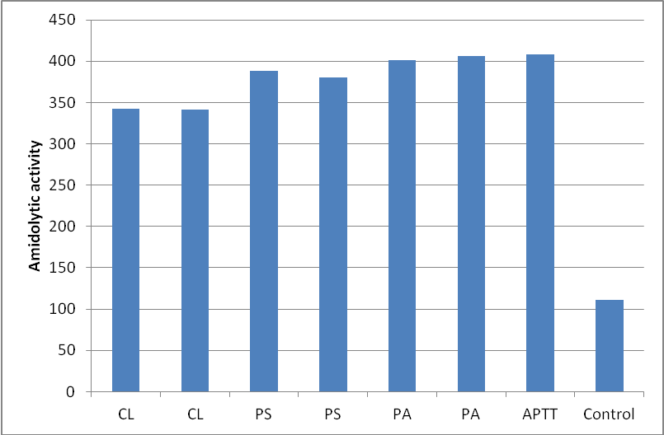
Figure 1

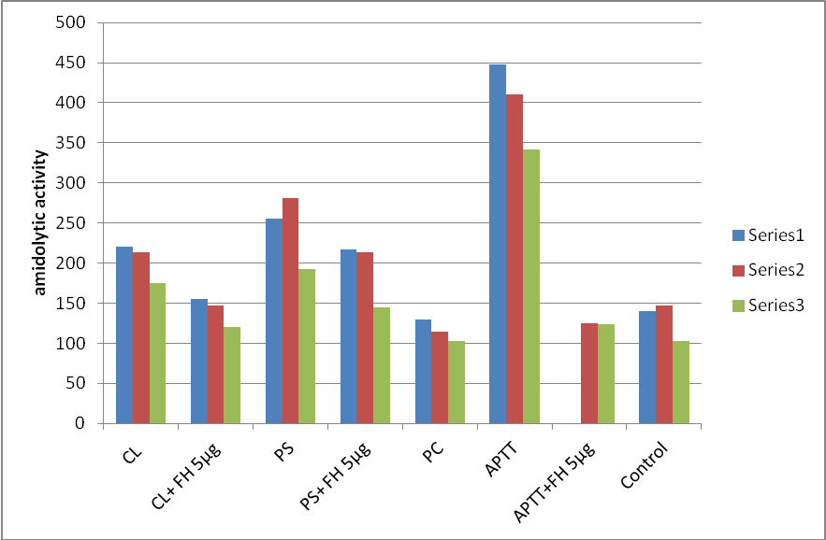
Figure 2

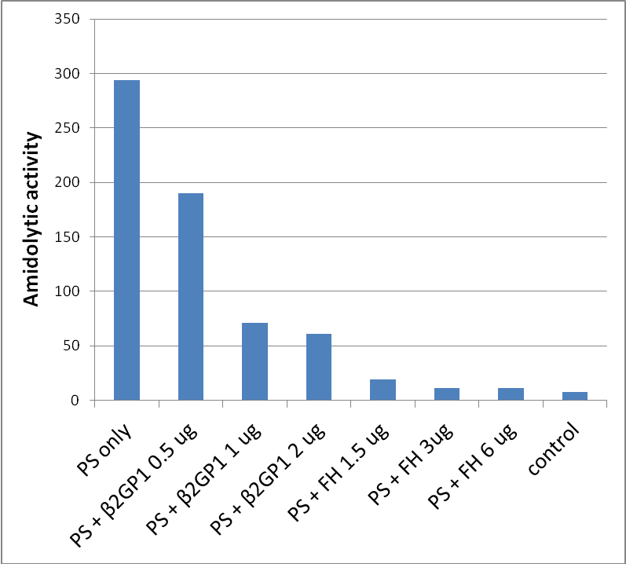
Figure 3

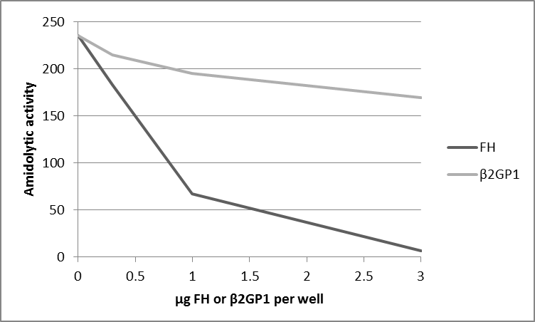
Fig. 4

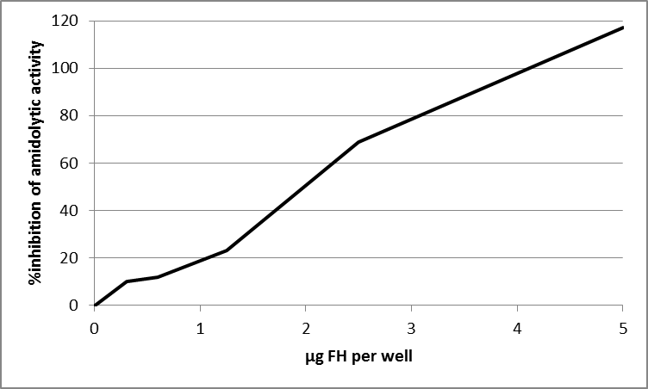
Fig. 5.
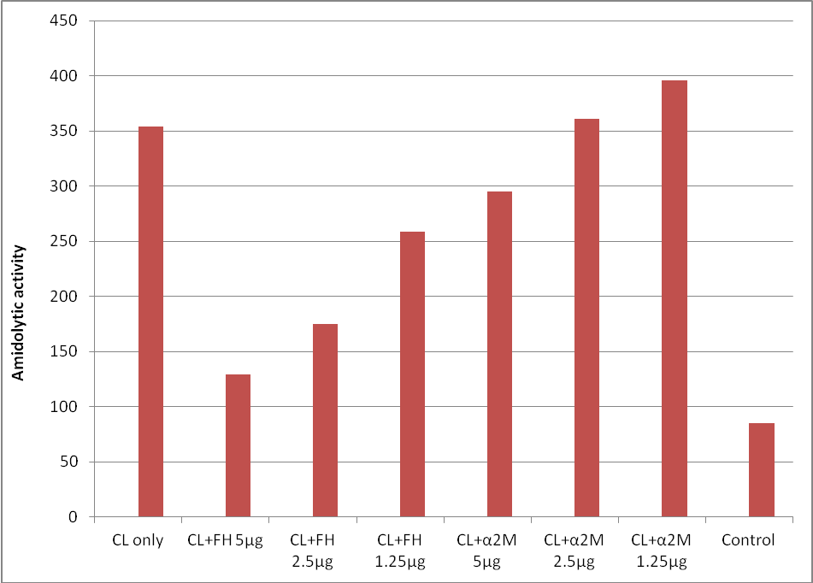
Figure 6

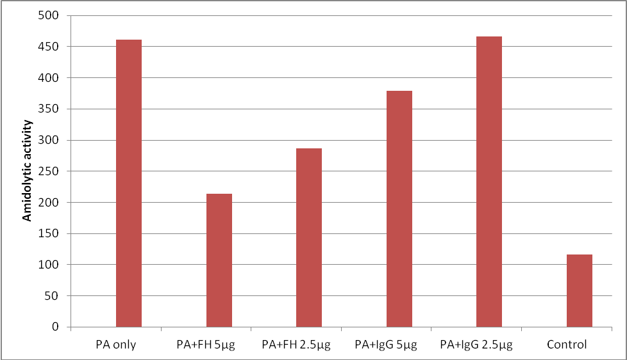
Figure 7

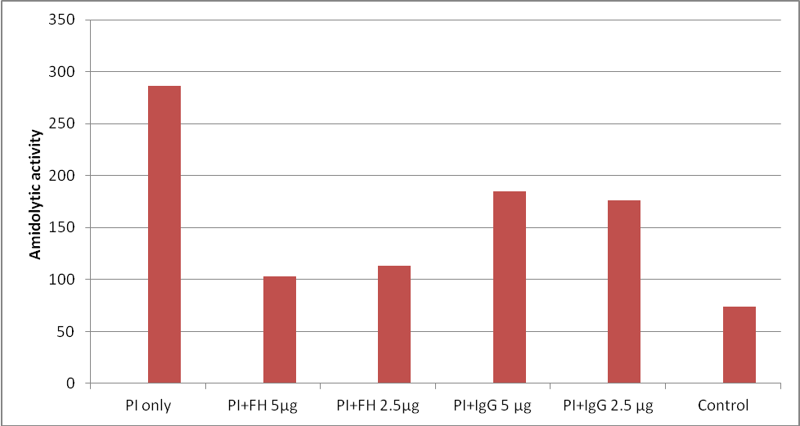
Figure 8

