A psychosocial model for the evolution of aesthetic patterns

Thibaud de Souza¹, Tatiana Kalganova
Brunel University; Uxbridge UB8 3PH

¹ee00ttd@brunel.ac.uk; ²tatiana.kalganova@brunel.ac.uk

Abstract

This paper describes an original attempt to evolve aesthetic patterns by integrating the rules of colour psychology into a multi-agent evolutionary model. The system uses the principles of evolution to determine social relationships between agents. Communication plays an important role in the evolution of social behaviour. In our case the exchange of information between agents determines their behavioural characteristics. The interaction between agents and their social behaviour may be controlled and monitored using real-time image animation technique.

1 Introduction

It is well known that it is difficult to guide the evolution of meaningful aesthetic patterns. Important problems associated to this include the design of systems with generic representational capabilities, the question of aesthetic judgement and knowledge integration (Machado et al 1996).
The use of artificial intelligence in evolution of artwork has been researched actively during the last decade. Thus, experiments described earlier involve manual guidance of evolution (Rooke, 2001). Mechanisms for rearranging ready-made forms have been presented in (Soddu, 2001). Behavioural agents have been used to evolve images of virtual creatures (biomorphs), through the use of genetic algorithm (Dawkins, 1987). However, in this case again, manual selection has been involved.
Recently the modelling of emotions has attracted much attention from researchers. Using this technique, believable agents have been created (El-Nasr et al 1998; ). At the same time it has started to be considered an essential component of intelligence (Gershenson, 1999; El-Nasr et al 1998).
Following some insights provided in (Taylor, 2001), we have attempted to evolve aesthetic patterns without manual intervention. We suggest that automatic evolution of aesthetic forms may be achieved by combining the following:
1- A generative system with sound potential in terms of the variety and level of organisation of created forms.
2- Behavioural scripts able to manipulate the data structures contained in the system
3- Encoded rules binding the behavioural scripts to the perceived psychological qualities of the produced forms.
A system binding behavioural agents to the perceived psychological values associated with colour was designed and implemented in order to test this hypothesis. In this paper, the design of the system is exposed, along with preliminary experimental results.

2. Modelling social behaviour

The purpose of the system is to evolve scripts describing the behaviour of individuals within social groups. Each individual is described using parameters that define its physical and emotional states and a behavioural script. Physical states of agents determine their emotional state. Emotional states control the execution of an individual's script. Behavioural script defines the interactions between agents.
Relations between individuals have been modelled at 3 distinct levels:
- The emotional states of an individual are derived from the colour of its neighbours using the rules of colour psychology.
- Informational and material transfers are performed between individuals in the form of data, code, colour, density and physical links exchange.
- Social units are modelled using directed links binding individuals. Such links constrain the relative positions of individuals in space while facilitating informational exchanges and amplifying individual contributions to local emotional climates.
The location of agents is constrained within spherical bounds. The graphical patterns created reflect the evolution of individual and group attributes over time.
The system allows controlling interactively the rules that constrain the behaviour of agents and the evolution of their physical and emotional states.

- Agent characteristics

In real life, individuals may be described by their physical and psychological states.

3.1 Physical states

In our system, physical attributes include location, colour, speed and density (see Table 1). The speed vector is decomposed into 3 distinct component vectors representing the agent's speed, the pull exerted by physical links (spring vector) and a variable amount of random noise.

Table 1: Agent physical attributes
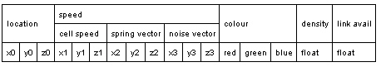

The location of each individual is initialised randomly within specified bounds. At each execution cycle the location is updated using the follow rule:
$\text{location}=\text{location}+s$
where s is calculated as a sum of cell speed, spring vector and noise vector.
The cell's speed is updated using the cell's target location, friction and acceleration parameters:
$$\text{speed}=(\text{speed}+A_{\text{acceleration}}⋅u)⋅(1−A_{\text{friction}})$$
where u is a normalised vector representing the direction of target location; $A_{\text{acceleration}}$ is an agent acceleration that is constant; $A_{\text{friction}}$is an agent friction that is constant.
The spring vector is the sum of the spring forces Fs _{i} generated by each physical links:
$$S=(S+\sum_{0<i<N_{\text{links}}}{{\text{Fs}}_{i})⋅(1−S_{\text{friction}})}$$
where $S_{\text{friction}}$ is a spring friction that is constant; $N_{\text{links}}$ is the number of physical links, ${\text{Fs}}_{i}$ is a spring forces that is calculated according to the following equation:
$${\text{Fs}}_{i}=v⋅(d_{i}−D_{i})⋅S_{\text{power}}$$
where v is a normalised vector representing the direction of the physical link; $d_{i}$is current length of physical link; $D_{i}$is reference length of the physical link; $S_{\text{power}}$ is the spring power constant.
The noise vector can be jittered randomly with a specified probability.

3.2 Colour coding scheme for modelling emotions

The psychological state of individuals has been modelled by describing the influence of the psychological climate produced by colours on individuals. Fig. 1 illustrates the relationships between agents and their emotions. The expressions of agents are derived from their colours. The expression values contribute to the emotion values of neighbouring individuals (see Fig. 2).
Figure 1: Deriving agents’ emotions from neighbouring agents’ expressions.

Figure 2: Evaluation of emotions

For each individual expressions and emotions are modelled. For any individual, values for 8 basic emotions and expressions are stored in arrays of decimal numbers in the range [0, 1] (see Table 2). The higher coefficient, the stronger the feeling.

Table 2: Psychological attributes of agent, where $E_{i},M_{j}∈[0,1]$.
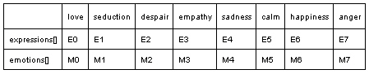

The expression of an individual is derived from its current colour using the rules of colour psychology. The intensity value for each expression component $E_{i}$ is calculated as a function of the agent's colour $(R_{a},G_{a},B_{a})$ and the expression component reference colour $(R_{e},G_{e},B_{e})$

$$E_{i}=(1−\frac{|R_{a}−R_{e}|+|G_{a}−G_{e}|+|B_{a}−B_{e}|}{3})^{2}$$

All expression components are then rescaled so that the maximum expression component value is 1.0 and the minimum is 0.0.
The overall expression intensity value is calculated according to the reference sizes of the physical links $D_{i}$ established by the individual with its neighbours (see Table 3).

Table 3: Calculation of expressions overall intensity
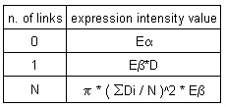

The chosen mapping between emotions and colour is exposed in Fig. 3.
The emotions of individuals $M_{i}(0<i<N_{\text{emotions}})$ are derived from the expressions of neighbours according to the equation:
$M_{i}=M_{i}⋅(1−A_{\text{affectivity}})+\frac{\sum_{j=0}^{N_{\text{neigb}}}{w_{j}⋅E_{i,j}}}{\sum_{k=0}^{N_{\text{neig}}}{w_{k}}}A_{\text{affectivity}}$;
$$w_{j}=\frac{I⋅M_{α}}{M_{β}+D^{2}}$$
where $M_{α},M_{β}$are emotion calculus coefficients that are constants; $N^{\text{neigh}}$ is the number of neighbours; $A_{\text{affectivity}}$is the agent affectivity.

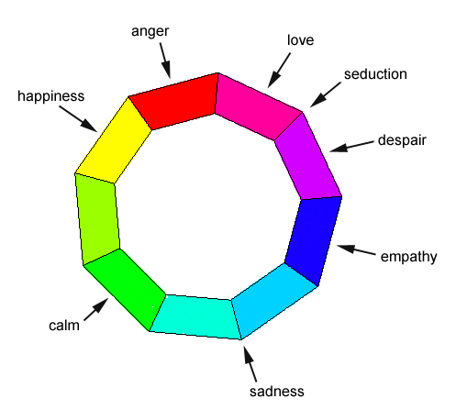
Figure 3: Colour coding scheme

3.3 Behavioural scripts

Each agent holds a thread that will execute the agent's behavioural script. Execution threads use reference and scheduling to perform operation. Every time invoked, an agent's thread performs zero, one or more operations before releasing control.
Behavioural scripts consist in operation sequences. Each operation is identified by a descriptor. The descriptor specifies the following parameters:
- an operation identifier (opcode);
- a ratio used by specific operations;
- 4 Boolean values used by Boolean logic operators;
- program and memory pointers used to address specific areas in cell memory;
- cell addressing parameters;
- one identifier controlling write access privileges.
Scripts may manipulate data stored in an individual's memory.
Behavioural scripts are initialised semi-randomly. Operators that play a crucial role in the evolution of the system are seeded in higher proportion. Memory buffers are initialised randomly.
At each execution cycle, an execution thread invokes one or more instructions. The execution thread releases control when one of the following occurs:
- The latest operator invoked specified a non-zero execution delay or had its break parameter set
- The program pointer is out of range.
- A stop operator was executed.
Execution may be controlled using a range of parameters that will influence the evolution and quality of the produced system (see Table 4).

Table 4: Execution control parameters
enable write access modifiers | Allows scripts to protect memory or code fragments in writing.
progressive data transfer checking; | Controls whether data transfer operations validity is checked once per transfer or once for each transferred memory buffer
progressive program memory transfers | Controls whether program code transfer operations validity is checked once per transfer or once for each transferred operator
allow data transfer offsets; | Controls whether an offset address should be used when transferring data from cell to cell
allow program transfer offsets | Controls whether an offset address should be used when transferring code from cell to cell
action threshold values A0,A1 | Used to determine success of failure of action operators, based on the distance from the caller to the target cell.
perception threshold values P0, P1 | Used to determine success of failure of perception operators, based on the distance from the caller to the target cell.

Each operator has a number of associated parameters: operator cost, break parameter, emotion code and emotion reference value (Table 5).

  - Operators

In the systems a number of operators has been defined according to the evolution of the system. Thus, one of the introduced operators is the transfer operator. This operator can transfer colour, link material or density to target agent using specified ratio. The operator has been designed in such way that no material can be added or removed to/from the system. If some material has been transferred from one agent to another, then the same amount of material will be subtracted from the source agent. Another operator that has been introduced in the system is a motion operator. The purpose of this operator is to identify the target location for the agent. The link operator allows establishing the physical links between agents. The specified value of link material can be allocated using an allocation operator. The allocation is carried out between two previously linked agents. Active agents are allowed to exchange information with their neighbourhood. In this case distance, colour and location of agent are taken into account. The enquiry is used in order to establish contacts with agents in neighbourhood and if the answer is positive the exchange of information takes place.

Table 5: Operation attributes
cost | Represents the amount of energy needed to execute operator.
break parameter | Determines whether an agent's thread should release control after execution of the associated operator.
execution delay | The time (in frames) necessary to complete execution.
emotion code | Successful execution of the given operator will be dependant on the value of one specified emotion
emotion reference value | The threshold value that the given emotion should have for the given operator to always execute successfully.

  - Evaluation criteria

The system potentially contains self-reproducing behavioural patterns involving one or more individuals. Evolutionary pressure arises primarily as a result of memory resources limitations. The fittest behavioural patterns use the given instruction set advantageously to reproduce faster and more accurately according to the physical and psychological rules governing the system.

- Graphical representation

The evolved patterns are represented in real-time. Images can be produced by rendering the system incrementally over time. Images contain information about agents and their physical links.
Fig. 4 illustrates an example of image produced after several generations. In this image the black tracks represent agent trajectories. The agents that established links with neighbourhood are drawn as polygons. The colours of polygons interpolate the colours of individuals. The presented picture is at an early stage of evolution. The distribution of colour is still random. This shows that the system has not evolved any specific emotional climate. One can notice that there are only few links established between agents. This is identified by the number of polygons in the presented image.

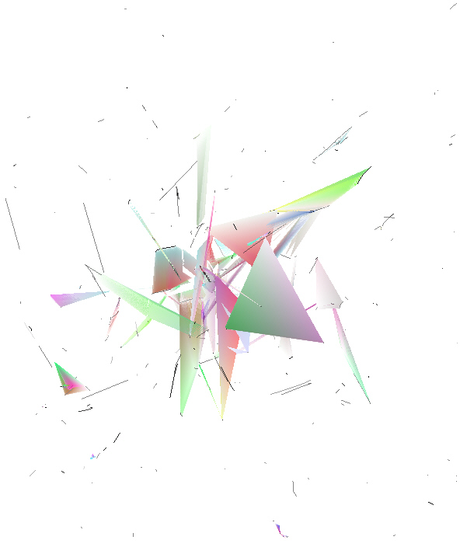
Figure 4: A sample output image

Physical environment and program execution parameters may be modified interactively. The user may tune the visual output using a range of parameters and navigate inside the system. These parameters include whether the links should be drawn or not, whether the neighbourhood should be drawn or not, etc.. The Viewing camera may be linked to one of the agents’ location.
A comparison between Fig. 4 and Fig. 5 demonstrates the use of different viewpoints.

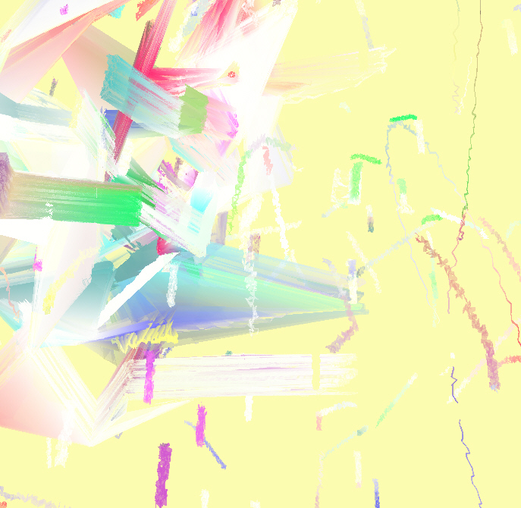
Fig. 5: Close up

5. Experimental results

The system has been implemented using C++. A number of experiments have been set up in order to test the technical and aesthetic qualities of the system. A population of one thousand of agents has been used in the performed series of experiments. The analysis of experiments shows the evolutionary qualities of the system, as well as its ability to produce a wide range of aesthetically pleasing visual patterns. Two main series of experiments have been carried out. In the first one the parameters of the system have been investigated in detail. In the second one the aesthetic qualities of the produced images have been evaluated by an expert in the field.

5.1 Numerical analysis

In order to identify how the system behaves depending on the used type of constraints, a number of experiments have been carried out. The purpose of the experiment is to illustrate how the system will behave with and without colour constraints. First of all we have been interested in the evolution of operator distribution in the system (Experiment A). In this case no colour scheme has been applied. In the second experiment, colour constraints have been applied (Experiment B). In this case one psychological colour based constraint has been applied to the copy and get cell reference operators.
Table 6: The parameters of the system
environment parameters
number of agents | 768
link avail/cell | 0.03
randomise colour | no
seed radius | 0.25
world radius | 1.50
reduced operator set ratio | 0.25
agent acceleration | 0.008
agent friction | 0.001
agent max. speed | 0.05
target threshold | 0.05
action thresholds A0,A1 | 0.3,0.5
perception thresholds P0,P1 | 0.3,0.9
stamina recovery | 0.01
environment depth | 0.4
spring power | 0.08
spring friction | 0.6
spring max speed | 0.045
noise amount | 0.001
noise frequency | 0.001
noise max speed | 0.01
execution control
use write protection | yes
progressive data transfer checking | yes
progressive program transfer checking
data transfer offset | yes
program transfer offset | yes

The operators were set to warrant execution only for love emotion values superior to 0.6.
The initial values of parameter used in this experiment are shown in Table 6. The experimental results obtained are plotted in the graphs shown in Fig. 6 (Experiment A) and Fig. 7 (Experiment B). The analysis of obtained results shows the following :
- In both cases, evolution arises and can be detected by the characteristic shape of the graphs.
- The distribution of operators evolves more slowly when additional colour constraints are applied.
- When colour constraints are applied, there is an increase in the proportion of arithmetic operators.
- It can be clearly seen that the copy operators is used more often if there are no colour constraints.
- The transfer link material is used less in Experiment B.
- The distribution of operators slows down with increase of number of generations.
Analysis of the results of these experiments shows that the use of colour-based constraints influences the overall performance of the system.

5.2 Aesthetic qualities of the produced images

Images produced after 10000 generations have been presented to an expert in the area of graphic design to identify the strengths and weaknesses of the generated images. The evaluation of the images has been focused on the evocative power and the dynamic qualities of the images.
8 images have been presented to the expert in graphic design. Some of these images are reproduced in Fig. 8 – Fig. 10. Fig. 8 and Fig. 9 present the evaluated images as well as the comments of the expert. It is interesting to note that associations with Van Gogh have been drawn with one of the presented images. At the same time another examined image has been associated with the works of Balla (not shown).
The overall impression is that “most images have a fractured quality to them and tonally occupy a similar amount of variation – all the images share a similar amount of activity except two depicted in Fig. 8 and Fig. 10 which seem to be more active. Apart of Fig. 8 and several others they look like abstract prints ... The one I find hardest to look at is Fig. 8”.
Based on the comments of expert one can conclude that the produced, graphical patterns are novel, original and inspiring.

Figure 6: Experiment A: Distribution of operators over time without colour constraints. The horizontal axis represents the number of generations and the vertical axis represents the number of operators used in the system.
Figure 7: Experiment B: Distribution of operators over time with colour constraints. The horizontal axis represents the number of generations and the vertical axis represents the number of operators used in the system.

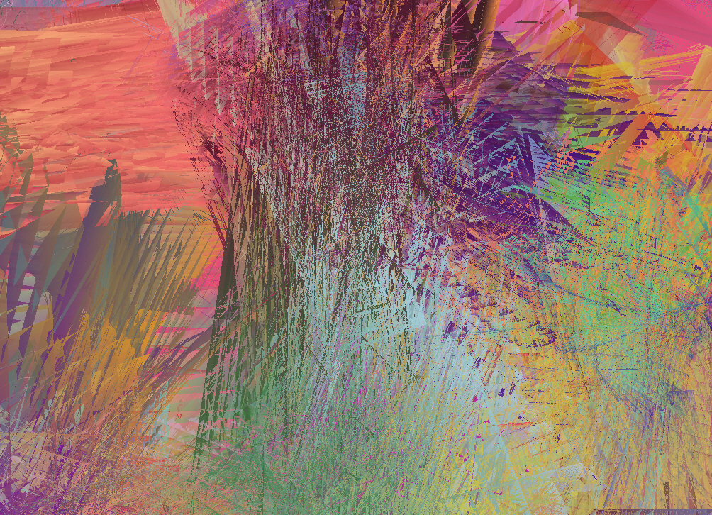
“A scratchy image, looking a little like a Van Gogh of a lave flow. Quite explosive but a cooler explosion - a steam geyser rather than a lave eruption. There is a sense of clashing and collision here between the linearity of the red (lower right) and the more chaotic greens and blues of the upper left.”
Figure 8. The first selected image, “Domain”


“A forest, a multi-layered image that does not seem to have a “ground” or a base on which the images are constructed, there is the sense of a continuing, scalable environment. It all seems very organic and natural. A “flat” composition with a rather uniform emphasis (hence the feeling of no foreground and no background just a continuing space).”

Figure 9. The second selected image


Figure 10: The third selected “active” image, “Ice skating”
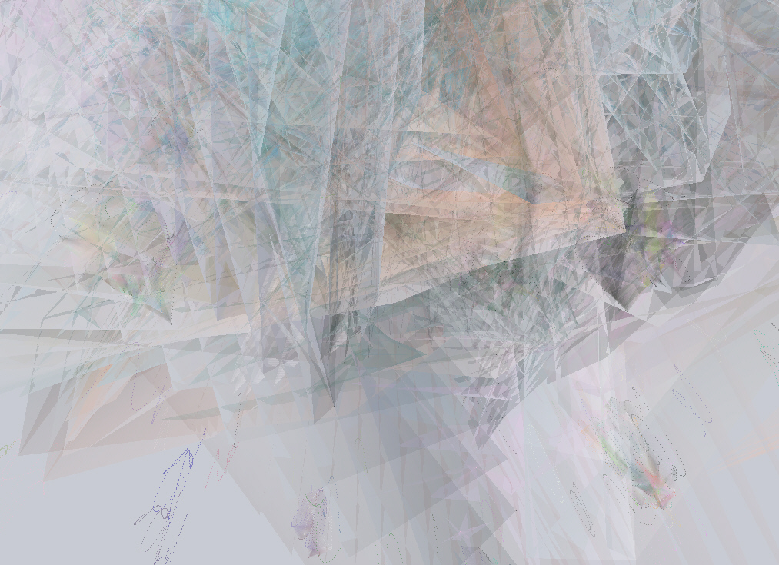
“Looking a mountain through frosted glass, its too tonally uniform to be mist. The more you examine it the more colourful it becomes and the more physical depth is perceived…. Turning it back to the correct orientation it reveals an eye in the centre, it is more sinister. Again it is top heavy, fractures, crystalline.”
Figure 11. The fourth selected image
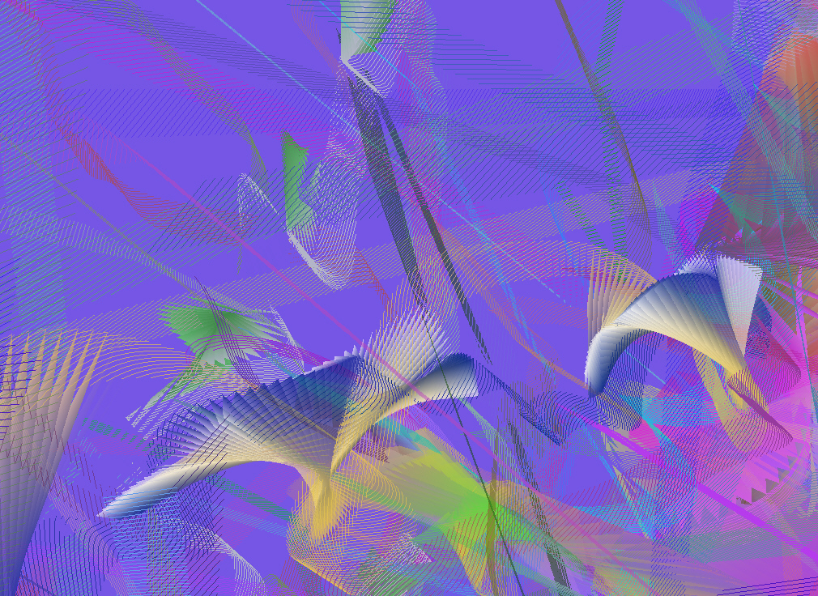
Figure 12. Generated image
A number of generated images produce very strong associations with real life. Thus, it has been noticed that the image depicted in Fig. 12 reminds a lot of the relaxing sea life. Dynamic motion inside the picture can be seen very clearly.
6. Future work
Extended analysis of the system may explore the spatial migration of passive and operational knowledge within the system and attempt to identify and understand specific behavioural patterns.
The rules of colour psychology should be combined with an anthropomorphic approach to space and motion to evolve appealing graphic configurations.
7. Summary
In this paper, a psychosocial model for the automated evolution of aesthetic patterns has been presented. A colour-coded scheme has been used to constrain the social behaviour of individuals. Experimental results demonstrate the influence of colour-based constraints on the evolution of behavioural and graphic patterns. An expert in graphic design has examined several produced images. The quality in terms of colour harmony and composition has been demonstrated. The dynamic is one of the specific features of generated images. The experimental results show the dominance of different colours in different neighbourhood. The produced images display aesthetic qualities in terms of colour harmony.

Acknowledgements

We would like to thank Leon Cruickshank from Brunel University for his evaluation of the produced images and anonymous reviews for their comments. The first author would like to thank Prof. John Stonham for advice and friends for kind support given during preparation of this paper.

References

Dawkins, R. The blind watchmaker. W.W. Norton & company , Inc., 1987.

El-Nasr, M.S. and M. Skubic. A Fuzzy Emotional Agent for Decision-Making in a Mobil Robot, Proc. of Fuzz-IEEE 98 , 1998.

El-Nasr, M.S. and J. Yen, Agents, Emotional Intelligence and Fuzzy Logic, Proc. of the 17th Annual Meeting of the North American Fuzzy Information, 1998.

Gershenson, C. Modelling Emotions with Multidimensional Logic. Proc. of the 18th Int. Conference of the North American Fuzzy Information Processing Society (NAFIPS '99), pp. 42-46. New York City, NY, 1999.

Machado, P., Cardoso, A., Generation and Evaluation of Artworks. Proc. of the 1st European Workshop on Cognitive Modeling, CM'96, in Schmid, Krems and Wysotzli (Eds.), TR 96-39, Technische Universität Berlim, Germany, 1996.

Rooke, S. Eons of Genetically Evolved Algorithmic Images. In “Creative Evolutionary Systems”. Eds: P.J. Bentley, D.W. Corne, published by Morgan Kauffman, 2001.

Soddu, C. Recognizability of idea. In “Creative Evolutionary Systems”. Eds: P.J. Bentley, D.W. Corne, published by Morgan Kauffman, 2001.

Taylor, T. Creativity in Evolution. In “Creative Evolutionary Systems”. Eds: P.J. Bentley, D.W. Corne, published by Morgan Kauffman, 2001.

