Research Paper
A Comparison of Different Algorithms for EEG Signal Analysis for the Purpose of Monitoring Depth of Anesthesia
Quan Liu ¹, Yi-Feng Chen ², Shou-Zhen Fan ³, Maysam F. Abbod ⁴ and Jiann-Shing Shieh ^{5, *}
1 Key Laboratory of Fiber Optic Sensing Technology and Information Processing, Ministry of Education, Wuhan University of Technology, Wuhan, Hubei 430070 China; E-Mail: quanliu@whut.edu.cn
2 School of Information Engineering, Wuhan University of Technology, Wuhan, Hubei 430070 China; E-Mail: chenyifengwhut@126.com
3 Department of Anesthesiology, College of Medicine, National Taiwan University, Taipei 100 Taiwan; E-Mail: shouzen@gmail.com
4 College of Engineering, Design and Physical Sciences, Brunel University London, UB8 3PH UK; E-Mail: maysam.abbod@brunel.ac.uk
5 Department of Mechanical Engineering, and Innovation Center for Big Data and Digital Convergence, Yuan Ze University, Taoyuan, Chung-Li 32003 Taiwan; E-Mail: jsshieh@saturn.yzu.edu.tw
* Author to whom correspondence should be addressed; E-Mail: jsshieh@saturn.yzu.edu.tw;
Tel.: +886-3-463-8800 (ext. 2470); Fax: +886-3-455-8013.
Received: / Accepted: / Published:

Abstract: The electroencephalography (EEG) signals have been commonly used for assessing the level of anesthesia during surgery. However, the collected EEG are usually corrupted with artifacts which can seriously reduce the accurate of depth of anesthesia (DOA) monitors. A robust and correct indicator is needed for measurement of DOA in order to avoid over or under dosing of anesthetics. We have compared five different EEG based indices, which are median frequency (MF), 95% spectral edge frequency (SEF), approximate entropy (ApEn), sample entropy (SampEn) and permutation entropy (PeEn), for their noise considerations to measure the DOA. The current analysis is based on synthesized EEG corrupted with four different types of synthesized noise and real data collected from patients undergoing general anesthesia during surgery. Performance of each method is investigated before and after filtering in real EEG signals respectively. The coefficient of variation (CV) and Pearson correlation coefficients between these indices and bispectral index (BIS) are measured as the criteria to quantify their performance of robustness and correctness. All the algorithms except PeEn are prone to interference from all of the noise types. Algorithm based on PeEn has the best performance for EEG corrupted with EOG, EMG and baseline drift but performs sensitive to power line noise. And PeEn also performs more insensitive to bandwidth of reconstructed EEG signals and accurate for monitoring DOA confirmed by higher correlation coefficients with bispectral index (BIS). Finally, a combined index is obtained based on ANN model and has extremely better performance for DOA monitoring in comparison with single indices.
Keywords: Electroencephalography; Artifacts; Depth of anesthesia; Noise consideration

1. Introduction
Anesthesia is a necessary tool for individual patient undergoing surgery in operating room to ensure loss of consciousness but has risks. Inadequate drug dosage may have severe consequences for patients such as possible intraoperative awareness with memory because of under dosage and recovery time delay and thus potential increase of other postoperative complications associated with over dosage . Evaluation of anesthetic depth provides knowledge of balance between state of patients and anesthetic drug administration . Therefore, accurate monitoring of DOA can contribute to improve the safety and quality of anesthesia thus patients’ outcomes.
Electroencephalogram (EEG), a measure of electric activity of human brain through non-invasive technique has long been widely used in clinical environment for offering evidence to determine the status of the patients directly and objectively. Especially, indices based on EEG analysis are increasingly applied to measuring the depth of anesthesia (DOA) during surgery . There are numerous features extracted from EEG based on different methods. Early attempts widely used linear methods in frequency domain based on Fast Fourier Transform (FFT). The EEG frequency spectrum analysis provides valuable information during intraoperative monitoring in the individual subject. And indices based on the frequency spectrum such as 95% spectral edge frequency (SEF) , median frequency (MF) are derived and have variously been used to estimate the depth of anesthesia.
Nevertheless, it has been noted that nervous systems of human being present various nonlinear characteristics in a certain extent . Thus, many researchers suggest that the EEG signals should be considered as a chaotic pattern instead of a series of sine waves . Consequently, methods from nonlinear dynamics seem to necessary in analysis of EEG signals . In particular, entropy is a widely developed concept related to chaotic system that measures the complexity in a time series in the past thirty years . Approximate entropy (ApEn) was introduced by Pincus in 1991 , which could easily be applied to anesthetic depth monitoring during surgery . ApEn provides a potential solution to rapid calculation of the regularity for medical data analysis. Sample entropy (SampEn) developed by Richman and Moorman is an improved algorithm to estimate the complexity of signals, such as heart rate variability and EEG . Furthermore, in 2002 Bandt and Pompe proposed a new method named Permutation entropy (PeEn) for measure of complexity. PeEn combines the concepts of entropy and symbolic dynamics.
The parameters mentioned above have been suggested as measures of the DOA using EEG data for clinical application. However, these all monitors have some limitations. They are easily contaminated by artifacts such as electrooculography (EOG) due to blinks and 60Hz power line interference from external electrical signals. The noise in EEG signal increases the difficulty in monitoring DOA in clinical surgeries. It is indicated that the corresponding technologies used to measure DOA of patients reliably do require the accurate detection of EEG pattern in the presence of noise. These issues are important design consideration for application in DOA monitoring.
The aim of this study is to quantify the relative noise effects of MF, SEF, ApEn, SampEn and PeEn for monitoring DOA. The database contains ten pairs of synthesized EEG and twenty-six real EEG signals collected from patients in operation room during surgery. We modeled four types of artifacts and then added them into uncorrupted EEG to form the synthesized signals. The performance of each algorithm to monitor the DOA is measured on both synthesized and real signals. In this paper, coefficient of variation (CV) of each index for synthesized EEG with different level of noise, and correlation coefficient between the indices calculated from EEG to measure the DOA of patients and bispectral index (BIS) recorded in real time used as a gold standard are calculated to compare their performance.
In addition, different kinds of methods examine a different dimension of EEG waveform. The linear quantification of DOA based on spectrum analysis reflects the frequency information. In contrast the nonlinear methods based on entropy extract regularity information. For this reason, a combination of these variables may monitor the DOA more reliably and accurately than a single index. Therefore, we combined all these five indices into a new single index to reflect the level of anesthesia more accurately. Consequently, artificial neural network (ANN) is used to estimating the relationships between BIS and multiple indices. The correlation coefficient between the combined index and BIS is extremely higher than each single index. The results of this study will provide an important reference for researchers and medical institutions to the development of a more robust clinical instrument to monitor DOA of patients during surgery.
2. The EEG Database Preparation
2.1. The Uncorrupted Signals
Two parts EEG signals were collected as the uncorrupted signals by MP60 system (Philip, IntelliVue MP60 BIS module), one of which was from ten patients when they had consciousness and closed their eyes without movement and the other part was from these ten patients when they were under general anesthesia during surgery. Then the collected EEG signals were preprocessed to remove noise using multivariate empirical mode decomposition (MEMD) based filter according to the following section. The duration of each EEG signal is 30 seconds with 3750 points. The signals were sampled with 125 Hz. An example of 30 seconds uncorrupted EEG is plotted in Figure 1.

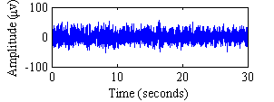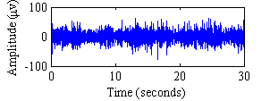
(a) (b)
Figure 1. Uncorrupted EEG with duration of 30 s. (a) Under awake state. (b) Under anesthesia state.
2.2. The Simulated Noise
Although EEG refers to the measure of cerebral activity, it also measures electrical activities due to other regions than brain. The electrical signals originate from other regions are termed as artifacts. Generally, the artifacts can be divided into the biological artifacts generated by the body such as electrooculography (EOG), electromyography (EMG) and environmental artifacts owing to outside such as 60 Hz power line interferences and baseline drift. The purpose of this paper is to compare the noise effect of five different indicators for monitoring DOA during surgery. In this study, four common artifacts contaminating measured EEG signals which are EOG, EMG, 60Hz power line interferences and baseline drift respectively are selected for simulation analysis. EOG is the most common type of biological artifacts due to blinks of eyes which occur several times per minute . EMG artifact is also quite common and caused by muscle activity . Inadequate grounding of the EEG electrodes on patients can lead to 60 Hz power line interference depending on its local power system . And movement by the patients may result in electrode motion and thus generates baseline changes termed as baseline drift with low frequency . In each case, the noise is added into the uncorrupted EEG signals with different signal noise ratio (SNR) ranging from 10dB to -20 dB with a step of -1 dB with respect to the EEG level. These four artifacts mentioned above are modeled according to the previous research as follows:
1) EOG are collected from Data sets 2a of BCI Competition IV in which we select the second channel which represent the blinks of eyes for EOG artifact simulation. Then the EOG are added into uncorrupted EEG. Figure 2(a) shows the EEG corrupted with EOG at -5 dB level.
2) EMG is simulated by a random data series generated using the “randn” function in MATLAB. Figure 2(b) illustrates the EMG-corrupted EEG signal with -5 dB.
3) Power line is modeled by sinusoidal function generated using the “sin” function in MATLAB at exact frequency of 60 Hz. An example of EEG corrupted by this noise at -5dB is given in Figure 2(c).
4) Baseline drift modeled by a low frequency at 0.333 Hz sinusoidal function is the same as power line noise except that the frequency is different as shown in Figure 2(d).

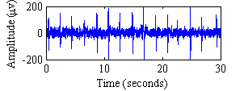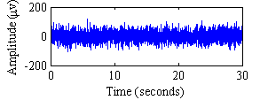
(a) (b)
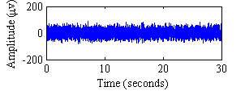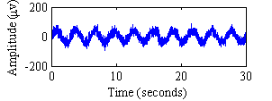
(c) (d)
Figure 2. An example of EEG signal under awake state contaminated by modeled artifacts with the level of -5 dB. (a) EOG. (b) EMG. (c) 60 Hz powerline. (d) Baseline drift.
2.3. The Real Signals
The real EEG signals were collected from 26 patients aged from 20 to 74 years undergoing general anesthesia during surgery at National Taiwan University Hospital (NTUH) of Taiwan. The device used to record EEG is MP60 patient monitor (Philips, IntelliVue MP60) with the sampling rate of 125Hz. At the same time, BIS was measured by BIS module every 5 seconds. All data were recorded and stored on a laptop for further analysis. This study is approved by the Institutional Review Board and written informed consent was also obtained from the permission of the patients. Generally, the operation procedure is divided into four stages: pre-operation (i.e., stage 1), induction (i.e., stage 2), maintenance (i.e., stage 3) and recovery (i.e., stage 4) . Before the patient receives anesthesia, they are conscious and thus always move or blink their eyes. The measured EEG signals are contaminated by EOG and EMG noise as indicated in Figure 3(a) and (b) during stage 1. Figure 3(c) provides an example of EEG contaminated by power line artifact in operation room. During stage 2, the patients need to be moved owing to intubation, the collected EEG are always corrupted with baseline drift as shown in Figure 3(d).

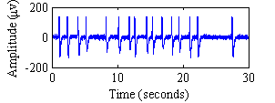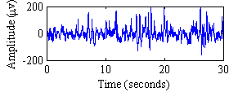
(a) (b)
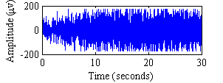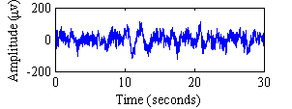
(c) (d)
Figure 3. The real noisy EEG signals collected from patients in operation room during surgery. (a) EOG. (b) EMG. (c) 60 Hz power line artifact. (d) Baseline drift.
3. Description of the Algorithms
3.1. Spectral Edge Frequency and Median Frequency
Several single variables could be derived from EEG signal with the analysis of power spectrum, such as spectral edge frequency. The 95% spectral edge frequency (SEF) and median frequency (MF) stand for the frequencies below which 95 and 50 percent of the total power of the EEG signal are located. SEF 95 and MF derived from EEG would be reduced with increasing anesthetic concentration of general anesthesia. Therefore, the frequency shift in the EEG signal from high in the awake state to low in the anesthesia state will be indicated by a numerical decrease in both MF and SEF 95. In this paper, the power spectral estimation of EEG signals is based on fast Fourier transform .
3.2. Approximate Entropy
Approximate entropy (ApEn) was proposed as a valuable tool to evaluate the regularity degree of data series and thus widely used to measure the complexity of EEG for quantifying the consciousness level of patients . For a given number of previous values used for the prediction of the subsequent value m, a filtering level r and a time series {x(n)} = x(1), x(2), ..., x(N) with N data points, the ApEn can be calculated according to the following algorithm :
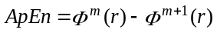 (1)
where 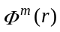 is defined as
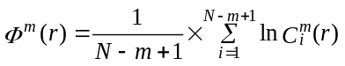 (2)
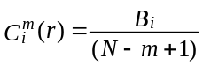 (3)
And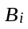 is the number of 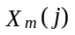 satisfying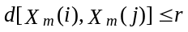, 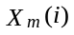 andare vectors defined by
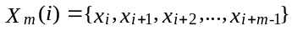 (4)
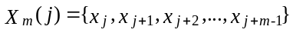 (5)
According to previous research , parameters m = 2, r = 0.2 were observed for ApEn calculation with best performance. Therefore, in this paper we set m = 2, r = 0.2.
3.3. Sample Entropy
SampEn is an improved algorithm from ApEn exclude self-matches used commonly to measure the complexity of a physiological time series. Similarly, for a given time series {x(n)} = x(1), x(2), ..., x(N) with N data points, embedding dimension m and tolerance r, SampEn can be calculated as follows:
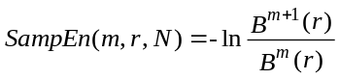 (6)
where 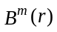 is defined as
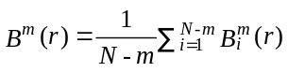 (7)
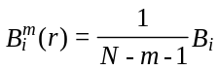 (8)
and 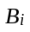 is the number of vectors meeting 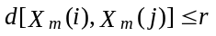,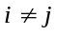, andare defined as (4) and (5) mentioned above.
Generally, the value of m is set to be 2 and the value of r to be 0.2 according to previous studies . In this paper the parameters are set as follows: m = 2 and r = 0.2.
3.4. Permutation Entropy
Permutation entropy (PeEn) provides a simple and robust method to estimate complexity of time series, taking the temporal order of the values into account. Given a time series {x(n)} = x(1), x(2), ..., x(N) with N data points, embedding dimension m, and the lag. Considering the value sequence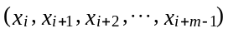, the permutation pattern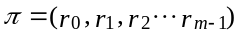 of 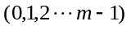is defined to fulfill
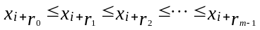 (9)
For each we determine the relative frequency
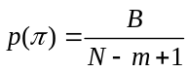 (10)
where is the number of which has the same type for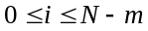.
Then, we further extend by considering an embedding delay as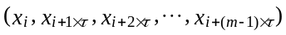 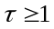, the PeEn is defined by
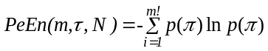 (11)
A previous study suggests 3 < m < 7 with 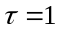 to measure the complexity of time series using PeEn, and the authors in set m = 6, to measure EEG signals. Thus in this paper the parameters are set as follows: m = 6 and.
3.5. Artifact filtering from EEG
It is noted that real EEG signals collected from patients during surgery are commonly contaminated by different kinds of artifacts. In order to investigate the difference of each indicator to noise, real EEG signals not only before filtering but also after filtering are used in this paper. In conventional method, fast Fourier transform (FFT) and wavelet transform based filter with fixed basis function are widely applied to remove noise from EEG. However, FFT based methods are suitable for analysis of linear and stationary signals and wavelet are appropriate to analyze linear and non-stationary signals. Therefore, they are inadequate in the application of EEG analysis which is nonlinear and non-stationary. Recently, empirical mode decomposition (EMD) was proposed to process non-linear and non-stationary signals . EMD can adaptively decompose a complicated data set into several intrinsic mode functions (IMF). In comparison with FFT and wavelet transform, EMD performs highly adaptive and efficient without any limitation of predefined basis function and window length. Multivariate empirical mode decomposition (MEMD) is an improved method to solve the mode mixing problem of EMD and can be applied to multichannel signals . In this study, MEMD is used instead of EMD to decompose the single channel EEG through adding two extra channels with independent white noise . According to the previous research , an MEMD based filter is designed to remove artifacts from EEG recordings described in detail as follows:
1) Decompose the multichannel signals consisting of one channel EEG and two channel independent white noise.
2) Extract the IMFs related to the EEG channel.
3) Reconstruct the filtered EEG signal by summing IMF2 and IMF3.
In order to compare the performance of MF, SEF, ApEn, SampEn and PeEn on EEG signals with different bandwidth, we also reconstructed the signals using different combination of IMFs which is demonstrated in the following section.
3.6. The Performance Criteria
For simulation data, coefficient of variation (CV) defined as (12) is used to quantify the differences of selected indicators to artifacts for measuring DOA of EEG signals. Lower CV value indicates the corresponding indicator is less sensitive to noise.
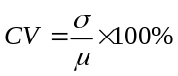 (12)
where is the standard deviation(SD) of data and is the mean value.
Furthermore, for real EEG signals collected from patients during surgery, the evaluations routine compares EEG based indices to a gold standard (e.g. BIS) measured in real time by MP60. Pearson correlation coefficient test between indicators and BIS is conducted for linear relationship measuring when the null hypothesis is not applicable. Values are expressed as meanSD. Data are analyzed by bi-variate correlation. Statistical analysis is performed in SPSS (v19, SPSS Inc.; Chicago, IL, USA). The level of significance is set at p < 0.05. Because the essence of BIS is to take the EEG signal, analyze it, and process the result into a single number every five seconds, in order to consistent with BIS recordings, a sliding window using fixed-size of 30 seconds including 3750 points is needed. The window moves once every five seconds for real time DOA monitoring.
4. Results
4.1. Comparison of EEG based indicators to artifacts
Simulated artifacts with different levels were added into uncorrupted EEG signals, which were reconstructed by summing IMF2 and IMF3 of EEG recorded by the commercial method as mentioned in section 2. Figure 4 shows the normalized mean values of EEG parameters MF, SEF, ApEn, SampEn and PeEn when patients have consciousness on the basis of simulated data. The change of mean values with different levels of noise in the 10 subjects was statistically investigated to determine whether the 5 measures perform as good assessment in different noise rejections for monitoring DOA. As can we see, the mean values of SEF, ApEn and SampEn decrease significantly with the increase of noise level and MF and PeEn seem to remain almost stable when adding EOG noise into EEG signals which indicates that MF and PeEn are less sensitive to EOG in comparison with the other three indicators. When adding EMG noise into EEG signals, MF, SEF, ApEn and SampEn monotonically increase while PeEn almost maintains a constant value. For 60 Hz power line noise, ApEn, SampEn and PeEn decrease significantly with the increase of noise level. ApEn and SampEn rise when the noise levels are low compared with the corresponding value measured from EEG without noise and then ApEn decreases when SNR is less than 10 dB and SampEn decreases when SNR is less than 0 dB, while ApEn reduces slightly until 0 dB and then decreases significantly. MF and SEF ascend and then remain a constant, and they closely approximate to 60 Hz after 0 dB and 10 dB respectively when converted into absolute value from normalized, which means MF and SEF are dominated by 60 Hz noise and less represent the feature of EEG signals. Furthermore, when EEG signals are contaminated by baseline drift modeled by 0.333 Hz sinusoidal wave, ApEn and SampEn monotonically reduce with the increase of noise level, and PeEn remains stable approximately, while MF and SEF descend until SNR is less than 0 dB and -13 dB respectively and then remain a constant approximating to absolute value of 0.333 Hz similar to power line noise, which means MF and SEF are dominated by baseline drift and less represent the feature of EEG signals.
Figure 5 represents the statistical result measured from EEG collected from 10 patents under general anesthesia without consciousness during surgery contaminated by different types of noise. Although it is less possible that EOG due to blinks of patients can contaminate EEG signals collected during maintenance stage because patients lose their consciousness and without blinking eyes, we still analyze this case in order to confirm the performance of EEG based indices to different artifacts under different state. When adding EOG noise to EEG signals collected from 10 patients under maintenance stage as shown in Figure 5(a), it can be seen that MF, SEF, ApEn and SampEn decrease with the increase of noise levels in spite of very slight in MF and SEF, while PeEn remains stable. Therefore, EOG reduce MF, SEF, ApEn and SampEn but have little effect on PeEn for measuring the DOA of EEG signals. For EMG, 60 Hz power line and baseline drift, the results of 5 indicators are similar to Figure 4 as analyzed above.
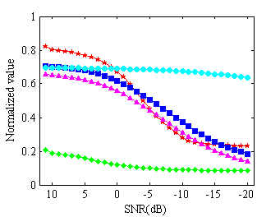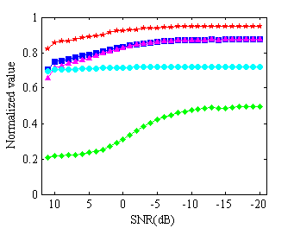
(a) (b)
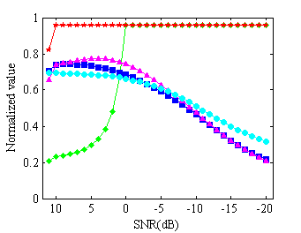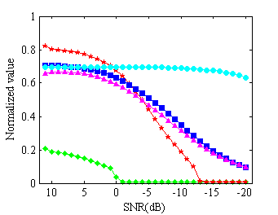
(c) (d)
Figure 4. The changes of index values with respect to SNR ranging from 10 dB to -20 dB with a step of -1 dB for DOA analysis of EEG signals corrupted with different kinds of noise. The EEG signals were collected from 10 patients under the state of consciousness and closing their eyes without blinks. And the first point is the result of EEG without noise. (a) EOG interference. (b) EMG interference. (c) Power line interference. (d) Baseline drift.
To sum up, each artifact has a similar effect on indicators for DOA measuring based on EEG collected no matter under awake or anesthesia state. Therefore, we can process the EEG regardless of patients’ state. Furthermore, Figure 4 and 5 indicate that EOG, EMG and baseline drift have little effect on PeEn but power line noise have bad effected on PeEn significantly. EMG model by white noise increase all 5 indices and baseline drift modeled by 0.333 Hz sine function decreases them despite slight in PeEn. In Figure 4(c) and Figure 5(c) in which the EEG are concentrated by 60 Hz sine wave, the absolute value of MF and SEF approximate to 60 Hz which means MF and SEF indices cannot accurately reflect the DOA in this situation. These will approximate to 0.333 Hz when EEG is added baseline drift as shown in Figure 4(d) and Figure 5(d).
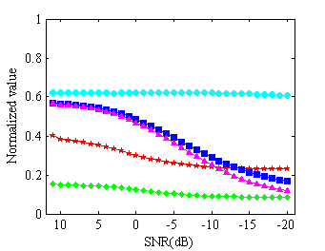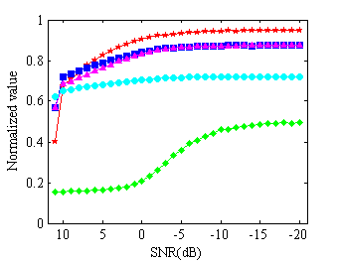
(a) (b)
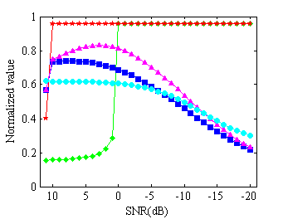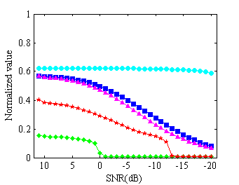
(c) (d)
Figure 5. The changes of index values for analysis of EEG collected from 10 patients under general anesthesia without consciousness during surgery. (a) EOG interference. (b) EMG interference. (c) Powerline interference. (d) Baseline drift.
In detail, to directly quantify the difference of each EEG based indicator to noise for measuring DOA, the CV values of 5 indices are calculated respectively as shown in Table 1 and Table 2. Table 1 indicates the CV values related to EEG collected from 10 patients under awake state and Table 2 shows the CV related to EEG collected from 10 patients under anesthesia state. Clearly, the CV values of PeEn are extremely smaller than the corresponding values of other indices except the 60 Hz power line interference regardless of patients’ state. Smaller CV implies less sensitive to noise thus PeEn lead to significantly higher performance than ApEn and SampEn. The CV of SEF is smallest compared with other indices when EEG signals were concentrated by power line interference. ApEn and SampEn perform very similar because of the similarity of their corresponding algorithms and are highly sensitive to EOG noise. While EOG is a very common noise in EEG recordings collected under awake state, the noise must be removed when using SampEn and ApEn to monitor DOA of patients.
Table 1. CV (%) values of 5 EEG based indices. The EEG signals were collected from 10 patients under awake state and closed eyes. Four kinds of noises were modeled to examine the performance of each index for measuring DOA.
Patient | EOG |  |  |  |  | EMG
Patient | MF | SEF | ApEn | SampEn | PeEn | MF | SEF | ApEn | SampEn | PeEn
1 | 32.95 | 47.56 | 36.90 | 41.26 | 2.02 | 21.81 | 2.27 | 1.53 | 1.73 | 0.56
2 | 23.46 | 49.71 | 38.03 | 44.15 | 2.77 | 32.91 | 2.98 | 6.83 | 8.22 | 0.72
3 | 12.53 | 50.80 | 38.70 | 44.05 | 2.92 | 44.33 | 4.14 | 7.23 | 9.13 | 0.89
4 | 14.12 | 47.25 | 39.43 | 43.60 | 2.83 | 44.65 | 5.90 | 6.50 | 8.85 | 1.26
5 | 19.22 | 48.57 | 39.45 | 44.33 | 2.19 | 41.01 | 4.93 | 4.94 | 6.23 | 1.32
6 | 23.76 | 48.95 | 37.76 | 40.25 | 3.28 | 35.23 | 4.12 | 9.13 | 12.24 | 0.28
7 | 27.52 | 48.55 | 38.88 | 43.53 | 1.94 | 36.32 | 4.73 | 3.72 | 4.59 | 1.42
8 | 20.22 | 43.35 | 39.07 | 44.45 | 2.29 | 42.15 | 7.29 | 6.27 | 7.86 | 1.59
9 | 18.32 | 49.13 | 38.30 | 42.49 | 3.25 | 35.17 | 3.72 | 7.09 | 9.44 | 0.59
10 | 19.96 | 49.71 | 39.20 | 44.34 | 2.52 | 41.74 | 4.82 | 5.30 | 6.54 | 1.09
mean  std | 21.21  6.05 | 48.36  2.04 | 38.57  0.82 | 43.25  1.45 | 2.60  0.48 | 37.53  6.90 | 4.49  1.43 | 5.85  2.11 | 7.48  2.90 | 0.97  0.43
Patient | 60Hz power line |  |  |  |  | Baseline drift
Patient | MF | SEF | ApEn | SampEn | PeEn | MF | SEF | ApEn | SampEn | PeEn
1 | 33.44 | 1.42 | 32.53 | 34.23 | 19.82 | 128.83 | 72.47 | 42.24 | 42.91 | 1.02
2 | 42.96 | 1.67 | 33.10 | 35.45 | 23.52 | 126.64 | 77.06 | 46.64 | 48.68 | 2.11
3 | 51.72 | 2.68 | 32.62 | 34.37 | 25.15 | 118.46 | 83.83 | 48.22 | 49.19 | 3.28
4 | 53.18 | 4.07 | 32.33 | 33.39 | 24.15 | 120.10 | 83.59 | 48.21 | 49.28 | 3.02
5 | 50.06 | 3.23 | 32.85 | 33.79 | 22.80 | 121.27 | 80.77 | 47.35 | 48.37 | 1.96
6 | 45.82 | 2.65 | 35.31 | 36.40 | 26.39 | 125.26 | 77.88 | 50.16 | 49.36 | 4.90
7 | 47.34 | 3.03 | 32.82 | 33.83 | 20.67 | 124.28 | 78.03 | 45.18 | 46.79 | 1.06
8 | 52.52 | 5.18 | 32.95 | 33.91 | 22.98 | 123.96 | 80.73 | 47.44 | 49.94 | 1.76
9 | 44.80 | 2.19 | 33.25 | 34.78 | 24.65 | 124.13 | 77.67 | 48.02 | 49.26 | 3.23
10 | 50.95 | 3.16 | 33.72 | 34.98 | 23.63 | 120.94 | 82.32 | 47.66 | 48.71 | 1.89
mean  std | 47.28  5.98 | 2.93  1.11 | 33.15  0.85 | 34.51  0.91 | 23.38  1.97 | 123.39  3.18 | 79.44  3.50 | 47.11  2.13 | 48.25  2.06 | 2.42  1.19
Table 2. CV (%) values of 5 EEG based indices. The EEG signals were collected from 10 patients under anesthesia state without consciousness. And four kinds of noises were modeled to examine the performance of each index for measuring DOA.
Patient | EOG |  |  |  |  | EMG
Patient | MF | SEF | ApEn | SampEn | PeEn | MF | SEF | ApEn | SampEn | PeEn
1 | 14.13 | 10.83 | 37.28 | 44.57 | 0.56 | 49.33 | 15.26 | 8.76 | 10.31 | 4.64
2 | 23.01 | 12.97 | 35.15 | 44.43 | 0.25 | 43.63 | 14.90 | 8.71 | 9.13 | 4.19
3 | 23.73 | 17.77 | 36.31 | 43.31 | 0.90 | 43.30 | 13.87 | 8.42 | 9.99 | 3.42
4 | 28.62 | 26.08 | 37.22 | 44.50 | 1.77 | 38.43 | 11.78 | 7.62 | 8.85 | 2.28
5 | 21.37 | 16.53 | 37.04 | 45.59 | 0.87 | 41.66 | 13.88 | 7.53 | 8.12 | 3.48
6 | 14.61 | 14.64 | 38.66 | 45.41 | 0.82 | 48.88 | 14.18 | 8.24 | 9.87 | 4.69
7 | 20.62 | 19.98 | 36.10 | 40.47 | 1.74 | 42.58 | 13.33 | 9.00 | 11.91 | 2.54
8 | 24.56 | 12.48 | 34.84 | 45.41 | 1.50 | 43.66 | 14.88 | 8.78 | 8.57 | 5.73
9 | 28.61 | 18.36 | 35.91 | 44.77 | 1.02 | 37.05 | 13.49 | 7.57 | 7.17 | 3.00
10 | 17.02 | 18.49 | 38.34 | 44.57 | 0.92 | 45.95 | 13.33 | 7.43 | 8.85 | 3.37
mean  std | 21.63  5.17 | 16.81  4.42 | 36.69  1.26 | 44.30  1.50 | 1.03  0.49 | 43.45  3.95 | 13.89  1.01 | 8.21  0.61 | 9.28  1.31 | 3.73  1.07
Patient | 60Hz power line |  |  |  |  | Baseline drift
Patient | MF | SEF | ApEn | SampEn | PeEn | MF | SEF | ApEn | SampEn | PeEn
1 | 57.36 | 12.18 | 32.69 | 32.74 | 21.82 | 121.28 | 67.03 | 48.06 | 53.00 | 1.27
2 | 54.67 | 11.80 | 32.72 | 32.59 | 20.52 | 122.98 | 65.66 | 44.50 | 51.80 | 1.06
3 | 54.67 | 10.90 | 32.32 | 32.69 | 20.83 | 122.95 | 67.42 | 45.43 | 50.92 | 1.78
4 | 51.63 | 9.24 | 32.81 | 33.31 | 20.99 | 128.58 | 69.17 | 44.79 | 49.95 | 1.30
5 | 53.43 | 10.96 | 32.85 | 32.56 | 20.42 | 124.41 | 66.56 | 45.19 | 51.63 | 0.80
6 | 57.30 | 11.33 | 32.77 | 32.70 | 21.42 | 120.23 | 69.41 | 48.60 | 52.72 | 1.29
7 | 53.66 | 10.49 | 31.05 | 32.21 | 21.32 | 125.28 | 68.21 | 44.81 | 48.70 | 3.07
8 | 55.03 | 11.83 | 32.87 | 32.19 | 19.22 | 126.33 | 65.00 | 44.17 | 52.43 | 0.18
9 | 50.75 | 10.60 | 32.60 | 32.52 | 18.95 | 124.85 | 64.56 | 42.49 | 50.15 | 0.55
10 | 55.62 | 10.75 | 32.64 | 32.63 | 21.43 | 119.80 | 69.16 | 47.16 | 51.89 | 1.28
mean  std | 54.41  2.15 | 11.01  0.84 | 32.53  0.54 | 32.61  0.31 | 20.69  0.95 | 123.67  2.77 | 67.22  1.77 | 45.52  1.88 | 51.32  1.37 | 1.26  0.78

Furthermore, SampEn and ApEn are less sensitive to EMG and baseline drift which are modeled by white noise and a sine wave with fixed frequency of 0.333 Hz respectively in comparison with SEF and MF. And the CV values of MF are extraordinarily larger than corresponding values of SEF except EOG noise which means MF is less sensitive to EOG but more sensitive to other three kinds of noises than SEF. Especially, MF is extremely sensitive to baseline drift, the CV values analyzed from EEG under awake and anesthesia states are 123.393.18 and 123.672.77 respectively. Supposing the CV values are evaluated from the artifacts in collected EEG signals, the statistical results indicate that each index performs different sensitivity to different noises and PeEn is relative robust to artifacts in EEG recordings but not good for 60Hz power line artifact.
4.2. Ability to discriminate states of patients during surgery
The CV values as analyzed above demonstrate the robustness of each indicator to artifacts for DOA monitoring, but the ability to distinguish EEG collected from different states also need to be confirmed. For example, in spite of smaller CV values (i.e., 2.931.11 and 11.010.84) of SEF for power line interference as shown in Table 1 and Table 2, the absolute value of SEF approximates to 60Hz which is the exact frequency of noise which means SEF cannot accurately reflect the DOA in this situation. Therefore, 10 patients’ real EEG signals are selected from 26 patients as mentioned in section 2. The real EEG signals were collected from patients under general anesthesia during surgery at NTUH of Taiwan. And then EEG time series during pre-operation and maintenance stages of the whole operation were abstracted from the completed EEG according to operation records which reserved the event notes and time in detail because the duration of these two stages is relative long and the differences between these two stages are also largest. Furthermore, in order to investigate the robustness of each parameter, we execute the calculations using four different combinations of IMFs decompose by MEMD from EEG: original EEG, IMF2+IMF3, IMF1+IMF2+IMF3 and IMF2+IMF3+IMF4 of EEG. According to the previous study, the reconstructed EEG using IMF2+IMF3 was considered as the filtered signal to monitor DOA . So in this paper, reconstructed signals using IMF1+IMF2+IMF3 and IMF2+IMF3+IMF4 with different bandwidth represent that EEG are contaminated by high and low frequency noise respectively.
Figure 6 shows the mean and standard deviation of MF, SEF ApEn, SampEn and PeEn calculated from EEG collected during pre-operation (i.e., stage 1) and maintenance (i.e., stage 3) stages respectively. And Table 3 represents the statistical results for two EEG segments collected from 10 patients. Difference is significant at the 0.05 level (2-tailed). If the significance level p is less than 0.05 then the corresponding indices measured from two EEG segments are significant different. Comparing the normalized mean and standard deviation indicates that MF, SEF, ApEn and SampEn are extremely relate to how signal are reconstructed, while PeEn performs less sensitive to noise in EEG signals. It is also suggested that no indices except PeEn can distinguish original EEG without filtering under awake state from anesthesia state. Furthermore, p < 0.05 as shown in Table 3 implies it is statistically significant between awake and anesthesia state in the difference of corresponding index, this means index has the ability to discriminate two states of patients correctly. Especially, the difference in PeEn represented in the last column is statistically significant for all signals therefore it is greatly resistant to noise in EEG signals. The filtering algorithm using IMF2+IMF3 have positive effect on SEF, ApEn and SampEn and the difference is significant after filtering. However, the difference is significant in MF for EEG signal using IMF1+IMF2+IMF3. This suggests that high frequency components in EEG is necessary for MF algorithm to distinguish awake and anesthesia state. Furthermore, comparing the statistic results of IMF2+IMF3+IMF4, SampEn is more sensitive to low frequency noise, while SEF and ApEn perform relatively better in comparison with SampEn. In fact, SampEn is an improved algorithm from ApEn in dependence on data length; however, all results were investigated under the same condition without considering data length so it is possible that ApEn perform better than SampEn.

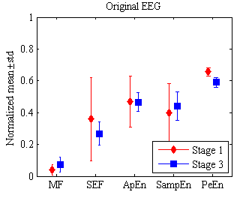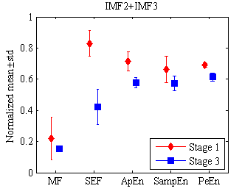
(a) (b)
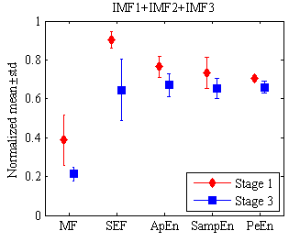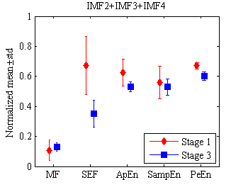
(c) (d)
Figure 6. Mean and standard error of MF, SEF ApEn, SampEn and PeEn measured from EEG segments during the pre-operation stage (i.e., stage 1) under awake state and maintenance stage (i.e., stage 3) under anesthesia state. (a) Original EEG signals. (b) Reconstructed EEG signals using IMF2+IMF3 decomposed by MEMD from original signals. (c) Reconstructed EEG signals using IMF1+IMF2+IMF3. (d) Reconstructed EEG signals using IMF2+IMF3+IMF4.
Table 3. The two-tailed test p-value calculated for paired EEG segments using Student’s t-tests. Each p value determines if two sets of index measured for EEG collected from 10 patients during stage 1 and stage 3 are significant different. Those giving p-value lower that 0.05 are marked with asterisk (*).
 | MF | SEF | ApEn | SampEn | PeEn
Original EEG | 0.045* | 0.235 | 0.919 | 0.474 | 0.000*
IMF2+IMF3 | 0.109 | 0.000* | 0.000* | 0.012* | 0.000*
IMF1+IMF2+IMF3 | 0.000* | 0.000* | 0.001* | 0.009* | 0.000*
IMF2+IMF3+IMF4 | 0.293 | 0.000* | 0.008* | 0.462 | 0.000*
4.3 DOA monitoring for patients under general anesthesia
It is noted that MF, SEF, ApEn, SampEn and PeEn have the ability to distinguish awake and anesthesia state for special reconstructed signals in spite of different noise injection by the analysis mentioned above simulation results. In this section, five algorithms are used to measure real EEG signals collected from 26 patients during surgery at NTUH of Taiwan for DOA monitoring. Correlation coefficient between each index and a gold standard (i.e., BIS) are calculated to investigate the performance of MF, SEF, ApEn, SampEn and PeEn to measure DOA during surgery as shown in Table 4. Similarly, we compared these five method on EEG signals reconstructed using different IMFs, for example IMF(1-3) in this table represents summing up IMF1, IMF2 and IMF3 and so on. It is clear that PeEn in 6th column is insensitive to reconstructed signals, the CV value (i.e., 0.34%) is smallest and the correlation coefficient (i.e., 0.5910.002) is largest in comparison with other indices. It is suggested that PeEn is more robust to measure the DOA for patients during surgery. Precisely, for each reconstructed signals, there are a stronger linear relationship between PeEn and BIS in comparison with other four indices which indicates that PeEn performs higher reliability for DOA monitoring. The correlation coefficients (i.e., 0.510.27, 0.520.24 and 0.450.29) are largest between SEF, ApEn, SampEn and BIS respectively for EEG reconstructed using IMF2+IMF3 among all signals. It is indicated that the filtering method by summing IMF2 and IMF3 take effect to move artifacts in EEG signals. However, the correlation coefficient (i.e., 0.460.27) between MF and BIS is largest for EEG reconstructed using IMF1+IMF2+IMF3, thus the high frequency component is necessary for MF algorithm to measure the DOA.
Table 4. Mean and standard error of correlation coefficient between each index and BIS recorded in real time during surgery for 26 patients. EEG signals reconstructed with different IMFs are analyzed to compare the performance of MF, SEF ApEn, SampEn and PeEn to measure DOA.
 | MF | SEF | ApEn | SampEn | PeEn
Original EEG | 0.110.25 | 0.230.31 | 0.220.34 | 0.180.32 | 0.5930.187
IMF(2-3) | 0.330.26 | 0.510.27 | 0.520.24 | 0.450.29 | 0.5870.213
IMF(1-3) | 0.460.27 | 0.360.27 | 0.310.29 | 0.360.29 | 0.5900.214
IMF(2-4) | 0.170.31 | 0.470.27 | 0.450.29 | 0.350.35 | 0.5920.203
IMF(1-4) | 0.100.30 | 0.370.27 | 0.350.34 | 0.280.35 | 0.5880.197
IMF(1-5) | 0.100.27 | 0.300.29 | 0.290.35 | 0.240.35 | 0.5920.192
IMF(1-6) | 0.120.25 | 0.260.30 | 0.260.35 | 0.220.34 | 0.5930.191
IMF(1-7) | 0.120.25 | 0.250.30 | 0.240.35 | 0.200.34 | 0.5930.191
IMF(1-8) | 0.110.25 | 0.240.31 | 0.230.35 | 0.190.31 | 0.5930.190
IMF(1-9) | 0.110.25 | 0.230.31 | 0.230.35 | 0.190.34 | 0.5930.189
IMF(1-10) | 0.110.25 | 0.230.31 | 0.230.34 | 0.190.33 | 0.5920.188
meanstd | 0.170.12 | 0.310.10 | 0.300.10 | 0.260.09 | 0.5910.002
CV (%) | 70.03 | 32.03 | 33.09 | 34.72 | 0.34
It is well known that the widely used BIS in operation room for DOA monitoring is a complex parameter empirically derived from several EEG based sub-parameters, containing time domain, frequency domain and high order spectral features . Different algorithms can extract different features from EEG signal and effectively taking advantage of multiple features will contribute to robust and accurate DOA calculation. Therefore, multi-feature fusion of EEG is studied using ANN model so we combined all these five indicators to derive a complex parameter as shown in the final column in Table 5. An ANN commonly includes hidden layer and output layer. In this study there are 200 and 1 neuron respectively for them and feed-forward back-propagation is applied as the network type. MF, SEF, ApEn, SampEn and PeEn calculated from EEG is treated as input data and BIS recorded in real time is target data respectively to train ANN model. Then the ANN outputs the new complex index for DOA monitoring. We note that there is a strong linear relationship between the combined index and BIS recordings. The correlation coefficient (i.e., 0.800.01) of the complex index is extremely higher than each single index after regression via ANN which indicates it performs better to trace the change of anesthesia level of patients. Furthermore, the CV (i.e., 1.25%) is greatly smaller than MF, SEF, ApEn, SampEn and approximates to PeEn (i.e., 1.33%). Thus it is also insensitive to noise in EEG signals and performs more robust to measure DOA.
Table 5. Mean and standard error of correlation coefficient between each index and BIS after regression via ANN. The combined indices are obtained by combination of MF, SEF ApEn, SampEn and PeEn as inputs and BIS as target data respectively to train ANN model.
 | MF | SEF | ApEn | SampEn | PeEn | Combined index
Original EEG | 0.350.18 | 0.420.22 | 0.440.17 | 0.400.15 | 0.600.18 | 0.800.09
IMF(2-3) | 0.430.23 | 0.500.23 | 0.550.19 | 0.560.20 | 0.610.21 | 0.790.11
IMF(1-3) | 0.480.22 | 0.430.27 | 0.400.22 | 0.450.20 | 0.590.22 | 0.780.12
IMF(2-4) | 0.500.21 | 0.440.20 | 0.480.21 | 0.510.21 | 0.600.20 | 0.810.10
IMF(1-4) | 0.480.22 | 0.410.25 | 0.480.20 | 0.460.19 | 0.580.19 | 0.800.10
IMF(1-5) | 0.450.21 | 0.410.21 | 0.470.18 | 0.440.17 | 0.600.19 | 0.780.11
IMF(1-6) | 0.420.18 | 0.420.22 | 0.470.19 | 0.460.17 | 0.600.19 | 0.790.10
IMF(1-7) | 0.390.19 | 0.420.23 | 0.440.20 | 0.450.17 | 0.600.19 | 0.800.10
IMF(1-8) | 0.380.18 | 0.420.22 | 0.360.17 | 0.450.17 | 0.600.19 | 0.800.10
IMF(1-9) | 0.390.19 | 0.420.21 | 0.470.17 | 0.430.17 | 0.600.19 | 0.810.09
IMF(1-10) | 0.370.20 | 0.420.23 | 0.460.17 | 0.440.17 | 0.600.19 | 0.800.09
meanstd | 0.420.05 | 0.430.02 | 0.460.05 | 0.460.04 | 0.600.01 | 0.800.01
CV (%) | 11.64 | 5.60 | 10.27 | 9.21 | 1.33 | 1.25
5. Discussion
In this paper, the indicators MF, SEF, ApEn, SampEn and PeEn based on EEG recordings to measure DOA of patients during surgery were investigated. It is really difficult to conclude which algorithm is the best to measure DOA of patients in clinical practice, because MF, SEF, ApEn, SampEn and PeEn are all used for this application in previous studies . The EEG contaminated by simulated artifacts and real EEG collected from patients under general anesthesia during surgery are used to test the performance of selected indices to noise. The variability at four kinds of artifacts ranged from 10 dB to -20 dB, with a step of -1dB, the ability to discriminate awake and anesthesia state and its corresponding measures of DOA were evaluated. The results show that PeEn have absolute advantage over MF, SEF, ApEn and SampEn.
In term of noise rejection, PeEn performs less sensitive to almost all modeled artifacts in EEG signals during both awake and anesthesia state in comparison with other indices. This is demonstrated by the lower CV as shown in Table 1 and Table 2. Although, MF, SEF, ApEn and SampEn are more sensitive to artifacts, generally ApEn and SampEn are relatively more sensitive to artifacts with high (i.e., 60 Hz power line) or low (i.e., EOG and baseline drift) frequency in contrast with EMG noise modeled by white noise with a wide frequency range. And when adding 60 Hz power line and 0.333 Hz baseline drift noise, the MF and SEF approximate to constant with the increasing of noise level because that almost all energy is concentrated around the frequency of added noise. So MF and SEF algorithms are sensitive to powerline and baseline drift as shown in Figure 4 and 5 in spite of smaller CV values (i.e., 2.931.11 and 11.010.84) of SEF in Table 1 and Table 2 for 60Hz powerline noise.
To compare the ability of MF, SEF, ApEn, SampEn and PeEn to distinguish between awake and anesthesia state under different noise conditions, we analyzed these indices on 10 pairs of EEG segments collected from patients under awake and anesthesia state respectively. Each EEG segment was decomposed by MEMD and reconstructed using different IMFs. Although all indices could discriminate these two state (i.e., p<0.05) under different condition as shown in Table 3, PeEn is extremely insensitive to noise in EEG signals.
Finally, the correlation coefficient (i.e., 0.5910.002) between PeEn and BIS is largest in comparison with MF, SEF, ApEn, SampEn which indicates PeEn performs better to measure the DOA of patients. And PeEn is also less sensitive to the bandwidth of EEG signals, thus it is more reliable. The correlation coefficients increase after filtering using IMF2+IMF3 for SEF, ApEn, SampEn which have similar performance but are smaller than PeEn.
There have been a large number of EEG based indices for DOA monitoring during last decade. However, no algorithm is perfect especially because of controversial interpretation of the results . MF and SEF is based on FFT algorithm which extremely depends on the spectrum distribution and is often unreliable for EEG with very wake amplitude and easily contaminated by noise. ApEn and SampEn are very valuable methods to measure the complexity of signal without considering frequency . These two algorithms set a threshold to reduce the influence of noise, thus they are better than MF and SEF for EEG corrupted by EMG modeled using white noise. However, we can see they have poorer performance for EOG, power line and baseline drift which are less complexity than EEG. Moreover, MF, SEF, ApEn are greatly depend on the length of data series, they maybe cannot calculate reliable results for short records . In this paper, we analyzed the performance of MF, SEF, ApEn, SampEn and PeEn under the same condition with fixed data length. In the future work, we will discuss their sensitive to data length to measure more accurate DOA. PeEn seems to be the most reliable method to measure DOA of patients. Although PeEn is an index to quantify the complexity of signal, it is different from ApEn, SampEn. Firstly, the data series is transform to ordinal patterns according to adjacent signal amplitudes , therefore it is less affected by the absolute value of signal . And thus PeEn performs more insensitive to noise in EEG signals demonstrated by the results of this paper. However, this method cannot measure the EEG signals with burst suppression patterns under deep anesthesia state according to previous study . Therefore, we combined all these single indices to obtain a new complex index for DOA calculation based on ANN model. It performs at least more accurate and robust in comparison with single index. In the further, we will study the complex index in detail to confirm its performance on the problem as mentioned above.
In real application, on the one hand, the situation is possibly very complex, the collected EEG is almost always contaminated by plenty of artifacts due to blink and movement of eyes, movement of body, muscle activity, power line or some other devices used by surgeons in operation room. Therefore, a reliable index which is insensitive to artifacts and can be used in a wide range of situation is necessary needed. On the other hand, the accuracy to trace the consciousness level of patients is also required. In this paper, a composite index by combination of all single indices more satisfies these two conditions in comparison with MF, SEF, ApEn, SampEn and PeEn to measures more accurate DOA.
6. Conclusions
In this paper, the main aim is to investigate the performance of MF, SEF, ApEn, SampEn and PeEn to measure DOA of patients during surgery, especially from the point of noise rejection in EEG signals. The results shows that PeEn is most insensitive to noise and bandwidth of EEG and reliable for monitoring DOA confirmed by smaller CV values and higher correlation coefficient with BIS. And finally, a complex index is derived from MF, SEF, ApEn, SampEn and PeEn based on ANN model. It is suggested that the complex index would be a relatively reliable indicator to design a DOA monitoring system for clinical application in comparison with the single indices.
Acknowledgements
This research was financially supported by the Center for Dynamical Biomarkers and Translational Medicine, National Central University, Taiwan which is sponsored by Ministry of Science and Technology (Grant Number: MOST103-2911-I-008-001). Also the work is supported by National Natural Science Foundation of China (Grant Number: 51475342).
References

Refs 43 and 44 have the samr year, vol and pp, please check.

