International Journal of Product Development 2015

Digital sketching and haptic sketch modelling during product design and development

Mark A Evans*; Eujin Pei**; David Cheshire***; Ian Graham*

*Loughborough Design School, Loughborough University, UK
**College of Engineering, Design and Physical Sciences, Brunel University London, UK
***Faculty of Engineering, Computing and Science, Staffordshire University, UK

ABSTRACT

Abstract: During the practice of industrial design, digital methods are used to support the generation, development and specification of creative three dimensional (3D) form. Despite the increasing capabilities of digital methods, the distinctive nuances of current practice continue to use non-digital methods, particularly during the creative concept generation activities. This paper reports on a research project that combined emerging and established digital design technologies to define an approach for total ‘Digital Industrial Design’ (DID) that employs only digital methods (e.g. no pens/paper) with no post-process finishing (e.g. smoothing/painting of rapid prototype parts). The paper concludes that DID has the greatest potential for change and benefit during concept generation, where haptic feedback modelling and monochrome 3D printing have the capacity to replicate some of the qualities of tactile form-giving associated with workshop-based sketch modelling. To maximise impact, the case study was translated into in a web-based resource (http://www.lboro.ac.uk/microsites/lds/did/).

1. Introduction

In the early 1960s, Ivan Sutherland, a PhD student at Massachusetts Institute of Technology (MIT), developed the first interactive Two Dimensional (2D) Computer Aided Design (CAD) system called "Sketchpad" (Sutherland, 1963). From these beginnings, CAD software started to move out of academic research and into commercial use, thereby allowing engineering designers and industrial designers to progress to digital methods. Incremental growth has now resulted in a wide variety of digital tools that have the capacity to impact on the activities associated with professional industrial and product design practice (Aldoy, 2011; Aldoy and Evans, 2011) thereby, “enabling designers and engineers to explore and push the limits of product form and visual complexity, to evaluate better and to test more accurately” (Bryden, 2014). Despite this capability and the ambitious claims of software and hardware developers, professional practice in industrial and product design continues to be undertaken using a hybrid approach that integrates both digital and non-digital techniques (Hallgrimmson, 2012; Aldoy and Evans, 2011). One of the reasons for this is that the commercial constraints of professional practice necessitates the use of proven techniques when working in a commercial context. This can results in resistance to change due to the risk posed if design solutions fail to be delivered on time and to specification (Jerrard et al, 2008). In contrast, academic research that employs design activity is not constrained by a client/practitioner relationship and has the potential to make a significant contribution to issues relating to practice that cannot readily be explored in a commercial environment. This approach fits within what can be referred to as ‘practice-led research’ in which, “the professional and/or creative practices of art, design or architecture play an instrumental part in the inquiry” (Rust et al, 2007). Archer (2004) identifies this as, “research through art and design which, for certain research questions, is the most appropriate approach to data collection”. A key contribution of academic research to design practice is in the impartial evaluation of new methods and approaches that have the potential to disrupt existing practice and identify opportunities for paradigm shift. The competitive and closed nature of professional practice also means that it has a natural tendency to evolve without open reflection and academic research can make a significant contribution to exploring the potential for change.

Academic research has a history of reporting on the emergence of individual design technologies and their potential to impact on practice. There is therefore an inherent value in the contextualisation of activities that must be undertaken before and after the proposed intervention to avoid exposure of a partial picture. To fully contextualise and build on stand-alone studies that have partially explored the role and contribution of digital methods to professional practice, this paper reports on a research project to investigate the potential for a complete model of practice in which all core activities of industrial design are undertaken using only digital methods. It is acknowledged that this represents a somewhat provocative approach as opinion is divided on the capacity of digital methods to replace established non-digital techniques. In developing the methodology for the study, the research sought to answer the following questions:

1. What digital tools and methods are available to replicate those of non-digital industrial design practice?
2. How should digital tools and methods be employed to support an entirely digital approach to industrial design?
3. What are the key issues arising from the implementation of an entirely digital approach to industrial design?

The methodology to answer these questions employed a literature review for Questions 1 and 2 and action research for Question 3 which incorporated the preparation of design proposals for a consumer product using entirely digital methods. In addition to providing rich data on the issues relating to the implementation of Digital Industrial Design (DID), the design activity resulted in extensive material with which to illustrate and analyse the design process and outcomes. This material was collated into a highly visual, open access, web-based resource to make the DID approach and outcomes readily accessible to educators, students and practitioners. The authors believe that this form of outcome is particularly important if research into design practice is to be accessible to the practitioner community.

The contribution of the research project is in the development of understanding in the capacity of digital tools to provide a seamless approach to digital product development from an industrial design perspective.

2. Industrial Design and Product Design

Use of the term ‘product design’ can be problematic as it is used to refer to industrial design, engineering design, or combination of both (Unver, 2006). As a professional activity, industrial design is well defined, with prominent design historians identifying its origins during the industrial revolution when craft-based production changed to a process in which the creative form-giving became separated from the means of production i.e. designers did not make the items that they designed (Heskett, 1980).

In defining the profession of industrial design, Conway notes the distinct association with professional institutions and publications (Conway, 1987). The largest and oldest professional society for industrial design is the Industrial Designers Society of America (IDSA) who define industrial design as: “... the professional service of creating and developing concepts and specifications that optimize (sic) the function, value and appearance of products and systems for the mutual benefit of both user and manufacturer” (IDSA, 2014). In contrast, the term product design is not represented by any dedicated professional body. The United Kingdom Design Council acknowledges that product design “….can have a wide remit” and “….is an integral part of the wider process of developing new products….” (Design Council, 2014), thereby indicating that the term can be used to describe industrial design, engineering design and activities that span between the two.

Where product design focuses on study or professional activity that involves the more technical roles involved in new product development (employing predominantly scientific methods), ‘engineering design’ appears to be a more appropriate descriptor. Engineering design has been described by Dumas as, “the development of a product from its technical conception through detail design, and the design of the related manufacturing process and tooling” (Dumas, n.d., p.3). In the UK, the Institution of Engineering Designers actively supports the profession of engineering design, with members being eligible for the award of Chartered Engineer (Institution of Engineering Designers, n.d.).

This paper acknowledges that the terms industrial design and product design are in common use and can refer to identical or contrasting professional activities. In terms of use within this paper, industrial design will be used to refer to the distinctive profession that is responsible form-giving during product development as defined by the IDSA (IDSA, 2014).

3. Industrial Design Practice

There are numerous academic models for the phases of industrial design practice, such as Analysis, Synthesis and Evaluation proposed by Jones (1963); Archer’s Analytical Phase, Creative Phase, Executive Phase (1965); Cooper and Press’ model of Concept, Embodiment, Detail, Production (1995); and the Investigation of Customer Needs, Conceptualization, Preliminary Refinement, Further Refinement and Concept Selection and Control Drawings, Coordination with Engineering/ Manufacturing/Vendors of Ulrich and Eppinger (2003). Whilst it is acknowledged that industrial designers may undertake activities that are precursors to their key role of visually creative form-giving, such as product analysis and the generation of cultural/user insights, the three stages employed in this study focus on the distinctive and core capabilities associated with defining product form. These stages acknowledge the established model of practice and, in the context of this paper, are summarised by Pipes (1990) as Concept Generation, Design Development and Specification.

  - Concept Generation

Concept generation involves the tangible visualisation of the designer’s first thoughts in response to a design brief. They will be, by necessity, spontaneous, lacking detail and numerous. The visual flair and ingenuity required for this phase is distinctive to the industrial design profession and requires the use of techniques that facilitate this rapid and reflective activity, with sketching being the preferred option (Prats et al., 2009).

Although a highly creative activity, industrial designers must be aware of constraints that impact on concept designs, such as the size of circuit boards, motors and other components. To provide additional feedback on emerging concepts, designers translate their two-dimensional (2D) sketches into three-dimensional (3D) sketch models (Ulrich and Eppinger, 2003) using materials that can be quickly worked by hand, such as card and closed cell foam (e.g. Styrofoam).

  - Design Development

Following presentation to the client and/or key stakeholders, one or more concepts are selected as proposals that have the greatest potential to progress to production and be resolved in greater detail through design development. Attention to manufacturing detail is a particular focus of this phase (Baxter, 1995). During Design Development, the loose and sometimes vague sketches produced during concept generation are translated into 3D geometry using CAD. In addition to defining component details, suitably trained industrial designers may use CAD for the analysis of technical parameters such as mould flow and stress.

Design Development ends when the design has been evaluated and approved for manufacture which may require several levels of presentation to facilitate further decision-making. For example, once 3D CAD has been employed, highly detailed, photorealistic visualisations, called presentation drawings (Pipes, 2007) or presentation renderings (Pei et al, 2011, Evans and Pei, 2011), are produced to give a clear indication of product appearance for approval prior to the production of a fabricated appearance model. Appearance models have the exact appearance of a proposed production item and allow full visual evaluation by clients and stakeholders (Kojima et al., 1990). Even when using additive manufacturing, appearance models still require a significant amount of hand finishing/fabrication (Evans and Campbell, 2003), with Hallgrimmson (2012) acknowledging that, “There is both time and cost associated with the manual labour involved in the finishing parts……the most time-consuming models tend to be the high-fidelity appearance models used for communication”.

  - Specification

Specification requires the parameters for each component to be defined in preparation for manufacture (Baxter, 1995). This is typically undertaken using 3D CAD and results in fully specified components that can also be used to generate the production tooling. Prior to commissioning tooling, the details of production components would be checked by producing tooling prototypes via additive manufacturing.

4. Digital Design Tools

Digital design tools have the capacity to enhance industrial design practice by efficiently modelling complex geometry (Sequin, 2005); digitising complex geometry from a physical object by 3D scanning (Willis et al., 2007); photorealistic rendering (Loosschilder, 1997); technical analysis (Unver, 2006); communication (Lau et al., 2003); reduction in the number of errors (Pipes, 2007); and facilitating collaboration (Pei et al 2010). Digital design tools have also been developed to support concept generation activities by using biomimetic software that proactively generates and evolves form, either spontaneously (Graham et al, 2001) or based on initial design inputs from the user (Krish, 2011).

Despite the fact that digital tools appear to have the capacity to replicate some or all of the characteristics of non-digital methods, a hybrid approach that blends digital and non-digital techniques is still employed by students and practitioners (Aldoy and Evans, 2011). Reasons for this appear to relate to the more iterative Concept Generation phase, as the methods associated with design development and specification employ a rigour that is appropriate to the use of 3D CAD.

Sketching is a key activity for concept generation and reasons cited by practitioners for retaining non-digital methods as opposed to using 3D CAD are its inherent spontaneity and convenience (Ronning, 2008). Techniques of digital sketching are now employed although this requires significant investment in hardware and software when compared to pen/pencil and paper. This issue was summed-up by an experienced practitioner member of the Industrial Designers Society of America who, when asked to comment on the capabilities of digital sketching, stated that, “Digital sketching is not as flexible as paper-based sketching that offers ease of use, speed and freedom and it is cost effective” (Aldoy, 2011). In the context of using a relatively large table-top pen display, such as the Wacom Cintiq, this comment is understandable. However, the use of a compact and highly portable Tablet PC that allows the screen to be flipped over and used as a touch-sensitive drawing surface (see Figure 1) challenges the larger sketching tools and has received positive feedback during use by students (Aldoy, 2011).

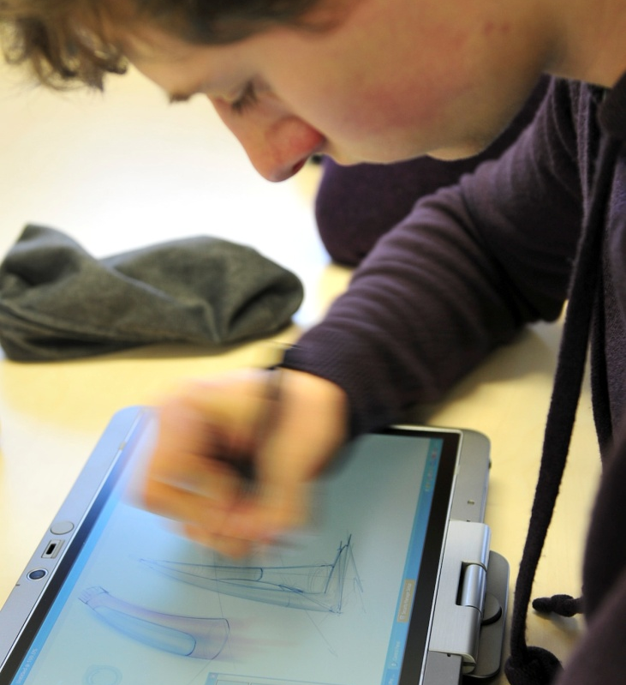

Figure 1. Designer undertaking sketching during concept generation using a Tablet PC

Academic research to explore the use of the pen display is limited and studies have focused on their contribution to collaboration as opposed to the creative form-giving process. In using the digital tablet and paper-based techniques to investigate the interaction between junior and senior industrial designers, it was reported that the pen display facilitated greater control (Lee and Wei 2007) although Tang et al (2011) noted that “the design process of the digital and traditional environments were similar in terms of the speed of the design process”.

The production of a 3D physical sketch model that has the spontaneity of a 2D sketch using digital techniques is problematic due to the sophisticated level of tactile interaction that takes place with the modelling material. The alternative is to avoid the use of sketch models but the issue of a lack of physicality has been identified by McCullough (1998) who comments that, “What good are computers, except perhaps for mundane documentation, if you cannot even touch your work?”. Sjolen and Macdonald contextualise this with other digital tools: “the belief that CAD and VR (virtual reality) would replace physical modelling in the design process has (so far) proved false). The desire to touch, hold and perceive with our own eyes and hands is just too strong”.

The aim of the form-giving that takes place during the production of a sketch model is to translate 2D visualisations into a physical object through direct interaction with an emerging form. This approach is of particular significance for automotive design where Hallgrimson (2012) acknowledges the fact that sketch modelling using physical clay, “is a naturally expressive and sculptural medium, easily manipulated by hand and simple tools” and “really exemplifies the convergence of digital and traditional workflow”.

As a means of translating the activity that would typically take place in a workshop into a digital process, haptic feedback modelling has been developed to enable the designer to ‘feel’ a digital model that is displayed on a computer monitor via a pen-type stylus on a moveable arm. Whilst this technology can reproduce some of the interactive form-giving associated with workshop activity, there are limitations in its suitability for use by industrial designers (Evans et al, 2005). Hence, Hallgrimson (2012) comments that, “whereas 3D Computer Aided Design (CAD) has made it easier to visualize (sic), analyse (sic) and implement product solutions, physical prototypes can still be played with and scrutinized (sic) in a way that is not possible on-screen”.

The advent of 3D Printers as an alternative to high definition/durable additive manufacturing systems has significantly reduced the cost of components, with manufacturers claiming to be up to a fifth of the cost lower and five to ten times faster (3D Systems, n.d.). These systems have the capacity, depending on the machine being used, to produce parts in a monochrome material or be multi-coloured with the inclusion of graphics that would typically be produced as badges or transfers. Models produced using the multicolour 3D printing systems may, therefore, have the characteristics of a full colour and badged appearance model, albeit with a reduced level of surface finish.

When the full range of digital design methods that are available to industrial designers are transposed onto the three phases of practice (Concept Generation, Design Development and Specification), it is possible to identify the potential for a totally digital approach that removes all non-digital techniques. The key feature of this approach is that no paper-based or workshop-based activity takes place as all digital outputs are complete solutions and require no other finishing process such as the removal of stepping and paint finishing for components produced using additive manufacturing. The development and evaluation of this DID approach will now be discussed.

5. Digital Industrial Design (DID)

An overview of the digital methods employed by industrial designers has been given by Yan et al. (2006) who identify these as Reverse Engineering, Rapid Prototyping Engineering, Virtual Reality Technology, Tactile Design Technology, Products (sic) Styling and Digital Modelling Tool. An approach for the integration of digital methods is proposed by Yang but this represents more of a diagrammatic overview as opposed to a sequential approach that could be applied by industrial designers. As a result, the conclusions to the study can only speculate on the merits of the proposed ‘Digital Product Design System’.

The benefits of digital design methods have been widely reported and previously discussed in the section on Digital Design Tools. General approaches have been identified by Yan et al. (2006) and opinion sought from students, practitioners and academics on the potential for a total strategy for digital industrial design (Aldoy and Evans, 2011). However, no substantive case study has been undertaken in which a clearly defined theoretical approach to DID is integrated into practice and evaluated during product design activity. This study has employed this distinctive research design and the theoretical approach to DID will now be defined in the context of Concept Generation, Design Development and Specification. This is based on an extension of the identification of Digital Design Tools as discussed in section 4.

  - Concept Generation (DID)

    - Phase 1: Capture of Engineering Hard-points (3D Scanning)

Case studies have been reported in which existing artefacts are used as the starting point of design activity, such as the scanning of a decorative vase and its subsequent development identified by Bryden (2014); scale models for automotive design (Hallgrimmson, 2012); or as a generic approach for product design (Yan, 2006; Willis et al, 2007). In applying these approaches, concept generation for DID commences by digitising internal product components, such as circuit boards and motors (hard-points), which must be included in the design proposal. This generates 3D digital models for hard-points that can then be used as a guide for Digital Concept Sketching and Digital Sketch Modelling. 3D scanning systems suitable for the capture of engineering hard-points include laser-based non-contact systems such as FARO Scan-arm or, for greater accuracy but reduced versatility and speed, more traditional co-ordinate measuring machines (CMM).

    - Phase 2A: Digital Concept Sketching (Interactive Tablet)

The efficiency gains afforded by undertaking sketching in a digital environment, as reported by Ronning (2008), resulted in a pen tablet being employed to produce Digital Concept Sketches. This enabled the application of tone/colour to add 3D effects using techniques that can be seen as analogous to those of paper-based sketching with marker/pastel. Whilst it is acknowledged that 3D CAD may be used to generate concepts and there have been studies claiming that this can support creativity whilst designing (Musta’amal, et al. 2009), the rigour of the modelling process for 3D CAD makes it unsuitable for the rapid and spontaneous externalisation of ideas (Yang, 2003; Pipes, 2007). The software used to support Digital Concept Sketching has a requirement to emulate the capabilities of paper-based tools where quality of line is particularly important to designers. Interactive tablets that are suitable for Digital Concept Sketching include the Wacom Cintiq and Hewlett Packard Elite Book Tablet PC. Software suitable for Digital Concept Generation includes Adobe Photoshop and Autodesk SketchBook Pro.

    - Phase 2B: Evolutionary Form Generation (CAD Add-in)

Software is available to facilitate the generation and evolution of form-based geometry in support of industrial design concept generation (Lin-Chien and Ming-Huang, 2014). When integrated with Digital Concept Sketching, this has the potential to foster the evolution and emergence of design ideas (Soufi and Edmonds, 1996). Software suitable for augmented form generation includes EvoShape (Evoshape, n.d.) and Morphogenesis (Morphogenesis, n.d.).

    - Phase 3: Digital Sketch Modelling (Haptic Feedback Device)

The transition from 2D sketches to 3D form marks a significant development in the form-giving process and is a key phase of industrial design practice. Studies have identified the complexities and limitations associated with sculpting tools that provide force feedback (Evans et al, 2005) or do not provide force feedback (Alcaide-Marzai et al (2012). As force feedback facilitates the sensation of the materiality experienced in a workshop (to a limited degree), the DID approach employs a haptic feedback device that allows the designer to receive tactile feedback from a virtual material as it is actively sculpted. The scanned geometry for internal components can then be imported into the digital modelling environment to ensure that these fit within the emerging forms. Haptic feedback devices suitable for Digital Concept Modelling include the SensAble Phantom/ FreeForm system (Evans et al, 2005) and Omega haptic devices (Pipes, 2007).

    - Phase 4: Tactile and Visual Evaluation of Sketch Models (Monochrome 3D Printing)

Digital Sketch Modelling allows the designer to receive a degree of tactile feedback from a digital material as the form emerges. If this geometry is then used to produce a 3D printed sketch model, the designer has access to something that has a resemblance to a sketch model that would have been produced by hand using closed cell foam in a workshop. Henry (2012) reports on the use of 3D printed sketch models for bottle designs that, “takes a few hours and allows the team to have something in hand”. These were produced using the Z-Corp 3D printing process that is based on inkjet printing technology and has been identified as, “being fast when compared with other RP processes” (Bryden, 2014). Whilst research has been undertaken to identify the mechanical properties of the lower cost monochrome 3D printing systems, such as Z-Corp Z Printer 310 (Iliescu et al, 2009), this process has not been explored as an alternative to the sketch model that is typically produced by hand in a design workshop.
Z-Corp 3D printing has been integrated in the DID strategy as its relatively low cost and build speeds provide the potential to make a significant contribution to the production of digital sketch models.

    - Phase 5: Rendered Concept Sketches for Client Presentation (Interactive Tablet)

Having used 2D and 3D digital methods to originate and translate design concepts into proposals that have sufficient merit to warrant presentation to the client, these can be formalised through the preparation of Rendered Concept Sketches that have been produced using digital techniques with accuracy but retain a loose and emotive style. Sjolen and Macdonald (2011) note that, “flexibility (not to mention the precious undo function) can help create a sense of freedom, encourage exploration and experimentation”. Rendered Concept Sketches represent a key creative outcome from industrial design activity as they allow the client to review a number of creative design options from which they can select one or more for further development. However, it is recognised as being important to present these in a consistent style to enable them to be reviewed fairly (ibid). Hardware and software used for the production of rendered concept sketches is the same as that used during the Concept Generation Phase 2(a).

  - Design Development (DID)

    - Phase 6: Refinement of Form (3D CAD)

To facilitate Design Development, there is a need for the concepts selected at the end of Concept Generation in Phase 5 to be rigorously defined using 3D CAD. As the 2D Rendered Concept Sketches presented for approval in Phase 5 would be based on the Digital Sketch Models that were produced using a haptic feedback device in Phase 3, this geometry is imported into a CAD system for use as the starting point for the full definition of geometry. This approach has been reported in case studies of commercial industrial design practice by Henry (2012) and Bryden (2014). 3D CAD systems that are suitable for refinement of form include Pro Engineer/Creo and SolidWorks.

    - Phase 7: Virtual Prototyping (3D CAD)

The capacity to use the 3D CAD geometry for Virtual Prototyping through the use of computer-aided engineering software facilitates performance testing without the need for physical prototypes where, “calculations are often required as part of the virtual prototyping of a product, prior to physical prototyping” (Bryden, 2014). The reduced time taken for the analysis of a virtual prototype when compared to a physical prototype means that more design iterations can be examined and optimised designs can be achieved, as in the case of the development of the cantilevered/perforated Myto chair by Konstantin Grcic Industrial Design (KGID) (Bryden, 2014). The analysis undertaken can cover physical properties such as analysis of the strength of a component under load; mouldflow; interaction with airflow; and the build-up of heat in electrical products.

    - Phase 8: Photorealistic Visualisation for Client Presentation (3D CAD)

The centrality of 3D CAD rendering to industrial design practice is well documented through best practice case studies (Cullen, 2004), with the effectiveness of computer rendering being enhanced over recent years as software became easier to use with faster processing (Bryden, 2014). Its contribution to new product development is significant as not only does 3D CAD visualisation have the capacity to produce photorealistic images for client approval, but the geometry can then be directly used to for the production tooling, thereby helping maintain integrity of the original design intent (Hudson, 2008; Bryden, 2014). Software suitable for photorealistic rendering includes KeyShot, Bunkspeed, Autodesk Showcase and 3ds Max.

    - Phase 9: Low Fidelity Appearance Model for Client Presentation (Multi-Colour 3D printing)

The production of physical models that have the exact appearance of a product is a time consuming and expensive activity as they are predominantly hand-made by experts using sophisticated workshop facilities. Whilst the use of additive manufacturing has made a significant reduction to timescales (Evans and Campbell, 2003), components produced by this technology still require considerable hand finishing to create a surface finish that is suitable for an appearance model: “the most time-consuming models tend to be the high fidelity appearance models used for communication” (Hallgrimson, 2012) . The scope of DID necessitates outputs to be entirely digital and the development of multi-coloured 3D printing has the capacity to directly deliver something that has a close association with an appearance model, albeit with limited strength (ibid). In addition to a lower resolution of surface finish in terms of smoothness (the build process uses a plaster-based powder), to avoid any post process finishing all components must be fused together so part lines between individual components are problematic or not possible. It is also significant that gloss finishes are not possible.
As these models deviate from an appearance model to some degree, a more suitable term might be ‘Low Fidelity Appearance model’. However, despite limitations, the process has the potential to produce full colour models that include all graphics and, as such, can have a high level of detail (Hallgrimmson 2012). Low fidelity appearance models have the potential to be used either with or after photorealistic visualisations to facilitate client approval.

  - Phase 10, 11, 12: Specification

As the industrial design solution progresses to the specification phase of DID, well established and proven techniques are employed. These are Phase 10, Detail Design (3D CAD); Phase 11, Pre-production Prototypes (Additive Manufacture); and Phase 12, Tooling Simulation (3D CAD). Whilst these phases must be acknowledged, the activities as part of the DID do not provide any new knowledge but their contribution to the entire DID must be recognised for completeness.

6. Methodology

In a formative paper on the contribution of design activity to support data collection for academic research, Archer (1995) acknowledges its capacity to “advance practice” and suggests the use of action research as a, “systematic investigation through practical action calculated to devise or test new information, ideas, forms or procedures and to produce communicable knowledge”. Its evolution reached a level of maturity with the publication of the Arts and Humanities Research Review of Practice-led Research in Art, Design and Architecture by Rust et al (2007) which defined ‘practice-led research’ as, “Research in which the professional and/or creative practices of art, design or architecture play an instrumental part in the inquiry”. The notion of an “action research cycle” is noted by Robson (2002) and involves “planning a change; acting and then observing what happens following the change; reflecting on these processes and consequences; and then planning further action and repeating the cycle”. However, weaknesses of this approach are identified in the inability to control variables and difficulties in generalising beyond the specific context (Allison, 1993).

Having developed a theoretical framework for DID through literature review, “research through the medium of practitioner activity” (Archer 1995) or, as it is generically referred, ‘action research’, employed an individual case study. This involved one of the co-authors (Pei), who had bachelors and masters qualifications in industrial design plus commercial experience, designing consumer products using DID to support its evaluation. This design activity was overseen by a co-author with more substantial experience as a practicing industrial designer (Evans) who took on the role of design manager. Additional CAD/engineering expertise was provided by another co-author (Cheshire).

Observations by a researcher or a video camera cannot record what a designer is thinking and a method of data collection was required to obtain an account of the designer’s reflective practice (Schon, 1983) when employing DID. Techniques such as shadowing participants have the potential of being disruptive and having to recall an activity (such as through an interview) sometime after the event can result in details becoming inaccurate (Pedgley 1997). In light of this, the use of a retrospective diary, where writing takes place at some point after an activity was identified to be more effective. This approach has been shown to facilitate understanding of the designer’s experiences with the capacity to identify inconsistencies (Pedgley, 2007; Webster, 2004) and is an established method of data collection in social sciences where records can be produced at the subject’s own pace in a relatively unobtrusive fashion (Bartlett, 2011).

In the DID case study, an electronic pro-forma diary sheet was generated and used to record both written and sketched reflection on the various design activities. The written reflection was categorised as “Key Activities and Output” and “Reflection”, with annotated sketches recorded under “References” which were linked to the two written headings. An example of a diary entry can be seen in Figure 2.
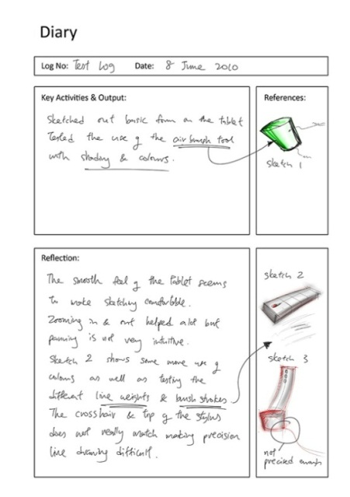
Figure 2. Example of a diary entry during Digital Concept Sketching

The diary was based on a digital pro-forma that facilitated a hand written narrative (using the tablet PC stylus) and inclusion of relevant images arising from the design activity (that could also be annotated as part of the diary narrative). The pro-forma required the completion of the Log Number (to ensure that the sequence was recorded); Date (some days had several diary pages); Key Activities and Output (as narrative); Reflection on design activity (Schon 1983). The References section was for the addition of images but, as the completion of the diary progressed, this often over-spilled into the other boxes as the intensity of exploration into the visual design activity increased. On completion of the diary, the 36 days of design activity was condensed for analysis using coding (Miles and Huberman 1994) by colour highlighting references to the strengths, weaknesses, opportunities of DID. Data reduction through coding (ibid) identified four categories of meaning within the dataset relating to issues of hardware, software, outcomes and future practice. A distinctive feature of the coding/clustering was that this extended to the annotated images of the design activity. The interpretation of the data reduction then formed the basis for drawing conclusions from the study.

Trends in design are sometimes stimulated and driven by the technology available at the time, such as early CAD systems lacking the ability to produce organic shapes (Powell, 1990; Pipes, 2007). As DID integrated several innovative technologies (haptic feedback device, monochrome 3D printing, multi-coloured 3D printing) in support of specific practitioner activities, it was necessary to keep an open mind in terms of strengths and weaknesses that might occur for specific geometry, i.e. would a geometric design present fewer or more challenges for DID than a freeform design? To accommodate any unpredicted/unknown strengths or weaknesses, two contrasting stylistic directions were taken for the industrial design of an Internet telephone handset; one using predominantly geometric elements based on primitive/planar surfaces and the other taking an organic, freeform strategy that had compound curvature. This represented a departure from professional practice but made a significant contribution to the research methodology by demonstrating ways in which academic research has the flexibility to investigate issues relating to practice whilst not being constrained by a client-focused commercial context. The specific design brief presented to the designer was, “To undertake the industrial design of an Internet telephone handset based on the internal electronics of the Ipevo Plus. Two stylistic directions will be taken: organic/freeform and geometric/primitive, with presentation material being produced for design concepts; photorealistic renderings; and appearance models”.

The key activities and findings from the DID case study will now be discussed and supported by using selected design outcomes plus findings from the use of the diary. The DID is based on the 12 phases as identified in Section 5. Although some of the elements of DID resulted in no issues, all phases are discussed and images of outputs provided for completeness and contextualisation.

- DID Case Study

7.1 Concept Design

    - DID Phase 1: Capture of Engineering Hard-points (3D Scanning)

In preparation for Digital Concept Generation, the electronic circuit board and components to be housed within the product were scanned using a FARO Scanarm V3 non-contact laser scanner and saved in .stl file format. A shaded view of the scanned component can be seen in Figure3.

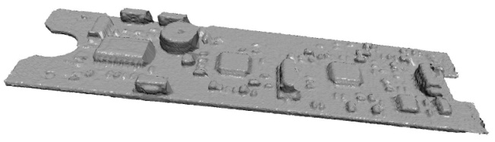

Figure 3. Shaded view of scanned electronics components

    - DID Phase 2(a): Digital Concept Sketching (interactive tablet)

Digital Concept Sketching is typically undertaken using a tower PC and desktop interactive tablet such as a Wacom Cintiq. This research employed a more self-contained and portable tool by using the interactive screen and stylus on a Hewlett Packard Elitebook 2730p Tablet PC with a 1.86GHz processor as seen in Figure 1. The use of the Tablet PC was selected as a portable design tool that was more closely linked to a designers sketch pad. To facilitate the use of the Tablet PC for Digital Concept Sketching, shaded elevational views of the scanned electronics were imported into Adobe Photoshop for use during Digital Concept Sketching. During this process, it was noted that the use of the interactive tablet did not offer instantaneous access to the sketching media (unlike pen paper) due to the boot-up time and it was considered as being relatively cumbersome due to its weight. There was also a need to calibrate the stylus to maintain accuracy and the viewing angle had to be adjusted to produce a comfortable orientation for sketching. An example of a concept sketch produced using the Tablet PC can be seen in Figure 4.

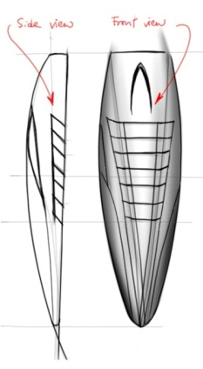

Figure 4. Digital concept sketch
7.2.3 DID Phase 2(b): Evolutionary Form Generation (generative CAD add-in)

As a relatively recent development in tools to support industrial design, augmented form generation through generative or evolutionary software has the potential to foster innovation through the unexpected/unplanned generation and evolution of form. During the DID case study, this was undertaken through the use of the EvoShape CAD add-in which offered novel geometric forms and encouraged the emergence of new ideas. However, as prototype software at the time of the case study, the user-interface was slow and unintuitive leading the designer to feel that this factor was limiting the enhancement of the creative process.
Examples of EvoShape outputs for phone design inspiration that was generated using the software can be seen in Figure 5.

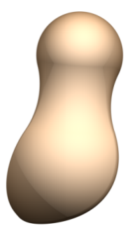
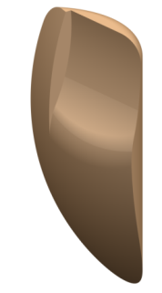

Figure 5. Shaded view of forms generated using Evoshape software

7.2.4 DID Phase 3: Digital Sketch Modelling (haptic feedback device)

The translation of 2D Digital Concept Sketches into a 3D format followed the same principle of non-digital methods, where closed cell foam would be shaped in a workshop. However, during DID, a SensAble Haptic feedback device along with Freeform software was used with the support of an expert user to maximise access to its full functionality. In use, the intuitive nature of the sculpting operation was found to be problematic unless the form was generated using CAD-type modelling methods. Records from the diary referred to the sculpting activity as being analogous to holding a piece of foam and sculpting with a knife/abrasive paper although it was difficult to get the required smoothness of finish. The diary also noted that the required effects could be achieved when the CAD-type functionality was employed which was similar to using pre-formed cutting tools in a workshop. Whilst successful outcomes were achieved (see Figure 6), they were through the CAD constrained approach that was not analogous to the more sculptural activity that would take place in a conventional workshop.

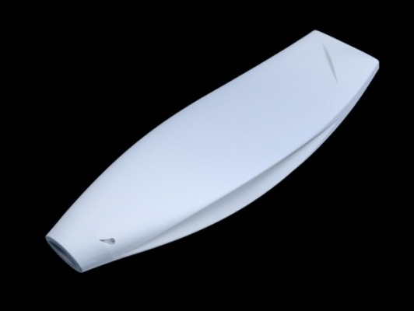

Figure 6. Shaded view of a Digital Sketch Model produced using haptic feedback modelling

7.2.5 DID Phase 4: Tactile and Visual Evaluation of Sketch Models (monochrome 3D printing)

Tactile feedback from the haptic interface was limited and, to support the physicality that is central to industrial design practice, the models were downloaded to a monochrome 3D printing machine (Z Corporation Z310) for the production of physical models. These models had a close association with closed cell sketch models and provided extremely useful feedback for ergonomic and visual evaluation. The diary noted that these were significantly heavier that closed cell sketch models although an opportunity exists to develop software that can automatically shell-out the interior to reduce the amount of material used. One of the six 3D printed Sketch Models can be seen in Figure 7.

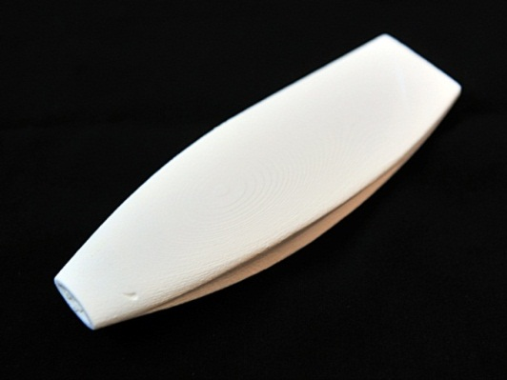

Figure 7. Physical sketch model produced using haptic feedback modelling followed by monochrome 3D printing

7.2.6 DID Phase 5: Rendered Concept Sketches for Client Presentation (interactive tablet)

Rendered concept sketches formalise early design proposals and provide a format suitable for evaluation by designers and other stakeholders. A key advantage noted in the diary that arose from the use of the Tablet PC was the portability and convenience for use when in transit (e.g. on trains and planes) as it removed the need for a sketch pad and associated media. An example of a Rendered Concept Sketch for client presentation that was produced using the Tablet PC can be seen in Figure 8.

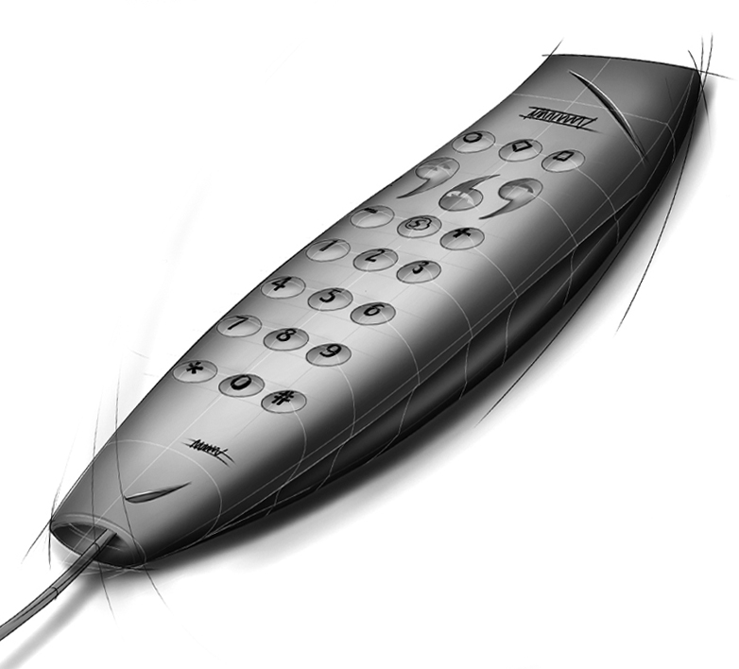

Figure 8. Rendered Concept Sketch Digital suitable for client presentation

7.3 Design Development

7.3.1 DID Phase 6: Refinement of Form (3D CAD)

The modelling of form using 3D CAD represents standard practice when a design has been selected for development. However, a key advantage of DID noted in the diary was that existing haptic feedback geometry was available as the starting point for this process and this was identified as a significant efficiency gain. The emerging 3D CAD model that exploited the geometry from the haptic feedback modelling can be seen in Figure 9.

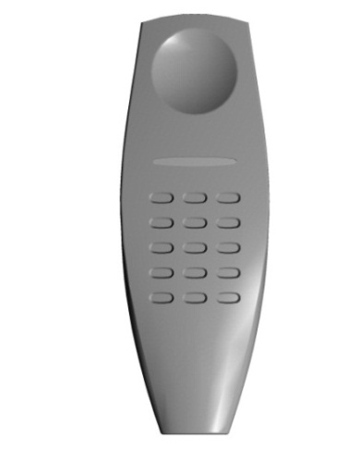

Figure 9. Shaded rendering of emerging CAD model

7.3.2 DID Phase 7: Virtual Prototyping (3D CAD)

The use of virtual prototypes for simulation and testing of mechanical properties is standard commercial practice and no issues were identified from its integration into the DID approach. An example of virtual prototyping can be seen in Figure 10 which shows the results of stress analysis on the handset. The different colours indicate different levels of stress being predicted under a specified loading case.

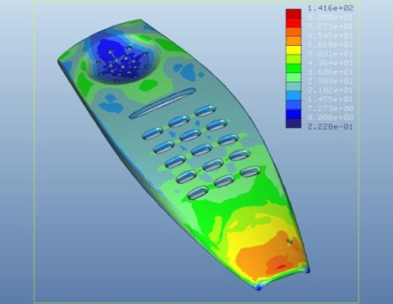

Figure 10. Simulated stress analysis during Virtual Prototyping

7.3.3 DID Phase 8: Photorealistic Visualisation for Client Presentation (3D CAD)

The use of Photorealistic Visualisation for client presentation is standard commercial practice and no issues were identified from its integration into DID. An example of the rendering for the organic design or Internet telephone handset can be seen in Figure 11.

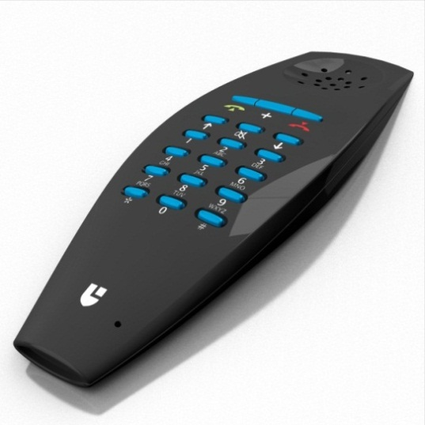

Figure 11. Photorealistic Visualisation during Design Development

7.3.4 DID Phase 9: Low Fidelity Appearance Model for Client Presentation (multi-colour 3D printing)

Once detailed 3D CAD geometry has been generated, additive manufacturing is generally used to produce components for appearance models. However, components produced by additive manufacturing include stepped features from the build process. As these components do not have a smooth surface finish, they must be sanded and painted before assembly. These skilled craft activities must be undertaken by hand and this level of post-process finishing and fabrication was considered as being beyond the scope of a total DID approach. As an alternative approach, multi-colour 3D printing was employed in the DID to produce a Low Fidelity Appearance Model instead of a more conventional appearance model that would look exactly like the proposed production item. To achieve this, it was necessary to define colours, logos and use the 3D CAD software to ensure that all individual components were attached. As the model used for the DID case study had been accurately modelled, no issues were identified and all parts correctly mated together.

Whilst the two Low Fidelity Appearance models produced during the DID case study had a textured finish and some of the colours were not as intense as those achieved by painting, they required no post-process finishing whatsoever and all graphics were in place. It was accepted that the low fidelity appearance model did not have the precise representation of an appearance model but, having obtained a quotation from a professional model maker, an estimated 95% reduction in build time was identified. The diary noted an opportunity to integrate the Low Fidelity Appearance model with the Photorealistic Visualisation (see DID Phase 8) to ensure that the design proposal was fully and accurately communicated. An example of the Low Fidelity Sketch Model for the organic design can be seen in Figure 12.

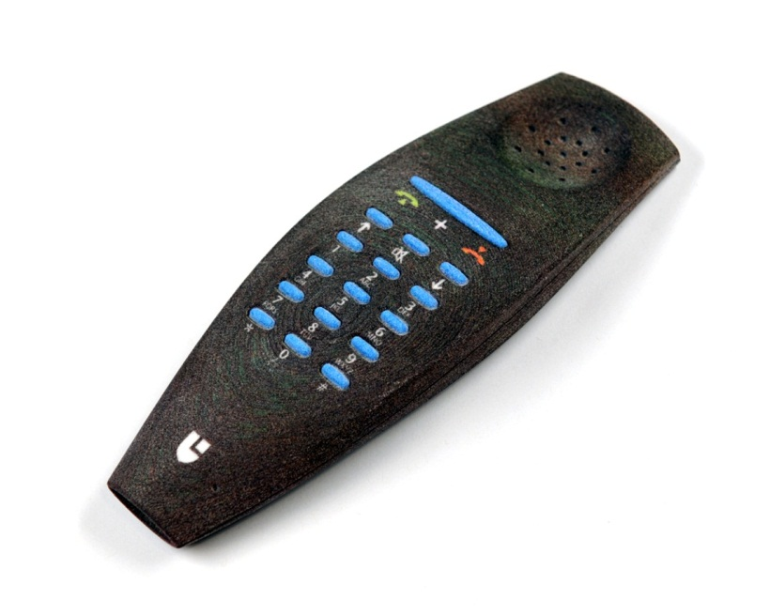
Figure 12. Low fidelity sketch model for one of the 6 design proposals

7.4 Specification

As previously discussed under 5.3 Specification, for completeness, Phases 10, 11 and 12 were undertaken as part of the case study and are included in the web-based dissemination resource but no new knowledge was anticipated or arose from this activity.

- Dissemination

As a complete industrial design case study that explored the potential for an entirely digital approach, significant material arising from the DID case study became available for dissemination. The DID approach plus the designed outcomes were considered to be of value to students, teachers, practitioners and researchers which led to a web-based tool being developed to demonstrate the process and outcomes. This included the phases of DID in the context of Concept Generation, Design Development and Specification; thumbnail images of the designed outputs that could be enlarged for greater clarity; and a brief overview of the project. The web-based DID case study was launched at http://www.lboro.ac.uk/microsites/lds/did/ and the three phases of DID plus thumbnail images as used on the web-based tool can be seen in Figure 13).

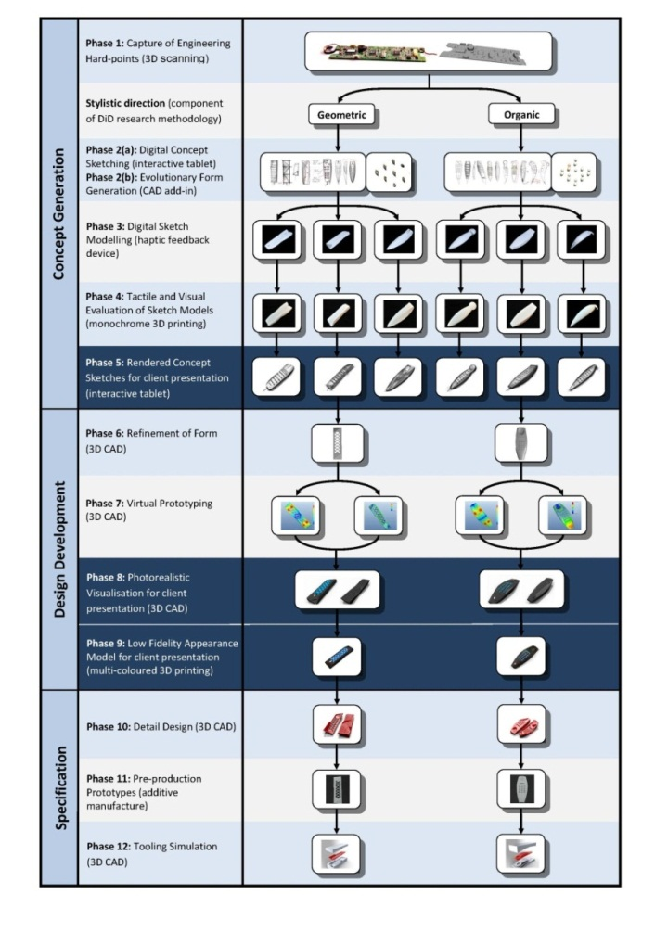
Figure 13. Interactive web-based dissemination tool (available from http://www.lboro.ac.uk/microsites/lds/did/)

- Conclusions

The research has identified a range of digital tools that have the capacity to support industrial design practice (Research Question 1); proposed a new theoretical approach to the way that industrial designers work (Research Question 2); and identified key issues arising from the implementation of DID through action research (Research Question 3). The case study was used to generate research data through a process of reflection (using a diary) that was supported by the collation of outputs from the design activity (images and physical models). The findings, including the web-based DID resource, are of significance to industrial designers as they demonstrate solutions to the digitisation of design intent through both theoretical and practical perspectives. Other professions with an interest in the DID approach include engineering designers (who work with the outcomes of industrial design decision-making) and marketing professionals (who must use design outputs for effective decision-making). Other stakeholders are students and educators for whom DID has significant implications for pedagogy and resources. In terms of pedagogy, the long-established practice of students exploring form-giving through the active sculpting of physical material in workshops is bought into question. This then raises the question as to whether DID has the capacity to replace this within the curriculum or is it more suited to experienced designer? The authors believe that the limited ability of haptic feedback to replicate the nuances of form-giving necessitates the retention of established workshop practice until there is a step-change in digital technology.

The findings indicate that the greatest potential for the introduction of additional digital methods was during Concept Generation, where haptic feedback modelling and monochrome 3D printing has the capacity to replicate, at least in part, the tactile form-giving that is associated with workshop-based sketch modelling. Advantages of this approach are that it removes the need for workshops and their associated costs and facilitates efficiency gains by re-using the 3D geometry of the Digital Sketch Model when undertaking 3D CAD in Phase 6 (Refinement of Form) during Design Development. This would not be possible when using closed cell foam in a workshop but there were limitations in the capacity of haptic feedback modelling to replicate workshop activity.
The Low Fidelity Appearance Model captured the key features of the proposed product with a high degree of detail but at a fraction of the cost and time required for a more conventional appearance model produced by fabrication and/or additive manufacturing. Whilst the Low Fidelity Appearance Model did have limitations in terms of surface finish and durability, when combined with the Photorealistic Visualisations of Phase 8, a comprehensive insight into the total product was generated. The degree to which stakeholders in new product development would acceptance these media as part of the decision-making process is yet to be identified and has the potential for future research. Anything that deviates from an artefact that does not have an exact resemblance to a production item would be problematic, but the author’s position is that efficiency gains that lead to reduced time to market may require a degree of compromise.

Beyond answering the research questions, the research has demonstrated a methodology that integrates action research in the form of design practice. As a case study in research design, it must be acknowledged that the capacity to generalise from a single study, despite being in-depth, is open to scrutiny. However, the reflective commentary, coupled with what the authors believe are credible design outputs, goes some way to confirm Archer’s position on research through practitioner activity in that it can, “produce insights which might otherwise never be obtained” (Archer, 1995). Whilst there is a need to carefully monitor the quality of design activity that takes place when such methods are employed, the added value in terms of designed outcomes can be significant. This is particularly relevant as universities and funding bodies seek to demonstrate impact of research beyond academia and the development of the DID web tool, with content that is of direct relevance to practitioners, can be seen as a strategy to support this. The methodology and its findings can therefore be seen as a research design that supports the translation of a theoretical knowledge framework into tangible examples of designed outcomes.

References
3D Systems (n.d.). Retrieved 24 January 2014 from http://www.zcorp.com/en/Products/3D-Printers/spage.aspx

Alcaide-Marzai, J., Diego-Mas, J. A., Asensio-Cuesta, S and Piqueras-Fiszman, B. (2012). An Exploratory Study on the use of Digital Sculpting in Conceptual Product Design. Design Studies Volume 32, Issue 2 pp 264 - 284

Aldoy, N. (2011). An Investigation into a Digital Strategy for Industrial Design Education. Unpublished doctoral thesis. Loughborough University, Loughborough, UK, p.316 , pp. 169-176

Aldoy, N and Evans, M. A. (2011). A Review of Digital Industrial and Product Design Methods in UK Design Education. Design Journal, 14(3). p.358

Allison, B. (1993). An Introduction to Research. Leicester: ARIAD Associates, p40

Archer, L. B. (1965). Systematic Method For Designers. In Cross, N. (Ed.) Developments in Design Methodology. Chichester: Wiley, p.64

Archer , L. B. (1995). The Nature of Research. CoDesign, January 1995, pp6 - 13

Archer, L. B. (2004). Designerly Activity in Higher Degrees. Wellesbourne: Design and Technology Association. P28

Bartlett, R. (2011). Using diaries in research with people with dementia. Realities toolkit #18: December 2011. Realities, Morgan Centre, University of Manchester. Retrieved 24 October 2012 from http://www.socialsciences.manchester.ac.uk/morgancentre/realities/ toolkits/diary/18-toolkit-using-diaries.pdf , p. 6

Baxter, M. (1995). Product Design: A Practical Guide to Systematic Methods of New Product Development. London: Chapman & Hall, pp. 262 – 263

Bryden, D. (2014). CAD and Rapid Prototyping for Product Design. London: Laurence King, p7, p110, p4)

Conway, H. (Ed.) (1987). Design History. London: Harper Collins , pp. 4-5

Cooper, R. and Press, M. (1995). The Design Agenda: A Guide to Successful Design Management. Chichester: Wiley, p.38

Cullen, C. D. (2004). Design Secrets 2: 50 Real-life Projects Uncovered. Gloucester: Rocklport Publishers.

Design Council. Accessed 21 January 2014 from http://www.designcouncil.org.uk/about-design/Types-of-design/Product-design/Introducing-product-design/

Dumas, A. (no date). Theory and Practice of Industrial Design. Retrieved 28 May 2012 from http://www.urenio.org/tools/en/Industrial_Design.pdf p. 3

Evans, M. A. and Campbell, R. I. (2003). A Comparative Evaluation of Industrial Design Models Produced using Rapid Prototyping and Workshop-based Fabrication Techniques. Rapid Prototyping Journal, 9(5), pp. 344 – 351

Evans, M. A and Pei, E. iD Cards. Retrieved 14 January 2014 from http://www.lboro.ac.uk/departments/lds/research/groups/design-practice/

Evans, M. A, Wallace, D, Cheshire, D. G and Sener, B. (2005). An Evaluation of Haptic Feedback Modelling during Industrial Design Practice. Design Studies 26 (5). pp.487 - 508)

Evoshape (n.d.). Retrieved 16 January 2014 from www.evoshape.co.uk

Graham, I. J., Case, K. and Wood, R. L. (2001) Genetic Algorithms in Computer-Aided Design. Journal of Materials Processing Technology, 117(1-2), p. 216

Hallgrimson, B. (2012). Prototyping and modelmaking for product design. London: Laurence King

Henry, K. (2012). Drawing for Product Designers. London:Laurence King, p76

Heskett, J. (1980). Industrial Design. London: Thames & Hudson, p. 10

Hudson, J. (2008). Process: 50 Product Designs from Concept to Manufacture. London: Laurence King, p199

IDSA. Accessed 21 January 2014 from http://www.idsa.org/what-is-industrial-design

Iliescu, M., Tabeshfar, K., Ighigeanu, A. and Dobrescu, G. (2009). Importance of Rapid Prototyping to Product Design. University Polytechnica of Bucharest Science Bulletin. Series D, Volume 71, Issue 2.

Institution of Engineering Designers (no date). Accessed 21 January 2014 from http://www.ied.org.uk/about

Jerrard, R. N., Barnes, N. and Reid, A. (2008). Design, Risk and New Product Development in Five Small Creative Companies. Intrernational Journal of Design. Volume 2, Number 1.

Jones, J. C. (1963). A Method of Systematic Design. In Cross, N. (Ed.) Developments in Design Methodology. Chichester: Wiley, p.11

Krish, S. (2011). A Practical Generative Design Method. Computer-Aided Design. 43(1) , pp.88-100

Kojima, T., Matsuda, S., Shimizu, Y. and Tano (1991). Models and Prototypes. Tokyo: Graphic-sha Publishing, p. 83

Lau, H. Y. K., Mak, K. L. and Lu, M. T. H. (2003). A Virtual Design Platform for Interactive Product Design and Visualization. Journal of Materials Processing Technology. 139(1-3), p. 402

Lei, L-C and Wei, W-J (2007). Behaviour analysis between paper sketching and interactive pen display sketching in collaborative design. Proceeding of the 2007 11th International Conference on Computer Supported Cooperative Work in Design. Melbourne Australia, p307

Lin-Chien, J. L. and Ming-Huang, L. (2014). Experimental Research in Applying Generative Design and 3D Printers in Proceedings of the Third International Conference, DUXU 2014. pp 296 - 307

Loosschilder, G. (1997). A Picture Tells a Thousand Words: Testing Product Design Concepts using Computer-Aided Design. The Design Journal. 0(1), p. 45

McCullough, M. (1998). Abstracting Craft - The Practiced Digital Hand. Cambridge: MIT Press. p. 25

Miles, M. B. and Huberman, A. M. (1994). Qualitative Data Analysis. Thousand Oaks, California: Sage Publications Inc

Morphogenesis (n.d.). Retrieved 16 August 2012 from http://www.solidthinking.com/pdf/en-US/sTinspired85brochure_Letter.pdf

Musta’amal, A. H., Norman, E. and Hodgson, T. (2009). Gathering Empirical Evidence Concerning Links Between Computer Aided Design (CAD) and Creativity. Design and Technology Education: An International Journal. 14(2), pp. 53 - 66

Pedgley, O. (1997). Towards a method for documenting industrial design activity from the designer’s perspective. IDATER 1997 Conference, Loughborough University, p. 218

Pedgley, O. (2007). Capturing and analysing own design activity. 28 (5), p. 463

Pei, E., Campbell, R.I., and Evans, M.A. (2010). Development of a Tool for Building Shared Representations among Industrial Designers and Engineering Designers, CoDesign Journal, 63, p139-166

Pei, E., Campbell, R. I. and Evans, M. A. (2011). A Taxonomic Classification of Visual Design Representations used by Industrial Designers and Engineering Designers. The Design Journal. 14(1), p.75

Pipes, A. (1990). Drawing for Three Dimensional Design. New York: Thames & Hudson, p.58

Pipes, A. (2007). Drawing for Designers. London: Laurence King, pp.20 – 35, p124

Powell, D. (1990). Presentation Techniques. London: Macdonald Illustrated, pp48-49

Prats, M., Lim, S., Jowers, I., Garner, S. W. and Chase, S. (2009) Transforming Shape in Design: Observations from Studies of Sketching. Design Studies. 30(5), p.503

Robson, C. (2002). Real World Research. London: Blackwell, p. 217

Ronning, O. (2008). Sketching Part 2: Paper in a Digital World. Retrieved 18 January 2014 from www.artefactgroup.com/#/content/sketching-part-2-paper-in-a-digital-world

Rust, C., Mottram, J. and Till, J. (2007). Practice-Led Research in Art, Design and Architecture. UK: Arts and Humanities Research Council, p11. Available from http://arts.brighton.ac.uk/__data/assets/pdf_file/0018/43065/Practice-Led_Review_Nov07.pdf

Schon, D. A. (1983). The Reflective Practitioner. London: Temple Smith, London, p.79

Sjolen, K., and Macdonald, A. (2011). Learning Curves: An Inspiring Guide to Improve your Design Sketch Skills. Sweden: KEEOS Design Books, p88

Sequin, C. H. (2005). CAD Tools for Aesthetic Engineering. Computer-Aided Design. 37(7), p.736

Soufi, B. and Edmonds E. (1996). The cognitive basis of emergence: implications for design support. Design Studies 17(4), pp. 451 - 463

Sutherland, I. E. (1963). SketchPad: A Man-Machine Graphical Communication System. In American Federation for Information Processing Societies Conference Proceedings Volume 23, pp. 323-328

Tang, H. H., Lee, Y. Y. and Gero, J. S (2011) Comparing collaborative co-located and distributed design processes in digital and traditional sketching environments: A protocol study using the function-behaviour-structure coding scheme. Design Studies 32, p22

Ulrich, K. T. and Eppinger, S. D. (2003). Product Design and Development. Boston: McGraw-Hill, pp.198-200

Unver, E. (2006). Strategies for the Translation to CAD-based 3D Design Education. Computer Aided Design & Applications. 3(1-4), p.323

Webster, H. (2004). The Design Diary: Promoting Reflective Practice in the Design Studio. In Transactions on Architectural Education, European Association for Architectural Education (EAAE) Architectural Design: Monitoring architectural design. No. 24, p. 11

Willis, A., Speicher, J. and Cooper, D. B. (2007). Rapid Prototyping Objects from Scanned Measurement Data. Image and Vision Computing, 25(7), p.1174

Yan, Z., Hongke, T., Li, G., and Guangyu, Z. (2006). Digital Technology and Digital Product Design. In CAIDCD: 7th International Conference on Computer-aided Industrial Design and Conceptual Design. Hangzhou: IEEE

Yang, M. C. (2003). Concept Generation and Sketching: Correlations with Design Outcome. In Proceedings of the 15th International Conference on Design Theory and Methodology. ASME Digital Library.

