Understanding the Impact of Online Reviews on Customer Choice:
A Probability Discounting Approach

Asle Fagerstrøm
Westerdals Oslo School of Arts, Communication and Technology,
Faculty of Technology
Gheorghita Ghinea
Brunel University, Department of Computer Science
Westerdals Oslo School of Arts, Communication and Technology,
Faculty of Technology
Lars Sydnes
Westerdals Oslo School of Arts, Communication and Technology,
Faculty of Technology

Address correspondence to: Asle Fagerstrøm, Westerdals Oslo School of Arts, Communication and Technology, Faculty of Technology, Schweigaardsgate 14, 0185 Oslo, Norway (asle.fagerstrom@westerdals.no).
Abstract
This study uses the concept of probability discounting to understand the impact of online customer reviews on consumer choice. Probability discounting describes how the subjective value of an outcome alters when its delivery shifts from certain to uncertain. An experimental study with 29 participants was conducted. Participants were run through an online shopping scenario where they had to choose whether to buy a product from a web shop with customer reviews on reliability or from a web shop without reviews but with a lower product price. A titration procedure over sales price for the web shop without reviews was run over seven probability conditions. The mean switching points where participants chose where to buy the product were extracted from the experimental data, and probability discounting factors were calculated. The results supported the assumption that online reviews indicate the probability of a successful transaction online and function as a guide to choices. Implications for marketers as well as suggestions for future research are discussed.

Keywords: online customer reviews, behavioral economic, probability discounting, experimental study, microworld
According to a survey by Forrester Research based on more than 58000 US respondents (Levien, 2013), approximately 70% of online customers rely on brand or product recommendations from friends and family. While 46% of the respondents reported that they rely on consumer-written online reviews, just 10% rely on banner advertisements on websites, and only 9% rely on text messages from companies. What does this mean for companies, marketers, and advertisers? Firstly, online recommendations have an important impact on companies’ results. According to Dellarocas (2003), online customer review systems are one of the most powerful channels to generate online word of mouth. Secondly – and consequently – it is more important than ever to monitor reviews to get insights into what customers are saying and reading online. Finally, understanding the impact of online customer reviews is crucial for a company to be able to manage online reviews in a manner that creates positive results. This last point is the focus of this study.
Previous research has examined how online customer reviews influence customers’ product evaluation and choices in specific product categories or different contexts. For example, Mudambi and Schuff (2010) found that review extremity, review depth, and product type affect customers’ perceived helpfulness of the review. In a study by Ho-Dac, Carson, and Moore (2013), the authors found that the effects of online customer reviews were influenced by brand strength and category maturity. Chatterjee (2001) examined the effect of negative reviews on retailer evaluation. The findings from this study indicate that the deleterious impact of negative consumer reviews is mitigated by consumers’ familiarity with the retailer. In a study of the impact of online reviews on box office revenue, Liu (2006) found that reviews offer significant explanatory power for aggregate and weekly box office revenue. Dellarocas, Zhang, and Awad (2007) studied forecasting movie sales and demonstrated that the inclusion of online product review metrics in a benchmark model that comprises prerelease marketing, theater availability, and professional critic reviews significantly increases its forecasting accuracy. Öğüta and Taşb (2012) investigated the impact of star ratings and customer ratings on online hotel bookings. They found that, in general, high customer ratings significantly increase online hotel bookings. A study by Wei and Lu (2013) compared the relative influence of celebrity endorsements and online customer reviews on female shopping behavior. The results show that shoes endorsed by a celebrity in an advertisement evoked more attention, desire, and action from participants than those endorsed by positive online reviews. Despite the large quantity of research on the impact of online customer reviews, the area is relatively fragmented, and empirical findings are sometimes inconclusive or contradictory (Dellarocas, 2003; Hu, Liu, & Zhang, 2008). According to Wu (2013), among other reasons, this is because of the complexity of the decision-making process, a lack of correct sales data, the difficulty of performing qualitative analysis with large text corpora, and variations in products, segments, and online shopping situations.
Behavioral economics might be able to shed new insights in such scenarios, for, as has been emphasized by Wilkinson and Klaes (2012), behavioral economics studies the behavior of humans confronted with the allocation of scarce resources. Moreover, by providing realistic psychological foundations to interpret this behavior, behavioral economics has the potential to increase the explanatory ability of economics (Camerer & Loewenstein, 2004). Moreover, discounting is a common issue within behavioral economics to understand choice when the consequences are delayed or uncertain, and it is defined as the process that takes place when the subjective value of some reward or cost is changed because that reward or cost is either delayed or uncertain (Madden & Bickel, 2010). Delay and probability discounting research has led to important findings regarding fundamental behavioral mechanisms that underlie numerous human choices, including gambling (e.g., Alessi & Petry, 2003), behavior related to sexual outcomes (e.g., Lawyer, Williams, Prihodova, Rollins, & Lester, 2010), drug use (e.g., Bickel et al., 2007), obesity (e.g., Weller, Cook Iii, Avsar, & Cox, 2008), health care utilization (e.g., Chapman, 1996), time management (e.g., König & Kleinmann, 2007), career choice (Schoenfelder & Hantula, 2003), products involving effort (Soman, 2004), and consumer choice (e.g., Smith & Hantula, 2003).
There is a strong body of discounting research in consumer choice, and most of these studies are done within an online choice setting. For example, Hantula and Bryant (2005) did a choice experiment in which participants engaged in a delivery-fee trading task after ordering music CDs online. Based on a psychophysical up-down titration procedure, participants were asked to choose between next-day delivery of the CD (for a fee) and delayed delivery of the CD (for free). The results show the benefits of a behavioral economic approach to the scenario, which provides an understanding of delayed choice when delivery fees are seen as a swap of money for time (Hantula & Bryant, 2005). In earlier work, DiClemente and Hantula (2003) studied participants’ sensitivity to feedback delay while shopping in a simulated web shop experiment. The findings demonstrated that a hyperbolic discount function best described the number of entries into each web shop, total time spent in each web shop, and relative number of purchases in each web shop. This study was replicated by Hantula, Brockman, and Smith (2008), and the results support previous findings. In a choice experiment by Fagerstrøm and Hantula (2013), participants could either save money for a new model of their favorite mobile phone brand and get it in the future or buy the product on credit and get it now. The findings showed that participants were willing to pay a high interest rate (nearly 40%) rather than wait to save money and then purchase the phone interest-free. Experimental data demonstrate that in some cases, the immediate availability of a much-desired product such as a mobile phone may induce credit spending with extremely high interest rates.
As demonstrated in these studies, discounting provides a way to understand how the subjective value of some reward or cost is changed because that reward or cost is either delayed or uncertain, and what impact this has on consumer choice. To our knowledge, no studies have aimed to analyze how online customer reviews influence consumer choice from a discounting viewpoint. Understanding how online customer reviews influence consumer choices from a discounting perspective could give researchers a better foundation for future studies on the topic. Moreover, a deeper insight would also help practitioners manage online reviews in a manner that creates more positive results for their company.
The paper has four parts. Firstly, the concept of discounting is reviewed in relation to online customer reviews and choice. This is followed by a description of the experimental design used in the study. Next, the findings are discussed and summarized. The paper concludes with a discussion of academic and managerial implications, and directions for future research are given.

Discounting, Consumer Reviews, and Choice
According to Madden and Bickel (2010), the discounting perspective proposes that the subjective value of a reward is discounted (reduced) from its original amount when the delay until or uncertainty of reception of the reward rises. Discounting is a common issue in any decision for which the consequences are delayed or uncertain. Delay discounting indicates that rewards and costs occurring at different points in time may be comparable by discounting future utility (Green & Myerson, 2004). For example, within the exponential model of delay discounting, an individual with an annual discount factor of 70% would feel indifferent about receiving $70 today and receiving $100 in one year, because $70 is 70% of $100. This utility value is the value of the reward decreased by a given factor over time.
Probability discounting assumes that the subjective value of a reward or cost is discounted from its original amount when the uncertainty of reception of that reward or cost rises (Green & Myerson, 2004). For example, if somebody owed you $1000, and there was only a 50% chance that the person was going to repay you, you might be willing to accept $500 rather than risk not getting any money back. Equally, if there was only a 25% chance the person was going to repay you, then you might be willing to accept $250 instead of taking the chance of getting nothing. Findings from experimental studies demonstrate that both delay and probability discounting can be described by the same mathematical function (e.g., Green & Myerson, 2004; Rachlin, Siegel, & Cross, 1994; Stevenson, 1986).
When it comes to making choices online, probabilities are omnipresent. For example, when choosing a pair of shoes, online consumers have to take into account the probability of the product quality presented on the web shop being correct, of the received product having the same design, of the market price being correct, of other customers’ online reviews being correct, and so on. Rachlin (1989) has argued that it is essential to understand probability to be able to analyze choices and stated that human behavior depends on probabilities – be they objective or subjective – and that ultimately one’s concept of probability will influence one’s behavior and, indeed, evaluation of others’ behavior. From this, it is assumed that online reviews indicate the probability of a successful transaction online and function as a guide to consumers’ online choices. A relevant question to ask is how online reviews, as an indication of the probability of a successful transaction online, guide choices. In a consumer choice situation, an online review indicates the probability of a successful transaction and, from the definition of probability discounting, alters the subjective value of its consequence. Moreover, the subjective value of an outcome impacts consumers’ online choices in relation to buying (approach) or not buying (escape) (see Alhadeff, 1982). Thus, this paper addresses the following research question: How can probability discounting contribute to understanding the impact of online customer reviews on consumer choice?
According to the standard discounted utility model, a person’s subjective value of a reward decreases as a function of uncertainty (Loewenstein & Prelec, 1992); moreover, this value would be expected to be a consistent linear function. In this simple model, the subjective value S of an uncertain reward is given by
S = Vp,
where p is the probability of reception of the reward and V is the subjective value of the reward in the case of a certain outcome. Hence, the subjective value of a transaction when buying such an uncertain prospect at price P equals
Vp − P. (1)
This model operates at the individual level. In this study, experimental data were analyzed on a group level. Hence, the study defines a group subjective value V of the reward. This is defined to be the price at which 50% of the population is willing to buy the product in the case of a certain outcome. In the same vein, the study also defines the group subjective value S of an uncertain reward.
In this study, participants were presented with two web shops, denoted in this paper as web shop A and web shop B. Web shop A had customer reviews concerning delivery reliability, while web shop B did not. The customer reviews were presented in terms of a star rating system, where N customers rated delivery reliability as 5 stars, while M customers rated it 1 star (the web shop did not receive any 2–4 star ratings). These conditions yield a review score
r = N/(N+M)
that measures the fraction of top ratings.
It is assumed that participants act as if r is the probability of actually receiving the goods when buying them from web shop A, and accordingly, formula (1) with r substituted for p can be used. Hence, since the price on web shop A is invariably equal to NOK 4250 (approximately USD 719), the group subjective value of the transaction offered by web shop A is
Vr – 4250. (2)
There is also an unspoken uncertainty associated with web shop B, and it is hypothesized that participants act as if there is a probability t of receiving the goods when buying them in web shop B. The value of t represents the reliability of web shop B. Again, (1) can be applied, which yields the group subjective value
Vt − P, (3)
when web shop B offers the price P.
When presented with the option of choosing between buying in web shop A with review score r and price NOK 4250, and buying in web shop B for price P, it follows from (2) and (3) that the group should be indifferent when
Vr – 4250 = Vt – P;
i.e.
P = (Vt + 4250) − Vr. (4)

This is a linear model of how the price of indifference P depends on the review score r. There are two unknown parameters: the group level subjective value V of a certain reward and the group level reliability t in web shop B.
Method
Participants
Twenty-nine students from a college in Norway accepted an invitation to participate in an experimental study about consumer choice. There were 22 males and 7 females with an age range from 18 to 42 years, with an average age of 23 years. Each participant was informed that the experiment would last up to 20 minutes; they were not offered any payment or incentives for participating.
Apparatus
A simulated shopping microworld (see DiFonzo, Hantula, & Bordia, 1998) programmed in MediaLab™ (version 2010) presented the tasks and recorded data. The experiment was conducted in a PC lab with 16 computers with Intel™ Xeon X3430 2.4 GHz processors and 19-inch monitors with a resolution of 1440 x 900 pixels. The monitors were arranged so that no participant could see the stimuli on other participants’ monitors. A standard mouse was used to make choices.
Procedure
Upon arrival in the PC lab, each participant was led to one of the computers and was informed about his/her general rights as a participant in the experiment. The experimenter explained that all necessary information for the task would be presented via the monitor. Participants completed the experiment alone. When the experiment was over, participants were asked if they had any questions regarding the experiment. They were also told that they could contact the experimenter if they had any questions about the experiment later.
Each session started with the following information (translated from Norwegian) on the computer monitor:
“The purpose of this experiment is to see how you make economic decisions. You will be presented with different hypothetical situations, and based on the information you get, you will make some choices. No sensitive information about you will be gathered. Your participation is voluntary, and you can discontinue the experiment at any time and leave the room where the study is taking place. Press ‘Continue’ to confirm that you have read and understood the information above and that you volunteer to participate in the experiment.”
After participants read the information regarding their general rights as participants and pressed “Continue,” a new text was presented for pretraining with a standard classical discounting experiment as presented by Rachlin, Raineri, and Cross (1991). The pretraining session was undertaken to ensure participants familiarized themselves with the titration procedure used in the main experiment. When participants had completed the pretraining session, they were all presented with the following scenario (translated from Norwegian):
“Imagine that you are going to buy a tablet. After searching, you find two web shops where you want to buy the product. At both web shops the tablet costs NOK 4250 inclusive of shipping. You discover, however, that one of the two web shops has reviews from previous customers on delivery reliability. You will now be presented different choice situations where you will choose which web shop you want to buy the tablet from: from the web shop that has customer reviews or from the one that does not have customer reviews. The choice situations are independent of each other. It is therefore not appropriate to plan ahead. You should, in other words, assess each situation and choose to buy from the web shop that you find most appealing. Press ‘Continue’ when you are ready to start.”
Based on the information above, the participants were presented with different situations where they had to choose which web shop to buy the tablet from. The experiment consisted of seven conditions, where other customers’ reviews on web shop A’s delivery reliability were as shown in Table 1.

[Insert Table 1 about here]

An illustration of how the stimulus card appeared is shown in the Appendix A. A sequence of two alternatives was presented on the monitor. For each pair, participants chose the preferred web shop by clicking on the appropriate “Buy from this web shop” button. This binary choice procedure is recommended as a best practice in discounting research and has been used in experimental studies since the 1970s (Smith & Hantula, 2008).
The prices in web shop B (without customer reviews) were arranged as a psychophysical down-up titration procedure after Raineri and Rachlin (1993). The experiment first titrated down using the following proportions of NOK 4250 as the price; 1.0000, 0.9900, 0.9800, 0.9600, 0.9400, 0.9200, 0.9000, 0.8500, 0.8000, 0.7500, 0.7000, 0.6500, 0.6000, 0.5500, 0.5000, 0.4500, 0.4000, 0.3500, 0.3000, 0.2500, 0.2000, 0.1500, 0.1000, 0.0800, 0.0600, 0.0400, 0.0200, 0.0100, 0.0050, 0.0010, 0.0005, 0.0001. When participants stopped choosing web shop A (with customer reviews) and started choosing web shop B, titration up was started using the proportions in reverse. When the participants switched again, from web shop B to web shop A, the experiment moved on to the next condition.
Postexperimental interviews
When the experiment was finished, participants were asked one last question: “What do you think influenced your choice when deciding which web shop to buy the tablet from?” The purpose of the postexperimental interview (see Whitley & Kite, 2013) is to determine any uncertainties participants may have developed about the purpose of the experiment, and the subject role they might have adopted, and to get an impression of why participants chose as they did.
Results
After the experiment, the median of the points of indifference for each review score level was calculated. This median value corresponds to the group level point of indifference. This is the price where one half of the group prefers web shop A while the other half prefers web shop B. Since web shop B was not allowed to increase its price above NOK 4250, problems arose when the median value was measured at NOK 4250, i.e., at the review score levels r = 0.05 and r = 0.1. In these cases, the only thing known about the median value is that it exceeds NOK 4,250. Accordingly, this study investigated only the data measured at review levels r = 0.3, 0.5, 0.7, 0.9, and 0.95. These data were compared with the model (4), and the unknown parameters were estimated to
V = 1418 NOK, t = 0.3192,
with R² = 0.97. See Figure 1 for a plot of the measurements together with the fitted model.

[Insert Figure 1 about here]
In Figure 1, it can be seen that the group demands lower prices in web shop B as the review score in web shop A increases. When the review score r in web shop A equals 0.3, it can be seen that the estimated group point of indifference is close to NOK 4250. This means that when the review score r is 0.3 and both of the web shops sell the product for NOK 4250, about 50% of participants prefer web shop A, while the other half prefers web shop B. When the review score r in web shop A equals 0.9, the estimated group point of indifference is close to NOK 3400.
The experiment in this study can be regarded as an idealization of the following business situation: The manager of web shop B is afraid of losing customers in a situation where web shop A receives very positive customer reviews. One natural course of action is to lower the prices. The experimental data can give insight about this situation. Thus, the optimal price reduction in web shop B is calculated, with respect to maximum income.
The results are presented in Figure 2, which clearly shows that an increased review score has to be counterbalanced by a larger price reduction. In the case of review scores of 0.7, 0.9, and 0.95, the optimal price reduction is about 25%.

[Insert Figure 2 about here]

Although this indicates that customer reviews have implications for price formation, it must be noted that Figure 2 represents an extreme simplification. First and foremost, the maximum income is not the same as maximum profit. To maximize the profit, the cost structure has to be taken into account. It should also be noted that Figure 2 shows the optimal price reduction with respect to the group of participants in the experiment. This group is quite special, since participants evidently are aware of both shops. In a natural setting, it would be expected that some customers in web shop B would not be aware of web shop A, and vice versa. If only a small portion of the customers in web shop B are aware of web shop A, the need for price reduction may be negligible. Finally, it should be mentioned that comparatively lower prices may yield higher income and that web shop B could probably increase its income by having lower prices than web shop A. Hence, the important feature of Figure 2 is not the exact numbers but the trend, namely, that higher review scores in competitor web shop A call for lower prices in web shop B.
All participants answered a postexperimental question. Twenty-five out of 29 participants mentioned that either online customer reviews, or price and online customer reviews, influenced their choice of which web shop to buy the tablet from. For example, Participant 3 stated, “I do not want to shop in an online store with a considerably high amount of unhappy customers.” Participant 18 answered that “price and risk” were the main factors that influenced choice. Participant 22 stated, “I can pay more if the web shop has good reviews from customers, but the price difference cannot be too large.” However, 4 out of 29 participants reported that price was the main factor that influenced their choices. For example, Participant 24 expressed that “the price being credible” was the most important factor influencing his/her choice of which web shop to buy the tablet from. No participants reported any uncertainty or misunderstanding regarding the scenario or tasks that were completed during the experiment sessions, nor did participants express any feelings to the effect that the experiment scenario was “artificial” and did not represent a real choice situation.

Discussion
This study investigates whether probability discounting can contribute to understanding the impact of online customer reviews on consumer choice. The results from the experiment show that variation in online customer reviews on delivery reliability influenced the participants’ choices regarding which web shop to buy the tablet from. This supports the general assumption that online reviews indicate the probability of a successful transaction online and function as a guide to consumers’ choice. Data from the experiment fits well the standard discounted utility model (see Loewenstein & Prelec, 1992). The concrete result from the experiment is that participants demanded lower prices in the web shop without customer reviews when the review scores increased in the competitor web shop that had customer reviews. This is consistent with the study by Öğüta and Taşb (2012) of the influence of online customer reviews on online hotel prices, which showed that higher customer ratings result in higher prices for a chosen hotel. Results from the present study clearly reveals a significant relationship between online customer reviews and price, demonstrating that a web shop’s having good online customer reviews indicates a high probability of a successful transaction, and, as a consequence, an alternative web shop (competitor) without online customer reviews has to lower prices to attract customers.
According to Foxall (2010), to be able to understand the complexity of consumer behavior, a highly interdisciplinary framework should be used. Including yet another factor in an eclectically multidimensional consumer model is not enough. Foxall (2010) has argued, furthermore, that fully understanding consumer behavior requires integrating explanatory variables from social, psychological, economic, and neurophysiological theory into a unified causal spectrum that highlights their interconnections and joint impacts on consumers’ choice. As demonstrated in previous research in consumer choice (DiClemente & Hantula, 2003; Fagerstrøm & Hantula, 2013; Hantula et al., 2008; Hantula & Bryant, 2005), discounting is an important issue in any consumer choice situation where the consequences are delayed or uncertain. The results from the present study are consistent with existing discounting research in consumer choice. Hence, this study extends a behavioral economic account of consumer choice to include online reviews. In addition, Smith and Hantula (2003) conducted an experiment across five simulated web shops, where mean prices for the product (CDs) were $9.99, $11.99, $13.99, $15.99, and $17.99. The prices for the product were generated randomly within a $4 range around the mean within each web shop. Participants’ preferences were recorded as the total proportion of purchases made within each of the five web shops. The results of delay manipulation show that the hyperbolic discount function provided the best fit to the data (Smith & Hantula, 2003). This study demonstrated not only the importance of discounting in consumer choice, but also time-money trade-offs in online shopping. In investigating the impact of online reviews on consumer choice, the present study examines reliability-money trade-offs in online shopping. Thus, the present study adds a new dimension to understanding of consumers’ trade-off when choices are made in an online shopping setting.
This study is not without limitations. Analysis of the results should be tempered by the understanding that participants were responding to a simulated shopping scenario. On the other hand, reviews of studies on differences in discount rates between real rewards and hypothetical rewards have concluded that methods involving hypothetical choices and those involving real consequences usually show qualitatively similar results (Camerer & Hogarth, 1999). In addition, none of the study participants expressed the sentiment that the experiment scenario was “artificial” and did not represent a real choice situation. The study has a small n, which is common for discounting studies in general. A solid base in behavioral economic theory, a well theoretically integrated method, and a good fit between theory and data compensate for the small n in the study. Nonetheless, future research could use larger samples.
Moreover, laboratory experiments as a method for pursuing research have pros and cons, as evidenced by the debate they have given rise to within the psychology community. As always, at their root there is a trade-off – in this case, of complexity – between the uncontrollability of field studies, which generates problems of inference, and the controlled case of laboratory experiments, which are susceptible to weak external validity (Brehmer & Dörner, 1993). DiFonzo et al. (1998) have contended that computer-simulated microworlds offer a solution to this dilemma. “Microworlds” is a term first introduced by Turkle (1984), who described them as the carefully constructed, graphically rich, and complex rule-governed worlds of video games. However, in the realm of decision-making studies, microworlds can also be computer-generated simulation environments that participants interact with and that possess, to varying degrees, a dynamic, complex, and opaque character (Brehmer, 1992; Brehmer & Dörner, 1993). Importantly, they are particularly convenient for laboratory-based studies, and they incorporate a level of realism not hitherto seen in their ability to simulate dynamic decision systems (DiClemente & Hantula, 2003; Hantula et al., 2008; Hantula & Bryant, 2005; Omodei & Wearing, 1995; Smith & Hantula, 2003). Furthermore, microworlds offer the researcher a high degree of experimental control, thus incorporating the benefits of experimental effects due to experimental manipulation.
Despite its limitations, this study has experimentally demonstrated that understanding online reviews from a behavioral economic approach is eminently feasible. The findings show that a participant’s subjective value of the product is discounted from its original amount when the uncertainty of reception (delivery reliability) of the reward (the tablet) rises. When a consumer purchases a product, the behavior itself can be understood as the result of two conflicting behaviors – approach and escape (Alhadeff, 1982) – each of which is controlled by different consequences in the specific choice situation. From this, customer reviews are antecedents in a choice situation that alter the subjective value of consequences and, as a result, influence consumers’ choice. Thus, the answer to the research question posed at the beginning of this paper is that behavioral economics in general, and probability discounting especially, do contribute to understanding the impact of online customer reviews on consumer choice.
This study takes probability discounting as a basis to understand the impact of online reviews on customer choices. The literature, however, indicates that probability and delay discounting share some properties (e.g., Green & Myerson, 2004; Rachlin, Siegel, & Cross, 1994; Stevenson, 1986). Any reward or cost delayed is less probable, and any reward or cost that is less probable is delayed (given that there is more than one choice involved). From this, what should possibly be taken into account is that, in addition to probability discounting, delay discounting should be incorporated into understanding of the impact of online reviews on consumer choice. There are, however, different opinions as to whether delay discounting (e.g., Rachlin et al., 1991) or probability discounting (e.g., Myerson & Green, 1995) is the fundamental underlying process. Future investigation of this issue would contribute to both behavioral economics in general and particularly to consumer research.
This study has demonstrated that the standard discounted utility model is applicable for understanding the impact of online customer reviews on consumer choice. However, findings from behavioral economic studies suggest that an individual person’s discount rate is better described as a hyperbolic function in which the rate of discounting decreases when the delay until or uncertainty of reception of the reward rises (Ainslie, 1992, 2001; Chung & Herrnstein, 1967). A hyperbolic discount function declines at a faster rate in the short run or low uncertainty than in the long run or high uncertainty. One follow-up of the present study would be to test the impact of online customer reviews on consumer choice based on the hyperbolic discounting function. This could contribute to understanding of the dynamics of the impact reviews have on consumers’ choice.
Finally, in the experiment described in this paper, it was assumed that pricing is the only mechanism available to web shop B to counteract web shop A’s better online reviews. However, this ignores the impact that mediating factors, such as brand, endorsement, or low- vs. high-involvement decisions, can have on the choice between price and reviews that a customer is faced with. All are worthwhile future research pursuits.
Conclusion
If companies are to manage online customer reviews in a manner that creates positive results, it is crucial that they understand the impact of these reviews. From a behavioral economics perspective, this study assumes that online reviews indicate the probability of a successful transaction online, thereby functioning as a guide to consumers’ online choices. From this, an online review indicates the probability of a successful transaction and, from the definition of probability discounting, alters the subjective value of its consequence. An experiment with 29 participants was conducted. Participants were run through an online shopping scenario where they had to choose whether to buy a product from a web shop with reviews on reliability from other customers or from a competitor web shop without customer reviews but with a lower price. A titration procedure over sales price for the web shop without reviews was run over seven probability conditions. The mean switching points where participants chose to buy the product were extracted from the experiment data, and probability discounting factors calculated.
The results show that a participant’s subjective value of the product was discounted from its original amount when the uncertainty of reception of the reward rose. The present study demonstrated how participants traded off between certain and uncertain outcomes, and data from the experiment fits the standard discounted utility model well. The managerial implication of this study is that when a competitor has a good review, one can compete by reducing prices. For example, when reviews indicate a high probability of delivery from competitor web shop A, web shop B has to reduce its prices to attract customers. Moreover, data in the present study implies that the impact from reviews is highly relative. That is, if a web shop has positive online reviews related to a specific product or service, it may not matter much competitively if all other shops in that market have the same reviews. These issues have interesting managerial implications for managing online reviews in a manner that creates business value.

References

Table 1
Conditions of other customers’ reviews used on web shop A (from five stars, signifying “very good,” to one star, signifying “very bad”).

 | Number | Conditions
 | 1 | 95 customers rated 5 stars and 5 customers rated 1 star
 | 2 | 90 customers rated 5 stars and 10 customers rated 1 star
 | 3 | 70 customers rated 5 stars and 30 customers rated 1 star
 | 4 | 50 customers rated 5 stars and 50 customers rated 1 star
 | 5 | 30 customers rated 5 stars and 70 customers rated 1 star
 | 6 | 10 customers rated 5 stars and 90 customers rated 1 star
 | 7 | 5 customers rated 5 stars and 95 customers rated 1 star

Figure Captions

Figure 1: Group level point of indifference of price in web shop B as a function of the review
score in web shop A.
Figure 2: Income optimal price reduction in web shop B as a function of the review score in web shop B.

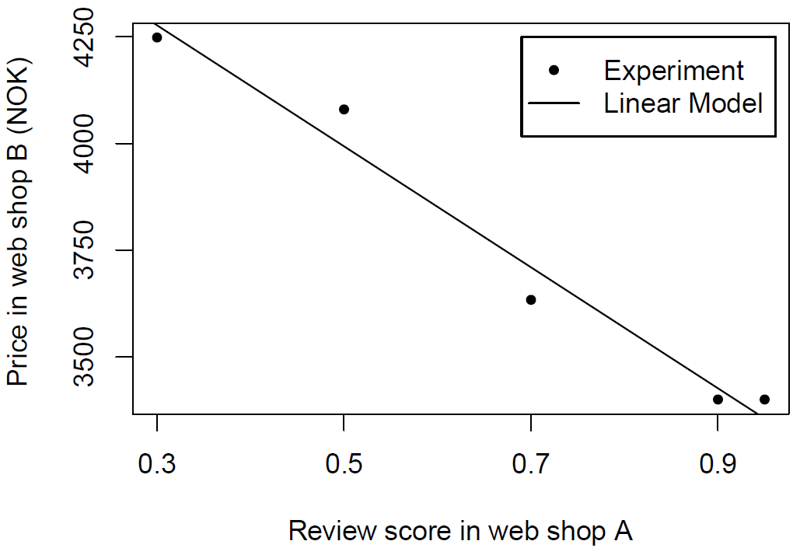

1

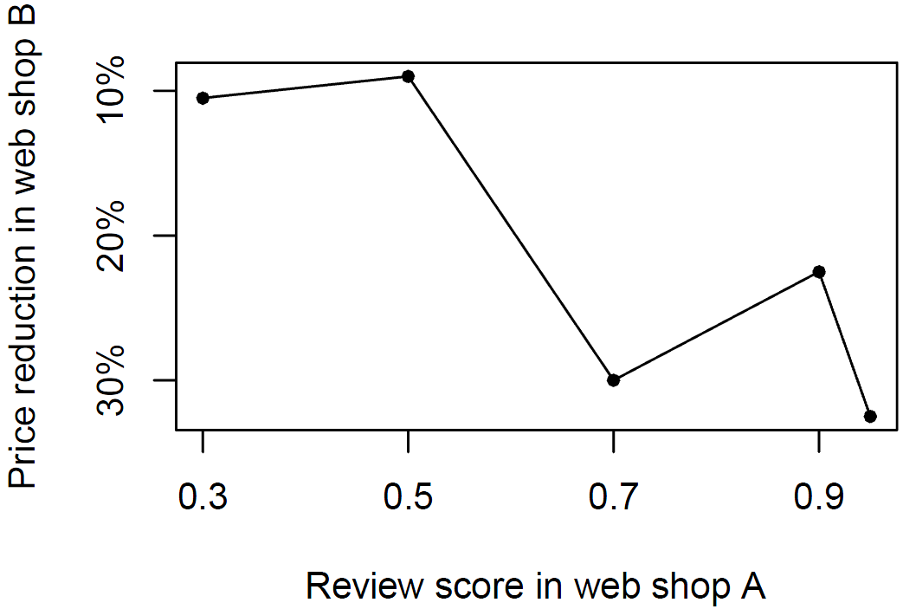

2

Appendix A: An Example of Conditions Used in the Study

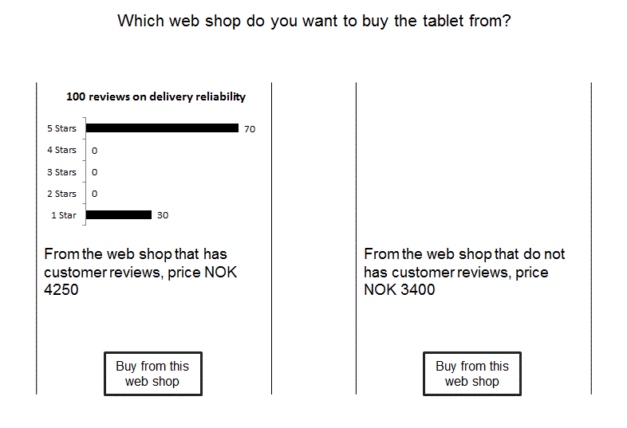
Illustration example of condition number 3; web shop A on left (70 customers rated 5 stars and 30 customers rated one star, and price NOK 4250) and web shop B on right (price NOK 3400).

