Red Quantum Dots under the electron microscope

G.R. Fern, J. Silver, S. Coe-Sullivan and J.S. Steckel

Centre for Phosphors and Display Materials, Wolfson Centre for Materials Processing, Brunel University London, Uxbridge, Middlesex UB8 3PH

QD Vision, Inc. 29 Hartwell Ave. Lexington, MA 02421, USA

Abstract
Cathodoluminescent imaging of the visible light emitted from quantum dots is reported. The shape and uniformity of individual particles is observed in the STEM electron image and the image of the particles created from their visible light collected simultaneously is shown. Visible light images of the 12-13nm sized particles are reported for clusters of just 2 particles. Emission spectra collected from small clusters of around 50 nano-particles are also reported.

Author Keywords
Red Quantum Dots, Quantum dot displays, Cathodoluminescence

1. Introduction
Core shell quantum dots (QD) have a range of applications in the optics industry from displays and lighting to lasers, optical communications, solar cells and biological markers. The materials studied here are composed of a CdSe core with a shell of ZnCdS that emit red or green light dependent upon the radius of the core material. The materials offer high colour gamut and color purity and are manufactured by QD Vision. In 2013 Sony Bravia LCD televisions, (LCDTV), containing QD Vision’s Color IQ optical components were launched onto the international domestic television market with dramatic success, winning prizes in several areas [1]. To enable mass production of this new generation of LCD TVs it was necessary for QD Vision to mass produce their quantum dots in a tight size and reproducible regime. During SID14 it was also announced that computer monitors manufactured by BOE and TPV will also incorporate these materials. It is recognised that this technology offers one potential way forwards in achieving 100% of the NTSC colour space and beyond into the future colour standards, e.g. Rec. 2020. The advantage that this offers is in ensuring the longevity of existing investments in money, staff training and natural resources used in the infrastructure of LCD manufacturing factories whereby only a small change in the manufacturing of the backlighting unit is required. Hence minimal investment is required to meet the colour standards for next generation high definition televisions.
Figure 1 simulates the impact of using this type of material over existing backlighting technologies that do not utilise QD colour conversion materials (ColorIQ).
Beyond the displays and lighting applications they also offer a potential step forwards in biological marker applications for use in vacuum environments, although this would require several further procedures to facilitate their use in this application.^{REF} There is also active research into using QDs as conversion materials in solar cells to improve the conversion efficiency.^{REF}
Brunel University London has recently acquired a new analytical transmission electron microscope (TEM) with a newly available cathodoluminescent detector (Gatan Vulcan) that allows the study of single nanoparticles of phosphors by obtaining cathodoluminescence (CL) spectra and images from individual crystals. One of the questions that phosphor chemists are often asked is how homogeneous is a phosphor sample? This question is not easy to answer as PL or CL spectra collected from phosphor samples are the average spectra of the samples making them up. This is true of most samples made either in the laboratory for research or commercial samples prepared by industrial companies. We have demonstrated that it is possible to collect CL spectra from individual nanometre sized particles and began to address the question of homogeneity in such samples with some success. [2,3]. As part of our continuing studies in this important area we have extended our studies to red quantum dots and report our findings herein.
The objectives of this work were to compare:
- The cathodoluminescence spectra of quauntum dots of ZnCdSe to see how they vary from dot to dot.
- How the shape of the quantum dots influence the spectra.

2. Experimental
A dilute dispersion of the sample was prepared and dropped onto a holey carbon 300 mesh copper TEM sample grid. The sample was allowed to air dry without further cleaning so as not to damage any surface coating on the particles.

The sample was observed in a JEOL 2100F TEM. The TEM was operated in scanning mode with a spot size of 0.2nm or 1.5 nm. To reduce X-ray excitation of the sample the hard X-ray aperture was inserted which reduces the background noise in CL imaging mode. The TEM was fitted with the Gatan Vulcan CL imaging and spectroscopic detector. This spectroscopic analysis was carried out using a Czerny-Turner spectrometer and back-illuminated CCD and a grating with 150 lines/mm. Light was collected from the sample using a mirror above and below the sample which gives a solid angle of about 5 sr. The high solid angle makes light collection highly efficient and makes it possible to collect the light at very low intensity. By collecting the visible light with the Vulcan system simultaneously with the JEOL high angle anullar dark field (HAADF) detector it was possible to observe the visible light that was emitted from the particles.

Photo luminescent spectra were collected using a Horiba Fluorolog spectrometer.

3. Results
Figure 1 shows the TEM images of a number of individual (ZnCd)Se nanometre-sized single quantum dots from the material of which some of the spectra were recorded for the studies presented in this work. The sample is exceptionally well dispersed and dried onto the carbon support as individual particles that are well separated from other particles, along with larger clusters of two particles and upwards. All the quantum dots were approximately the same size (about 12-13nm), though their shapes appeared to vary. However, all were seen to be discrete particles with many appearing to be hexagonal (or some derivative of hexagonal) in shape (see figure 1). The observed shapes are in keeping with the known hexagonal structure of the material. Under the magnification used in figure 1 the quantum dots have apparently smooth surfaces. Organic residue is observed on the carbon film which is deposited after the sample dispersion dries. Plasma cleaning was not carried out due to the desire to maintain any surface coating.
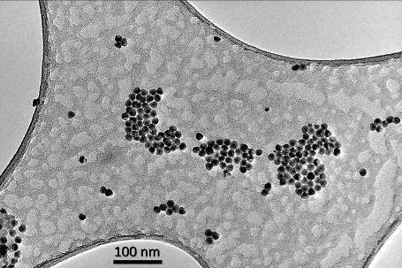

Figure 1. TEM image of red light emitting Quantum Dots on a holey carbon grid.

In Figure 2 a single quantum dot is shown and the particle is demonstrated to consist of a single crystal. Some organic residue is seen around the quantum dot, but we cannot say that this is from the surface coating that surround the quantum dot.

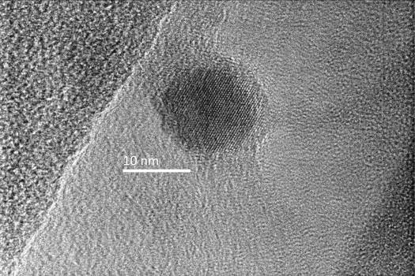

Figure 2 TEM image of an individual red Quantum Dot.
In figure 3 the particles are observed at a nominal magnification of x50,000 since improved stability is observed to the electron beam when recording the CL light image. In this initial study a relatively large condenser lens aperture has been used so that the CL emission intensity will be larger at the slight detriment of the STEM resolution. However small clusters of particles can be observed to emit light.
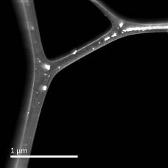
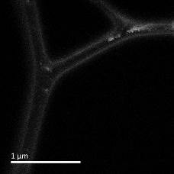

Figure 3 Simultaneous dark field STEM image on the top and CL light image on the bottom at a nominal magnification of x50,000.

Figure 4 demonstrates that it has been possible using the current experimental configuration to directly visualize the light emission from the quantum dots. The numbers shown in the images on the right hand side show a count of the numbers of particles in each cluster. The larger clusters are easily seen under the operating conditions with an accelerating voltage of 100kV and it is possible to distinguish clusters down to just 2 particles using visible light, however individual particles have not yet been observed at the time of submission of this article.
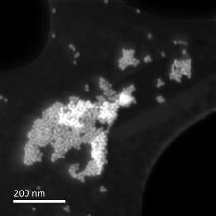
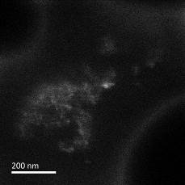
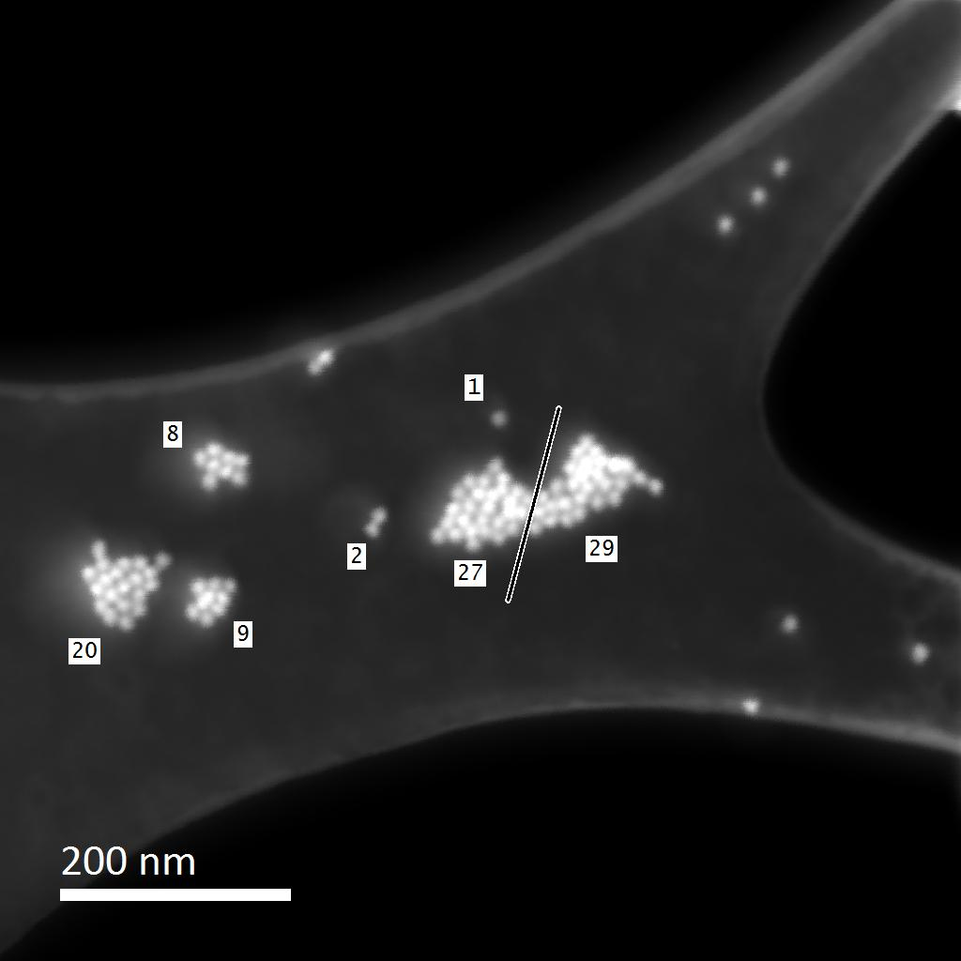
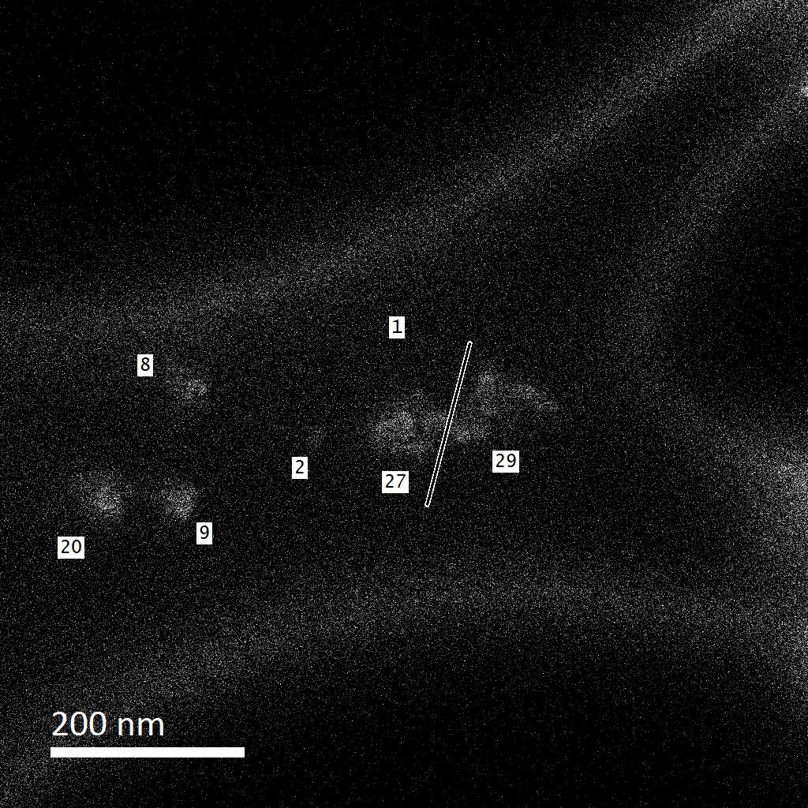

Figure 4. Simultaneous HAADF STEM image (TOP images) and cathodoluminescent light image (BOTTTOM images) taken at a nominal magnification of x150,000 times. The images on the right are shown with the numbers of particles in the cluster.

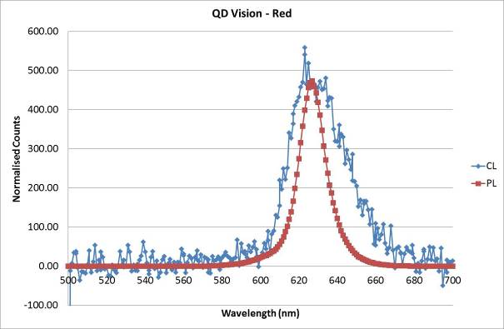
Figure 5. Overlay of the emission spectra of the quantum dot sample. The red line is from the photoluminescent measurement made on the dispersed sample outside of the microscope and the blue line is from the cathodoluminescent measurement made in the electron microscope.

In figure 5 the sharp red line represents the photo-luminescent emission spectrum collected on a ‘bulk’ dispersion of the same material. This has been scaled down such that the λ_{max} values of the two spectra are approximately equal. The blue, broader line represents the emission spectrum from about 50 particles as opposed to the PL data that was taken using a dispersion of about 70 mg/ml of particles with a sample path length of 1 cm in a standard cuvette.

5. Impact
- The shape and uniformity of individual particles can be identified.
- Particles can be identified and the visible light emission observed from a cluster of just 2 particles.
- A spatial resolution of 25nm has been demonstrated for the particles from the CL images.
- Emission spectra can be collected from small clusters of around 50 nano particles and the shape of the particles investigated considered
- This work represents a significant advance towards reconciling the visible light emission properties of individual nano-particles with the size, shape and composition of the particles.
6. Acknowledgments

We are grateful to the Technology Strategy Board (TSB) (UK) for substantial financial funding in the form of TSB Technology programs for the PLACES, FAB3D, ACTIVEL, SHAPEL, and BEDS programs and to our many industrial collaborators on these programs that have allowed us to develop our knowledge and capability in this field.
7. References

[1] “Color IQ™ Optics Deliver Best in Class Color Performance in Award Winning Sony TVs” Reuters Tue Oct 8, 2013 9:00am EDT.
[2] “Cathodoluminescence spectra of single Y₂O₂S:Tb³⁺ nanometer sized phosphor crystals excited in a field emission scanning transmission microscope.” Jack Silver, Xiao Yan, George Fern and Neil Wilkinson, Proc. IDW, 823-826, (2013).
[3] “Cathodoluminescence Spectra of Single Gd₂O₂S:Tb³⁺ Nanometer Sized Phosphor Crystals Excited in a Field Emission Scanning Transmission Electron Microscope” George R. Fern, Xiao Yan, Neil Wilkinson and Jack Silver, Proc. IDW, 820-822, (2013).

