An Investigation into the Use of the Heat Pipe Technology in Thermal Energy Storage Heat Exchangers
Amir Amini^{1a}, Jeremy Miller^{1b}, Hussam Jouhara^{2*}

¹Technology Centre, Spirax-Sarco Engineering Plc, Runnings Road, Cheltenham, Gloucester, GL51 9NQ, UK; e-mail: ªAmir.Amini@uk.spiraxsarco.com, ^{b}Jeremy.Miller@uk.spiraxsarco.com
²Institute of Energy Future, RCUK Centre for Sustainable Energy Use in Food Chains (CSEF), College of Engineering, Design and Physical Sciences, Brunel University London; Email: hussam.jouhara@brunel.ac.uk, Tel. +44(0) 1895267806

*Corresponding author

ABSTRACT
Finding a solution to store industrial wasted heat for later use in order to reduce energy usage has been on the rise in recent years. This paper investigates the capability of latent heat Thermal Energy Storage (TES) system using Phase Change Material (PCM) to store/release a large amount of energy in a small volume compared to sensible heat TES system. In this work, the issue of the low conductivity of PCMs has been addressed by using an embedded finned water-charged heat pipes into the PCM bulk. Both heat pipes and the PCM tank used in this investigation were made of 316L stainless steel. The PCM used in this work was PLUSICE S89, which has a melting temperature of 89°C and crystallization point of 77°C. The evaporator section of the heat pipe was heated by condensing a steam flow. The heat that was absorbed in the evaporator section was then discharged to the PCMs by the heat pipe multi-legged finned condenser. Tests were conducted for both charging (melting) and discharging (crystallization) of PLUSICE S89. It was observed that the thermal resistance posed by PCM during the discharging stage was higher compared to that during the charging process.

Keywords: Thermal Energy Storage (TES); Phase Change Material (PCM); Charging (melting); Discharging (crystallization); Thermal conductivity, Heat pipes

introduction
An efficient and cost-effective solution is a necessity to store industrial wasted heat for later use in order to enhance the energy efficiency of industrial processes. Thermal Energy Storage (TES) has the ability to store energy for later use, improve the reliability and performance of the system and reduce the mismatch between supply and demand of the available energy sources. TES has been used extensively in most buildings in the form of a hot water storage tank.
There are many types of TES systems and many forms that energy can be stored, such as the sensible, latent, chemical, mechanical and electrical TES systems. However, latent heat TES systems have begun to receive more and more interest, due to their large energy storage density, low storage volume and uniform temperature behaviour.

Thermal Energy storage (TES)
Thermal energy can be stored in the form of sensible heat or latent heat. Sensible heat TES system stores energy in a liquid or solid medium by raising its temperature and without changing its phase. This type of TES systems do not have the ability to store large amounts of energy in relation to their volume and cannot provide accurate temperature control. The amount of energy that sensible TES systems can store depends on the temperature difference, the specific heat and the amount of the medium [1,2]. Some commonly used sensible heat storage materials are brick, concrete, oils (e.g. engine oil) and organic oils (e.g. ethanol, propanol, octane), while water considers to be one of the best options, due to its readability, low cost and high value of specific heat. The storage capacity of sensible TES systems is given by
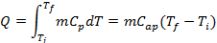

Where m is the mass of the heat storage medium (kg), C_{p} is the specific heat of the medium (J/kgK), T_{f} and T_{i} are the final and initial temperatures (°C), respectively, and C_{ap} is the average specific heat for this temperature range (J/kgK) [3].

Latent TES systems are an alternative approach to thermal energy storage systems and they utilize the storage capacity of PCMs; as a material changes phase, it can either release or store a large amount of energy in a small volume compared to sensible storage. These systems offer the possibility to store greater amounts of energy - approximately 5-14 times more heat per unit volume - and maintain nearly constant temperatures, based on the phase transition temperature of PCM [3–6]. Depending on the application, a TES heat exchanger will utilize a phase change material (PCM) that is designed to melt and solidify at a specific operating temperature. For such temperature, the selected PCM would have a melting temperature that is slightly higher in value. The melted PCM in the heat exchanger has the ability to transfer its stored energy back into the circulating fluid, when solidifying, for the end-use application. The amount of energy latent TES systems can store is given by

Where m is the fraction of the melted medium, Δh_{m} is the heat of fusion per unit mass (J/kg), T_{m} is the melting temperature of the PCM (°C), C_{sp} is the average specific heat between the initial and the melting temperatures (J/kgK), while C_{lp} is the average specific heat between the melting and final temperatures (J/kgK) [3].

Phase change materials
The selection of a PCM is made based on its thermal, physical, kinetic and chemical properties, as well as on economic criteria. To begin with, one of the most important factors is the phase-transition temperature of the PCM, as it must comply with the operating temperature requirements of the application. Then, high latent heat and high density will reduce the actual size of the heat container, while high thermal conductivity will enhance the charging and discharging procedures of the energy storage. Moreover, the PCM should show physical and chemical stability and small volume changes during its phase transitions. It is important to eliminate any supercooling effects, as it can interfere or even stop the proper heat transfer. Finally, the cost and availability of PCMs plays a major role of their selection [7–9].

The phases that a PCM can be transformed are solid-to-solid, solid-to-liquid, solid-to-gas and liquid-to-gas. In solid-to-solid phase transitions, the only thing that changes is the internal crystalline structure of the material. Their design is quite flexible and their container requirements are less strict compare to other categories of PCMs [10]. However, they are generally considered to provide small amounts of latent heat. The solid-to-gas and liquid-to-gas on the other hand are capable of storing higher amounts of latent heat, but their volume changes as they change phase raise concerns about their container storage and potential usage in TES systems. Solid-to-liquid transition PCMs show lower latent heat storage abilities than the liquid-to-gas PCMs, but due to their minimum change in volume, they find application in TES systems [11–14].
Another classification of PCMs is based on their nature. To be more specific, PCMs can be organic (paraffins or non-paraffins), inorganic (salt hydrates or metallics) and eutectic (organic-organic, inorganic-inorganic, inorganic-organic).
Paraffins have a very wide temperature range, but due to their high cost only technical grade paraffins are used as PCMs in latent TES systems. Their chemical stability, small volume changes, low cost, predictability and non-corrosiveness are the advantages of technical paraffins. However, they show low thermal conductivity, are flammable and are not compatible with plastics, factors that minimise their application [15].
The majority of PCMs are non-paraffins (esters, fatty acids, alcohols and glycols), as they are characterised by a variety of properties [16]. Basically, they are flammable, with high heat of fusion, low levels of thermal conductivity, mild corrosive and potentially toxic. The main drawback of non-paraffins and especially fatty acids is their high compared to technical grade paraffins.
Salt hydrates find great application as PCMs as they combine high latent heat of fusion, high thermal conductivity and small volume changes during phase transitions. Other characteristics are non-corrosiveness, plastic compatibility and low cost [17]. The major concerns about salt hydrates are that they get supercooled and the fact that they are not totally soluble during melting, as the salt components settles at the bottom of the container and they cannot be recombined with the water molecules during solidification, which results the reduction of PCMs efficiency.
Metallics are not considered as the best choice of PCM, due to their weight. However, they show high thermal conductivity and heat of fusion per unit volume [3].
The following table presents a list of some of the most promising PCMs.

latent tes systems
PCMs are capable of only storing the thermal energy; in order to transfer this energy from the source to the PCM and from the PCM to the load a heat transfer medium combined with a heat exchanger is required. Therefore, the basic components of any latent TES systems are the appropriate PCM - according to the application, a suitable heat exchange device and a container compatible with the phase changes of the PCM.
Latent heat thermal energy storage by PCMs is also an important technology for building energy conservation, solar energy utilisation and industrial heat recovery due to rise of energy cost [11,14,15,18]. As a result, lots of research has been focused on the development of latent TES systems.
A latent TES with a heat exchanger and an array of cylindrical tubes for the passage of the PCM was firstly developed by Shamsundar and Srinivasan on 1978 [19]. In 1996, Brousseau and Lacroix introduced a multi-layer latent TES system, with vertically parallel PCM plates, to reduce the mismatch between energy supply and demand [20]. Then, Banaszek et al. studied the behaviour of PCMs during charging and discharging periods in a spiral TES system [21], while a year later they developed a numerical model of the system and compared it to their previous experimental results [22]. Ismail and Henriquez proposed the design of a storage tank, fitted with working fluid circulation systems and spherical capsules filled with PCM, place inside the tank [23].
The presence of natural convection heat transfer during the storage/release of thermal energy in PCM

Has been investigated Jamal and Baccar [24] numerically studied the heat transfer in a

PCM-air heat exchanger system using internally and externally finned tubes. The effect of natural convection on the PCM (paraffin C₁₈) solidification time and the influence of fins number on heat transfer rate were investigated. A high-performance PCM for medium-temperature latent heat storage applications was investigated by Zhang et al [25]. They reported that the combination of PCM (RT100) with expanded graphite (EG) shows excellent photo-thermal performance, good thermal storage/release thermal capacity and enhanced thermal conductivity. Zhang and Faghri [26] studied the heat transfer enhancement in the latent heat thermal energy storage heat exchanger by using an internally finned tube. Khalifa et al. [27] demonstrated that by using finned heat pipes in high temperature latent heat thermal energy storage systems, the energy extracted increased by 86% and the heat pipes effectiveness increased by 24%.

Heat Pipe technology
While using PCM materials for thermal energy storage is an attractive option, the low thermal conductivity of the PCMs is an issue. This is because when charging or discharging heat to/from the PCM through the walls of the heat exchanger, a layer of the molten/solid PCM will surround the heat transfer surface inhibiting the heat transfer between the PCM and the heat transfer fluid that facilitates the delivery/removal of the thermal energy.
In order to overcome the low conductivity issue that is discussed above, various methods have been proposed, with the attachment of fins to the heat transfer walls and the implementation of metal particles or rings or carbon fibres of high conductivity into the PCMs being the most popular [28–32]. However, a more promising solution to deliver the heat effectively to within the bulk of the PCM is the use of heat pipe technology.
Heat pipe based heat exchangers are playing a more important role in many industrial applications, especially in increasing heat recovery and energy savings in commercial applications and improving the thermal performance of heat exchangers. In terms of energy management and heat recovery, applications of the loop heat pipe have been investigated by a number of researchers.
Heat pipes are considered to be thermal super conductors due to the high heat rates they transfer across small temperature gradients. On their simplest form heat pipes are called thermosyphons and their operation relies on gravity, whereas the heat is transferred only from the lower to the upper end of the pipe. A heat pipe which allows the bi-directional transfer of heat is called wickless. The main structure of heat pipes is an evacuated tube partially filled with a working fluid that exists in both liquid and vapour phase. The figure below represents the basic steps of operation of heat pipes. The bottom part of the heat pipe is the evaporator and the top part is the condenser. When a high temperature is applied at the evaporator section of the heat pipe, the working fluid existing in the liquid phase evaporates and flows with high velocity towards the cooler end of the pipe – the condenser. As soon as the vapour reaches the condenser section, condenses and gives up its heat. Then the liquid working fluid returns to the evaporator part of the pipe, by the influence of gravity [33]. A series of straight heat pipes joined in one structure can be considered as a heat recovery device. Its advantages are high thermal conductivity, passive and reliable operation, uniform temperature distribution, affordable cost and no need for external pumping system as in the conventional exchangers.
The potential for energy and cost saving that can be realized through the incorporation of a wraparound heat pipe heat exchanger into the apparatus of a conventional means of dehumidification was investigated by Jouhara [35]. Another investigation, introduced by Jouhara and Meskimmon [36] carried out an experimental investigation on the thermal performance of a wraparound loop heat pipe heat exchanger used in air handling units for the purpose of energy savings. The investigators examined the relationship between heat pipe effectiveness and velocity of air flow through the heat exchanger. An experimental investigation of heat exchanger utilizes finned water-charged wickless heat pipes in a modified inline configuration was carried out by Jouhara and merchant [37]. The experimental results show that significant energy savings can be achieved using air-air heat pipe based heat exchanger to transfer heat energy between two air streams at different temperatures. Jouhara et al. [38] also demonstrated that by combining the heat pipe based heat exchanger in an air conditioning system the outside air is cooled and dehumidification prior to being direct supplied to the occupied room for ventilation.
In this paper, the use of the heat pipe technology to enhance the use of PCMs in energy storage is investigated experimentally. This is done by testing the option of combining the latent heat thermal energy storage heat exchanger with a finned and multi-legged heat pipe. The thermal resistance posed by PCM during solidification and mantling was also investigated. It is believed that the use of the PCM/Heat pipe heat exchanging systems will lead to a enhancing the efficiency and sustainability of energy stores and recovery systems [39–42].

Experimental apparatus and procedure
In order to carry out the investigation, an experimental apparatus was constructed that consisted of a storage tank, t a PCM and a finned, multi-legged heat pipe. The PCM used in this study was PLUSICE S89 and the heat pipe was made out of 316L stainless steel to prevent corrosion by the salt hydrate.
A heat pipe is a two-phase heat transfer device with a high effective thermal conductivity that transfers heat through evaporating and condensing a fluid that is circulating in a sealed container. In a heat pipe, heat is added to the evaporator where a working fluid exists, changing the liquid into vapour. The vapour then flows upward and passes through the adiabatic section towards the condenser, where it condenses and gives up its latent heat that is absorbed in the evaporator.
Fig.1. shows CAD drawing of the heat exchanger. Isothermal processes have occurred on both heat transfer fluid and PCM. The heat pipe has been positioned through the bottom chamber in contact with the heat transfer fluid and extending into top part of the heat exchanger to charge PCMs in spaced separated from heat transfer fluid chamber by separation plate.

A schematic diagram of a TES showing the components is illustrated in Fig.2. Fig.2 (1) shows the container covered with the working fluid coil and the thermocouples that fitted on the top plate in order to monitor the temperature profile. Fig.2 (2) shows the heat pipe that is used to transfer heat to the PCM and Fig.2 (3) shows the container filled with the PCM and fitted with a glass panel in order to monitor the phase change process.

Fig.2 (4) shows the inlet and outlet for the supply steam and condensate liquid, respectively. The investigated TES unit was designed to be filled with different PCMs.

The PCM was charged (melted) by the condenser legs of the heat pipe. The heat pipe evaporator section removed the heat that was generated by the condensation of a steam flow through its evaporator side and released this heat into the PCM through its condenser sections. The heat was later discharged by allowing a water flow through the discharging stainless steel coil that is connected to the inlet and outlet ports at the chamber’s top.
High heat transfer area per volume unit was required to ensure a good heat exchange between the surrounding heat transfer medium.

Fig. 3 shows the DSC measurements of heat flow versus sample temperature for PCM. It can be seen that the melting process is occurred around 90°C and the crystallization around 77°C.

The solid’s temperature is lower than the liquid’s because of the poor equilibrium within the frozen crystals and so that solidification and melting occurred over a wide temperature range.
The annotations show the total heat going into and out of the sample between 66-110°C. The Peak Maximum, Onset and Offset indicate the temperatures when phase change occurs. There is a little peak around 73°C and 66°C that is unexpected; possibly due to impurity or a secondary/crystalline phase transition.

Fig. 4 shows a schematic diagram of the HTS rig. Fig. 5 shows the investigated TES test rig. Steam has been supplied via steam isolation valve, pressure reducing valves, temperature control valves for adjusting inlet temperature and steam flowmeter. Condensate has been trapped and drained to weight tank to measure steam flow rate. Water has been supplied from tank through circulation pump and flow has been measured by turbine flow meter. The unit has been powered by main supply and compressed air used for the actuators. All measured variables were recorded using Data Logger.

results and discussion
3.1. Charging (melting) process: The heat pipes have affected shape, number and propagation of multiple solid/liquid interfaces. This is because of the secondary melt fronts around the warm heat pipe legs. These legs have provided pathways for molten PCM, which has lower density than the solid, in order to flow to the top of the tank, downward propagating melting process. They also provided secondary natural convection currents.
Fig.7, Fig.8 and Fig.9 illustrate these phenomena. Approximately 380kg of PCM have been melted during the melting process. Fig.6. shows the trend of the data recorded by the data logger.

3.2. Discharging (crystallization) process: Water pumps from the TES heat exchanger test rig have been utilised in order to ensure a stable and precise supply flow. Discharging tests were all conducted with water temperature of 24°C and a flow rate of 5.5 l/min. Tests were carried out and each discharging phase was lasting approximately 6 hours. Photographs (Fig.10: first 50 minutes) were taken during the tests. The solid PCM started to form around the heat exchanger coil surface and along the pipes.

Salt hydrates have changed TES capacity of the solution with a progressive and irreversible process. They are compound of salt and water. Heavier salt is deposited on the bottom of the solution during the charging and discharging processes, affecting the form of the segregation.

The ratio of stored energy in the PCM that discharged by water to the energy that was supplied by heat pipe using steam as heat transfer fluid during total period of charging and discharging has been calculated and it was found to be about 27%. This ratio could further have been improved to an estimated 50% by optimising the heat exchanger.

For the discharging case, complex freezing phenomena have been observed. These phenomena and measured values can be used as a guide to develop a model that used to simulate the discharging and charging process in both laboratory and large scale systems.
The experimental results illustrate that the thermal resistance posed by the PCM was greater during the discharging stage than during the charging stage. This is explained by the fact that the freezing on cold heat transfer surfaces during the discharging stage formed an insulation barrier between the coil carrying water and the solid/liquid interface. In contrast, molten PCM that has undergoes natural convection was adjacent to the hot heat transfer surfaces during the PCM melting process, promoting heat transfer between the hot heat pipe surface and the solid/liquid interface. Therefore, a design that performs well during discharging is expected to operate satisfactorily during charging.
Fig.12. shows two charging regimes and three discharging regimes. The first charging regime (1) is rapid accumulation of energy in PCM within first the 180 minutes until PCM became liquid and its temperature was about 90°C. The second charging regime (2) is associated with steady state heat transfer rate to the liquid PCM. The first discharging regime (1) is rapid reduction of PCM temperature from 98°C to 89°C (PCM melting point) releasing sensible heat. Second discharging regime (2) is associated with the release of latent heat for 150 minutes when phase change started and the third regime (3) is associated with two phase liquid/solid releasing sensible heat stored by PCM.

Fig.13. shows the temperatures variation at different location within the container during charging and discharging process for a period of 17 hours. This was the result of a PCM with low thermal conductivity and heat transfer to and from PCM during melting and solidification process. It also shows that the condensate temperature at steady state condition was much closed to the inlet steam temperature during charging time, i.e. no significant sub cooling.

Conclusions
The experimental works carried out in this study show the feasibility of using the PCM as a thermal storage media. A heat pipe based thermal energy storage heat exchanger can be successfully used to recover and reuse the wasted heat. Higher efficiency could be achieved by optimising the performance of the heat exchanger and selecting PCM with higher thermal conductivity. The payback could be improved with lower PCM cost.
The experimental works and analysis of the results do not correspond to optimised conditions. Further, investigations are required to determine how the heat pipe might be incorporated better in TES heat exchanger to improve phase change rate in charging and discharging the PCM.
Heat transfer could be improved using a better finning strategy for the condenser side of the used heat pipe. Having that in mind, the used fins have to be as thin as possible with the highest possible heat transfer area to minimise the volume loss for the working PCM in the storage tank. This is feasible as of the advances in formed finning techniques.

The proper design of the storage system must take into account proper material characteristics, available resources, desired storage rate and required energy storage capacity; the system may be only by then designed for its optimal use. It should be pointed out that the characteristics shown in Fig.11 are true for this prototype and could be different for other design of TES system with different PCM.
The observation and experimental data can be used as a guide for the development of a large scale system.

ACKNOWLEDGMENTS
The work has been funded by Spirax Sarco Engineering PLC.

REFERENCES
[1] Lane GA., Solar Heat Storage: Latent Heat Materials, Boca Rat. I (1983).
[2] I. Dincer, On thermal energy storage systems and applications in buildings, Energy Build. 34 (2002) 377–388. doi:10.1016/S0378-7788(01)00126-8.
[3] A. Sharma, V.V. Tyagi, C.R. Chen, D. Buddhi, Review on thermal energy storage with phase change materials and applications, Renew. Sustain. Energy Rev. 13 (2009) 318–345. doi:10.1016/j.rser.2007.10.005.
[4] A. Sari, K. Kaygusuz, Thermal Energy Storage System Using Some Fatty Acids as Latent Heat Energy Storage Materials, Energy Sources. 23 (2001).
[5] B. Zalba, J.M. Marı́n, L.F. Cabeza, H. Mehling, Review on thermal energy storage with phase change: materials, heat transfer analysis and applications, Appl. Therm. Eng. 23 (2003) 251–283. doi:10.1016/S1359-4311(02)00192-8.
[6] J. Heier, Energy Efficiency through Thermal Energy Storage, KTH School of Industrial Engineering and Management, 2013.
[7] M.M. Farid, A.M. Khudhair, S.A.K. Razack, S. Al-Hallaj, A review on phase change energy storage: materials and applications, Energy Convers. Manag. 45 (2004) 1597–1615. doi:10.1016/j.enconman.2003.09.015.
[8] J.C. Kurnia, A.P. Sasmito, S. V. Jangam, A.S. Mujumdar, Improved design for heat transfer performance of a novel phase change material (PCM) thermal energy storage (TES), Appl. Therm. Eng. 50 (2013) 896–907. doi:10.1016/j.applthermaleng.2012.08.015.
[9] M. Liu, W. Saman, F. Bruno, Review on storage materials and thermal performance enhancement techniques for high temperature phase change thermal storage systems, Renew. Sustain. Energy Rev. 16 (2012) 2118–2132. doi:10.1016/j.rser.2012.01.020.
[10] K.K. Pillai, B.J. Brinkworth, The storage of low grade thermal energy using phase change materials, Appl. Energy. 2 (1976) 205–216. doi:10.1016/0306-2619(76)90025-8.
[11] H.P. Garg, S.C. Mullick, A.K. Bhargava, Solar Thermal Energy Storage, Springer Netherlands, 1985. doi:10.1007/978-94-009-5301-7.
[12] D.N. Nkwetta, F. Haghighat, Thermal energy storage with phase change material—A state-of-the art review, Sustain. Cities Soc. 10 (2014) 87–100. doi:10.1016/j.scs.2013.05.007.
[13] E. Oró, A. de Gracia, A. Castell, M.M. Farid, L.F. Cabeza, Review on phase change materials (PCMs) for cold thermal energy storage applications, Appl. Energy. 99 (2012) 513–533. doi:10.1016/j.apenergy.2012.03.058.
[14] D. Zhou, C.Y. Zhao, Y. Tian, Review on thermal energy storage with phase change materials (PCMs) in building applications, Appl. Energy. 92 (2012) 593–605. doi:10.1016/j.apenergy.2011.08.025.
[15] D.R. Rousse, N. Ben Salah, S. Lassue, An overview of phase change materials and their implication on power demand, Electr. Power Energy Conf. (EPEC), 2009 IEEE. (2009) 1–6. doi:10.1109/EPEC.2009.5420979.
[16] A. Abhat, D. Heine, M. Heinisch, N.A. Malatidis, G. Neuer, Development of a modular heat exchanger with integrated latent heat energy store, (1981).
[17] Q. V Report, Macro- Encapsulation of Pcm Masti ’ R, (1978).
[18] M. Zhang, Y. Lai, J. Zhang, Z. Sun, Numerical study on cooling characteristics of two-phase closed thermosyphon embankment in permafrost regions, Cold Reg. Sci. Technol. 65 (2011) 203–210. doi:10.1016/j.coldregions.2010.08.001.
[19] N. Shamsundar, R. Srinivasan, Analysis of energy storage by phase change with an array of cylindrical tubes, in: ASME Winter Annu. Meet., USA: San Francisco, 1978: pp. 35–40.
[20] P. Brousseau, M. Lacroix, Study of the thermal performance of a multi-layer PCM storage unit, Energy Convers. Manag. 37 (1996) 599–609. doi:10.1016/0196-8904(95)00207-3.
[21] J. Banaszek, R. Domañski, M. Rebow, F. El-Sagier, Experimental study of solid–liquid phase change in a spiral thermal energy storage unit, Appl. Therm. Eng. 19 (1999) 1253–1277. doi:10.1016/S1359-4311(98)00120-3.
[22] J. Banaszek, R. Domañski, M. Rebow, F. El-Sagier, Numerical analysis of the paraffin wax–air spiral thermal energy storage unit, Appl. Therm. Eng. 20 (2000) 323–354. doi:10.1016/S1359-4311(99)00028-9.
[23] K.A.R. Ismail, J.R. Henrı́quez, Numerical and experimental study of spherical capsules packed bed latent heat storage system, Appl. Therm. Eng. 22 (2002) 1705–1716. doi:10.1016/S1359-4311(02)00080-7.
[24] I. Jmal, M. Baccar, Numerical study of PCM solidification in a finned tube thermal storage including natural convection, Appl. Therm. Eng. 84 (2015) 320–330. doi:10.1016/j.applthermaleng.2015.03.065.
[25] Q. Zhang, H. Wang, Z. Ling, X. Fang, Z. Zhang, RT100/expand graphite composite phase change material with excellent structure stability, photo-thermal performance and good thermal reliability, Sol. Energy Mater. Sol. Cells. 140 (2015) 158–166. doi:10.1016/j.solmat.2015.04.008.
[26] Y. Zhang, A. Faghri, Heat transfer enhancement in latent heat thermal energy storage system by using the internally finned tube, Int. J. Heat Mass Transf. 39 (1996) 3165–3173. doi:10.1016/0017-9310(95)00402-5.
[27] A. Khalifa, L. Tan, A. Date, A. Akbarzadeh, A numerical and experimental study of solidification around axially finned heat pipes for high temperature latent heat thermal energy storage units, Appl. Therm. Eng. 70 (2014) 609–619. doi:10.1016/j.applthermaleng.2014.05.080.
[28] T. Guo, Y. Zhang, X. Ge, Theoretical analysis of heat transfer in a cool storage tank filled with rectangular enclosures containing phase change material, in: B. Wang (Ed.), 4th Int. Symp. Heat Transf., Higher Education Press, China, Beijing, 1996: pp. 734–739.
[29] R. Velraj, R.V. Seeniraj, B. Hafner, C. Faber, K. Schwarzer, HEAT TRANSFER ENHANCEMENT IN A LATENT HEAT STORAGE SYSTEM, Sol. Energy. 65 (1999) 171–180. doi:10.1016/S0038-092X(98)00128-5.
[30] L.. Chow, J.. Zhong, J.. Beam, Thermal conductivity enhancement for phase change storage media, Int. Commun. Heat Mass Transf. 23 (1996) 91–100. doi:10.1016/0735-1933(95)00087-9.
[31] J. Eftekhar, A. Sheikh, D. Lou, Heat transfer enhancement in a paraffin wax thermal storage system, Sol. Energy Eng. 106 (1984) 299–306.
[32] A. Siahpush, J. O’Brien, J. Crepeau, Phase Change Heat Transfer Enhancement Using Copper Porous Foam, J. Heat Transfer. 130 (2008) 082301. doi:10.1115/1.2928010.
[33] J. Danielewicz, M.A. Sayegh, B. Śniechowska, M. Szulgowska-Zgrzywa, H. Jouhara, Experimental and analytical performance investigation of air to air two phase closed thermosyphon based heat exchangers, Energy. 77 (2014) 82–87. doi:10.1016/j.energy.2014.04.107.
[34] H. Jouhara, V. Anastasov, I. Khamis, Potential of heat pipe technology in nuclear seawater desalination, Desalination. 249 (2009) 1055–1061. doi:10.1016/j.desal.2009.05.019.
[35] H. Jouhara, Economic assessment of the benefits of wraparound heat pipes in ventilation processes for hot and humid climates, Int. J. Low-Carbon Technol. 4 (2009) 52–60. doi:10.1093/ijlct/ctp006.
[36] H. Jouhara, R. Meskimmon, Experimental investigation of wraparound loop heat pipe heat exchanger used in energy efficient air handling units, Energy. 35 (2010) 4592–4599. doi:10.1016/j.energy.2010.03.056.
[37] H. Jouhara, H. Merchant, Experimental investigation of a thermosyphon based heat exchanger used in energy efficient air handling units, Energy. 39 (2012) 82–89. doi:10.1016/j.energy.2011.08.054.
[38] H. Mroue, J.B. Ramos, L.C. Wrobel, H. Jouhara, Experimental and numerical investigation of an air-to-water heat pipe-based heat exchanger, Appl. Therm. Eng. 78 (2015) 339–350. doi:10.1016/j.applthermaleng.2015.01.005.
[39] A.G. Olabi, 100% sustainable energy, Energy. 77 (2014) 1–5. doi:10.1016/j.energy.2014.10.083.
[40] A.G. Olabi, State of the art on renewable and sustainable energy, Energy. 61 (2013) 2–5. doi:10.1016/j.energy.2013.10.013.
[41] A.G. Olabi, Developments in sustainable energy and environmental protection, Energy. 39 (2012) 2–5. doi:10.1016/j.energy.2011.12.037.
[42] A.G. Olabi, The 3rd international conference on sustainable energy and environmental protection SEEP 2009 – Guest Editor’s Introduction, Energy. 35 (2010) 4508–4509. doi:10.1016/j.energy.2010.09.053.

Table 1: Melting point and latent heat of fusion for different PCMs [3]
PCMs
Category | Material | Melting Point | Latent Fusion Heat
Paraffins | C₁₄ | 5.5 °C | 228 kJ/kg
Paraffins | C₁₆ | 16.7 °C | 237 kJ/kg
Paraffins | C₁₈ | 28 °C | 244 kJ/kg
Paraffins | C₂₀ | 36.7 °C | 246 kJ/kg
Non-Paraffins | D-Lattic Acid | 26 °C | 184 kJ/kg
Non-Paraffins | Caprylone | 40 °C | 259 kJ/kg
Non-Paraffins | Eladic Acid | 47 °C | 218 kJ/kg
Non-Paraffins | Acetamide | 81 °C | 241 kJ/kg
Salt Hydrates | LiNO₃2H₂O | 30 °C | 296 kJ/kg
Salt Hydrates | FeCl₃6H₂O | 37 °C | 223 kJ/kg
Salt Hydrates | Fe(NO₃)₃9H₂O | 47 °C | 155 kJ/kg
Salt Hydrates | NaOHH₂O | 64.3 °C | 273 kJ/kg
Metallics | Gallium | 30 °C | 80.3 kJ/kg
Eutectics | Cerobend | 70°C | 32.6 kJ/kg

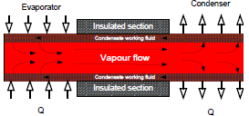
Figure 1: Heat pipe exchanger’s working cycle [34]
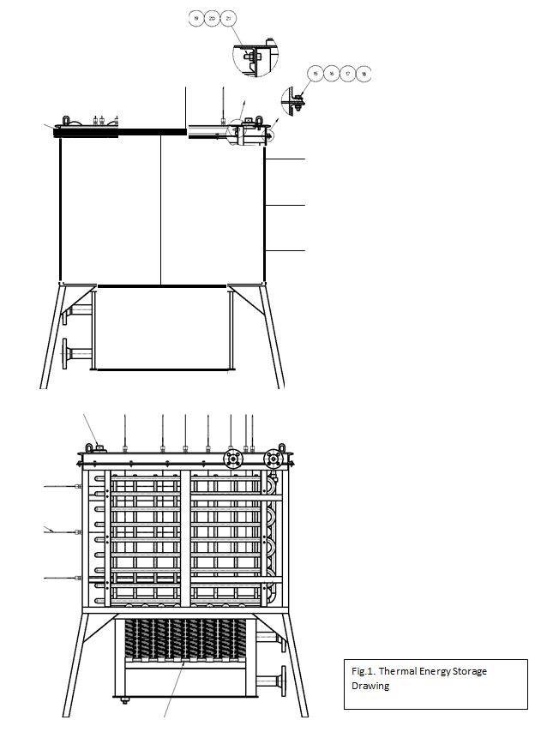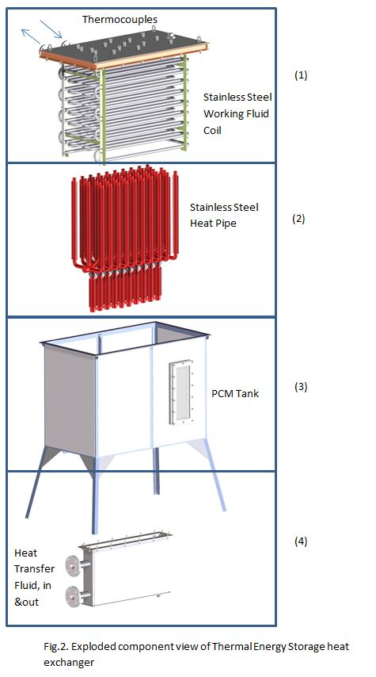
Figure 2: The thermal storage system’s drawing
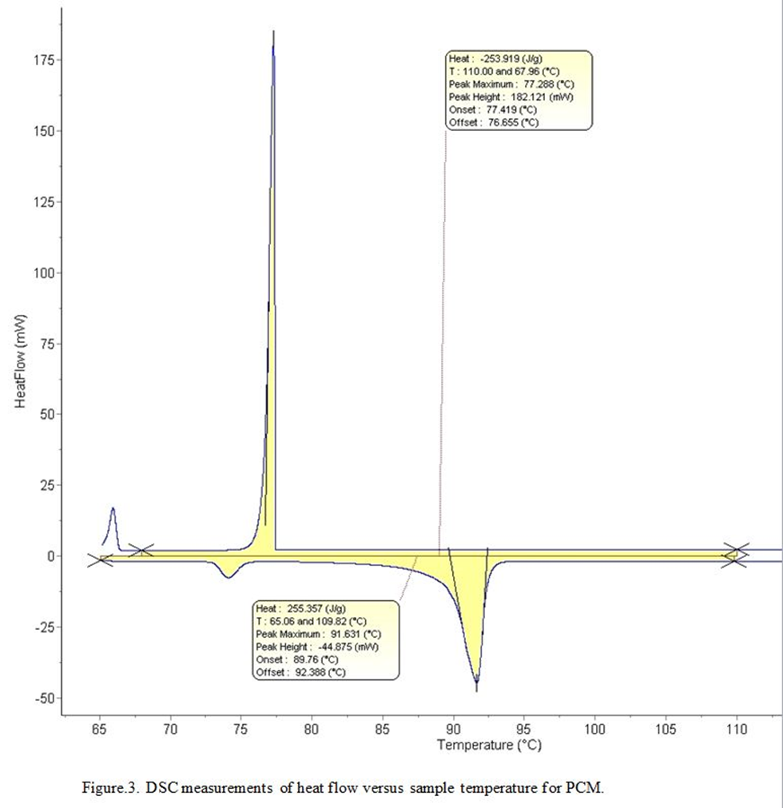

Fig. 3: DSC measurements of heat flow versus sample temperature for PCM.

Fig. 4: Schematic Diagram of the Experimental Rig.

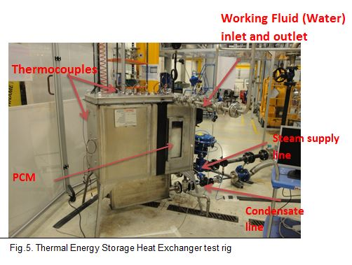

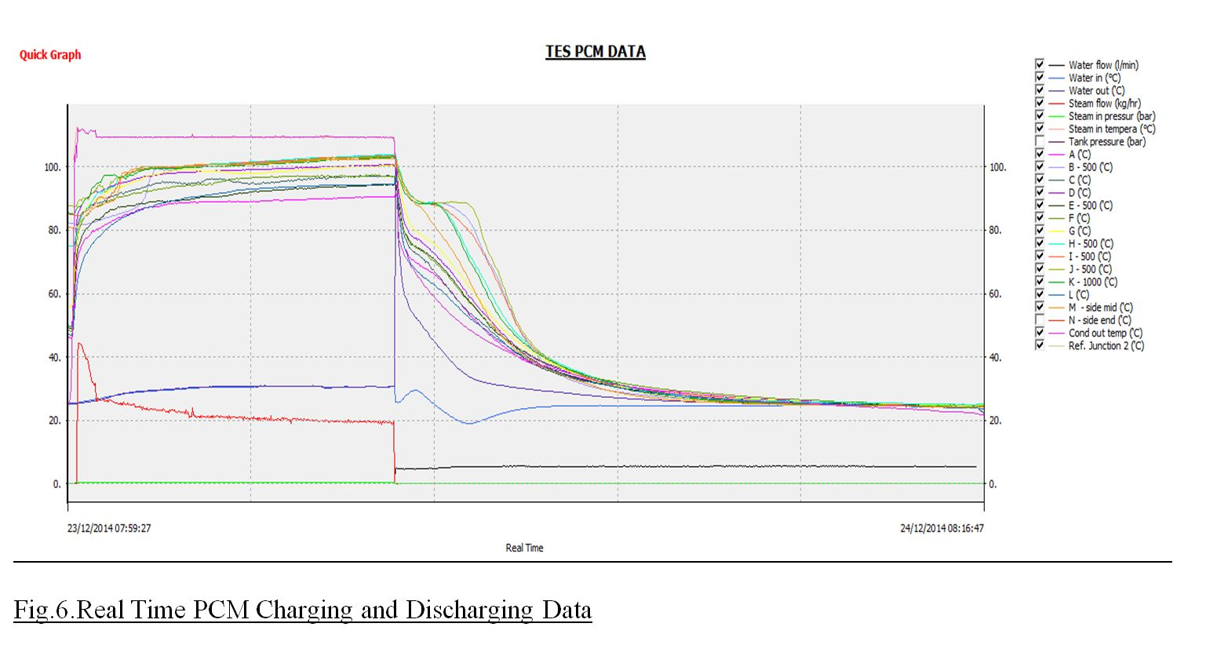

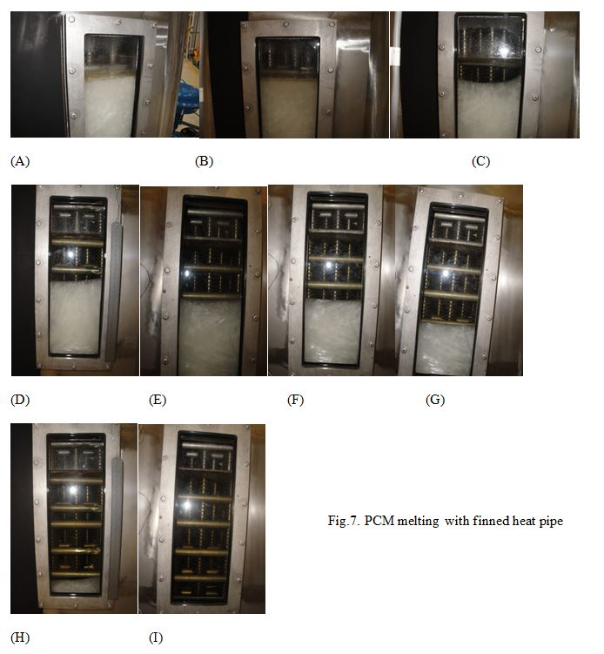
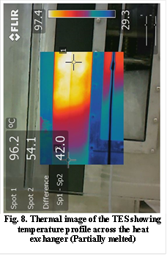

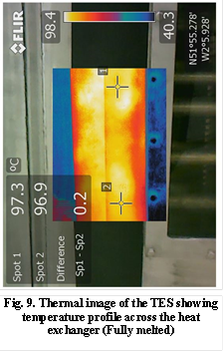

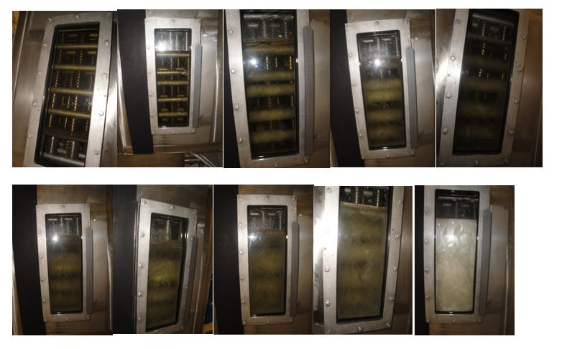
Fig.10. PCM (discharging) solidification

Fig.11. shows the energy stored in the PCM and released from PCM for the finned heat pipe Thermal Energy Storage unit.

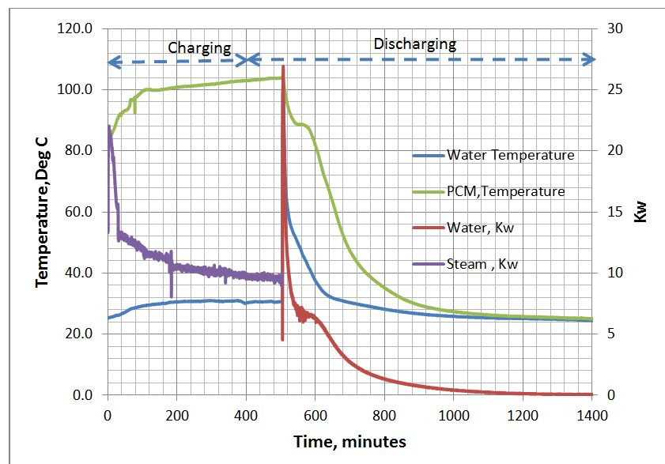
Fig.11. Energy stored in PCM and Energy released from PCM during charging and discharging.
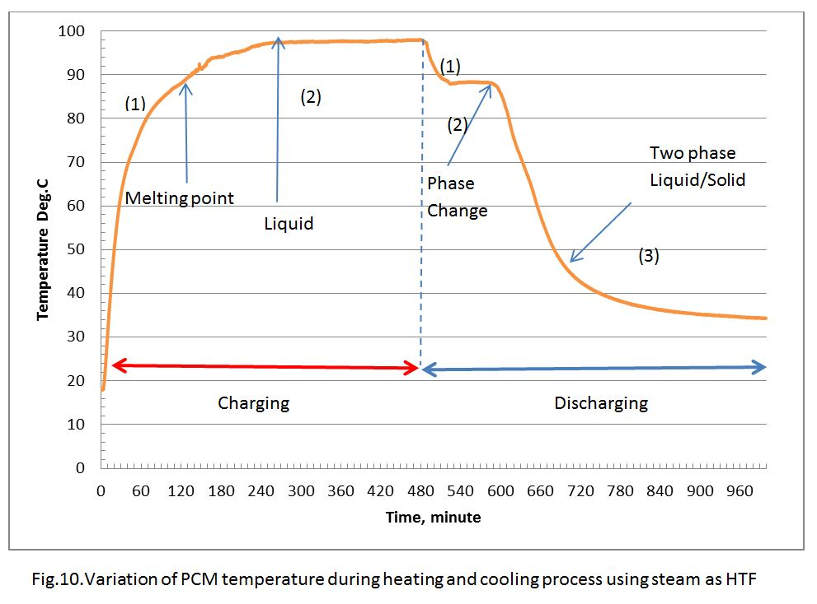
Fig. 12 Variation of PCM temperature during heating and coolin process using steam as HTF.
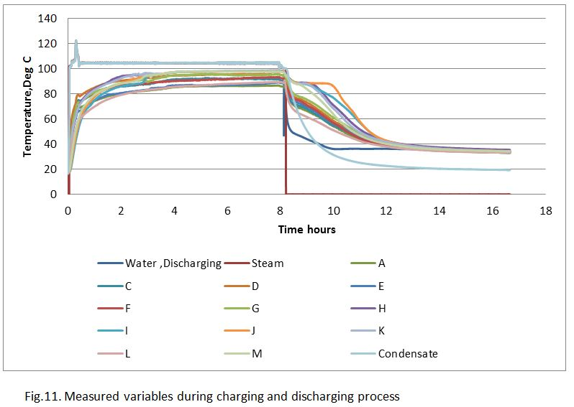
Fig. 13 Measured variables during charging and discharging process.

