A Novel Approach to the Manufacture of Micro-LED Colour Conversion Structures

Jack Silver¹, Paul Harris¹ George Fern¹, Jim Bonar², Gareth Valentine², Steve Gorton².

¹Wolfson Centre for Materials Processing, Brunel University, Uxbridge, Middlesex, UB8 3PH, UK.
² mLED Ltd., Glasgow, G1 1XP, UK.
Keywords: MicroLED, Colour conversion, quantum dots, phosphors

ABSTRACT
This report discusses a novel approach for manufacturing colour conversion layers for micro-LED arrays. Colour conversion layers with discrete 20µm pixels have been made using photolithography to define well structures which are then filled with either conventional phosphors or quantum dots.

1. INTRODUCTION
Micro-LEDs arrays are an emerging flat panel display technology which offers the potential for displays of substantially improved brightness and contrast compared to rival technologies such as OLEDs (1-3). There are two ways in which such panels can be made. One is to produce discrete red, green and blue LEDs and then to assemble them into RGB arrays and make connections to them with post processing techniques. This approach is potentially the brightest solution, with very high colour rendering performance, but the assembly of microscopic LEDs into an array is a daunting task. A more straightforward approach is to use an array of LEDs with a single pump wavelength, for example blue (450nm-460nm), and then use colour conversion layers to convert one third of the pixels to green and one third to red.
In principle the colour conversion structure could be built either directly onto the LED surface or onto a transparent cover sheet that is subsequently positioned over the array. Building the structure directly onto the fragile and expensive LED structure, however, is likely to result higher costs due to manufacturing defects. In this work therefore it has been built on a cover sheet, and this has the additional benefit of providing a thermal break between the hot surface of the LED and the phosphor material, whose efficiency decreases with increasing temperature. Moreover, substantial heat sinking of the LED itself has been incorporated to minimise heating effects.
A colour conversion layer would have to contain either a conventional phosphor material or quantum dot (QD) materials that (4) are able to stand up to high levels of light intensity. Such levels of light intensity and elevated temperatures are likely to break down organic luminescent dye compounds (5) and so are unlikely to be sufficient for this application.
The Wolfson Centre for materials processing at Brunel University in collaboration with mLED Limited have been developing conversion structures for this type of display for some time, and have patented a process for achieving this. The objective has been to develop RGB displays with pixel sizes of 10µm or less.

2. RESULTS AND DISCUSSION
The first challenge in making a conversion layer is to confine the conversion material within the bounds of each pixel so that it does not overlap onto adjacent pixels. Conventional printing techniques, such as silk-screen, stencil or flexographic printing, are not able to meet the resolution requirements needed here. In the past cathode ray tube phosphor screens were manufactured by using photolithographic binders (typically polyvinyl alcohol/ammonium dichromate based) with phosphor particles incorporated into them. In the present case we need to achieve pixel sizes more than an order of magnitude smaller than this process was used for, with height to width ratios of >1, rather than < 0.1 for CRTs. In this case the possibility of cross-talk between pixels is substantially higher.
Thus the second challenge is to prevent light from one pixel from encroaching onto adjacent pixels, either due to the natural spread of emission angles from the micro-LED and fluorescent materials, or due to scattering from the conversion material.
In this work both of these objectives have been successfully achieved by making a well structure by photolithography on a transparent cover sheet (which is eventually positioned over and in intimate contact with the array).
Figure 1 illustrates the process.
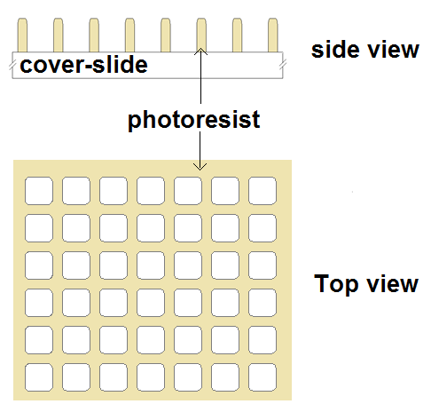
Figure 1. Well structures formed from photoresist.

A negative photoresist was used (SU-8 2000, MicroChem Corporation, USA) on glass cover slides.
The sidewalls of this well structure were coated with aluminium by evaporation at an oblique angle (to prevent any possible cross-talk). An oblique angle was used so that the surface of the cover sheet was not metallised, in order that the light could escape the assembly, Figure 2.

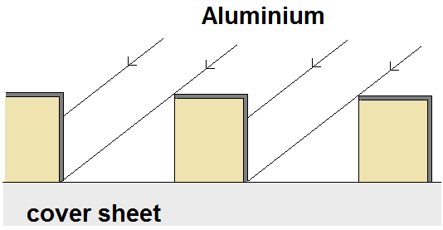
Figure 2. Angled metallization

Figure 3 shows before and after optical micrographs showing the metallization of a well structure.
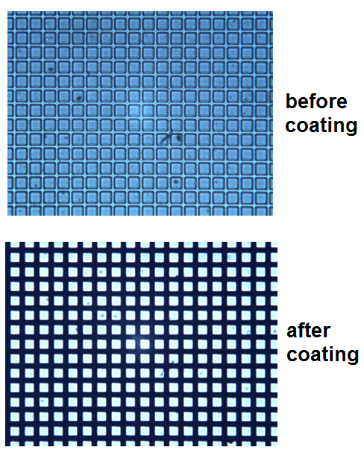
Figure 3. Optical micrographs (transmitted light) of well structure, before and after angled metallization (20µm pitch).

The conversion (phosphor) materials were prepared in a photocurable binder and applied to the well structure. The red (or green) pixels can then be individually exposed and developed and the process repeated for the other colour. Again the metallised side-walls are important to prevent the UV curing radiation from being scattered into adjacent pixels.
Figure 4 illustrates the process. A 70 Shore A hardness rubber squeegee was used to apply the ink, and with 4µm cell walls this caused no detectable damage to the photoresist.
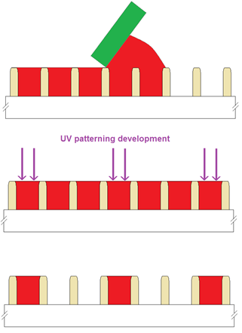
Figure 4. Well-filling process.

Conversion materials based on both quantum dots (QDs) and phosphors have been successfully made, in pixel structures down to 20µm pitch. Figures 5 and 6 show scanning electron micrographs of filled well structures in cross-section (secondary electron mode) and from above (cathodoluminescence mode).

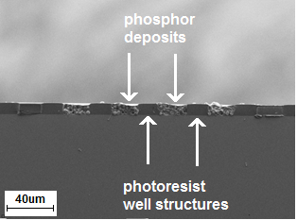
Figure 5. Secondary electron micrograph of filled well-structures in cross-section, 40µm pitch.
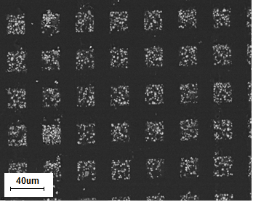
Figure 6. Cathodoluminescence image of filled well structure, 40µm pitch.

QDs have the advantage of small particle sizes and could be used for even smaller arrays. They also have excellent colour purity, and are highly efficient conversion materials. They also have disadvantages, however, including very high cost and concerns over their high toxicity and longevity which are not a problem for most conventional phosphors.
In the case of conventional phosphors, however, the main drawback at this time is in sourcing suitable ones with small enough particle size to fit into such structures. It appears that a particle size of no more than one quarter of the well width is essentially (and ideally smaller) to ensure reproducible well filling and inter-pixel uniformity.
As the thickness of the conversion layer increases the proportion of the pump radiation converted increases. For example Figure 7 shows a 20µm pitch device filled with red quantum dots. Note the blue component resulting in a violet colour.
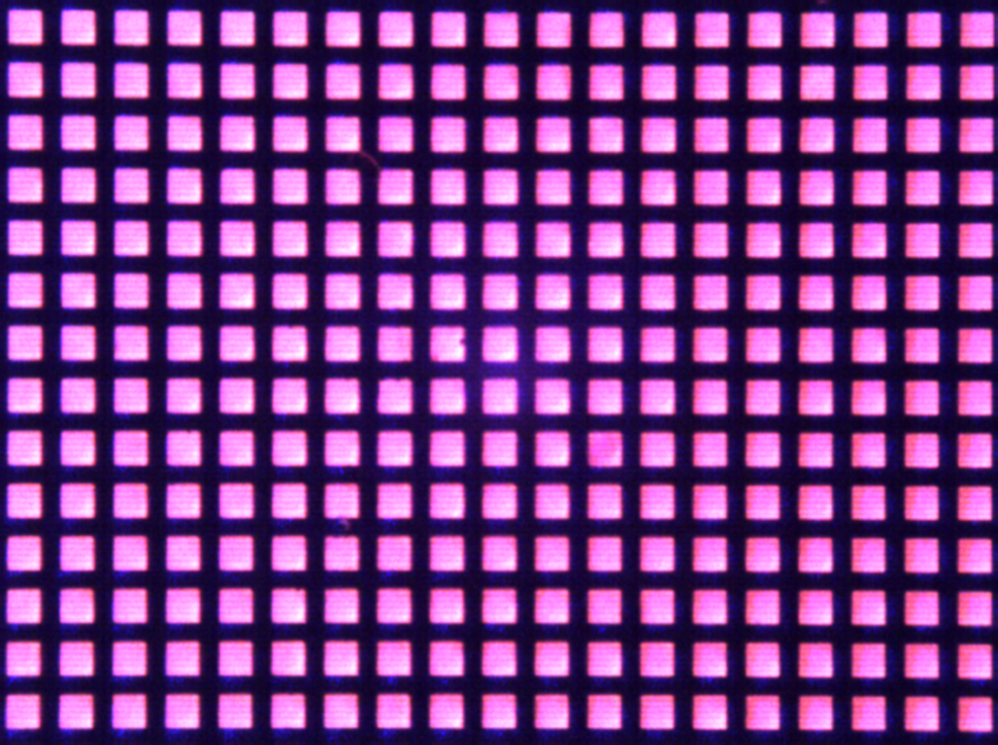
Figure 7. 20µm pitch structure filled with red Quantum dots (illuminated from behind by 460nm light).
In order to completely eradicate the pump radiation, however, requires a very thick deposit and this lowers the total light output significantly. The largest blue component was detected normal to the surface and at large angles the colour purity was much better. Figure 8 illustrates spectra taken from deposits of decreasing thickness (A<B<C<D). Note that as the thickness increases the blue signal is reduced but the red signal also decreases.

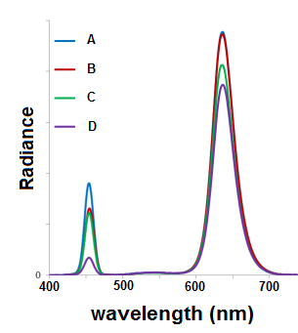

A better solution is to either use either a (photolithographically defined) blue filter in front of the red and green pixels of the conversion layer, or preferably to define the structure on top of a dichroic filter so that any pump radiation that passes through the conversion layer is reflected back into the deposit (and hence is not wasted).

3. CONCLUSIONS

Structures for converting the emission from micro-LED arrays into RGB have been successfully fabricated at 20µm pitch by defining well structures using photolithography on a transparent cover sheet and selectively filling the wells with either conventional phosphor materials or quantum dots.

Quantum dots have the advantage of small size, and would permit even smaller sized arrays to be fabricated. They are, however, expensive, in some cases toxic and comparatively little is known about their longevity.

Conventional phosphors are much cheaper, well characterized, and are usually of much lower toxicity. Here the primary obstacle to further progress is identifying commercial sources of fine particle size material.

ACKNOWLEDGEMENTS

The authors are grateful to Brunel University London and mLED for funding the program.

REFERENCES
1. H. X. Jiang and J. Y. Lin, ‘Nitride micro-LEDs and beyond - a decade progress review’ Optical Society of America, V21, No S3, pp 475-484, (2013).

2. H. X. Jiang, S. X. Jin, J. Li, J. Shakya, and J. Y. Lin, “III-nitride blue microdisplays,” Appl. Phys. Lett. 78(9), 1303 (2001)

3. C-W Jeon, K-S Kim, M.D.Dawson, ‘Fabrication of two-dimensional InGaN based Micro-LED arrays’, phys. stat. sol. (a) V192, No. 2, pp325–328 (2002)

4. D. Bozyigit, V., Wood, ‘Challenges and solutions for high efficiency quantum dot-based LEDs’ MRS Bulletin, V 38 pp731-736, (2013).

5. A.M.Weiss, E.Yariv, R.Reisfeld, ‘Photostability of luminescent dyes in solid-state dye lasers’, Optical Materials, V24, Issues 1-2, pp31-34, (2003).

