Effect of substrate chemistry on prenucleation by ab initio MD simulation

C. M. Fang, H. Men, Z. Fan
BCAST, Brunel University London, Uxbridge, Middlesex, UB8 3PH, UK.

Abstract
Prenucleation refers to the phenomenon of atomic ordering in the liquid close to the substrate/liquid interface at temperatures above the liquidus. Based on our previous work on the structural effect (i.e., lattice misfit) on prenucleation, here we investigate the effect of substrate chemistry on prenucleation by ab initio molecular dynamics (MD) simulations using the supercell approach. Our study has shown significant influences of the substrate chemistry on substrate–metal spacing, atomic layering and in–plane ordering of the liquid Al at temperatures above liquidus. Attractive substrate promotes prenucleation while repulsive substrate impedes prenucleation. We also find that the effect of substrate chemistry is local and mainly confined to the first layer of liquid atoms closest to the substrate/liquid interface.
Keywords: Chemistry of substrates; Prenucleation of liquid Al; Ab initio MD simulations; Layering and in–plane ordering.

1. Introduction
Solidification of an alloy begins at a temperature below its liquidus through heterogeneous nucleation on existing solid particles in the alloy melt [1]. Such heterogeneous nucleation usually takes place by epitaxial growth of the solid phase on a crystalline substrate and proceeds layer by layer [2]. This means that the atomic arrangement in the liquid at the substrate/liquid interface (SuLI) is of importance for understanding heterogeneous nucleation. The recent experimental observations and atomistic simulations showed that at temperatures above the liquidus, there exists significant atomic ordering of the liquid atoms at the substrate/liquid interface [3–9], which is manifested by atomic layering perpendicular to the SuLI and in–plane ordering parallel to the SuLI. We refer such atomic ordering at temperatures above the liquidus as prenucleation, which can be understood as substrate–induced (or stabilised) atomic ordering at the SuLI. Men and Fan [7–9] investigated systematically using MD simulation the effect of temperature and the lattice misfit (between the substrate and the solid) on the prenucleation phenomenon. They found that both atomic layering and in–plane atomic ordering increases with the decrease of temperature. More importantly, their results suggest that a decrease in lattice misfit promotes the in–plane ordering, whereas the atomic layering is inherent of a flat surface and is almost independent of lattice misfit. Such enhanced atomic ordering at the SuLI by a crystalline substrate with low lattice misfit can be described as structural templating, which has been shown to have strong implications on heterogeneous nucleation process [2, 10]. Based on such understanding of structural templating of prenucleation, here we present our atomistic investigation of the effect of substrate chemistry on prenucleation by an ab initio molecular dynamics (MD) simulation technique using designed SuLIs with 0% lattice misfit.

2. Simulation approach
In order to facilitate the simulation of the effect of substrate chemistry on prenucleation we choose pure Al as liquid and other pure metals as substrate. There are two major considerations for the choice of metal substrates: (1) the substrate metal has a close packed crystal plane which matches closely the atomic arrangement of {111}_{Al}; (2) the substrate metal has a strong chemical interaction with Al, being either strongly affinitive or strongly repulsive. In other words, the substrate metal should have a heat of mixing (ΔH^{mix}) being either strongly negative or strongly positive. Based on such considerations we have selected Ag, W and Cd as metal substrates. The crystallographic and thermodynamic data for the substrate metals are summarised in Table 1. In order to assess the chemical effect without the interference of the structural effect all the substrate metal atoms have been manipulated to take the positions of the Al atoms (thus 0% lattice misfit) and were pinned at their lattice position during the simulation. This 'pinned substrate' method excludes the structural effect and avoids the circumstance of substrate metals with lower melting point than that of Al (e.g. Cd).
We employed a large hexagonal supercell with lattice parameters of a = 14.57 Å and c = 49.95 Å. This supercell contains 100 (solid) metallic atoms as the substrate and 425 liquid Al atoms. Our ab initio MD simulations with full relaxation of the systems, including the substrate metals with higher melting temperature (e.g. Ag), have shown that relaxation of the substrate has but minor effect on the prenucleation. Therefore the substrate atoms are fixed in all the simulations.
The pure liquid Al was generated by equilibrating the system for about 9 ps (picoseconds) at 3000K to compensate for the relatively short simulation time. Then the structure was slowly annealed to the desirable temperature. The obtained liquid Al was used to form the simulation cell. The obtained samples were then heated to the designed temperature for another 6 to 12 ps. We used the simulated configurations for 3 to 9 ps to obtain the averaged results of statistical meaning.
Table 1: Summary of crystallographic and thermodynamic data for Al, Ag, W and Cd.
Metal | Crystal  structure | Lattice  parameter  (Å)[12] | Atomic spacing  (Å) | Lattice misfit  (%) | ΔH^{mix}  (kJ/mol)  [11]
Al | FCC | a=4.05 | 2.86 | – | 0.0
Ag | FCC | a=4.09 | 2.89 | +0.8  (111)_{Al} //  (111)_{Ag} | –4.0
W | FCC* | a=4.02 | 2.84 | –0.7 (111)_{Al} //  (111)_{W} | –2.0
Cd | HCP | a=2.98  c=5.62 | 2.98 | +3.7  (111)_{Al} //  (0001)_{Cd} | +3.0

*The novel FCC W lattice is predicted using the DFT approach.

All ab initio MD simulations and calculations were performed using the VASP code [13] which employs the first–principles density functional theory (DFT) within the Projector–Augmented Wave (PAW) frame [14]. The exchange and correlation terms were described using the generalized gradient approximation (GGA) [15]. For the ab initio MD simulations we employed a cut–off energy of about 200 eV, and only Γ–point in the Brillouin Zone (BZ). To quantify the ordering of the liquid atoms at SuLI, two different parameters were defined [6, 7]. Atomic density profile is used to describe the atomic layering of liquid atoms near the substrate, and in–plane order parameter which provides a measure on the atomic ordering in each layer.

3. Results
3.1 Atomic layering
Figure 1 shows the snapshots for the liquid Al on the metal substrates of different chemical nature at 1000 K. There are several distinct layers in the liquid Al close to the substrate for all three systems. Compared with that of the L–Al/S–Al system, the atomic layering in the L–Al/S–Ag system is more pronounced and that in the L–Al/S–Cd system is less. In addition, it is noted that the first layer in the L–Al/S–Ag system has a smaller interlayer spacing while that in the in the L–Al/L–Cd system is larger. This suggests that the substrate chemistry does affect the atomic ordering in the liquid and worth of further investigation.
The detailed atomic density profile and layer spacing in the liquid for these 3 different systems are presented in Figures 2 and 3, respectively. Figures 2 and 3 have revealed the following facts:

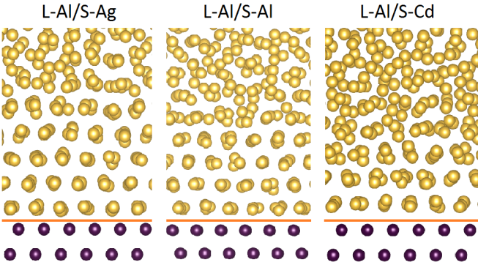
Figure 1: Snapshots for the L–Al/S–M interfaces simulated at 1000 K using an ab initio molecular dynamics technique. The orange line separates the liquid Al (gold spheres) and the substrate atoms (dark brown). The snapshots reveal notable effects of substrate chemistry on the atomic layering in the liquid close to the substrate/liquid interface.

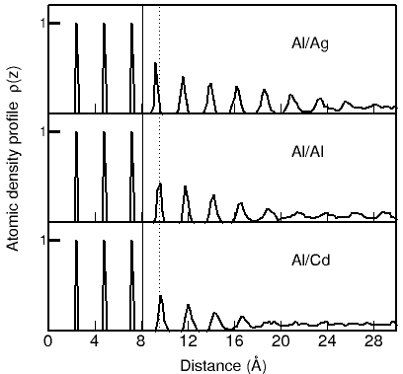
Figure 2: The normalised atomic density profiles ρ(z) for the liquid Al on substrate of different chemistry at 1000 K. The solid line is to separate the substrate and the liquid. The dotted line indicates the peak of the first liquid layer on the Al substrate. This result reveals the effect of substrate chemistry on the M–Al spacing and atomic layering for the liquid Al near the substrate.

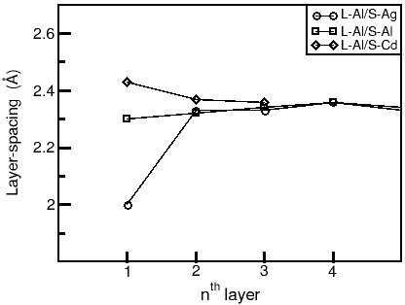
Figure 3: Atomic layer spacing in the L–Al/S–M systems showing that the effect of substrate chemistry on atomic ordering is local and mainly confined to the first layer of liquid atoms.

- The numbers of distinct layers revealed by the density profiles (Figure 2) are different for the 3 systems: decreases with change of heat of mixing: 8 for the L–Al/S–Ag system, 6 for the L–Al/S–Al system and 5 for the L–Al/S–Cd system.
- The peak density of liquid Al layers also varies with the substrate chemistry. For instance, the peak density of the first layer is 0.57 for the L–Al/S–Ag system, 0.44 for the L–Al/S–Al system and 0.39 for the L–Al/S–Cd system.
- The interlayer spacing of the first layer in the liquid is strongly affected by the substrate chemistry while that for the subsequent layers away from the interface is not affected by the substrate chemistry (Figure 3). The interlayer spacing of the first peak is 2.01 Å for the L–Al/S–Ag system, 2.30 Å for the L–Al/S–Al system and 2.43 Å for the L–Al/S–Cd system. Figure 3 suggests that the chemical effect of the substrate on atomic ordering in the liquid is local and is mainly confined to the first later.

3.2 In–plane ordering
We have analysed the in–plane ordering for the liquid Al on the three typical substrates using the in–plane order parameter described in our previous work [7,8]. The results are shown in Figure 4.

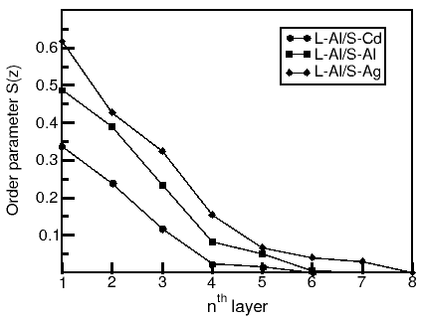
Figure 4: The in–plane order parameter (S(z)) of liquid Al atoms in the L–Al/S–M systems as a function of position relative to the interface.

As shown in Figure 4, when going deeper into the liquid the in–plane ordering decreases. This is the case for all 3 investigated systems. If we use the in–plane order parameter S(z) = 0.05 as a cut–off point for non–existence of in–plane ordering, the number of layers containing in–plane ordering will be 3 for the L–Al/S–Cd system, 4 for the L–Al/S–Al system and 5 for the L–Al/S–Ag system. In addition, it is noted that compared to that of the L–Al/S–Al system, the in–plane ordering in the first layer is increased in the L–Al/S–Ag system (from 0.49 to 0.62) and decreased in the in the L–Al/S–Cd system (from 0.49 to 0.34). This suggests that the in–plane ordering disappears faster than the atomic layering does with increasing the distance from the SuLI.

3.3 The effect of substrate chemistry
To get general understanding of the effect of substrate chemistry on prenucleation phenomenon, we also performed ab initio MD simulations for the L–Al/S–W system since W has different chemical nature and a good lattice match with Al. The simulation results for the L–Al/S–W system and other 3 systems are presented in Figure 5 as a function of heat of mixing. Due to the localised nature of the substrate chemistry, our analysis has been mainly focused on the first layer in the liquid (in direct contact with the substrate) in terms of interlayer spacing (d_{L1}), peak density (ρ(z)_{L1}) and in–plane order parameter (S(z)_{L1}) of the first of the first layer.
This study revealed linear relations between these structural parameters and heat of mixing (Figure 5). With the change of heat of mixing from strongly negative values (strongly affinitive) to strongly positive values (strongly repulsive), the spacing of the first layer is increased linearly. This in turn caused the decrease of atomic ordering in the liquid close to the interface as manifested by the linear decrease in number of atomic layers and the peak density and in–plane order parameter in the first layer (Figure 5).

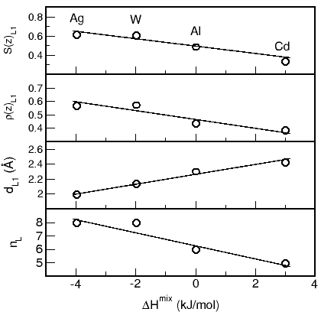
Figure 5: Atomic arrangements of liquid Al atoms at the substrate/liquid interface in the L–Al/S–M systems at 1000 K as a function of heat of mixing (∆H^{mix}). n_{L} is the number of ordered layers at the interface; ρ(z)_{L1} is the peak density of the first layer; S(z)_{L1} is the in–plane order parameter of the first layer; and d_{L1} is the spacing of the first layer from the substrate.

3.4 Temperature effect on pre–nucleation
We also performed ab initio MD simulations for liquid Al on the pinned Al–substrate at different temperatures. Analysis showed that there are notable changes of the number of ordered layers and the peak densities for the simulated system at different temperatures. The ordered layers become wider and the peak densities become lower for the corresponding layers of liquid Al on the substrate with increasing temperature [16].
4. Discussion
To get insight into the local chemistry for the interfacial atoms, we plotted the electron density distributions for L–Al/S–Ag and L–Al/S–Cd for comparison in Figure 6. The electron density between Ag and Al is higher that between Cd and Al suggesting stronger chemical interactions between Ag and Al than that between Cd and Al.
Bader charge model is very useful for analysing local chemical interactions [17]. Our analysis showed that there are moderate charge transfers from the liquid atoms to the substrate atoms being about 0.1e(electron)/atom from the liquid Al to solid Cd and 0.3e/atom from the liquid Al to solid Ag. These scale well with their electronegativity differences (1.61 for Al, 1.93 for Ag and 1.69 for Cd in Pauling scale). Our analysis also showed that the charge transfer occurs locally and mainly between the first layer in the liquid and the surface of the substrate. That is understandable since chemical bonding occurs mainly between an atom and its nearest neighbours [17, 18].

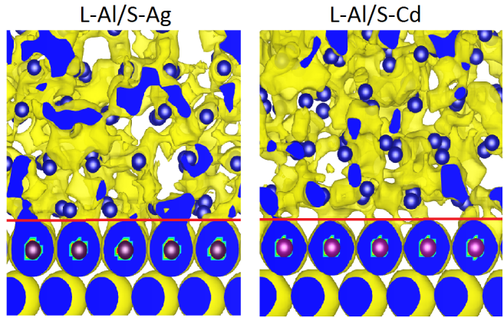
Figure 6: Contour plots of electron density for a snapshot of the L–Al/S–M (M= Ag, Cd) systems. Clearly, the electron density between the L–Al and S–Ag interface is higher than that between the L–Al and S–Cd interface.

The present parameter–free ab initio MD simulations for the potent systems have shown profound impacts of chemistry of the substrates on both layering and in–plane ordering of liquids. Though both Ag and Cd are s–d metals and have larger M–M bond–lengths than that of Al (Table 1), on affinitive substrates the liquid atoms have shorter M–Al spacing, more ordered layers and higher in–plane ordering. In other words, the liquid on the affinitive substrates exhibits more solid–like nature. Therefore, for potent affinitive substrates occurrence of heterogeneous nucleation requires lower driving forces. To the opposite, the larger M–Al spacing, less ordered layers and lower local ordering for liquid on repulsive substrates indicate that occurrence of heterogeneous nucleation requires large driving forces or larger undercooling. Considering the collective behaviour of grain refinement, nucleation on Al–affinitive substrates occurs more frequently under the same conditions.
Our ab initio MD simulations have also concluded that the effects of substrate chemistry are local, mainly on the liquid atoms nearest to the substrate. Such localised nature of substrate effect helps us to obtain insight into the adsorption of solute/impurity elements at the SuLI. The adsorbed layer at the interface is usually a mono–atomic layer, which is either a 2D solid solution (2DS) or of a 2D compound (2DC) on heterogeneous substrate. One good example is the formation of 2D TiAl₃ on TiB₂ substrate [19]. The observed interlayer spacing of 2D TiAl₃ is 2.5 Å, which is substantially smaller than the {0001}_{TiB2} spacing (3.2 Å).

5. Summary
Ab initio MD simulations were performed for liquid Al on substrates of different chemistry during the prenucleation processes. The simulations showed atomic layering and ordering phenomena for the liquid on the potent substrates. Moreover, the ab initio MD simulations also revealed the impacts of the substrate chemistry on the M–Al interface spacing, the layering and in–plane ordering of liquid metal. The substrate chemistry has the impacts mainly on the first layers. The obtained information is useful to have a better understanding about the role of the substrate [1,2,10,19]. Furthermore, the information helps experimentalists to realize the dream of controlling the solidification processes and further the microstructures in order to obtain metals and alloys of designed chemical and mechanical properties.

Acknowledgements
Financial support from EPSRC (UK) under grant number EP/N007638/1 is gratefully acknowledged.

References
1. K. F. Kelton and A. L. Greer, Nucleation in condensed Matter: Applications in materials and biology, Elsevier, Amsterdam, (2010).
2. Z. Fan, Metall. Mater. Transaction A, 2013, 44: 1409.
3. S. H. Oh et al., Science, 2005, 310: 661.
4. Y. Kauffmann et al., Acta Mater., 2011, 59: 4378.
5. A. Hashibon et al., Interface Science, 2001, 9: 175.
6. J. R. Morris, Phys. Rev. B, 2002, 66: 144104.
7. H. Men and Z. Fan, Comput. Mater. Sci., 2014, 85: 1.
8. H. Men and Z. Fan, IOP Conf. Series: Mater. Sci. Eng., 2011, 27: 012007.
9. H. Men and Z. Fan, Structural templating, in this Proceeding, 2017.
10. H. Men and Z. Fan, Heterogeneous nucleation, in this Proceeding, 2017.
11. A. Takeuchi et al., Mater. Transaction, 2005, 46: 2817.
12. W. B. Pearson, Handbook of lattice spacings and structures of metals and alloys, Pergamon Press (1967).
13. G. Kresse and J. Furthmüller, Phys. Rev. B, 1994, 49: 14251.
14. P.E. Blöchl, Phys. Rev. B, 1994, 50: 17953.
15. J. P. Perdew et al., Phys. Rev. Lett., 1996, 77: 3865.
16. C. M. Fang et al. unpublished results.
17. R. F. W. Bader, J. Phys. Chem., 1998, 102: 7314.
18. C. M. Fang et al, Phys. Chem. Chem. Phys., 2015, 17: 365.
19. Z. Fan et al, Acta Mter., 2015, 84: 292.

