Chromatic blur perception in the presence of luminance contrast

Ben J. Jennings* and Frederick A. A. Kingdom*

*McGill Vision Research
Department of Ophthalmology
Montreal General Hospital
McGill University, Montreal, Quebec, Canada

Hel-Or showed that blurring the chromatic but not the luminance layer of an image of a natural scene failed to elicit any impression of blur. Subsequent studies have suggested that this effect is due either to chromatic blur being masked by spatially contiguous luminance edges in the scene (Journal of Vision 13 (2013) 14), or to a relatively compressed transducer function for chromatic blur (Journal of Vision 15 (2015) 6). To test between the two explanations we conducted experiments using as stimuli both images of natural scenes as well as simple edges. First, we found that in color-and-luminance images of natural scenes more chromatic blur was needed to perceptually match a given level of blur in an isoluminant, i.e. colour-only scene. However, when the luminance layer in the scene was rotated relative to the chromatic layer, thus removing the colour-luminance edge correlations, the matched blur levels were near equal. Both results are consistent with Sharman et al.’s explanation. Second, when observers matched the blurs of luminance-only with isoluminant scenes, the matched blurs were equal, against Kingdom et al.’s prediction. Third, we measured the perceived blur in a square-wave as a function of (i) contrast (ii) number of luminance edges and (iii) the relative spatial phase between the colour and luminance edges. We found that the perceived chromatic blur was dependent on both relative phase and the number of luminance edges, or dependent on the luminance contrast if only a single edge is present. We conclude that this Hel-Or effect is largely due to masking of chromatic blur by spatially contiguous luminance edges.

Introduction
Blur can take many forms. For example the background scenes of photographs taken while tracking a moving object are blurred, and objects not located in the focussed plane are blurred. Blur can be a useful cue, for example with motion blur for determining relative velocity and with defocus blur for determining relative depth (Mather, 1997; Vishwanath & Blaser, 2010). On the other hand blur can make tasks such as reading and driving difficult.
The role of colour in blur perception has previously been investigated using isoluminant (colour-only) stimuli as well as stimuli containing both colour and luminance, as in studies that use images of natural scenes. With square-wave stimuli, blur detection thresholds are similar (~0.5’) for isoluminant reddish-greenish and luminance defined stimuli, but significantly elevated thresholds for isoluminant yellowish-bluish stimuli (~1.5’) (Wuerger, Owens, & Westland, 2001). It has additionally been shown that adaptation to blur caused changes to perceived blur in both luminance and chromatically defined stimuli (Webster, Mizokami, Svec, & Elliott, 2006).
The interest in using mixed colour-luminance images of natural scenes as stimuli for studying chromatic blur perception stems from a compelling demonstration devised by Hagit Hel-Or. Her demonstration was first published in Wandell (1995), and hence has previously been referred to as the “Wandell Effect”. Hel-Or showed that when the chromatic but not luminance layer in the scene was physically blurred, there was little impression of blur, yet when the blur was the other way round a strong impression of blur occurred. The effect is demonstrated in Fig. 1. The left most column of images are un-blurred, while columns 2 to 5 are blurred to an increasing degree. In row (d) only the chromatic layer is blurred, while in row (e) only the luminance layer is blurred. As the blur increases the images containing luminance blur appear increasingly blurred, while the images containing chromatic blur produce little impression of blur. For completeness row (a) shows the result of blurring both the chromatic and luminance layers, row (b) the result of blurring the luminance layer in isolation, and row (c) the result of blurring the chromatic layer in isolation (though due to the limits of photographic reproduction these images will unlikely be isoluminant).

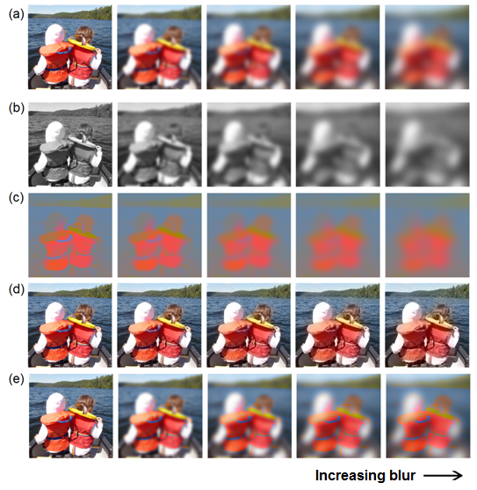
Fig. 1. An image subject to different blur manipulations (rows), with no blur (column 1) and increasing blur from column 2 to 5. Images in (a) are the original images containing both chromatic and luminance information; (b) luminance-only images; (c) isoluminant images; (d) chromatic-blur-only images; (e) luminance-blur-only images. Images in row (d) do not illicit an impression of a blurred scene.

Sharman et al. (2013) vs. Kingdom et al. (2015)
Two recent studies, based on psychophysical data, have offered different explanations for the effect in Fig. 1. Sharman, Mcgraw, & Peirce (2015) found that thresholds for detecting chromatic blur were higher in normal compared to isoluminant images of natural scenes. Conversely, luminance blur detection thresholds in the same scenes were largely independent of whether or not chromatic information was present. Two important controls were performed. First, to control for the fact that there is typically less chromatic than luminance contrast in natural scenes (Rivest & Cavanagh, 1996) Sharman et al. equated the two types of contrast. Second, to control for the possibility that there is more high frequency structure in the luminance compared to chromatic layer, they swapped the chromatic and luminance layers. Upon re-testing, both controls yielded the same pattern of results as in the initial experiments. Sharman et al. suggested that the sharp luminance edges in the image masked the blur in the spatially aligned chromatic edges, due to a process similar to that mediating the Boynton illusion (for an example see Stockman & Brainard, 2009), in which a yellow edge appears to spread into the space around an undulating black contour. Thus according to Sharman et al., reduced chromatic blur perception in natural scenes is caused by masking of chromatic blur by spatially contiguous luminance edges.
An alternative explanation for the effect was proposed by Kingdom, Bell, Haddad, & Bartsch (2015). Kingdom et al. measured perceived blur differences rather than blur detection thresholds. They employed fractal textures composed of two superimposed layers of densely packed, but not spatially correlated, Gabor patches. One layer’s Gabor patches were defined with luminance information and the other with color information (either red-green or blue-yellow), and each layer could be independently blurred. Using a modified version of paired-comparisons observers on each trial compared two textures that contained both chromatic and luminance blur differences. The blur differences were independently selected from a pre-defined set (for example if the two textures on a trial were A and B, A could have three times the chromatic blur and half the luminance blur of B). Observers were required to indicate on each trial the texture that appeared more blurred. Results showed that the luminance blur difference between the texture pairs strongly dominated the observers’ choices, as if the chromatic blur differences were perceptually reduced, or ‘compressed’. Kingdom et al. argued that because the chromatic and luminance layers were spatially uncorrelated it was unlikely that this was caused by masking from the luminance layer. Instead, they opined, it was intrinsic to the way that blur was represented in colour vision. Thus for Kingdom et al. reduced chromatic blur perception in natural scenes is caused by chromatic blur scale compression.

Two predictions
In the present study we aim to test between the two aforementioned explanations of the reduced chromatic blur effect, by testing specific predictions that arise from each of them. These are as follows.

Prediction 1: Following Sharman et al., if spatial contiguity between the luminance and chromatic edges in natural scenes underpins the reduced chromatic blur effect, spatially rotating the luminance and chromatic layers away from each other, and hence rendering them non-spatially aligned, should substantially reduce the effect.

Prediction 2: Following Kingdom et al., if the perceptual scale for chromatic blur in natural scenes is relatively compressed, then a given level of blur in a colour-only image will be matched by less blur in a luminance-only image.

We first test these two predictions using as stimuli images of natural scenes, and then, based on our findings, conduct further experiments using simple edge-based stimuli.

General Methods

Observers
Five observers participated in the experiments. Two were non-naive (one of which was author BJ); the other three were naive as to the purpose of the experiments. All observers (except KL) were experienced psychophysical subjects, had 6/6 visual acuity and tested normal on the Ishihara colour deficiency test (24 plates edition). All experiments were approved by the McGill University Ethics committee and were conducted in accordance with the Declaration of Helsinki (version 6).

Equipment
All visual stimuli were generated using a Dell Precision T1650 PC and the ViSaGe stimulus generator (CRS, UK), using custom software developed in-house in C. The stimuli were displayed on a Sony Trinitron Multiscan G500 CRT Monitor. A ColorCAL colorimeter and spectroCAL spectroradiometer (CRS, UK) were employed to respectively colour calibrate and linearise the visual display. The display was driven with a resolution of 1280 x 960 pixels (pixel size was 0.027 cm) and an 80 Hz refresh rate. In order to ensure a stable luminance output the display was powered with maximum R, G and B outputs for at least 20 minutes prior to testing. During the data collection observers sat in a dark room with a viewing distance was 70 cm and submitted their responses via a keypad.
The CIE 1931 xyY chromaticity coordinates of the phosphors were; Red xyY: (0.64, 0.35, 16.0), green xyY: (0.29, 0.61, 68.1) and Blue xyY: (0.15, 0.07, 7.75), where Y is given in Candelas per meter squared.

Colour space
The DKL color space (Derrington, Krauskoph, & Lennie, 1984) was employed to define the chromatic and luminance properties of the stimuli in experiments 3 and 4. Based on the activations of the L (long-wavelength-sensitive), M (medium-wavelength-sensitive), and S (short-wavelength-sensitive) cones, the two chromatic and one luminance axis of the DKL space are defined by combinations of cone activations. The chromatic axes are L−M and S–(L+M), which correspond to color directions red-cyan and violet-lime, with chromatic contrast given by the length of the vector along the axis. The achromatic luminance axis is defined as L+M and corresponds to the black-white (achromatic) direction. Points in the DKL space were selected by means of a 3x3 conversion matrix derived by multiplication of the spectral power distributions of the display’s red, green and blue phosphors, as recorded with a SpectroCAL (CRS, UK), and the human L-, M- and S- cone fundamentals (Stockman, Sharpe, & Fach, 1999; Stockman & Sharpe, 2000).

Isoluminance
In the experiments employing simple edge stimuli (3, 4 and 5) isoluminance was determined separately for each observer, as there are individual differences in the luminosity efficiency function. To this end we used heterochromatic flicker photometry. Observers adjusted an amount of added luminance contrast to the L-M or S stimuli until the perception of flicker was either reduced to its minimum or entirely nulled. Each observer made ten adjustments that were averaged. The resulting mean luminance contrasts were added to the stimuli to achieve isoluminance, they were typically and additional ~0.02 luminance contrast in the red-green direction and approximately zero in the yellow-blue direction.

Blur
In all experiments blur was applied by convolving the stimulus with a Gaussian filter (G), as defined by Eq. 1.

$${{G\left(x,y\right)= e}^{-(\frac{x^{2}+ y^{2}}{σ^{2}})}}/{{2πσ}^{2}} Eq.1$$

The filter was defined in 2-dimensions (coordinates: x and y) and implemented as a circular symmetric convolution matrix; the blur level was controlled by varying the standard deviation of the Gaussian envelope (σ).

General experimental design and data analysis
All experiments employed a similar 2IFC (two-interval-forced-choice) paradigm to establish the point of subjective equality (PSE) in perceived blur between pairs of stimuli. In each experiment one interval was presented at a fixed blur level - the ‘test’ - while the blur level in the other interval – the ‘match’ - was varied from trial to trial. The task was always to report the stimulus with the greater perceived blur. The set of match blur levels was pre-determined from pilot experiments and presented according to the method of constant stimuli. Data were fitted with a sigmoidal Logistic function (Eq. 2):

$$f\left(I\right)= \frac{1}{1+ e^{-β\left(I-I_{0}\right)}} Eq.2$$

Where, I₀ represents the blur at the midpoint of the sigmoid and β the steepness of the curve. The curves vary in the range 0 ≤ f(I) ≤ 1 (limited by the 1 in the numerator) allowing for a particular match intensity to be judged always below ($f\left(I\right)=$0) or always above ($f\left(I\right)=$1) the test blur. From these fitted functions the match blur (I) at which the observer was equally likely to report the test as being higher of lower in blur was estimated using the psychometric function fitting tools in the Palamedes toolbox (Prins & Kingdom, 2009; and see Kingdom & Prins, 2016), running under MatLab (Mathworks, Ltd).

Experiment 1: Testing Prediction 1
This experiment determined whether spatial contiguity between the luminance and chromatic layers in images of natural scenes was necessary for the reduced chromatic blur effect, as predicted by Sharman et al. (2013). Three conditions were tested. In each condition one trial interval consisted of an isoluminant scene with a fixed blur level (σ=6 pixels). PSEs were estimated from comparisons of these isoluminant scenes to (i) another isoluminant scene, (ii) scenes containing an unaltered luminance layer and a blurred isoluminant layer, termed the correlated luminance-plus-color condition, and (iii) scenes containing a luminance layer that had been rotated ±90° (either direction occurring with a probability of 0.5) coupled with a blurred colour layer rotated 90° in the opposite direction, termed the uncorrelated luminance-plus-color condition. Example stimuli with high and low chromatic blur levels are depicted in Fig. 2a-f. In all conditions the test is the isoluminant scene, while the match is one of the three aforementioned conditions.
The prediction based on Sharman et al. (2013) for the isoluminant vs. isoluminant scene condition is that observers will match similar blur levels. For the isoluminant vs. correlated luminance-plus-color condition, the prediction is that more blur will be needed in the latter to match the isoluminant stimulus. Why? Because the effect of the correlated luminance edges in the scene is predicted to reduce the scene’s perceived chromatic blur, requiring more chromatic blur to match the fixed blur level in the isoluminant comparison. For our new third condition - isoluminant vs. uncorrelated color-plus-luminance - the prediction is that observers will match similar blur levels.

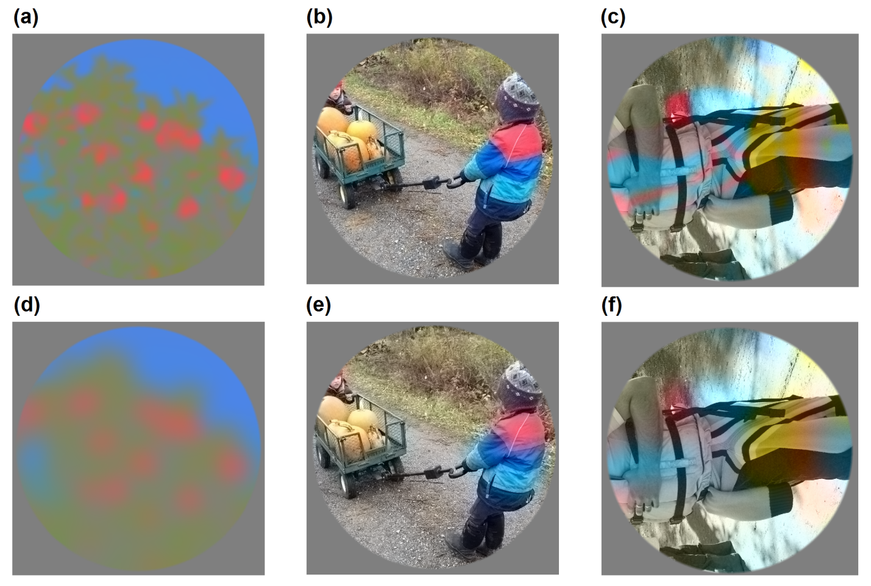
Fig 2. Example stimuli in Experiment 1. Left: Isoluminant condition with low (a) and high (d) chromatic blur levels. Middle: correlated colour-plus-luminance condition, a scene with low (b) and high (e) chromatic blur levels. Right: uncorrelated colour-plus-luminance condition, a scene in which the colour and luminance layers have been rotated through ±90° relative to each other, at low (c) and high (f) levels of chromatic blur.

The raw RGB images of natural scenes were taken from the McGill Colour Calibrated Image Database (Olmos & Kingdom, 2004). They were first gamma corrected, then transformed into the Y’UV colour space via a 3x3 transformation matrix. This allowed the independent manipulation (i.e., blurring, deletion or rotation) of the colour and luminance layers, before the inverse matrix (Y’UV to RGB) was applied, restoring the image to a displayable RGB image.
Due to the large numbers of colours (both hues and saturations) present in images of natural scenes a ‘perfect’ isoluminant correction is not possible, since a luminance correction would be required for each colour present in the image. As a result the ostensibly isoluminant images might contain luminance artifacts such as shadows (as noted in Jennings, Wang, Menzies, & Kingdom (2015), though these will be rare and will tend to be very low in contrast.

Fig. 3 shows data for the three conditions (columns are means ±2SE, n=4). The physical blur level employed for all conditions in the isoluminant interval was $σ$=6 pixels as indicated by the dashed horizontal line. As expected, PSEs for the isoluminant vs. isoluminant condition were veridical (green column). For the correlated luminance-plus-color vs. isoluminant matches PSEs were highly elevated (light blue column). Finally, for the uncorrelated color-plus-luminance vs. isoluminant conditions PSEs were veridical, albeit noisier (red column). These results are consistent with Sharman et al.’s explanation of the reduced chromatic blur effect based on their threshold data, namely that it is the spatial contiguity between the luminance and chromatic edges in the images of natural scenes that is responsible for the reduced chromatic blur effect.

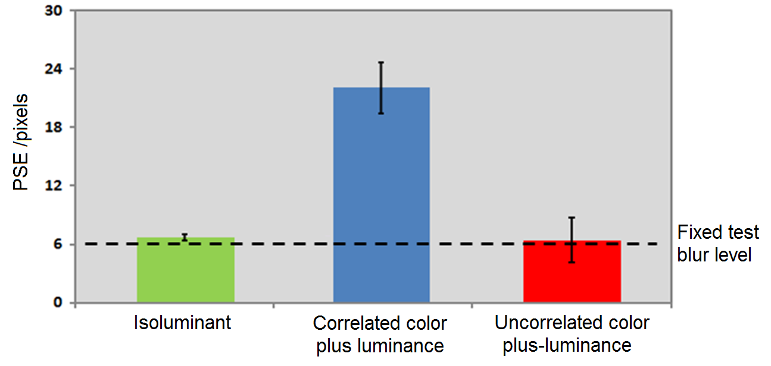
Fig 3. Results of Experiment 1. Mean measured PSEs for the three conditions of experiment 1, with each PSE estimated from the blur matches relative to an isoluminant scene. Error bars are ±2* bootstrapped SEs.

Experiment 2: Testing prediction 2
Kingdom et al.’s suggestion that the reduced chromatic blur effect is a result of an inherently compressed perceptual scale for chromatic blur leads to the prediction that less chromatic blur will be needed to match a given level of luminance blur in colour-only (isoluminant) versus luminance-only images of natural scenes.
To test this prediction isoluminant and luminance-only natural-scene stimuli were created using the methods described in Experiment 1. Fig 3a-f illustrates example stimuli with no, low and high blur levels (from left to right). Again, a 2AFC method was employed to measure chromatic blur PSEs for six levels of physical luminance blur.

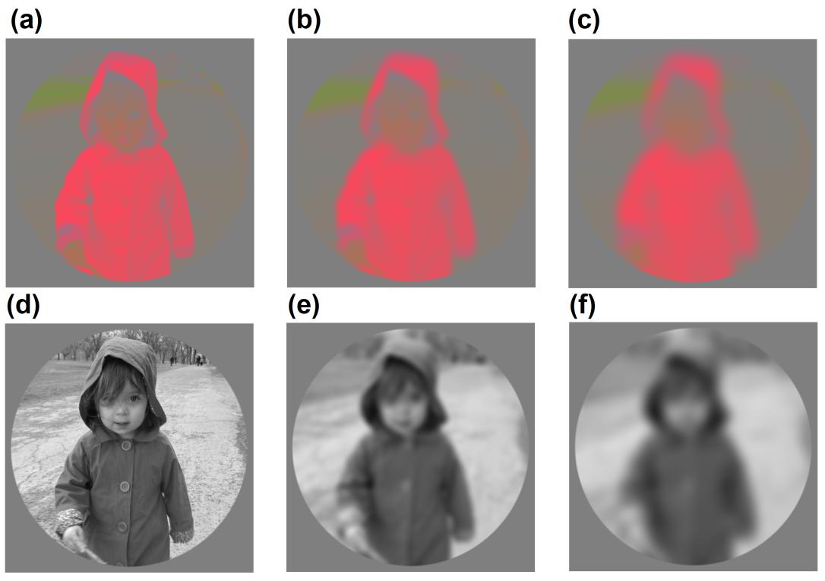
Fig 4a-f. Example stimuli in Experiment 2. Top row shows examples an isoluminant with no blur (a), low blur (b) and high blur (c). The bottom row illustrates corresponding examples of luminance-only images.

Fig. 5 plots the measured PSEs (data points are means±2SE, n=4). Results show that physical luminance blur is directly proportional (r=.97, p<.001) to matched chromatic blur, with a gradient close to 1 (0.903). These data are not consistent with the prediction from Kingdom et al.
Given that the results of the above two experiments favour Sharman et al.’s explanation of the reduced chromatic blur effect in terms of chromatic blur masking from spatially contiguous luminance edges, we wanted to explore in more detail the spatial properties of this masking effect. To this end we now switch from images of natural scenes as stimuli to simple edges.

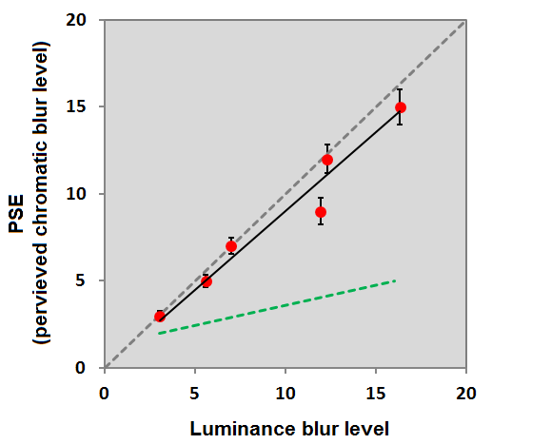
Fig. 5. Results of Experiment 2. PSEs (perceived chromatic blur) plotted as a function of physical luminance blur levels. The dashed green curve is the expected result based on a compressed chromatic blur transducer function. Error bars are ±2* bootstrapped SEs.

Experiment 3: effect of a luminance step-edge on a single chromatic edge
The stimuli for this experiment are illustrated in Fig. 6, and comprise a single circular edge enclosed within a larger circle set against a mid-grey background. The size of the inner and outer circles was jittered between trials, as was also the global position of the stimulus on the display device, in order to minimise the build up of afterimages. The size of the inner and outer circles (±jitter) was 75±5 and 135±15 pixels, respectively. Stimulus contrast was defined as the difference along the DKL axis between the outer and inner circles. The edge bounding the inner and outer circles was the edge of interest and was subjected to different amounts of blurring.
One interval in the 2IFC task contained the test, which was a blurred chromatic edge together with a sharp luminance-defined step-edge in the same position (see Figs. 6b and d). The other interval contained the matching stimulus, an isoluminant version of the stimulus, i.e., with no luminance edge (see Fig. 6a and c). Two chromatic conditions were tested, L-M and S-(L+M), and there were three test blur levels per condition: 𝜎=3, 5 and 8 pixels. The polarity of the luminance edge was randomly assigned between trials, such that on half the trials there was a luminance increment over the central circle (for example Fig. 6b), while for the other half of the trials there was a luminance decrement over the central circle (for example Fig. 6d). The stimulus was ramped on and off according to a positive sine, with a presentation time of 500 ms. Before testing the stimuli were equated for visibility by means of a contrast (via a 2IFC task) matching experiment (via a 2IFC task). An additional control condition measured perceived blur as a function of contrast using a similar method as above, i.e., PSEs were obtained using a 2IFC method. Over the contrast range tested (0.05 - 0.8) the data revealed that perceived blur did not vary significantly as a function of contrast over the range for either the L+M, L-M or S-(L+M) isolating conditions.

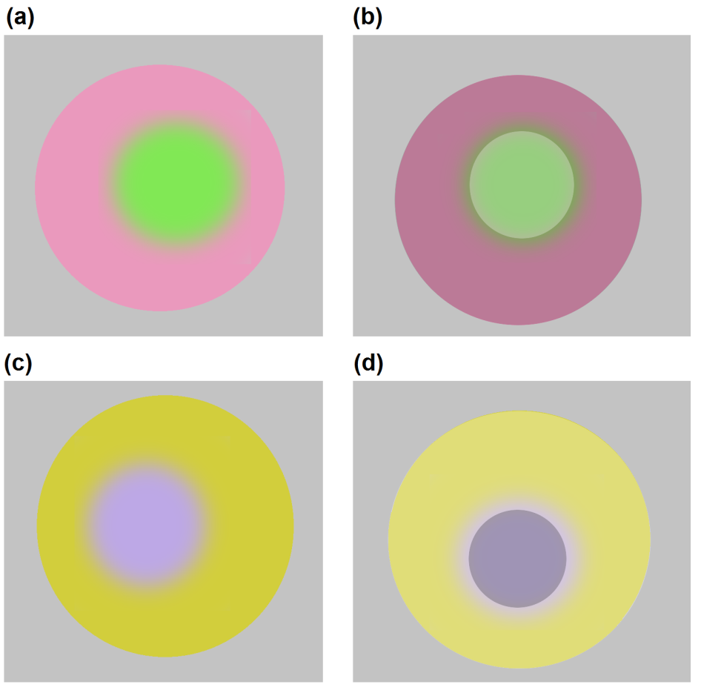
Fig. 6. Example stimuli used in Experiment 3. Isoluminant L-M and S-(L+M) stimuli with a blurred edge are illustrated in (a) and (c); (b) and (d) show examples with the added luminance step-edge.

Fig. 7 plots the mean results for three observers (BJ, KL and YJK), with the left and right hand panels showing the L-M and S-(L+M) isolating conditions, respectively. The data are plotted as a function of the contrast of the luminance step-edge. The three blur levels are 3 (blue curve), 5 (lilac curve) and 8 (black curve) pixels. It can be seen when the contrast of the luminance step-edge is zero, i.e., the stimuli is isoluminant, as expected a veridical match is made, that is, PSEs match the physical test blur levels. It is also clear from Fig. 7, that the contrast of the luminance step-edge has no effect on PSEs until a relatively high luminance contrast is present, at which point a reduction in the perceived chromatic blur is observed, consistent with experiment 1 in the current study and Sharman et al. (2015).

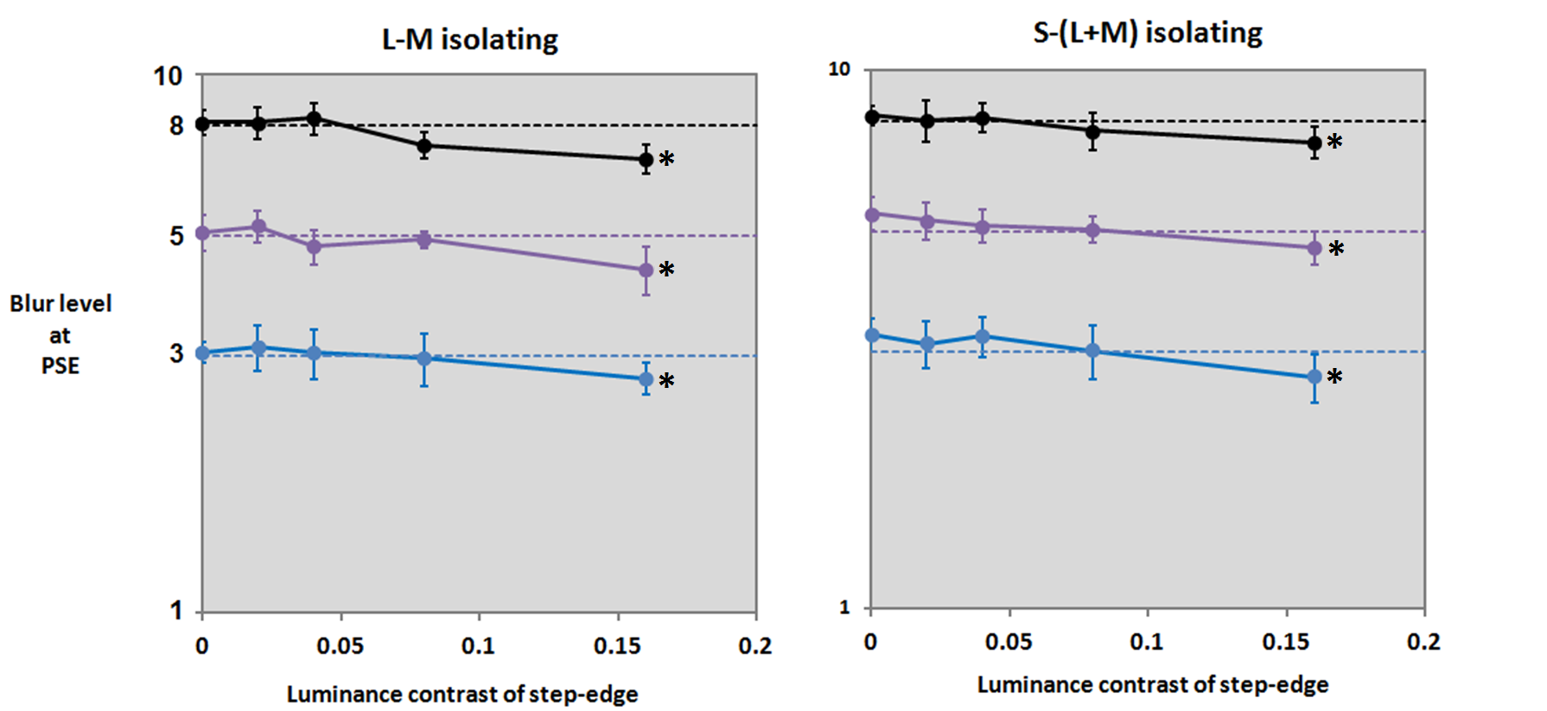
Fig. 7. Results of Experiment 3. Mean PSEs (n=3) are plotted for the L-M (left panel) and S-(L+M)(right panel) isolating conditions, for the three blur levels tested; blur level 3 (blue curve), blur level 5 (lilac curve) and blur level 8 (black curve). At the highest luminance contrast level tested all PSEs are reduced (all ps<.021) denoted by *. Error bars are ±2* bootstrapped SEs.

Experiment 4: Multiple luminance edges and phase alignment
At first sight the results from the previous experiment obtained at low luminance contrasts are not consistent with Sharman et al.’s explanation of the reduced chromatic blur effect. However, it is possible that the lack of an effect of the luminance step-edge on perceived chromatic blur is because only one luminance edge is present: in the natural scene stimuli used in the first set of experiments luminance edges abound. We tested this possibility by adding more luminance edges to our simple chromatic edge stimuli. We also manipulated the relative phase of the chromatic and luminance edges, i.e., the amount the chromatic blur was spatially aligned with a luminance step-edge, due to changes in the size of the chromatic stimuli. Five relative phases were tested: 0, 45, 90, 135 and 180°. Fig. 9a-e shows examples of the multiple luminance-edged stimuli for each of the tested phases. We also measured the PSE for a single in-phase luminance edge for comparison. All PSEs were measured according to the same 2IFC test procedure as in the previous experiment. The test blur level was fixed at 15 pixels which allowed the chromatic blur to spread across more than one luminance step-edge.

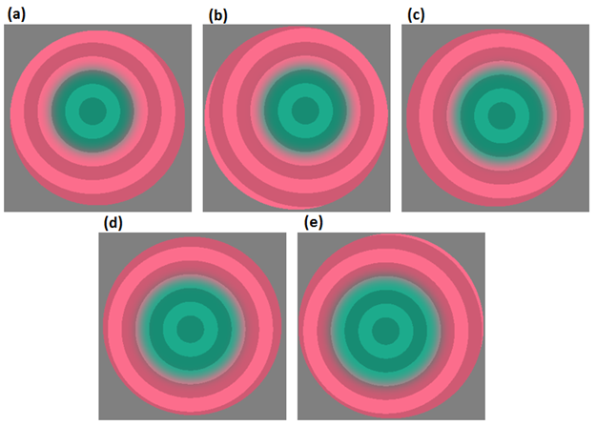
Fig. 8. Example stimuli used in Experiment 4. The five tested phases are; 0° (a), 45° (b), 90° (c), 135° (d) and 180° (e). All stimuli have the same amount of chromatic blur. The reader might have the impression of more chromatic blur in (c) than in either (a) or (e).

PSEs are plotted as a function of phase alignment in Fig. 9 (mean of n=4). The mean value for the single edge is plotted as the red horizontal dashed line (the reddish shaded area represents ±2SE of these measurements): a single edge appears to have no effect – the measured PSE equals the physical chromatic blur level (the physical blur was 15 pixels, while the PSE was 15.18°±0.53°). We hypothesise however that a higher luminance contrast would reduce the perceived blur, consistent with experiment 3. Fig. 9 shows however that with multiple edges, when the chromatic and luminance edges are in phase (at 0 and 180°) PSEs are lower, i.e., the perceived chromatic blur is significantly reduced (comparing the single to multiple edges at 0 and 180°, both ps<.001). As the chromatic and luminance edges are shifted out of phase (at 90°) the effect of multiple luminance edges becomes weaker with the result that PSEs are approximately equal to the single luminance (in-phase) condition (p=.44, 2-tailed). This experiment shows that multiple luminance edges together with chromatic-luminance phase alignment is critical for the reduction in perceived chromatic blur.

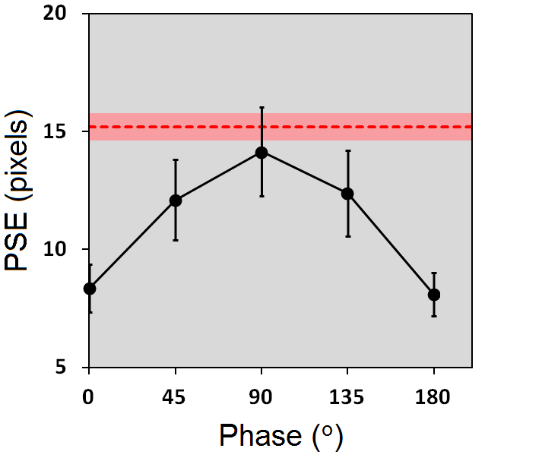
Fig. 9. Results of Experiment 4. PSEs plotted as a function of chromatic and luminance edge phase alignment. The horizontal dashed red line is the PSE measured with a single luminance in-phase step-edge. All error bars are ±2SE.

2.4 Discussion

The following summarises the findings of this study:

Experiment 1: Rotating the luminance layer of an image of a natural scene eliminates the reduced chromatic blur effect: perceived chromatic blur in the luminance-rotated image is the same as when the luminance layer is absent.

Experiment 2: Perceived blur in luminance-only and chromatic-only images of natural scenes is equal.

Experiment 3: A single luminance step-edge added to a chromatic blurred edge has no effect on perceived chromatic blur for low luminance contrast levels, but did reduce perceived chromatic blur for the highest level tested.

Experiment 4: The presence of multiple luminance step-edges with one of them in-phase with a blurred chromatic edge reduces perceived chromatic blur.

The current study provides evidence in support of Sharman et al. (2013), who concluded that the reduced chromatic blur effect in images of natural scenes was due to masking of chromatic blur by sharp, spatially contiguous luminance edges. Overall, none of the results in the present study support the conclusion of Kingdom et al. (2015), namely that the reduced chromatic blur effect was caused by chromatic blur scale compression, not luminance masking.
Why does the luminance masking effect only manifest itself with multiple edges? As we noted in the Introduction, Sharman et al. suggested that the sharp luminance boundaries in the image masked chromatic blur by a process similar to that mediating the Boynton illusion (Boynton, 1978), in which a yellow edge appears to spread into the space around an undulating black contour. With a blurred chromatic edge, the effect of the spreading will be to reduce the chromatic gradient that signals blur. It seems reasonable to argue that the gradient reduction is most marked when there are neighbouring luminance edges that act to contain the spread, causing the chromatic signal to perceptually ‘flatten’ between the edges.

Reconciling Kingdom et al.’s (2015) data with the current study
Kingdom et al.’s stimuli were fractal textures containing uncorrelated chromatic and luminance layers. Their finding that luminance blur differences between pairs of such textures were far more salient than chromatic blur differences was consistent with Sharman et al., but was rejected on the grounds that the two texture layers were spatially uncorrelated and contained no sharp luminance edges. In the light of the present results, we suggest that the luminance layers in Kingdom et al.’s textures did indeed reduce the perceived chromatic blur differences, presumably by reducing the perceptual chromatic gradients that signalled blur.

Theoretical implications
The way that chromatic and luminance information combines in natural viewing continues to engage the research community (see reviews by Kingdom, 2016; Shevell & Kingdom, 2008). The present study reinforces the conclusions reached by Sharman et al. (2015) that there is a powerful interaction between colour and luminance in the encoding of natural image blur: luminance edges inhibit the perception of chromatic blur. Therefore, in spite of our ability to detect and discriminate chromatic blur when color is presented on its own (e.g. Wuerger et al., 2001, plus here), when combined with sharp luminance edges, as in natural viewing, color information would appear to provide little information about blur. This leaves luminance with the sole responsibility for signaling blur under natural viewing conditions for depth perception, accommodation etc. As yet however we do not know the exact mechanism by which this inhibition occurs, for example whether it is a simple masking effect, or whether, as suggested by Sharman et al. 2015 and by the results of our multi-edge experiment, it is the constraining of the spread of chromatic information. Hopefully the present study will serve to encourage further research into the nature of the underlying mechanism.

Acknowledgements
We thank Katrina Li (Department of Anatomy and Cell Biology, McGill University) for help with data collection.
This work was funded by the Canadian Institute of Health Research grant #MOP 123349 awarded to F.K.

References
Derrington, A. M., Krauskoph, J., & Lennie, P. (1984). Chromatic mechanisms in lateral geniculate nucleus. Physiol, J, 241–265.
Jennings, B. J., Wang, K., Menzies, S., & Kingdom, F. A. A. (2015). Detection of chromatic and luminance distortions in natural scenes. JOSA. 32(9), 1613–1622. doi:10.1364/JOSAA.32.001613
Kingdom, F. A. A. (2016). Interactions of color vision with other visual modaliities. In Human Color Vision, by R. Baras, J. Marshall & J. Kremers (Eds.), Springer.
Kingdom, F. A. A., Bell, J., Haddad, C., & Bartsch, A. (2015). Perceptual scales for chromatic and luminance blur in noise textures, 15, 1–10. doi:10.1167/15.9.6.doi
Kingdom, F. A. A., & Prins, N. (2016). Psychophysics: A Practical Introductio, 2nd edition. Elsevier Academic Press.
Mather, G. (1997). The use of image blur as a depth cue. Perception. 26(9):1147–1158.
Olmos, A., & Kingdom, F. A. A. (2004). A biologically inspired algorithm for the recovery of shading and reflectance images, 33. doi:10.1068/p5321
Prins, N & Kingdom, F. A. A. (2009) Palamedes: Matlab routines for analyzing psychophysical data. http://www.palamedestoolbox.org.
Rivest, J., & Cavanagh, P. (1996). Localizing Contours Defined by More Than One Attribute, 36(1), 53–66.
Sharman, R. J., Mcgraw, P. V, & Peirce, J. W. (2015). Luminance cues constrain chromatic blur discrimination in natural scene stimuli, 13(2013), 1–10. doi:10.1167/13.4.14.doi
Shevell, S. K. & Kingdom, F. A. A. (2008). Color in complex scenes. Annual Review of Psychology, 59, 143-166.
Stockman, A., & Brainard, D. H. (2009). Color vision mechanisms. In M. Bass, C. DeCusatis, J. Enoch, V. Lakshminarayanan, G. Li, C. Macdonald, V. Mahajan & E. van Stryland (Eds.), The Optical Society of America Handbook of Optics, 3rd edition, Volume III: Vision and Vision Optics. New York: McGraw Hill.
Stockman, A., & Sharpe, L. T. (2000). The spectral sensitivities of the middle- and long-wavelength-sensitive cones derived from measurements in observers of known genotype. Vision Research, 40(13), 1711–1737. doi:10.1016/S0042-6989(00)00021-3
Stockman, A., Sharpe, L. T., & Fach, C. (1999). The spectral sensitivity of the human short-wavelength sensitive cones derived from thresholds and color matches. Vision Research, 39(17), 2901–2927. doi:10.1016/S0042-6989(98)00225-9
Wandell, B. (1995). Foundations of Vision. Sinauer Associates, Inc. Sunderland, Massachusetts.
Vishwanath, D., & Blaser, E. (2010). Retinal blur and the perception of egocentric distance. Journal of Vision, 10(10), 26. doi:10.1167/10.10.26
Webster, M. A., Mizokami, Y., Svec, L. A., & Elliott, S. L. (2006). Neural adjustments to chromatic blur, 19(2), 111–132.
Wuerger, S. M., Owens, H., & Westland, S. (2001). Blur tolerance for luminance and chromatic stimuli. Journal of the Optical Society of America. A, Optics, Image Science, and Vision, 18(6), 1231–9. doi:10.1364/JOSAA.18.001231

