Electrocatalytic Oxidation of Orange 122 in Wastewater by Using Three-Phase Three-Dimensional (3D) Electrode Reactor
MEHMET UĞURLU, ALİ İMRAN VAİZOĞULLAR, MÜSLİH GÜNBELDEK, İLTERİŞ YILMAZ ABDUL J. CHAUDHARY3
1Department of Chemistry, Faculty of Science, Mugla Sıtkı Koçman University, 48000 Muğla/Turkey
2Vocational School of Healthcare, Med Lab Program, Mugla Sıtkı Koçman University 48000 Muğla/Turkey
3Institute of Environment, Health and Societies, Brunel University London, UB8 3PH, UK
* Corresponding author (aliimran@mu.edu.tr)

Abstract
The effect of different catalysts on the oxidation of Orange 122 in wastewater is investigated by using an electrocatalytic system. For this study, TiO₂/AC, V₂O₅/TiO₂/AC and WO₃/TiO₂/AC (over activated carbon) catalysts were prepared by a sol–gel method in aqueous solution. The oxidation process was optimised by investigating the effects of differemnt paperemeter, for example, time, voltage, suspension’s pH, dye concentration, the amount of supporting electrolyte (NaCl) and the type of catalysts used. Optimum values for these parameters were found as 120 min., 15 volt, 6.5, 250 mgL⁻¹ and 800 mgL⁻¹ respectively. All experiments were carried out at room temperature and in the stability of constatant. During the experiment, samples were taken prediocally and the residual dye concentration present in aqueous wastewater samples was analysed to evaluate the efficiency of different catslysts. The results obtained show that after 30 minutes only 30% colour was removed in the absence of activated carbon and this value increased to 60% in the presence of activated carbon. However, the percentage removal increased to 98% in the presence of cataysts TiO₂/AC, V₂O₅/TiO₂/AC and WO₃/TiO₂/AC under the same experimental conditions. In addition, when used as the working electrode in a three-dimensional photoelectrochemical reactor, for all catalyst reacting, the pseudo-first-order rate constants were obtained amoung 1,12 ×10⁻² min⁻¹ and 3,97 ×10⁻² min⁻¹ with the individual use of the composite in electrocatalysis. .The high degradation efficiency of this system is attributed to the synergistic combination of different chemical processess ocurring simultaneously, for example, adsoption, electrocatalytic and electrochemical oxidations.

Keywords: Actived Carbon, TiO₂, Wastewater, TiO₂, V₂O₅, WO₃, Electrocatalytic

Introduction
Currently, there are many industries, for example, food, textile, paper and cellulose, chemical, oil, coal mines, metal finishing, and synthetic rubber/plastic which produce waswater containing different types of both inorganic and organic pollutants. Textile industry has served as a source of income for many developed and developing countries. The amount of money made in the textile industry runs into billions of US dollars due to the high demand by growing consumers in the clothing market. Major textile producers such as China, US, EU, India, Pakistan, Bangladesh and Turkey have increased production over the past many years. However, the discharge of synthetic textile dyes from textile industries into the aquatic ecosystem poses a threat to its habitants and human health [1]. The presence of dyes in the effluent at a very low concentration can be highly visible and undesirable in the wastes [2,3]. The coloured wastewater damages the aesthetic nature of water and reduces the light penetration through the water's surface [4]. Textile dyes are relatively resistant to microbial degradation due to their complicated structures [5]. Consequently, the removal of dyes from effluent is required, usually through physiochemical means [6]. Some treatment methods include oxidation using Fenton's reagent [7], ozone [8], and adsorption which using synthetic or natural adsorbents [9,10]. Many dyes used in industry are stable to light and oxidation [11], resistant to aerobic digestion and may be non-oxidisable due to their complex structure and large molecular size [12].
Electrochemistry opens new horizons for the elimination of pollution problems in industrial processes. Reduction or removal of the pollutant-forming components is possible by directly or indirectly performing the electrochemical reduction and oxidation of the material in the electrochemical cell [13]. These processes also have the advantage of requiring lower temperatures than necessary in other treatment processes, reducing voltage drop in side-reactions in electrodes and cells, or minimizing power losses in the event of non-uniform distribution of current. In summary, it is suggested that electrochemical processes designed to remove pollution and clean up wastewater are promising, and that there will be no problem in integrating the environment with proper control of time, energy and other parameters [14,15]
Apart from the use of activated carbon as an adsorbent, in recent years catalytic removal studies have been found by bonding the semiconductors (TiO₂) with various adsorbent materials. In these studies, it is reported that active carbon adsorbs organic or inorganic substances in aqueous media, and organic substances can be removed from the media by using substances such as TiO₂ present on the surface [16]. In the literature, studies on the use of active carbon as a catalyst carrier are limited and usually consist of laboratory-scale studies. In addition, there are no studies on the treatment of wastewaters originating from paper and textile manfactruring industries. In the present study, the catalytic active TiO₂/AC material as an upper product was first loaded with TiO₂ under optimum conditions of commercial activated carbon (AC), and V₂O₅/ TiO₂/AC and W₂O₅/TiO₂ with high photocatalytic activity by loading this material (TiO₂/AC), V₂O₅ and W₂O₅/AC catalysts. Finally, these catalytic materials were used to investigate the decolourization of textile wastewater by using electrocatalytic oxidation process.
Materials and Methods
In this study, TiO₂/AC, V₂O₅/TiO₂/AC and W₂O₅/TiO₂/AC catalysts were obtained by loading V₂O₅ and W₂O₅, separately and together by using TiO₂ as semi-conductor material on the surface of activated carbon (AC) materials.

Synthesis of TiO₂/AC particles
Initially, 500 ml of a solution containing 30% isopropyl alcohol and 100 ml of titanium isopropoxide was prepared. Then, 50 ml from this solution were added over 30 g of AC sample and mixed at constant temperature (25ºC). This mixture was first dried in a vacuum oven at 100 ºC for 2 hours and then left at room temperature. The impregnation process using a 50ml of solution was repeated 4 times under the same conditions and calcined for one hour at each temperature of 300 °C, 400 °C and 500 °C gradually. After this process, the sample was cooled in a desiccator and kept in dark.

Synthesis of V₂O₅/TiO₂/AC and W₂O₅/TiO₂/AC Particles
In this study, 120 ml ethanol and 20 ml tetra-n-butyl titanate were mixed and then 10 ml acetic acid, 2 ml distilled water and a few drops of acetone were added and stirred for 3 hours (solution A). After that, 8-20 mesh AC was activated with nitric acid, washed with distilled water and left for drying. Acid activated carbon was then stirred for three hours with the previously prepared solution A. After completion of the reaction, (NH₄)₁₀H₂ (W₃O₇)₆ solution was added drop-wise and kept under constant temperature to get TiO₂/W₂O₅/AC particles. Prepared particles were filtered and dried at 100°C for 3 hours. Dried samples were thermally activated at 300, 400 and 500°C each for one hour. Same procedure was repeated to prepare TiO₂/V₂O₅/AC particles but NH₄VO₃ solution was used instead of (NH4)₁₀H₂(W₃O₇)₆. After these processes, the samples were cooled in a desiccator and kept in a light-free condition.

Electrocatalytic Experiments
In experimental process, TiO₂/AC, V₂O₅/TiO₂/AC and W₂O₅/TiO₂/AC materials were used as a catalytic agent. Reactive Orange 122 (RO122) dye was used as a source of chemical contaminant and its chemical structure is shown in Fig 1. The electrolytic system consists of a perspex rectangular box of 500 ml capacity containimng three dimensional graphite electrodes as shown in Figu 2. The anode and cathode (feeder electrodes) were situated 5.0 cm apart from each other. Stirring was done by using a magnetic stirrer (50 rpm). Compressed air was spared into the bed electrodes from the bottom of the reactor.
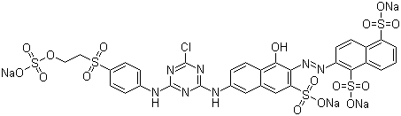
Fig. 1: Chemical structure of textile dye RO 122, λ_{max}: 488nm; solubility in water: 75gdm⁻³; degree of purity: 80-85 %.
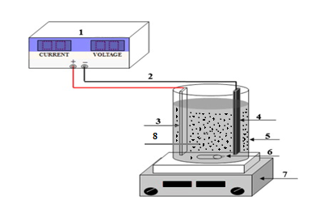
Fig.2: Experimental 3D system for the electrocatalytic treatment of real printing wastewater (1.DC power supply, 2.copper wire, 3.anode, 4. cathode, 5. electrolysis reactor, 6. magnetic bar, 7. electromagnetic stirrer and 8. Catalysts (working electrode)

For process optimisation, the effect of parameters such as; initial pH, type of catalysts, voltage, wastewater concentration, and the amount of table salt as supporting electrolyte were investigated. Cell voltage was measured digitally by using Topward Dual-Tracking DC6303D, Keithley 2010 power supply. At the end of experiments, the treated solution was filtered and then color changes were measured before and after electrolysis by using a spectrophotometer. In addition, JEOL brand JSM-7600F model for SEM analysis and, JEOL brand JEM 2100F HRTEM model for TEM analysis were used.

Determination of Color Change
To deteremine the λ_{max} of RO122, the aqueous solution containing a know concentration of dye was analysed using a UV spectrophotometer. The λ_{max} of RO122 was found to be at 488 nm. All wastewater samples were analaysed at this λ_{max} value to determine the residual concentration of syes remaining in aqueous solutions. The percentage removal of RO122 was calculated by using the following formula.
% colour removal x 100
A⁰_{λ}: Initial absorbance
A_{λ}: Final absorbance.

Results and Discussion
SEM analyses
The surface morphologh of the calaysts prepared as part of this project was investigated using a scanning electron microscopy (SEM) and the SEM images are given in Fig. 3(a, b, c and d). The SEM micrograph of AC at the lower magnification (Fig.3a) clearly show that the, AC structure has porous morphology. Fig b shows the AC structure at the higher magnification. The SEM images of TiO₂/V₂O₅ and TiO₂/W₂O₅ doped AC samples are given in Fig.3c and 3d. As seen from these figures, TiO₂/V₂O₅ and TiO₂/W₂O₅ were attached to the AC surface. The proof of this adhesion was demonstrated by Energy Dispersive X-ray Spectroscopy (EDS) and compositional element rates obtained by EDS (Table 1).
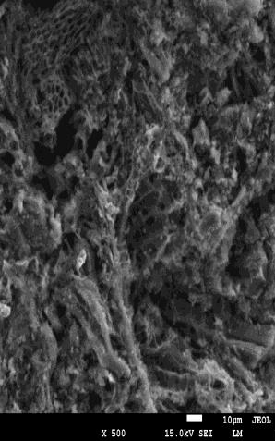 | 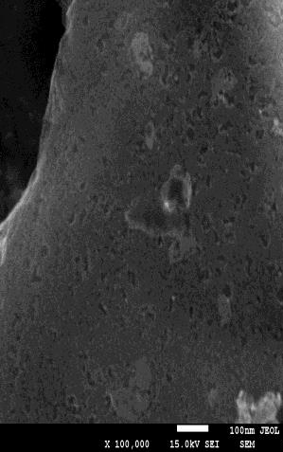 | 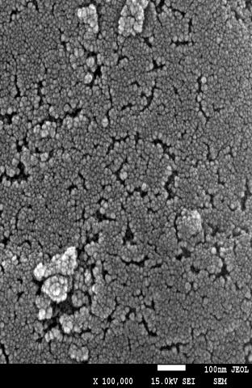 | 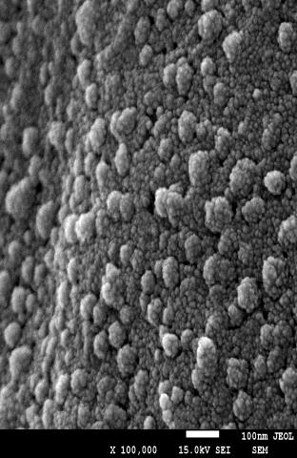
(a) | (b) | (c) | (d)
Fig.,3: SEM images belonging to Activated carbone (a)(b), TiO₂/V₂O₅/AC(c) and TiO₂/WO₃/AC(d).
Table 1: EDS results of the three catalytic samples
Element (Weight %)
 | C | O | Ti | V | W | Mg | Ca | Si | P | Totals
AC | 86.71 | 11.00 | - | - | - | 0.84 | 0.82 | 0.46 | 0.32 | 100.00
TiO₂/V₂O₅/AC | 65.47 | 21.37 | 12.10 | 1.07 | - | - | - | - | - | 100.00
TiO₂/WO₃/AC | 71.66 | 20.75 | 6.39 | - | 1.21 | - | - | - | - | 100.00

TEM analyses
The samples were also analysed using a transmission electron microscopy (TEM) for investigating the morphology of the prepared catalysts. Fig.4 (a, b, c) shows the images with increasing magnifications from the samples. Fig.4a shows the typical TEM micrograph of the amorphous AC. The TEM images of TiO₂/V₂O₅ and TiO₂/W₂O₅ doped AC samples were given in Fig.4b and 4c. As seen in the Fig.4b and 4c, TiO₂/V₂O₅ and TiO₂/W₂O₅ were attached to the AC as with SEM results.
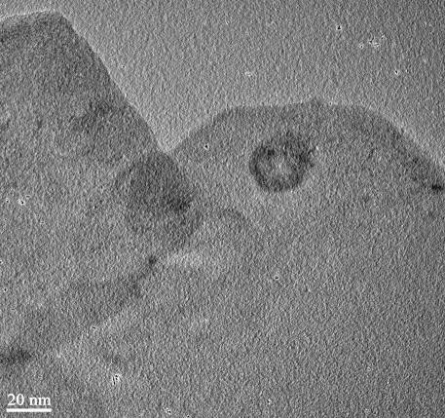 | 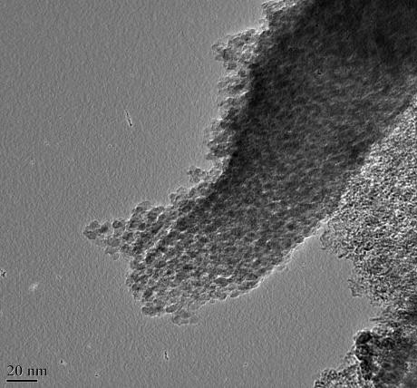 | 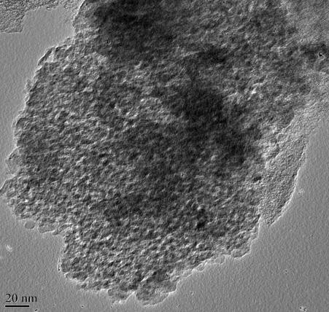
(a) | (b) | (c)
Fig., 4: TEM images belonging to AC (a), TiO₂/V₂O₅/AC (b) and TiO₂/WO₃/AC(c)

XRD analysis
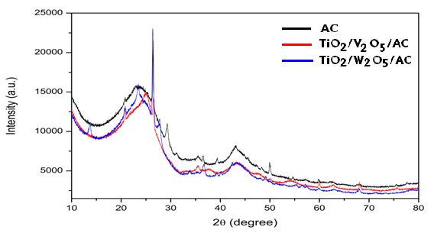
Fig., 5. XRD spectra belonging to TiO₂/AC, TiO₂/V₂O₅/AC and TiO₂/WO₃/AC
AC
TiO2/V2O5/AC TiO2/WO3/AC
Figure 5 shows the XRD patterns of TiO₂/AC (a), TiO₂/V₂O₅/AC (b) and TiO₂/WO₃/AC (c) amorphous and crystal structures. According to Figure 5, the X-ray patterns confirm that activated carbon samples were amorphous and TiO₂/V₂O₅ and TiO₂/W₂O₅ doped samples have crystal diffractions peaks.
FTIR Analysis
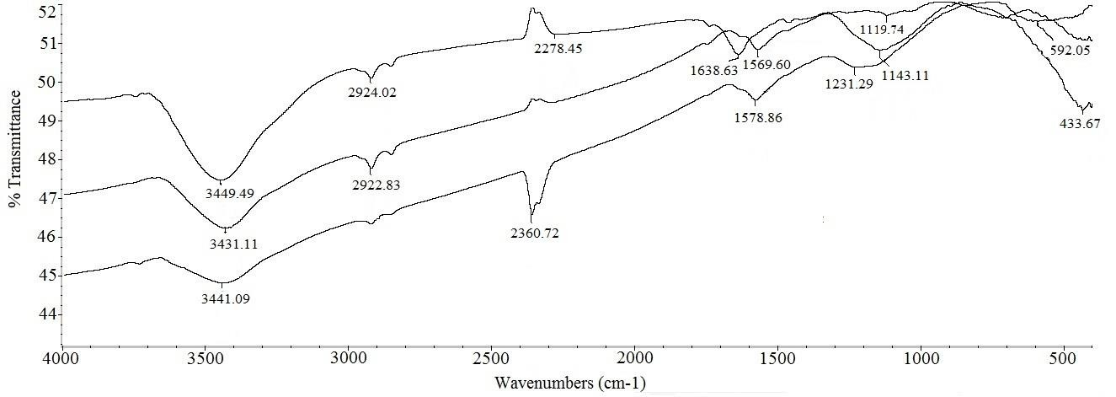
Fig., 6: FTIR spectra belonging to TiO₂/AC (a), TiO₂/V₂O₅/AC (b) and TiO₂/WO₃/AC (c)
When compared, both AC and TiO₂/AC spectra showed stretching vibration at 3440 cm-1 related to −OH. C−H stretching was also observed at 2923 cm-1 related to −CH₂. Band height and broadness reflects that these groups did not change after the application of TiO₂. The band at 1575 cm-1 disappeared that was related to aromatic C=C and a new band appeared at 1638 cm-1 related to titanium carboxylate. Disappearance of C=C related band and appearance of TiO₂ bands proves the impregnation of TiO₂ particles on the surface of AC (Figure 6a). Hydroxyl band on the surface of TiO₂/V₂O₅/AC decreased and shifted to 3431 cm-1 was also observed. It was different from WO₃ as −CH₂ bands did not disappear that means they were unaffected, only −OH groups were involved in reaction. Similar to WO₃ connectivity, bands at 1638 cm-1 related to titanium carboxylate disappeared. Similarly, the C=C band at 1575 cm-1 shifted to 1569 cm-1 after reaction with V₂O₅. The C−O band at 1156 cm-1 in pure AC also shifted to 1143 cm-1 after the removal of titanium carboxylate and reaction with V₂O₅ (Figure 6b). After comparing the spectrum of TiO₂/WO₃/AC, the band of −OH shifted from 3440 cm-1 to 3441 cm-1 and area under the peak is also decreased in addition to the disappearance of −CH₂ band at 2924 cm-1 after the addition of WO₃ (Figure 6c). Therefore, it can be believed that WO₃ affected these groups. Separately, the band related to titanium carboxylate after the addition of TiO₂ disappeared after heating and a small peak was observed at 1578 cm-1. Another band appeared at 1231 cm-1 that is related to W=O. It proved the addition of WO₃.

Effect of Experimental Parameters
The Effect of Salt Concentration
The study of the effect of salt concentration is important because it determines the electrolytic current. The enhancement of electrolytic current can improve not only the degradation of organic pollutants present in wastewater streams but also some side reaction such as producing H₂ at cathode. The results are shown in Fig 7 at varying NaCl amounts for color remaval.

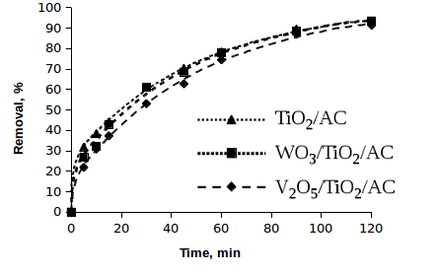  TiO₂/AC  WO₃/TiO₂/AC  V₂O₅/TiO₂/AC |  | ( a )
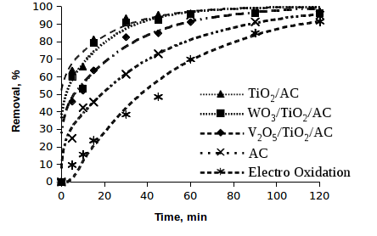 | ( b )
TiO₂/AC  WO₃/TiO₂/C  V₂O₅/TiO₂/AC | ( c )
Fig7. Changes in color removal rates over time depending on catalyst and salt concentrations. (a:0.4 g/L, b:0.8g/L and c:1.6 g/L) (voltage:15V, pH:6.5 and concentration: 250 mg/L)

The data in Figure 7 show that the percentrage removal of colour depends on the concentration of salt used during the reaction. The best removal percentage was obtained when 0.8 g/L salt was used in all catalyst examples. No advantages in the colour removal were achaived by increasing the salt concentration from 0.8 g/L to 1.6 g/L. In addition, it was observed that 90% colour removal was achieved at the end of 30 minutes, and then this percentage is constant. The addition of NaCl would also lead the decrease in power consumptions because of the increase in conductivity [17,18]. The main reactions occurring during the anodic oxidation of organic compounds in the presence of NaCl are given below
Anode | Cathode
Hypochlorite formation:  Cl⁻ + 2OH⁻ → OCI⁻ + H₂O + 2e⁻ | Hydrogen evolution:  2H₂O + 2e⁻ → H₂ + 2OH⁻
Chlorate formation:
6ClO⁻ + 3H₂O → 2CIO⁻₃ + 4CI⁻ + 6H⁺ + 3/2O₂ + 6e⁻
Oxygen evolution:
4OH⁻ → 2H₂O + O₂ + 4e⁻

Solution and/or near the anode surface, Indirect oxidation of organic compound and its oxidation intermediate with hypochlorite in electrochemical treatment of dye effluent via chlorine generation is: Dye + OCl⁻ → CO₂ + H₂ O + Cl⁻

Effect of Dye Concentration
Electrocatalytic experiments were carried out using wastewater streams containing three different concentrations (125mgL⁻¹, 250 mgL⁻¹ and 500 mgL⁻¹) of dye. The percentage removal of color observed over time depends on the initial concentration of dye present in wastewater streams (Figure 8).

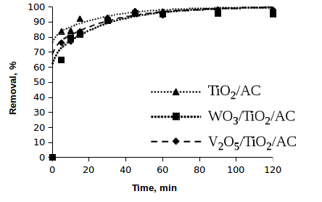 | (a)
 | (b)
TiO₂/AC  WO₃/TiO₂/C  V₂O₅/TiO₂/AC | (c)
Fig 8. Effect of intial concentrations of the dye on the percentrage removal of colour vs time (a: 125 mg/L, b: 250 mg/L and c: 500 mg/L). (NaCl:0,8 g/L, voltage: 15V, pH: 6,5)

The data in Figure 8 show that the percentrage removal of colour increased with time. The percentage removl after 15 minutes was 90% when the dye concentration was 125 mg/L. However, the percentage removal decrsesed to 80% and 70% when the dye concentration was increased to 250 and 500 mg/L respectively. It was also observed that the percentage removal of colour reached to a maximum value 99% after 120 minutes for all concentrations under different catalytic conditions. At low initial concentrations, the electrocatayst reaction is faster than the diffusion. Too many dye molecules in solution could not be removed completely for the agglomeration of organics and the shortage of reactive oxidative species. Considering that the percentage removal of color reached 99% when the dye concentration was 250 mg L⁻1. All subsequent experiments were carried out using 250 mg L⁻1 of dye. The results indicate that the RO122 degradation at different initial concentrations ranging from 125 to 500 mgL⁻¹ is in good agreement with the pseudo-first-order kinetics. The rate constant for all catalyst samples are shown in Table 1

pH Effect
The pH of solution in the electrocatalytic reactions taking place on the particle surface is an important parameter. The color removal for three catalyses was examined at different pH and the obtained results are plotted in Fig. 9.

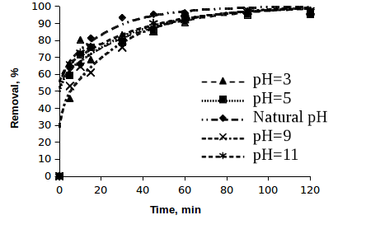 | ( a )
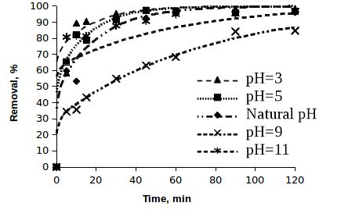 | ( b )
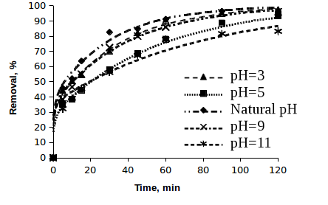 | ( c )
Fig.9: Effect of pH on the percentage removal of colour using using (a: TiO₂/AC, b: WO₃/TiO₂/AC, c: V₂O₅/TiO₂/AC, solid/liquid: 0.8 g/L, voltage:15V, Init.cons.:250 mg/L)

The results also showed that the color removal efficiency reached the highest level at pH:5.0 and pH:3.0. It is mainly because that quinoid structure may be more likely to be degraded, and quinoid structure is a main form at the low pH value [19]. In addition, it is well known that the increase of the solution pH is favorable for the occurrence of secondary reaction (oxygen evolution) meaning more energy consumption, which results in decreasing the current efficiency. The data in Figure 9a show that the optimum pH condition nearly 99% of the orginal colour was removed after 120 minutes.

Voltage Effect
Electrocatalytic experiments were carried out firstly with carbon electrode and then TiO₂/AC, WO₃/TiO₂/AC and V₂O₅/TiO₂/AC, using the catalyzers separately at different voltages (10, 15 and 20V). The results obtained are plotted in Fig.10 respectively.

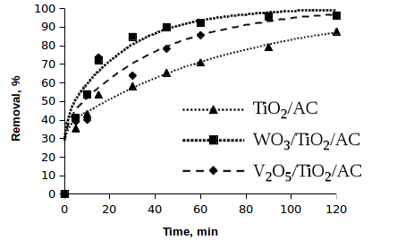  TiO₂/AC  WO₃/TiO₂/C  V₂O₅/TiO₂/AC | ( a )
 | ( b )
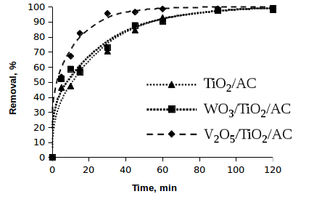  TiO₂/AC  WO₃/TiO₂/C  V₂O₅/TiO₂/AC | ( c )
Fig.10. Effect of voltage on the percentage removal of colour vs time (a:10 V, b:15 V, and c:20 V) (NaCl conc: 0,8 g/L, pH:6,5, Initial dye conc: 250 mg/L)
It was reached to the rate of %65 colour convergence in the first 5 minutes generally at the study made with optimum levels (0,2 gr catalys, natural pH, 0,8 gr NaCl and 15 volt). It was also reached to the rate of % 96 colour convergence after 60 minutes. The results obtained show that highest percentage removal of colour was was obtained with TiO₂/AC, closely followed by TiO₂/AC and WO₃/TiO₂/AC, V₂O₅/TiO₂/AC. It was also observed that the lowest percentage removal was achieved at 10 volts with the use of TiO₂/AC as catalyst. However, higher percentage removcal was achieved at the same voltage when WO₃/TiO₂/AC catalyst was used. When the voltage was increased to 20 volts then the highest percentage removal was abtained with the use of V₂O₅/TiO₂/AC catalysts. Overall, the percentage removal increased with increasing the voltage from 10 to 20 volt.

Catalytic Mechanism
Based on the experimental results and discussion above, TiO₂/AC, TiO₂/WO₃/AC and TiO₂/V₂O₅/AC have been demonstrated to possess a much higher electrocatalytic activity for oxidizing organic pollutants than only AC and electrooxidaton (as well as the 2D system). It is well known that the hydroxyl radical (*OH), a powerful oxidizing agent, plays a key role in the electrochemical oxidation of organic compounds. In the litertaure study, it was stated that the electrogeneration of *OH occurred on various granular activated carbon (GAC) based electrodes when current was applied and demonstrated that the usage of GAC-based granular electrodes can effectively improve *OH production in electrochemical oxidation systems (in 3D system) [20-21]. When it is thought that all of sentezed, catalyzers are typical “nonactive” electrocatalyst, at this “nonactive” metal oxide electrode (MOx) over granular activated carbon (GAC) surface, water molecules were easily decomposed to form strong oxidants, such as physisorbed *OH, MOx(*OH) which allow nonselective oxidation of organics and may result in complete oxidation of organic carbon to CO_{2.} In addition, *OH is a well acknowledged oxidant and its advantages in pollutant degradation include the high efficiency and low production of by-products. As schematic representation describing the possible mechanisms involving the 3D electrocatalytic process is therefore provided in Fig. 11.
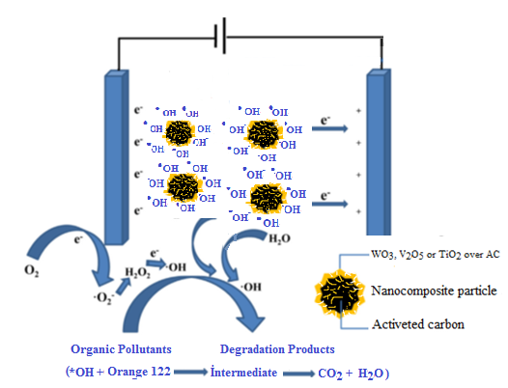
Fig. 11. A schematic representation describing the mechanisms of the charge separation and active species generation in a 3D electrocatalytic system with different nanocomposite particles used as the particle electrodes.

In the 3D reaction system with WO₃, V₂O₅ or TiO₂ over granuled activated carbon used, each particle electrode could act as a microelectrolysis cell. As a result, the 3D electrocatalytic system owns much higher electrode areas than 2D reaction, and the process performance is much improved [22]. Overall, in the 3D photoelectrocatalytic system, the high degradation efficiency of orange 122 should be ascribed to the synergistic effect of activated carbon adsorption, electrocatalytic and electrochemical oxidation. Another advantage of the granular particle in practical application is relating to separable property of the particle electrodes. While the composite material could still be easily recovered from the bulk solution by using filter apparatus after the photoelectrocatalytic reaction, In the future work, comprehensive studies on the effect of the applied field on the properties of the composites are required.

Photodegradation kinetics.
The degradation kinetics of wastewater by using four catalysts were evaluated using the linearised form of pseudo first- order rate
Ln (C_{t}/C_{o})= -kt | (5)
where C_{o} is the initial concentration (mg/L), C_{t} is the concentration (mg/L) at time t, t is exposure time and k is the first-order rate kinetics. Table 1 shows that the degradation process follows the pseudo first-order rate kinetics as evidenced from the regression (r2) analysis that is greater than 0.70. The higher rate constant achieved using TiO₂/AC can be attributed to the combined effects of adsorption of organic molecule over catalyst surface followed by oxidation using the generated hydroxyl radical and direct attack of photogenerated holes [23]

TABLE 1 - k and R² values for Colour removal to different parameters and nanoparticles
Parameters | TiO₂/AC |  | WO₃/TiO₂/AC |  | V₂O₅/TiO₂/AC
 | R² | kx10⁻² (min⁻¹) | R² | kx10⁻²(min⁻¹) | R² | kx10⁻² (min⁻¹)
Salt effect (g/L)
0,4 | 0,99 | 2,19 | 0,99 | 2,23 | 0,99 | 2,05
0,8 | 0,75 | 2,77 | 0,82 | 2,83 | 0,92 | 2,55
1,6 | 0,78 | 3,21 | 0,80 | 2,63 | 0,91 | 3,55
Concentration (mg/L)
125 | 0,70 | 2,59 | 0,78 | 2,72 | 0,80 | 3,21
250 | 0,75 | 2,77 | 0,78 | 2,69 | 0,95 | 2,97
500 | 0,97 | 3,26 | 0,95 | 3,84 | 0,88 | 3,44
Voltage effect (volt)
10 | 0,86 | 3,71 | 0,88 | 2,72 | 0,96 | 2,94
15 | 0,96 | 2,89 | 0,88 | 3,34 | 0,96 | 3,06
20 | 0,94 | 1,12 | 0,99 | 3,97 | 0,86 | 3,87
pH effect
3 | 0,92 | 3,08 | 0,72 | 3,05 | 0,98 | 3,04
5 | 0,83 | 2,32 | 0,74 | 2,46 | 0,99 | 2,15
6.5 | 0,75 | 2,77 | 0,78 | 2,72 | 0,94 | 2,91
9 | 0,93 | 3,08 | 0,96 | 1,38 | 0,97 | 2,75
11 | 0,89 | 2,72 | 0,79 | 2,34 | 0,90 | 1,45

Conclusions
In this study, electrocatalytic systems have been optimized for the treatment of orange 122 present in aqueous wastewater streams under different conditions. The nanocomposite materials were prepared and their efficiencies were examined in the operation condition. As a result of this study, optimum values were found as reaction time; 120 min., voltage; 15 volt, solution pH; 6.5; initial concentration; 250 mg/L and NaCl concentration; 0.8 g/L. The results indicated that only 30% percentage removal of colour was obtained after 30 minutes in the absence of active carbon. This value increased to 60% in the presence of AC. However, the percentage removal of colour was reached to 98% when the reactions were carried in the presence of cataysts (TiO₂/AC, V₂O₅/TİO₂/AC and WO₃/TİO₂/AC (under the same experimnental conditions. In addition, for all catalysts, the pseudo-first-order rate constants were obtained amoung 1.12 × 10⁻² min⁻¹ and 3.87 ×10⁻² min⁻¹ with the individual use of the composite in electrocatalysis. Moreover, the necessity to analyze and identify the formation of different intermediate products using mosern analytical tecahniques equppied with identification library is needed. It would also be useful to identify the structure of these intermediate products to fully understand the degradation mechanism dueing the electrocatalytic oxidation process using HPLC, gas chromatography, NMR and other analytical techniques in further studies.

Acknowledgements
This study was financially supported as a project (15/041) by Research Project Coordination Unit, Muğla Sıtkı Koçman University. The authors wish to thank Muğla Sıtkı Koçman University for XRD, BET, FTIR, SEM and TEM analyses.

References
[1] T.Uruj, Y. Azra and HK. Umair, Phytoremediation: Potential flora for synthetic dyestuff metabolism, J. Kıng. Saud. Unıv. Scı., 28,119 (2016).
[2] P. Nigam, G. Armour, IM. Banat, D. Singh, and R. Marchant, Physical removal of textile dyes from effluents and solid-state fermentation of dye-adsorbed agricultural residues, Bıoresource. Technol., 72, 219 (2000).
[3] A.Gürses, M. Yalçın and Ç. Doğar, Electrocoagulation of some Reactive Electrochemical Variables, Waste Manage., 22, 491 (2002).
[4] A. Gürses, M. Yalçın , and Ç. Doğar, Investigation on settling velocities of aluminium. 500 hydroxide-dye ﬂocs. Fresen. Envıron. Bull, 12,16 (2003).
[5] O. Yesilada, S. Cing and D. Asma, Decolourisation of textile dye Astrazon Red FBL by Funalia trogii pellets, Bıoresource Technol., 81, 155 (2002)
[6] T. Robinson, B. Chandran and P. Nigam, Effect of pretreatments of three waste residues, wheat straw, corncobs and barley husks on dye adsorption, Bıoresource Technol., 85(2),119 (2002) .
[7] D. Pak and W. Chang, Decolorizing dye waste water with low temperature catalytic oxidation. Wa. Scı. Technol., 40:115 (1999)
[8] F.Dinçer, M.H.Karaoğlu, M. Uğurlu, and A.İ. Vaizoğullar. Ozonation of Reactive Orange 122 Using La3+-Doped WO3/TiO2/Sep Photocatalyst., Ozone-Scı. Eng., 38 (4):291 (2016)
[9] A.Gürses, S.Karaca, Ç. Doğar, M. Açıkyıldız, R Bayra , and M. Yalçın. Determination of adsorptive properties of clay/water system: methylene blue sorption. J Colloıd Interf Scı, 269 (2):310 (2004).
[10] F. Akbal, Adsorption of basic dyes from aqueous solution onto pumice powder J. Colloıd Interf. Scı., 286 (2) 455 (2005).
[12] A. R.Dinçer, N.Karakaya, E.Güneş, and Y.Güneş, Removal of cod from oil from aqueous solution, Bıoresource Technol., 98; 834 (2007).
[13]K.Jüttner, M.Galla, H.Schmieder, Electrochemical approachestoe nvironmentalproblems in the process industry, Electrochım. Acta 45, 2575 (2000).
[14] A. Fernandes, A. Morão, M. Magrinho, A. Lopes, and I. Gonçalves, Electrochemical degradation of C. I. Acid Orange 7, Dyes Pigments., 61, 287 (2004).
[15] M.J. Matteson, R.L. Dobson, Jr. R.W, Glenn, N.S, Kukunoor, W.H. WaıtsIıı, and E.J. Clayfield, Electrocoagulation and separation of aquenouns suspensions of ultrafine particles, Colloıd Surface A., 104:101 (1995).
[16] SJ. Zhang, HQ. Yu, and Y. Zhao, Kinetic modeling of the radiolytic degradation of Acid Orange 7 in aqueous solutions, Water Res., 39,839 (2005).
[17] A. Ziylan-Yavaş, and N.H.Ince, Catalytic ozonation of ibuprofen with ultrasoundand Fe-based catalysts, Catal. Today., 240,2 (2015).
[18] MS.Morsia, AA.Al-Sarawyb, and WA. Shehab El-Dein, Electrochemical degradation of some organic dyes by electrochemical oxidation on a Pb/PbO₂ electrode, Desalın Water Treat., 26;301 (2011)
[19] A.I. Vaizogullar, M.Ugurlu, A.Ayyildiz, SI Yılmaz, and AJ Chaudhary, TiO₂, WO₃, and V₂O₅, Supported On Activated Carbon: Preparation, Structural and Catalytic Behaviour In Photocatalytic Treatment Of Phenol And Lignin From Olive Mill Wastewater, Fresen Envıron Bull., 26, 3529- (2017).
[20] Sun H., Liu, Z., Wang, Y and Li Y. Electrochemical in situ regeneration of granular activated carbon using a three-dimensional reactor, J. Envıron. Scı., 25:77 (2013).
[21] M. Uğurlu, and H.Karaoğlu, Removal of some compounds from bleached kraft mill effluent by UV oxidation in the presence of hydrogen peroxide utilizing TiO₂ as photocatalyst, Environ. Sci. Pollut. Res., 16;265 (2009).
[22] J.Song, X.Wang, J.Huang, J. Ma, X.Wang, H.Wang, R.Ma, P.Xia, and J. Zhao, High performance of N-doped TiO2-magnetic activated carbon composites under visible light illumination: Synthesis and application in three-dimensional photoelectrochemical process, Electrochim. Acta., 222:1 (2016).
[23]C.Zhang, Y.Jiang, Y Li. Z.Hu, L.Zhou, M.Zhou, Three-dimensional electrochemical process for wastewater treatment: A general review, Chem. Eng. J., 228:455 (2013)

