Ensounded

An introduction to the Special Sound/Theatre: Sound in Performance Issue

Johannes Birringer

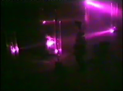

Geräusche aus der Helle, installation/performance by Andreas Maria Jacobs, Circuit du Théâtre Festival Amsterdam 1989. © Courtesy of the artist.

Inspired by recent productions in theatre, dance, music-theatre and the sonic arts, as well as by the increasing scholarly attention given to an acoustic/sonic turn in recent years¹ – closely linked as well to the growth in scenographic, acoulogical and design studies – this special issue of Critical Stages focuses on the sonification/musicalization of the stage environment, on the Ortsklang or “aural choreography” imbued in spaces and sites, on voices and echoes, mirroring generative sonic and corporeal processes, theatre auralities, testimonials and recitals, tangible and audible interfaces, digital performances and sound design. Dramatic and fictional texts appear too, as espaces musicaux, and the rush of the heard, of the real world sound, is drawn and drawing closer. Sometimes, the frequencies of imagination, as Pieter Verstraete has argued, can cause auditory distress in the ear-witnesses of our world.² This we may not be able to avoid.

All myths (including the one about Echo) are changing of course, yet being alive, as anthropologist Tim Ingold³ reminds us, is a matter of realizing how we move and change, and how we are always ensounded moving, through the world which is also a world of sonorities and auditory spaces (and of enforced silences, as one writer from the borderlands points out, referring to the violent socio-political realities that are ours). Sound is thus not (only) even an object of knowledge but a main medium of our perceptions, and sometimes of our survival. We close our ears, if only we could, at our peril. The attention to sound in performance, I suggest, is most welcome since we are again perhaps required to listen more carefully to fabrications and authenticities, the cooked and the raw in the ever expanding technologized, mediated noisy realms of life in the anthropocene era of relations and mash-ups, dub versions and glitches, faultlines and crashes.

Looking at a widening arena of composed theatre as well as interactive and sonic installation art, choreographic and kinetic objects and performance apparatuses, for this edition I tried to encourage vigorous debate on emerging concepts of rhythmic spaces, resonant dramaturgies, audiophonic scenographies, vibrational theatres and collective bodies – multisensory atmospheres in performance. Immediately when the call for papers came out, a sound artist responded sending me the grainy photo (above) from Geräusche aus der Helle, an installation he created in 1989 inside a former atomic bomb shelter.

Atmospheres are difficult to capture and explain – and the artist did not comment on the event except briefly declaring it a “theatre/movement piece” with its immersive “playground divided in three sections from bottom to knee, from knee to middle and from middle to head, whereas the horizontal plane consisted of 8 to 9 perspex columns prepared with electronic devices – both senders and receivers – which triggered the sounds of a prepared tape recordings…” (http://www.nictoglobe.com/new/Installations/text.html). Dancers and audience moved around, there were vertical and horizontal frequencies, wave-tones of color – and this was evocative enough for my imagination, especially when Andreas Maria Jacobs added that the youtube link shows a “rather grainy and dirty registration of one of its enactments.”

INSERT
https://www.youtube.com/watch?v=h8hAl1sa5S0

<iframe width="560" height="315" src="https://www.youtube.com/embed/h8hAl1sa5S0" frameborder="0" allowfullscreen></iframe>

Many creative processes today (enhanced by diverse technologies and ever-changing techniques) gather momentum, in which audible, but also tactile, haptic and/or visible dynamics, actions, atmospheres and traces are recreated, without that theories of affect and perception have yet fully defined or explored the contours sound affords for the spectators/listeners, especially if interactions unfold within the area of the non-verbal and beyond alignment with signs, narrative threads. The historically grainy interests me (what did Yoko Ono’s Cut Piece or Nam June Paik’s drawing of LaMonte Young’s Composition 1960 No. 10 sound like?), as does the paradoxical and perverse (Francisco López blindfolding his audience; Scanner sampling cell phone conversations and using them, unbeknownst to the callers, in electronic music concerts; Socìetas Raffello Sanzio’s claustrophobic scenes of torture, blood pouring into the mike; or Ryoji Ikeda piercing my ears with fiercely high-pitched sine tones, sending me down the white corridor in spectra II, until I disappear), and the complex machinations at work, for example, in a choreographic object such as Heiner Goebbels’s Stifters Dinge, where music is an uncanny metamorphosing assemblage.

In this edition of Critical Stages, we are interested in hearing from practitioners who work on such contouring and composing, and from cultural critics reading into many diverse instruments of performance, on and off stage.⁴ The following articles encompass a broad range of interdisciplinary perspectives drawn from compositional processes and production aesthetics as well as from investigations into the perception of the interplay of analogue/digital, instrumental/vocal, musical or noise-sound, and various manifestations of sound design and sonic scenographies.

¹ A diagnosis of these so-called turns was offered, for example, by Adrian Curtin & David Roesner (2015) “Sounding out ‘the scenographic turn’: eight position statements,” Theatre & Performance Design 1 (1): 107-25. See also Salomé Voegelin (2010) Listening to Noise and Silence: Towards a Philosophy of Sound Art, New York: Continuum; Johannes Birringer (2013) “Audible Scenography,” Performance Research 18 (3): 192–193; George Home-Cook (2015) Theatre and Aural Attention: Stretching Ourselves, Basingstoke: Palgrave Macmillan.
² See Pieter Verstraete (2009) The Frequency of Imagination, Enschede: Ipskamp Drukkers BV.
³ Cf. Tim Ingold (2011) Being Alive: Essays on Movement, Knowledge and Description, London: Routledge, 138.
⁴ Songs of(f) Stage was the pertinent title of Helmi Vent’s provocative TanzMusikTheaterWerkstatt in Salzburg (1998), during which her team recorded and then reprocessed innumerable sounds collected in the vast structure of the Mozart Academy Theatre: http://www.helmi-vent.com/en/projects-and-films/12-songs-off-stage.html). Dedicated to Mauricio Kagel, Songs of(f) Stage performs a closer look at the open and covered spaces in a classically built theatre, in order to converse with the actually existing space sounds and sound spaces with the help of its own ‘equipment’ (stationary and mobile components from the stage and offstage, e.g. assembly catwalks, protective grilles, safety chains, profiled steel base plates, motor-controlled lifting platform hydraulics, trash cans, etc), projecting different playback versions into multiple redrafts – vocal, instrumental, dance and film performances.

____________________________________________________________________________________________________________
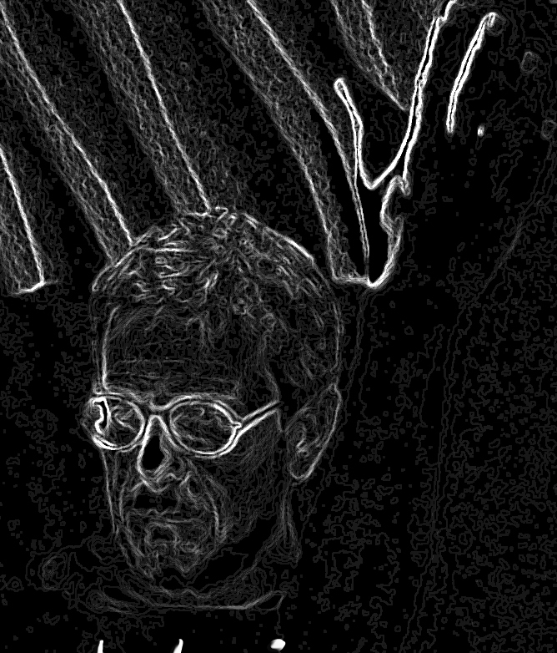

Johannes Birringer is a choreographer and media artist; he co-directs the Design and Performance-Lab at Brunel University, where he is a Professor of Performance Technologies in the School of Arts, and the multimedia ensemble AlienNation Co. in Houston, TX (www.aliennationcompany.com). He has created numerous dance-theatre works, installations and digital projects in collaboration with artists in Europe, the Americas, China, and Japan. The DAP-Lab’s cross-media research explores convergences between choreography, visual expression in dance/film/fashion, wearable design and real-time interactive environments (www.brunel.ac.uk/dap). DAP-Lab’s interactive dance-work Suna no Onna was featured at festivals in London (2007-08); the mixed-reality installation UKIYO went on European tour in 2010. for the time being (2014), a dance opera, premiered at Sadler’s Wells in London. A new series of immersive dance installations, metakimospheres, began touring in Europe in 2015-17. His film-concert Sisyphus of the Ear (music by Paulo C. Chagas) premiered in Ufa and Moscow (2016). His books include Theatre Theory Postmodernism (1989), Media and Performance (1998), Performance on the Edge (2000), and Performance, Technology, and Science (2009). He has spearheaded new trans-disciplinary dance-research projects, and co-edited (with Josephine Fenger) Tanz im Kopf/Dance and Cognition (2005), and Tanz & Wahnsinn/Dance & Choreomania (2011).

