Kinetic Atmospheres and Immersion Architecture

Johannes Birringer

School of Arts
Brunel University
London, UK
johannes.birringer@brunel.ac.uk
http://www.brunel.ac.uk/dap

Keywords

atmospheres, architecture, interaction, movement, wearables, tactile-liquid vision, augmented virtuality

Abstract

This presentation extends the author’s earlier work on dance technologies and in/audible choreographies to delve into participatory sensory architecture and augmented virtuality, introducing concepts of the material affects of flows and aural environments, and discussing the design of wearables used in immersive environments (kinetic atmospheres or ‘kimospheres’). Kinetic atmospheres are conceived as formative, not built/constructed in a stable form but responsive to movers or even ‘wearable’ themselves. Basing its investigation of such porous interactive environments for wearable performance in recent installations of the DAP-Lab, as well as acoustic-theatrical installations and contemporary choreographic architectures and objects, the paper explores the impact of audiophonic wearables on movement choreography and role-play within such kimospheres. Finally, it sketches more speculative developments of how bodies and wearables come to affect, and be affected by, kinetic, sonic and Virtual Reality interfaces – in the sense in which the composer Xenakis had envisioned reverberant multimedia architectures and spatial intensities to be live instruments, not static objects or envelopes. Birringer proposes to rework architectural, cybernetic, and hydrogeological theories of the liquid, and shift attention to liquid aurality and virtuality derived also from anthropological concepts of understanding the movement of water, mist, and vapor (immersion, animation, animateriality).

Kinetic Atmospheres and Immersion Architecture

Immersion is the term that has gained much currency in recent years. I believe its history, however, is one dominated by an ocular emphasis – visuality and visual stimulation also being of main importance in the world of computer gaming’s POV and the increasing interest in Virtual Reality’s immersive experience. From a holistic phenomenological and somatic perspective, such visual dominance is reductive, since our being alive to all divergent perceptions always involves movement At the same time, one ought not to forget the manual dexterity and physical reflexes of the gamer, the ability to focus.
The poetry lines [fig.1] are from the game “Red Ghosts” that can be played at a computer screen while the player listens to a recitation of the poem and scrolls the cursor along the lines. This game is set up as but one station in a larger theatrical architecture in which the real and the virtual merge, with the virtual complementing the real in a nearly tangible way as these realities are layered on top of and within each other. The layering invites and proposes different experiences for each audience member, creating a sense of their own emerging views as they construct a narrative. Ironically, the older theatrical term of augmented reality is now superseded by the notion of an augmented virtuality as it is promoted in the VR interaction design industry.
The poetry of the game is also an allegory, as it evokes the notion of slow time or slow evolutionary space, which was pertinent for the temporally extenuated experience we had devised for the theatrical environment of kimosphere no. 4/Horlà. I will therefore not touch upon games as such or VR technology, for that matter, but explore an expanded, multi-sensorial sense of playful immersion that my research, and my work as a choreographer, has sought to uncover through theatrical and architectural design.

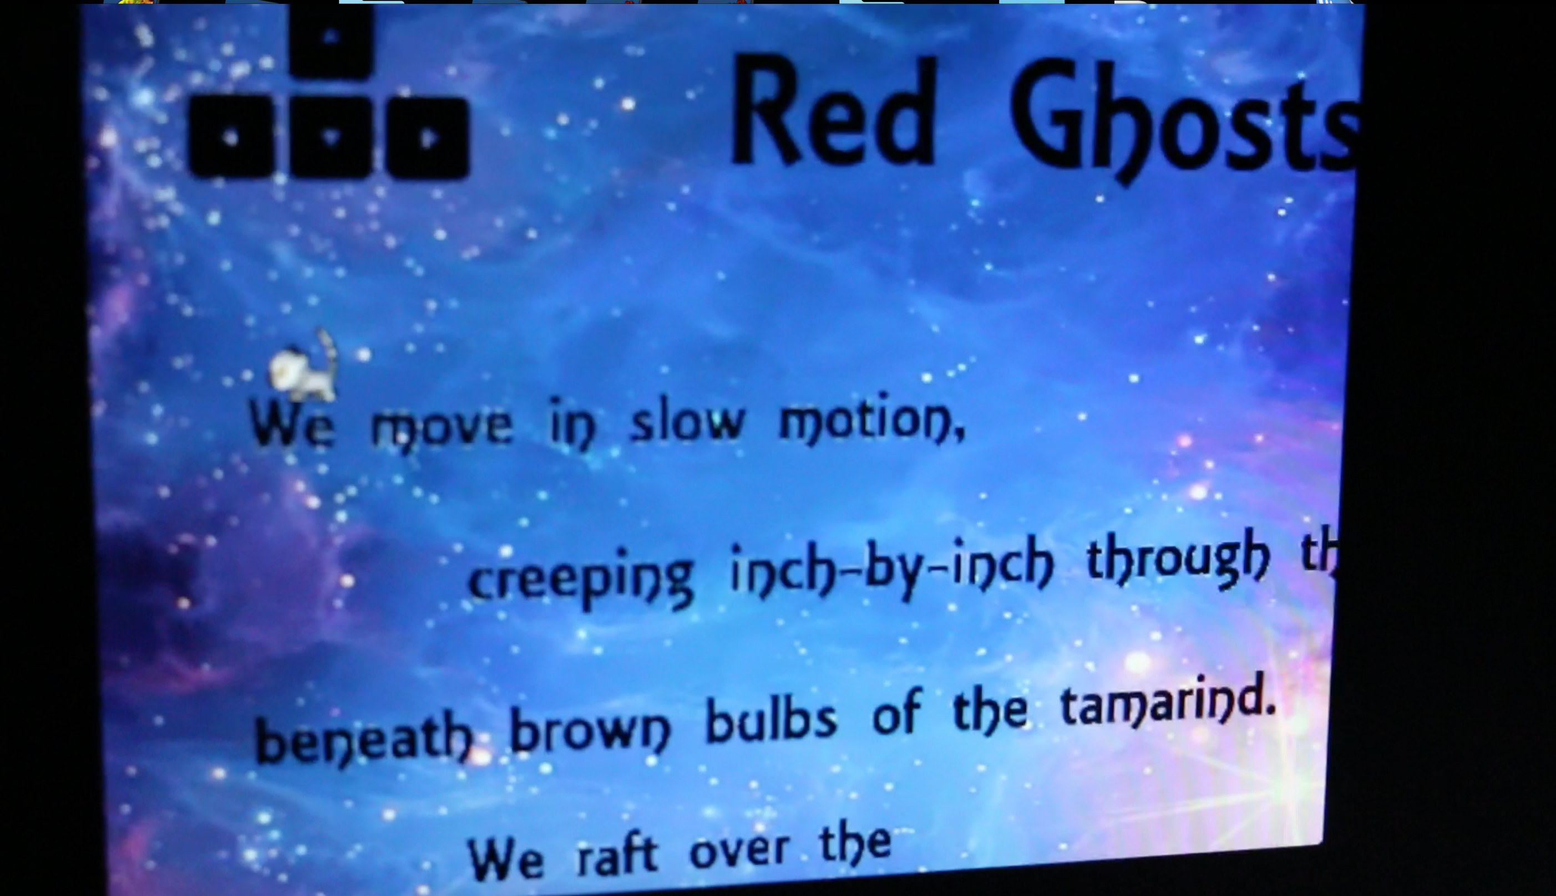
Fig. 1. “Red Ghosts/Shadows of the Dawn,” video game, kimosphere no.4/Horlà,
London, 2017 © DAP-Lab

Nevertheless, I give attention to the role of the virtual and of wearable VR heasdsets inside this design scenography, questioning their role and whether their inclusion was a good idea in the last instalment of the metakimosphere series (in 2017). Discussing it here will help to generate new questions and responses; the listener may have already found different solutions to what I would basically consider an isolating, insulating experience within the social theatrical – and often a ritual-communal – event. The isolating experience in question is the game at the computer screen, and the wearing of the VR-headset (goggles wired to a computer) or the lighter cardboard 3D headsets (with inserted iPhone) provided for our installation audiences. Visitors were invited to wander around a large-scale audio-visual and tactile landscape initially called “Red Ghosts/Shadows of the Dawn” – the ghosts in question being the eight speakers of an 8-channel sound installation, set upon tall stands, creating a tactile aural territory. Then there are the little ghosts of the Malagasy lemurs, the moonlit acrobats, evoked by our narrative subtexts about slow evolutionary history. [fig.2]
The sonic and tactile materials move these kinetic stories, disseminate them around the architecture of the whole, with voices, electronic sounds, echoes, processed natural sounds, distorted crackles and hisses, lights, mists, colors and moving textures. The 8-channel installation, with each speaker shrouded in a mosquito net suspended from the ceiling grid, in fact conjures a metaphorical or mythical forest of ghostly presences (three dancers, wearing masks, are hidden quietly inside this environment, still or barely moving), with dense layers of a sound-in-motion that is experienced by visitors while moving around the forest of speakers.

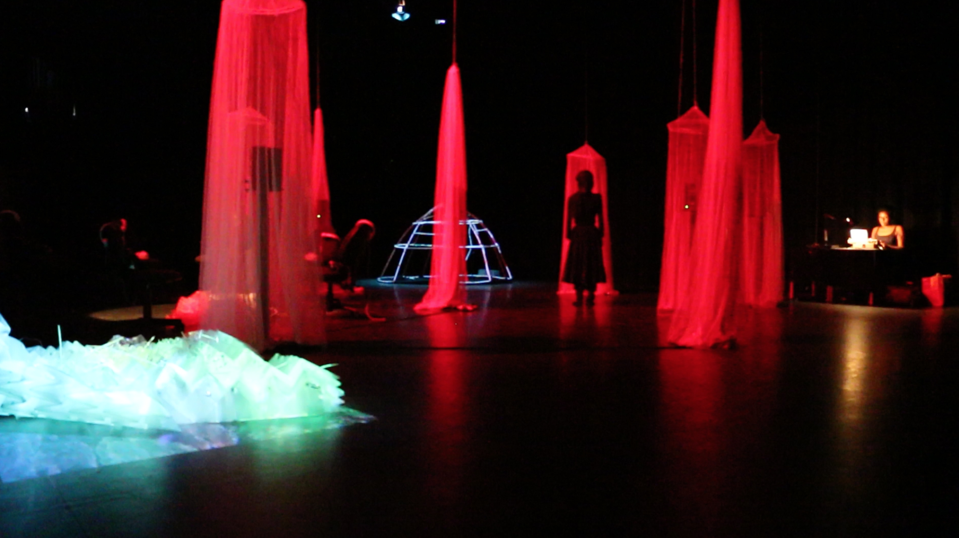
Fig. 2 Yoko Ishiguro, standing still in font of a ghost speakers; coral reef on the
left, and sound artist Sara S. Belle performs in background right. Soundsphere skeleton
visible in the back. metakimosphere no.4/Horlà, 2017. London © DAP-Lab

The micro-polyphonies in fact are only audible if they move across and between the nets, listening. The installation also has various stations on the perimeter, such as the VR interfaces just mentioned, as well as an igloo-like soundsphere where the visitor can crawl inside to explore a GSR biosignal interface (listening to galvanic skin response turned into sound), and a “coral reef” sculpture where they can lie down and float inside a deep sea film projection that percolates over a synthetic origami architecture.[fig. 3]
The ritual-communal aspect of immersion and participatory art is an important concern, otherwise there would be no reason to experiment with these forms of liquid interaction. For many years of working in the theatre, it appeared quite satisfactory to create a dance or performance piece on the stage, for an audience to watch from the auditorium. But atmospheres of choreographic design suggest a new conceptual approach with which to pursue questions about sensorial immersion which change the older dispositif, asking audiences to step inside and come closer, touch, listen and act in greater intimacy with the unfolding action. [1] Such an approach to immersive dance, emphasizing a stronger kinaesthetic and multi-sensory affective impact on audience perception, has developed concurrently with an altered understanding of digital embodiment which has grown over the past decades, countering the so-called dematerialization of the art object, even if fluxus events and happenings, along with more ritual, psychedelic, or politically activist forms of performance had always existed within the vanguard traditions of modern art. The politicized and eroticized psychedelic happenings of the Living Theatre or of Carolee Schneemann’s Kinetic Theatre of the 1960s provide an undercurrent for the more formal constraints that our immersive dance installations imply. [2]

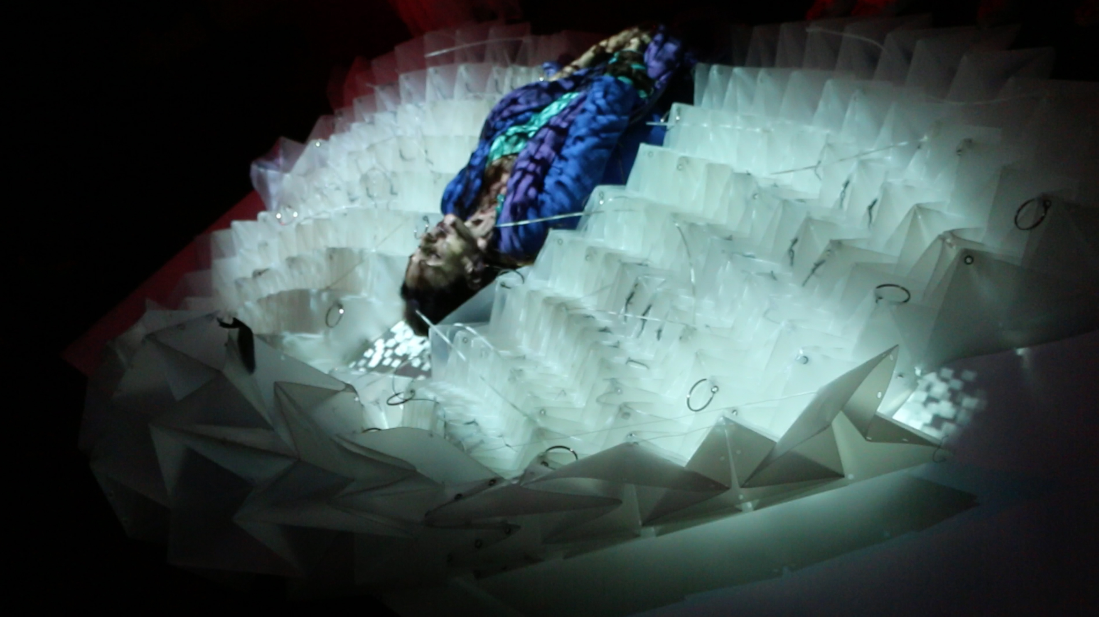
Fig. 3. Visitor floating inside coral reef, metakimosphere no.4 © DAP-Lab

The questions that interest us (in theatre as in architecture) concern the extended mode and model of performance with can contribute to other disciplinary studies of “atmosphere” (e.g. Gernot Böhme’s writings on the aesthetics of atmosphere and the “art of the stage set”). A concern with atmosphere intersects with other overlapping sites of inquiry, including studies of mood, affect and histories of emotion, as well as ecocritical, climatological, and legal theory. Performance studies, like other academic or artistic inquiries, cannot avoid the complex and pressing ecological context of anthrogenic climate change, and its implications for what Böhme has termed “ecological aesthetics” (1993). DAP-Lab’s kimospheres can thus be received in relation to these wider political and environmental concerns.
Since becoming involved in international co-productions of the European METABODY project after 2013, the new term I have used for our approaches is “kimosphere.” [3] Kimospheres (kinetic atmospheres) are living, breathing spaces; not clearly definable or bounded, they are felt and perceived like weather, they flow, float, spread. One is corporeally present in them, moving through their Stimmungen (the German word Stimmung, similar to Atmosphäre, implies in its etymological origin also Stimme, i.e. voice, an acoustic experience, a tuning), perceiving-listening to the relational, dynamic and metastable states of such atmosphere. As designed spaces, kimospheres are installed, thus “built” and choreographed for visitors, and they often focus on audio-visual and material-sculptural or fabric configurations.
They are also informed by the developments of embodied interaction in dance and digital media – dance that incorporates technologies and associates its compositional ideas with software programming (mathematical and abstract languages). Earlier multimedia work I had created took place on the stage (or, telematically, on screens); thus it was projected for audiences, not designed to be entered by them, unfolding and pulsating close up. Breathing in and touching thus also closely connect the atmospheric to listening-sensing. Atmospheres are sensed, and if you imagine walking in a forest or unfamiliar urban territory at night, you will be listening to the atmosphere and the not-seen, to imperceptible movement. You become more succinctly “attuned” to the environment since you are hyper-activating your survival instincts and peripheral senses.
From projection to (virtually) embodied immersion – this is not necessarily a shift as projections may still remain a part of the installation architecture. 3D film or VR remains a cinematic projection medium, yet it has enhanced its plasticity and the illusion of absorption (of the viewer feeling being inside rather than looking from the outside in). 3D interaction designers emphasize that such absorption – and what our collaborator Doros Polydorou refers to as “the perception of being physically present in a non-physical world” – relies on the plausibility illusion, namely that you are not only using your body to perceive in the way you normally do, but that the environment believably responds to your actions to make you think it is real. [4] DAP-Lab’s research on formative and wearable space, on a mediated and yet highly visceral environment that is not constructed in a stable form but evolves through movement, now provides the basis on which I reflect current ideas and practices of immersion-dance, perhaps also questioning those notions of plausibility. Movement, in this sense, can also include the motion of light and graphic projection, the diffusion of sound waves, energy fields, color fields, edgespaces and anomalies, and various forms of embedded motion sensing which result in reactions (in the environment).
If one were to embrace an even larger notion of the environment, say, an ecological and hydrogeological sense of infrastructures that may not even be visible and sensorially directly experienceable, the wearable becomes abstracted or, rather, shifts into more imaginary affective tonalities and synaesthetic resonances evoked by liquid materialities (e.g. underground water, mist, vapor, fog, atmospheric pressure). These are dislocating effects of augmented virtuality only now being tested and explored in the arts and in some work by anthropologists (c. Andrea Ballestero’s study of aggregation and collective care). Caring for the environment and listening to its visible and invisible flows, I argue, becomes an important part of our understanding of the sensing the wearable.

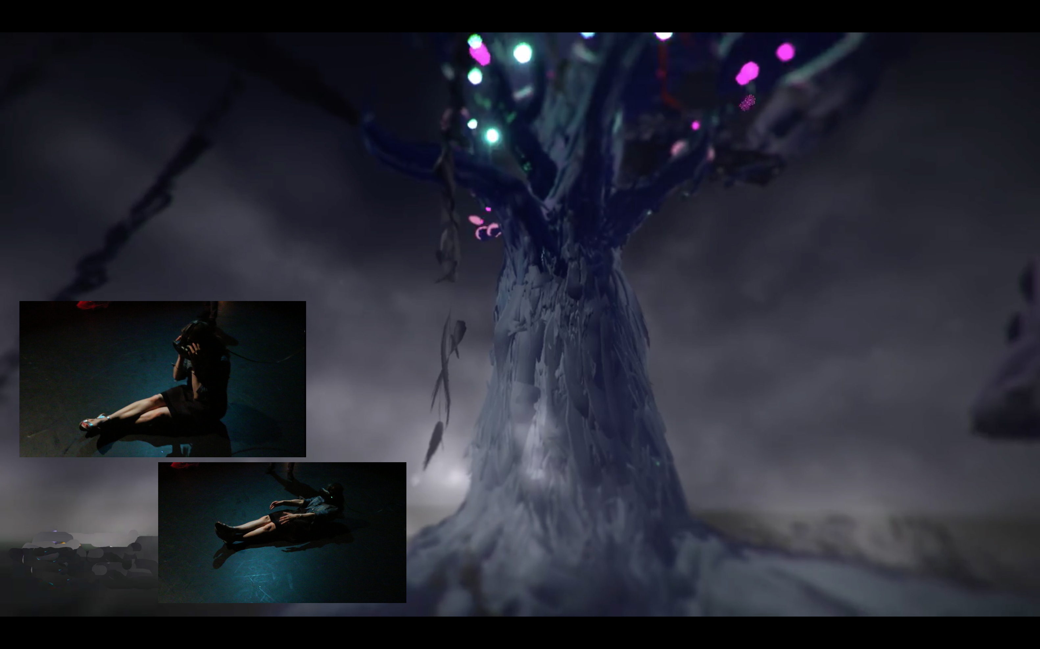
Figure 4. Metakimosphere no. 4. Visitor [left] enacting/embodying what she perceives
inside “Lemurs” interface with VIVE headset, conducted by Doros Polydorou,
2017 © DAP-Lab

This idea of the choreographic suggests a technologically infused dance or, rather, a material-sensory practice filtered through fashion and expanded sculpture. Movement and fashion design for our wearables are understood by DAP-Lab to be choreographic as well as architectural, examining how costumes are immersive and what concepts of the wearable allow – for example a double wearabilty, both of our specially designed garments and yet along with the wearability of space – the choreography of architectural scores.5 The sensorial environments that I describe are also sometimes refered to as “choreographic objects” (e.g. the installations by William Forsythe), but in our case it is more pertinent to think of the fluidity of atmospheres rather than objects.
In conclusion, the notion of a fluid “immersive dance” needs to qualified in so far as I notice an increasing reduction of our dancers’ activities or, rather, a shift towards a different role regarding the interactional invitations of the kimospheres to the visitors. This became clearer in metakimosphere no. 4 (2017), where our dancers relinquished dancing altogether. It was the visitors who were invited to move through the parcours, at their leisure, and explore tactile and auditory experiences while at the same time being challenged into somatic (inner) bodily sensations afforded by the new kinetics of augmented virtuality. With metakimosphere no. 4, DAP-Lab for the first time fielded proto-narratives, composed through an 8-channel sound installation (Red Ghost Speakers) and five interface stations that each intertwine aspects of two narratives (Horlà, adapted from a short story by Guy de Maupassant; Shadows of the Dawn, adapted from a field report on lemurs by primatologist Alison Jolly in Madagascar).
Their exploration is the choreographic process: it includes intimate personal (meditative) resonances derived from the floating “coral reef” and the “Red Ghost” poetry game. There are two VR interfaces where visitors enter ghostly worlds via goggles. Metakimosphere no. 4 thus combines two atmospheres, a real architectural space and a virtual (computational) space, both actuated through the same tactile narrative, neither perhaps completely plausible. The critical aspect for us is the immersant’s sensory participation: the resonances of real and virtual spaces are to be rhythmically entwined.
The occurrent gestures are envisioned to become reciprocal – pushing the kinaesthetic into a perceptual virtuality (VR) that so far is largely contained in the visual (the ergonomic challenges with virtual reality headsets are well known: the more powerful headsets must be tethered by thick cables to computers or consoles), yet also provides tactile and synaesthetic affects. These are feeding the virtual “play” back to the corporeal, pouring it back into the player’s gestural action (see fig.4) even if our playfully physical interface can tangle up immersants’ legs when the rigs occlude their view of the real world. The kinematic, then, is the challenge for a social VR choreography which does not insulate/isolate the immersant but allows for an expanded synaesthetic perspective and embodiment where imagined full-body perceptual virtuality feeds back into the kinaesthetic. The momentary insulation from other visitors or friends, during the installation, turned out not to be a problem: everyone seemed patient, waited their turn, observed, and even chatted and commented upon one another’s “choreography” of following into the lemurs’ forest, trying to catch a glimpse of the moonlit acrobats. A knowledge exchange, right there on the spot.
This requires a process where the virtualizing instrument is not perceived as an enclosure-object or prosthesis but as a wearable that becomes a part of the body as a metamorphic process and hyperobject. The immersant dances, so to speak, with the instrument. Given the precarious experience of a technological body or technical being that is mutable and relational, movement becomes a vector of affect. The immersant can enact, or fail to enact, specific bodily gestures or movements: there is no correct way of executing a particular movement but only actualized potentials (virtuals) derived from resonant narrative or kinaesthetic stimulation. “Dancing” in such augmented reality can let movement emerge from the rhythm of sound, vibration, graphics, colors and light produced by the engineered atmosphere, real and 3D digital. It is another kind of dancing, not one we know from the theatrical stage.
The immersant performer adopts and crafts the instrument of the relational contexture. Movement and sensation in kimospheric environments are interdependent threadings, and the installations we build tend to mesh numerous fabrics so that one can also think of the atmospheric as an open, interlaced fabric or meshwork along which the visitor travels. “Embodiment” is an ambitious term in such immersive augmented reality, and Böhme certainly touches upon the mystical when he writes of the “ecstasy of things” that touch us in the atmospheric aura.5 More modestly, the last version of the kimosphere is, on one level, an exploration of light and what is (still) discernible in the dusk when contours begin to dissolve – the light entre chien et loup, as French cinematographers call it. This space of the lemurs is perhaps an ideal space for the potential virtual, especially of the not plausible kind.

References
The first experiment by DAP-Lab with the immersive form was created in UKIYO (2009-2010) when I designed an open space criss-crossed by five hanamichi on which the dancers and musicians performed while the audience was free to walk around and across the space in whatever way they liked. Visitors often came very close, inches away from the dancers who wore specially designed audiophonic costumes (wearables) created by Michèle Danjoux, DAP-Lab’s fashion director. For a film excerpt, see: https://youtu.be/g2yfYrlvOLM.
2 I am tempted to use the French term contrainte, referring to the deliberate constraints that George Perec and the artists of the OuLiPo (Ouvroir de Littérature Potentielle) used for their compositions, as it associates the virtual (potentielle) and also describes well the function of our wearables and costumes in DAP-Lab performances, which are constructed as stimulus and encumbrance that invite/require new and unpredictable movement possibilities. See Birringer 2017. Regarding kinetic theatre and the erotic, the retrospective of Carolee Schneemann’s art at Museum für Moderne Kunst Frankfurt (“Kinetic Painting,” May 31 – Sept. 24, 2017) gives ample evidence of her radical expansion of “painting” into performative actions (e.g. Meat Joy, 1964) that were highly tactile, plastic, palpably fleshly and also deliriously messy.
3 METABODY was initiated in Madrid (July 2013) by a collaborative network of arts organizations, research labs and performance companies engaged in a provocative rethinking of perception and movement away from the mechanistic and rationalistic tradition, and thus also the dominant western tradition of visuality or ocularcentrism combined with formal and systemic ‘built’ environments and protocols that take certain embodiments for granted, towards a (digital) embodiment that puts emergent differentials of bodies and affects in the forefront of its concerns. METABODY was coordinated by Jaime del Val (Asociación Transdisciplinar Reverso) and comprised eleven primary partners including DAP-Lab, STEIM, Palindrome, K-Danse, InfoMus Lab, Stocos, Hyperbody Research Group, and Trans-Media-Akademie Hellerau (http://www.metabody.eu). DAP-Lab wishes to thank partner artists in the METABODY project for the knowledge transfers, especially Nimish Biloria and Jia Rey Chang (LOOP Pavilion) and Hyperbody master students who worked on a computationally generated origami pattern based surface with integrated lighting, motion capture and robotic actuation: the {/S}caring-ami team gave us polypropylene materials to create new wearables. Michèle Danjoux’s ideas for conductive wearables and proximity-sensing performance evolved from working with Jonathan Reus during the e-textile lab at STEIM (October 2014); my scenographic sketches for “kinetic atmospheres” originated in early 2015 during the first public presentation of metakimosphere no.1. I thank all dancers who collaborated on the exhibitions: (http://people.brunel.ac.uk/dap/metabody.html and http://people.brunel.ac.uk/dap/kimosphere4.html/). Core elements of kimosphere no. 4 include 8-channel sound design by Sara S. Belle; “Red Ghosts” and “Horlà” cut cup poetry by Emma Filtness; “Shadows of the Dawn” cut up by J. Birringer; performance by Yoko Ishiguro, Helenna Ren, Haein Song, and Sara S. Belle; biosignal interface by Claudia Robles-Angel; Horlà 3D film by Paul Moody; “Red Ghosts” game by Ashley Rezvani; coral reef projections by Chris Bishop and J. Birringer.
4 Doros Polydorou’s “Embodiment in Virtual Reality” presentation was made during a Symposium on Immersion/Presence, May 27, 2017, preceding the premiere of kimosphere no. 4/Horlà at Artaud Performance Centre, Brunel University London.
5 Böhme 2013: 33. See also Zumthor 2012; Pallaasma 2014.

Bibliography
Birringer, Johannes (2017) “Audible and Inaudible Choreography: Atmospheres of Choreographic Design,” in Sabine Kaross and Stephanie Schroedter, eds., KlangSpuren/SoundTraces, Bielefeld: Transcript Verlag, 121-42.
Böhme, Gernot (2013) Atmosphäre. Essays zur neuen Ästhetik, Frankfurt: Suhrkamp.
DAP-Lab (2010) UKIYO (Moveable Worlds), dir. by Johannes Birringer and Michèle Danjoux,
Sadler’s Wells, London. https://youtu.be/g2yfYrlvOLM.
Pallasmaa, Juhani (2014) “Space, Place and Atmosphere: Peripheral Perception in Existential Experience,” in Christian Borch, ed., Architectural Atmospheres: On the Experience and Politics of Architecture, Basel: Birkhäuser, 18-41.
Polydorou, Doros (2017) “Embodiment in Virtual Reality” , paper presented at Immersion/Presence
Symposium, Artaud Performance Centre, Brunel University London. May 27.
Zumthor, Peter (2012), Atmospheres, Basel: Birkhäuser.

Author Biography

Johannes Birringer is a choreographer and media artist; he co-directs the DAP-Lab at Brunel University where he is Professor of Performance Technologies in the School of Arts. He has created numerous dance-theatre works, video installations and digital projects in collaboration with artists in Europe, the Americas, China, and Japan. DAP-Lab’s interactive dance Suna no Onna was featured at festivals in London (2007-08); the mixed-reality installation UKIYO went on European tour in 2010. The dance opera for the time being was shown at Sadler’s Wells, 2014. A series of immersive dance installations, metakimospheres, began touring in Europe in 2015-17 as part of the Europe-wide METABODY project. He authored Media and Performance (1998), Performance on the Edge (2000), Performance, Science and Technology (2009), and transdisciplinary research projects, including the books Dance and Cognition (2005), and Dance and Choreomania (2011). He is editor of “Sound in Performance” for Critical Stages #16 (2017).

