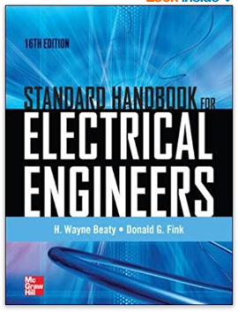

**Abstract**

For more than a century, the *Standard Handbook for Electrical Engineers* has served as the definitive source for all the pertinent electrical engineering data essential to both engineering students and practicing engineers. It offers comprehensive information on the generation, transmission, distribution, control, operation, and application of electric power.

Completely revised throughout to address the latest codes and standards, the 16th Edition of this renowned reference offers new coverage of green technologies such as smart grids, smart meters, renewable energy, and cogeneration plants. Modern computer applications and methods for securing computer network infrastructures that control power grids are also discussed. Featuring hundreds of detailed illustrations and contributions from more than 75 global experts, this state-of-the-art volume is an essential tool for every electrical engineer.