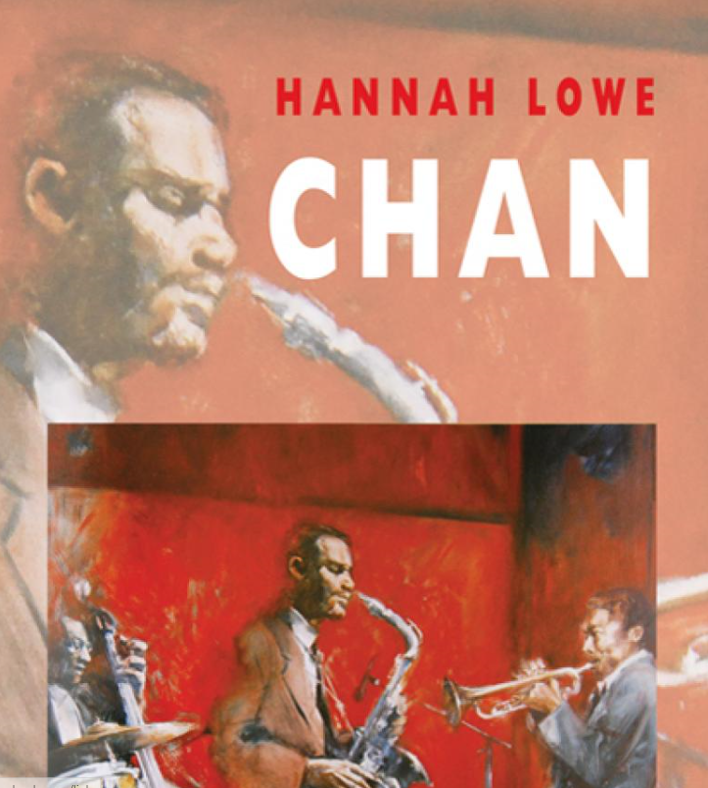

Abstract
Chan is a mercurial name, representing the travellers and shape-shifters of the poems in this collection. It is one of the many nicknames of Hannah Lowe’s Chinese-Jamaican father, borrowed from the Polish émigré card magician Chan Canasta. It is also a name from China, where her grandfather’s story begins. Alongside these figures, there’s Joe Harriott, the Jamaican alto saxophonist, shaking up 1960s London; a cast of other long-lost family; and a ship full of dreamers sailing from Kingston to Liverpool in 1947 on the SS Ormonde.
Hannah Lowe’s second collection follows her widely acclaimed debut, Chick, which took readers on a journey round her father, a gambler who disappeared at night to play cards or dice in London’s old East End to support his family.
‘While life at the border is not always easy, Lowe celebrates the importance of cultural diversity in her poems… by demonstrating that diversity is natural to the development of all societies, and indeed, a beautiful thing. As a woman with a diverse heritage herself, this message occupies a crucial role in the undercurrent of Lowe’s poetry, specifically in the face of the world’s current, culturally protectionist attitudes. Indeed, what is most compelling about Chan is that through the personal Lowe’s work reaches the universal by inviting us ‘to look both ways’. – Amanda Merritt, The London Magazine
‘Lowe's poetry is focussed upon her Chinese-Jamaican father and his milieu between the 1950s and the 1970s… Lowe's verse evokes this subculture's steamy excess in long, loping lyrics… a rediscovery and celebration of a precious segment of the UK's migrant experience.’ Peter Carty, International Business Times (Top 5 Summer Poetry Collections 2016)
‘Hannah Lowe is one of our very best young poets. Her new book Chan is every bit as good as her debut collection Chick… It is a book about memory and the construction of memories, unreliable memories, family memories, invented memories and make-believe, along with the brilliant If You Believe poems.’ – Andy Croft, Morning Star

