Application of Bayesian Estimation to Structural Health Monitoring of Fatigue Cracks in Welded Steel Pipe
Mohd Fairuz Shamsudin¹, Cristinel Mares¹, Carol Johnston², Yoann Lage², Graham Edwards², Tat-Hean Gan^{1,2}
¹Brunel University London,
School of Engineering and Design, Uxbridge, Middlesex UB8 3PH, UK
²TWI Ltd,
Granta Park, Great Abington, Cambridge CB21 6AL, UK
Corresponding author: mohd.shamsudin@brunel.ac.uk

ABSTRACT
Vibration induced fatigue is a well-known problem in oil and gas piping systems. However the use of vibration data to detect damage is not an easy task without a priori knowledge of the undamaged condition. In this paper, level 1: Detection and level 2: Localization of damage from structural health monitoring strategies is adapted for damage identification. An experimental trial of acoustic emission monitoring was run to monitor fatigue damage during a full-scale resonance fatigue test of a girth-welded steel pipe from healthy condition until failure. The pipe was excited into the first mode of vibration using a resonance fatigue testing machine in order to determine the high-cycle fatigue strength of the weld. The information provided by acoustic emission monitoring is useful in evaluating the condition of the pipe during the test and the occurrence of cracking before failure. However, the acoustic emission signals are embedded in noise. To overcome this problem, the signals from different combinations of sensors were recursively cross-correlated, which provides for the derivation of a new effective coefficient (EC) parameter for Bayesian estimation. This parameter is useful for evaluating uncertainty arising from the signals that contribute to source localization errors. The estimation finds the most probable parameters corresponding to cracks using prior knowledge derived from standard pencil lead break tests. The proposed method demonstrates a strong relationship between the acoustic emission energy and the estimated coefficients. A high correlation between signals was found to be associated with cracking, and a low correlation between signals was found to be associated with random signals or noise. The method will be useful for monitoring the condition of piping to manage the risk of vibration induced fatigue failure.
KEYWORDS: Vibration induced fatigue, acoustic emission, Bayesian estimation.

Introduction
Vibration induced fatigue is a well-known problem in oil and gas piping systems
[1]. Various vibration-based monitoring techniques have been implemented in the field of condition (CM) and structural health monitoring (SHM). However, the major challenge in monitoring technology is to detect failure with high confidence. In principle, vibration-based techniques evaluate structural condition from physical and dynamic characteristics. This method is useful particularly for damage detection and localization. However, the information obtained may be insufficient for complex problems of detection and localization of cracks, where the scale of damage is relatively small compared to the overall size of piping system. The difficulty arises due to negligible changes in structural stiffness, and thus no observable change in natural frequencies. Unmeasurable local stresses at crack tips further increase the risk of fatigue failure. In this paper, acoustic emission (AE) is used for damage detection and localization in a welded pipe subjected to dynamic loading by resonance fatigue testing. Acoustic emission is a passive non-destructive testing (NDT) technique due to rapid changes of stress state such as during crack extension. The energy is released as elastic waves that travel within material in the form of microscopic displacements and are then converted into electrical signals by AE sensors. The acoustic emission method is very sensitive to crack evolution. However, the signals are also susceptible to extraneous noise. Therefore Bayesian estimation, which uses a probabilistic approach to estimate the unknown parameters for damage evaluation, is proposed. The estimation was carried out using a signal-based method where the parameter used for Bayesian estimation is derived directly from the signals.

Experimental Setup
A 15 inch diameter carbon steel pipe with a 50mm wall thickness was installed and tested in a resonance fatigue testing machine
[2]. The pipe was 7.2m long and contained a girth weld at mid-length. The pipe was filled with water, which has the effect of increasing the overall mass, and thus reducing the pipe length required for the same resonant frequency if it were empty. The pipe length was calculated based on its mass including the internal medium and both end attachments, to achieve a resonance in the first bending mode at around 30$Hz$. The resonance fatigue test rig comprises a drive unit at one end as shown in Figure 1-a. A ‘balance’ unit is present at the other end for dynamic symmetry. The drive unit contains an eccentric mass which is spun using a motor to provide a rotating radial force to the system. The driving frequency was adjusted to achieve a particular strain range (as measured by strain gauges located at the mid-length of the pipe). The pipe mid-length, where the welded joint is located, is subject to the highest cyclic strain and hence the highest cyclic stress around the pipe circumference. The variation in stress from maximum to minimum is defined as a stress ratio of R=-1, and is superimposed on the axial stress generated by pressurising the water. The water pressure is chosen to produce an axial stress that is half of the applied stress range so that the resulting R ratio is greater than zero (R > 0). The pipe is supported at the nodes of the first vibration mode as illustrated in Figure 1-b, where the displacement is minimal.
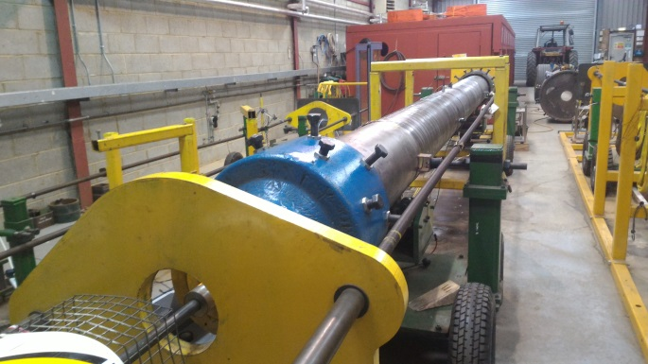  Drive End  Balance End  Nodes  (a) | 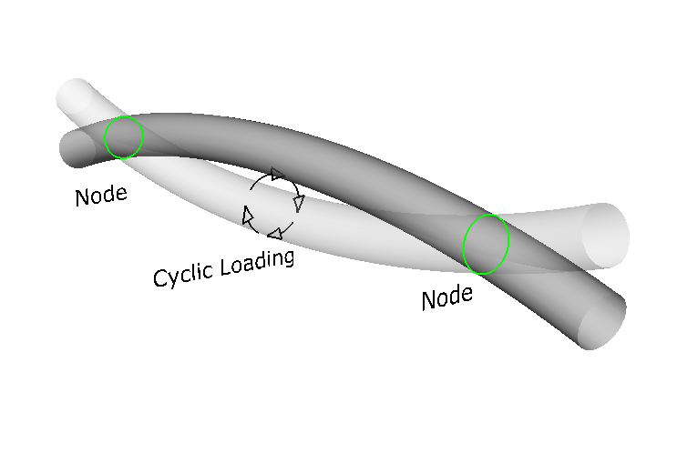  (b)
Figure 1: The test set up. (a) Cyclic excitation is driven by a rotating eccentric mass at the drive end. There is a similar (static) mass at the other (balance) end for dynamic symmetry. (b) Two supports are positioned at the nodes where the pipe displacement is almost negligible.

Instrumentation setup
Four broad band acoustic emission sensors (model VS900-RIC) with built in pre-amplifier from Vallen Systeme were used with a Vallen AMSY-6 multi-channel test system. The system was set to 5$MHz$ sample rate with a band-pass filter between 95$kHz$ and 850$kHz$. The duration discrimination time (DDT) and number of samples were set to $400μs$ and $2,097,152$, respectively, to allow for sufficiently long recording of transient signals. Acoustic emission signals are highly contaminated by extraneous noise such as fretting at the pipe supports. Other sources of noise may be generated due to the mechanisms of fatigue cracking such as crack closure or crack face rubbing. Therefore, appropriate sensor positioning is crucial to avoid unwanted signals. In order to remove the effect of noise generated from the pipe supports and mechanical noise from both pipe ends, guard sensors (the noise will hit the guard sensor before hitting the data sensors) were placed at the 6 o’clock position (see Figure 2) at either side of the nodes close to the pipe supports. Elastic deformation creates additional noise by friction between the sensors and the pipe surface. To overcome these problems, two sensors were located at each node where the local displacement should be minimal, as illustrated in Figure 2. To reduce the uncertainty related to AE signal source location, an asymmetric ring set-up was used allowing each sensor to record different arrival times than the case when all sensors would be located in the same plane. The sensors are attached using magnetic holders with grease between them and the pipe surface.
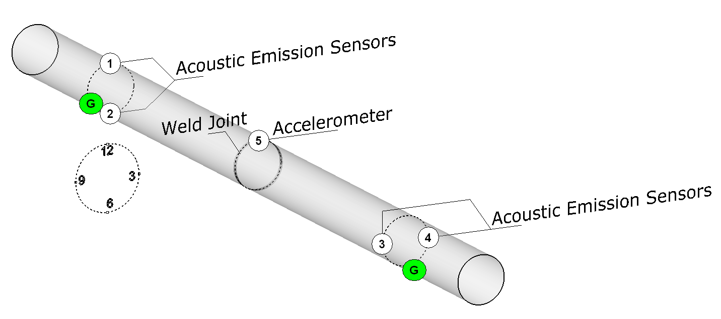
Figure 2: The location setup of acoustic emission sensors (numbered 1-4) at 12, 6, 9 and 3 o’clock positions respectively. A guard sensor (G) was mounted at 6 o’clock position close to each node and an accelerometer was mounted at 12 o’clock position in close proximity to the weld joint.
The vibration measurement was evaluated from the input and output signals. The input (excitation) frequency from the motor was monitored and compared with the output vibration response of an accelerometer mounted near the weld joint. The measured output was fed into the Vallen system as parametric input with a sampling rate of 500$Hz$.

Localization Technique
A planar localization method was used to locate the source of acoustic emission. A maximum time of arrival, $∆t_{max}$ is introduced by limiting the arrival time of sensor signals detected after the trigger sensor signal. The trigger sensor is the first sensor that receives signal above threshold. Limiting the arrival time prevents detection of AE signals outside the assessment area. The asymmetric sensor arrangement provides a triangular pattern for localization where limiting the time of arrival can be applied effectively. However, this method requires a specific arrangement of the sensors such that the defect locations are expected at the circumcentre of a triangular sensor arrangement. In this work, the expected defect location is in the weld areas at the mid-point between the supports where the sensors are placed. The maximum time of arrival can be written as;
 | $$∆t_{max}=\frac{\sqrt{{\left(x-x_{d}\right)}^{2}+{\left(y-y_{d}\right)}^{2}}}{V_{g}}$$ | (1)
where $x_{d},y_{d}$ are the centre of the assessment area (weld area) or equivalently the identified damage locations,$V_{g}$ is the group velocity, and $x,y$ are the extents of the measurement area. This approach removes further uncertainties of falsely detected AE signals, such as reflection from boundaries with longer arrival times than the limit. Figure 3 shows the areas of possible sources marked in red for arbitrary $∆t_{max}$ and$V_{g}$.
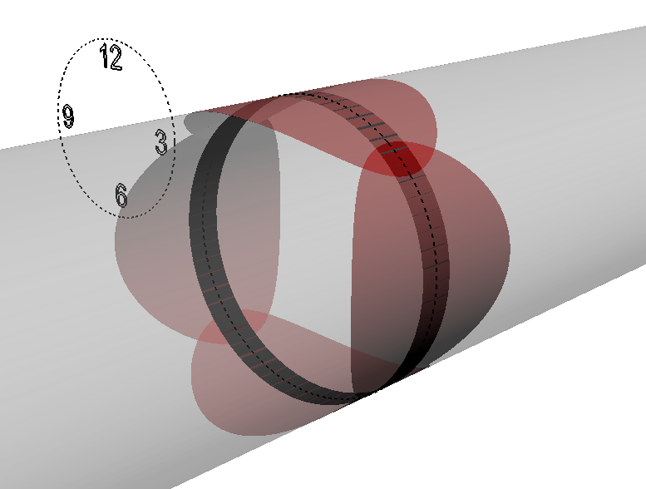
Figure 3: An example of coverage area (red) around weld joint using the proposed triangular sensor arrangement with $∆t_{max}$.

Calibration measurement
The average group velocity, $V_{g}$ is determined by pulsing between acoustic emission sensors (using one as a transmitter and the others as receivers). The propagating waves are identified by comparing the wave velocity against the DISPERSE code
[3], a general purpose program for creating dispersion curves. A high threshold setting of 70dB was used during the calibration to remove the background noise based on initial trials carried out prior to the actual test. The frequency of the arriving waves and their velocity were measured as approximately 180$kHz$ and$3000ms^{-1}$, respectively. Although many wave modes appear at the measured frequency, the calculated velocity is close to the transverse wave velocity (S-wave) in steel, which indicates Rayleigh waves in thick structures. Calibrations using a pencil lead break test (PLB)
[4,5] were performed at the 3, 6, 9 and 12 o’clock positions near the girth weld to examine the reliability of the proposed sensor arrangement. Using the standard localization method provided by the Vallen Systeme, the events were accurately located as shown by the green dots in Figure 4. It has been noted that using a single wave velocity can be erroneous due to the dispersion effect and mode conversion resulting from reflection at boundaries. Crack orientation could also influence the propagating waves
[6]. In this work, the calculated velocity was assumed to be similar to that when the crack propagates through the thickness of the pipe.
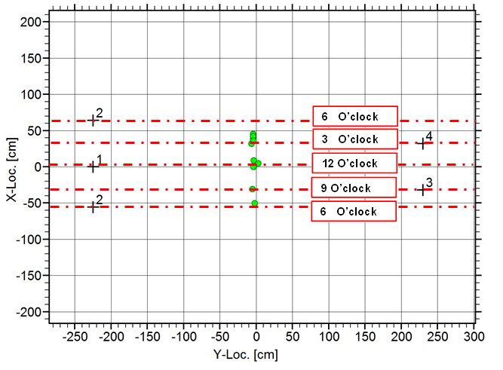
Figure 4: The located events from PLB tests. Sensor 2 is labelled twice which marks a complete pipe revolution.

Signal Processing Method
The literature summarizes many different techniques and approaches for damage detection in structural health monitoring
[7–10]. Generally, selection of features can be categorized as parametric-based or signal-based
[11]. The signal-based method employs signal processing techniques which acquire parameters directly in the time domain, frequency domain or time-frequency domain
[12–15]. The parametric-based method uses explicit physical-dynamic parameters from the measurements
[16–18]. These methods have been applied in many engineering applications. Damage detection using signal-based methods receives less attention due to large uncertainties associated with the measurement output. Thus, in this paper, Bayesian estimation is used to reduce the uncertainties rising from the signals acquired in extreme conditions during resonance fatigue tests. In comparison with the above signal processing techniques, Bayesian estimation takes advantage of a priori information from past measurements and updates the prior based on the current data. The posteriors are the probability distribution where inferences can be made about the underlying parameters. The results are compared with acoustic emission burst energy, which is attributed to the rapid change of stress state within the pipe as a result of fatigue damage.

Cross Correlation of Signals
Cross correlation is a method to find correlation between two signals. The method is useful to measure similarity of signals
[19] or their time differences for source localization
[20]. In general, a cross correlation$ϕ_{x,y}(τ)$ between two functions $x\left(t\right)$ and $y\left(t\right)$ can be calculated as follows;
 | $$ϕ_{x, y}(τ)=\lim_{T→∞}{\int_{-T}^{T}{x\left(t\right)}y\left(t+τ\right)dτ}$$ | (2)
The cross correlation functions are a matrix of cross correlation values obtained by shifting one signal relative to the other. These values are based on the length and amplitude of the signals. The maximum values can be normalized by the autocorrelation of each signal at zero lag to obtain a cross correlation coefficient between zero and one as follows;
 | $${\overline{ϕ}}_{i,j}=\frac{max\left|ϕ_{i,j}(τ)\right|}{\sqrt{ϕ_{i,i}{\left(0\right)ϕ}_{j,j}(0)}}$$ | (3)
where;
$ϕ_{i,j}(τ)$ is the cross correlation function of signals $i$and$j$ at lag of $τ$
${\overline{ϕ}}_{i,j}$ is the cross correlation coefficient of signals $i$and$j$
$ϕ_{i,i}(0)$ is the autocorrelation of signals for sensor$i$at lag of zero
Acoustic emission signals are susceptible to extraneous noise and may consist of burst-type signals that are normally generated from rapid released of energy such as cracks, or continuous signals resulting from plastic deformation
[21,22]. Continuous emission can also be generated due to rubbing of materials in contact during dynamic motion. The significance of using cross correlation for acoustic emission signals is that some signals with specific characteristics can be distinguished from other signals detected at the same instance. In this paper, Bayesian estimation is inferred from a set of time series signals represented by the effective coefficients (EC) from all possible sensor/signals combinations. The relationship can be described as follows;
 | $$EC= α(Min {\overline{ϕ}}_{i,j})$$ | (4)
where;
$α$ is the correction factor $Min {\overline{ϕ}}_{i,j}/Max {\overline{ϕ}}_{i,j}$
${\overline{ϕ}}_{i,j}$ is the cross correlation coefficient of signals $i$and$j$
EC measures a minimum degree of similarity of the correlated signals taking into account the maximum and minimum cross correlation coefficients of any two signals from the located events. Using this relationship, if all signals are perfectly similar then the ratio$Min {\overline{ϕ}}_{i,j}/Max {\overline{ϕ}}_{i,j}$ is equal to one. Therefore, the EC in this case is also one. If only two out of three signals are similar, then the less correlated signals reduce the calculated EC. An example of this is illustrated in Figure 5. The signal which is different in b) that is continuous rather than a short burst is at sensor 1. Using this relationship any located event that has high EC means the signals are similar. However, the coefficients calculated from the cross correlation are highly dependent on the lengths and amplitudes of the signals which will have an impact on the measured EC. A number of PLBs (i.e. similar calibration techniques as described in section 2.3) were carried out around the weld circumference to obtain a range of EC values for various signal lengths between $50μ$ and $500μs$ in increments of$50μs$.
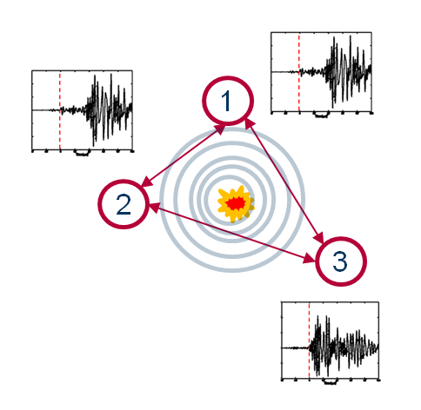  (a) | 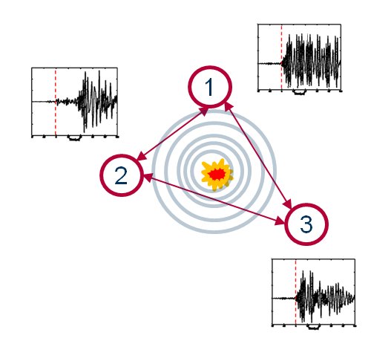  (b)
Figure 5: The located events from (a) high EC values (b) low EC value.

Bayesian Estimation
Bayes’s Theorem is attributed to Reverend Thomas Bayes (1702-1761). The premise of using Bayesian methods is based upon the ‘degree-of-belief’ interpretation of probability. The ‘belief’ is updated upon ‘seeing’ evidence, which updates the distribution of parameters. Statistical inferences can be made from the updated distributions either by point or interval estimates
[23,24], such as the mean values of the posterior distributions. Bayesian estimation consists of a prior probability distribution,$P\left(θ\right)$ which is the initial hypothesis of random parameters that cannot be measured directly. It represents the distribution of the sought-after parameters before considering any observations (i.e. the input data). In this work the prior knowledge is assumed to follow the distribution obtained from the pencil lead break tests, which is considered the most relevant method to simulate cracks. The quality of the process depends on the likelihood function$P\left(D | θ\right)$ which finds the most probable data set for different values of$θ$. Bayes’s theorem can be written as follows;
 | $$p\left(θ | D\right)=\frac{p\left(D | θ\right)p\left(θ\right)}{\int_{-∞}^{∞}{p\left(D | θ\right)p\left(θ\right)dθ}}$$ | (5)
where;
$θ$ - The sought-after parameters or variables
$D$ - The observed data

Analysis Procedures
In Bayesian estimation, the integration in the denominator of Eq. 5 (i.e. “evidence”) must be carried out over a high-dimensional space and may not be tractable. This problem is usually solved using the Markov Chain Monte Carlo (MCMC) method
[25,26] which enables the solution of integrals over high dimension probability distributions. The Monte-Carlo method approximates the integration of a continuous random variable$, θ$ , by summation over a large number of discrete random variables${ θ}^{(i)} i=0,1,2,..,N$, which is independent and identically distributed$(i.i.d)$. The solution is computed by concentrating the samples $θ^{(i) }$in the regions of high probability. The stochastic process of Markov Chain Monte Carlo (MCMC) method
[26], is referred to as a guided random walk which combines multiple samples sequentially. In the estimation of the posterior distribution, a chain of distributions of the random variables is constructed. The sequence of distributions tends to equilibrium, independent of the initial estimate. The convergent to posterior distributions i.e. $p\left(θ | D\right)$ is termed the stationary distribution of the Markov chain such that $f\left(θ^{\left(τ+1\right)} | θ^{\left(τ\right)},…,θ^{\left(0\right)}\right)=f(θ^{\left(τ+1\right)}|θ^{(t)})$. This means the parameter distribution $θ^{(t+1)}$ at step $t+1$ depends only on $θ^{(t)}$ and is independent of $t$.

Bayesian Model
The WinBUGS
[27] (Bayesian Inference Using Gibbs Sampling
[28]) program is used to generate samples from full conditional distributions of the posterior distribution
[29]. The likelihood estimation of the parameter is assumed to follow a Gaussian distribution given the random nature of the fatigue damage process. The likelihood is formulated as follows;
 | $$p\left(D | θ\right)=p\left(D | μ,τ\right)=\sqrt{\frac{τ}{2π}}exp⁡\left(-\frac{τ}{2}\sum_{i=1}^{N}{{\left(EC_{i}-μ\right)}^{2}}\right)$$ | (6)
where;
$μ$ is the mean of the distribution
$τ$ is the precision or inverse of variance$σ^{2}$
The prior distribution for the samples’ precision,${ τ}_{0}$, in this case is set to follow the Gamma distribution $τ_{0}\sim Γ(r,μ)$; where $r$ is the shape parameter and $μ$ is the rate parameter. The parameters are unknown and hence$r, μ=0.001$. However, “Informative prior” is used for $μ_{0}$ based on the fitted distribution from the PLB tests. Therefore the posterior distribution is;
 | $$p\left(μ | D\right)∝p\left(D | μ,τ\right)p(μ|μ_{0},τ_{0})$$ | (7)
In this model the mean of the posterior distribution is indeed the most probable EC. The estimation was carried out with the signals obtained from the located events. The signals were extracted and cross correlated in MATLAB®. The EC values were calculated for each event and imported into WinBUGS for estimation. A schematic of the process is illustrated in Figure 6. During the estimation process, there is non-stationary period known as a “burn-in” stage at the beginning of the iterations before the Markov chain is converged. These values are discarded in the final estimation.
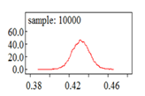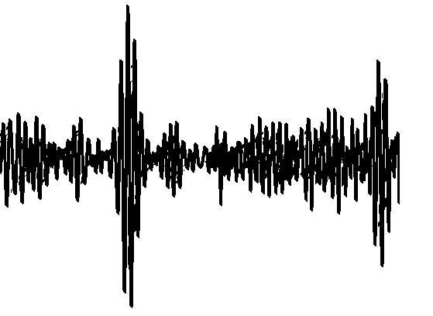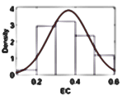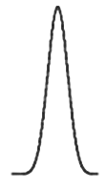
Transient signals
Transient signals
Data sorting
Located events from PLB tests
Located events from fatigue test
Data processing
MATLAB®
Bayesian estimation in
WinBUGS
Data processing
MATLAB®
Evaluation of the estimated EC
Figure 6: Estimation process flow chart.

Results and Discussion
The resonance tests lasted in this experiment from start-up to failure for six days (corresponding to 14,106,360 applied cycles). The drive motor was stopped by a trip system immediately as the internal pressure in the pipe dropped rapidly when a through-wall crack was present. The failure location was identified at the 6 o’clock position where a 4mm long crack was present on the pipe outer wall. The crack had initiated on the inner surface and propagated through the pipe thickness. The vibration frequencies were calculated to be 30Hz consistent over one hour durations at the beginning and end of the test. This shows that the excitation frequency of the pipe remained constant throughout the test, and is equal to the resonance frequency. The vibration amplitudes increase considerably towards the end of the test, and additional frequencies of approximately 50Hz emerged as soon as the drive motor was stopped allowing the pipe to come freely to a stop. These frequencies were identified as corresponding to damage as reported in the authors’ separate paper
[30]. The acoustic emission test recorded significant events in the last three days of the test when cracks were actively propagating. Therefore only these results were post-processed to demonstrate the practicality of using the proposed method. In this experiment the potential crack location is around the weld joint and hence damage was expected to concentrate in this area. However, the located events are distributed across the entire mid-section and span about 100cm in each direction along the pipe length from the weld joint as shown in Figure 7-a. This implies the located events are uncertain due to large false events being recorded, and hence motivates the current research to understand the signals which generated these events. Figure 7-b shows the AE burst energy corresponding to those events. There are peaks of AE energy towards the end of Day 4. However the energy is relatively low before the pipe failed, which requires further investigation.
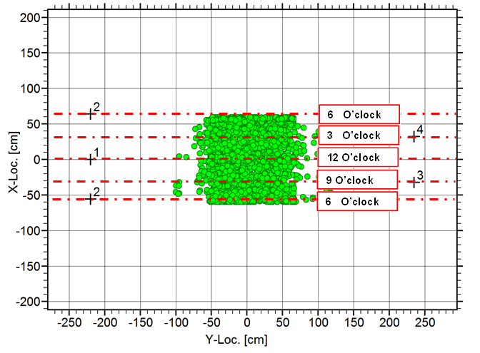  (a) | 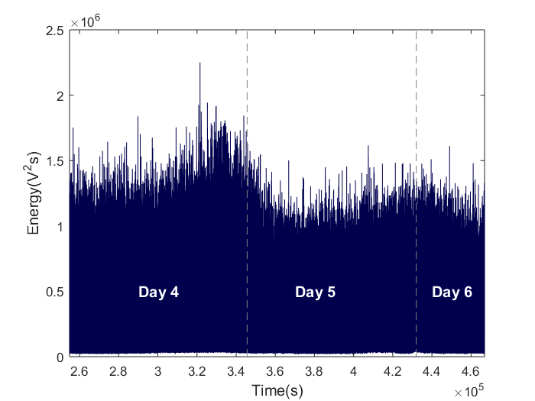  (b)
Figure 7: test (a) Located events on the pipe. Sensor 2 is labelled twice, marking a complete pipe revolution (b) Acoustic emission energy recorded for the last three days of the fatigue test.
The acoustic emission signals associated with the located events were identified not only as typical burst signals that are normally observed from crack-related activities. There are several random signals which are continuous and have long signal duration. Figure 8-a shows the signals from sensors 1-3, which are more random in nature, despite some signal peaks being recorded. Although the signals from sensor 3 may have some burst-like formation, the acoustic emission event was actually generated from the combination of less-well correlated signals as can be seen from the correlogram in Figure 8-b. In contrast, the event generated by the other sensor combination shown in Figure 9-a and Figure 9-b provide better correlation, and such signals are predominantly generated from cracks. Therefore, based on this idea, Bayesian estimation is used to estimate recursively the credible parameter derivable according to this relationship, and to compare with the acoustic emission energy.
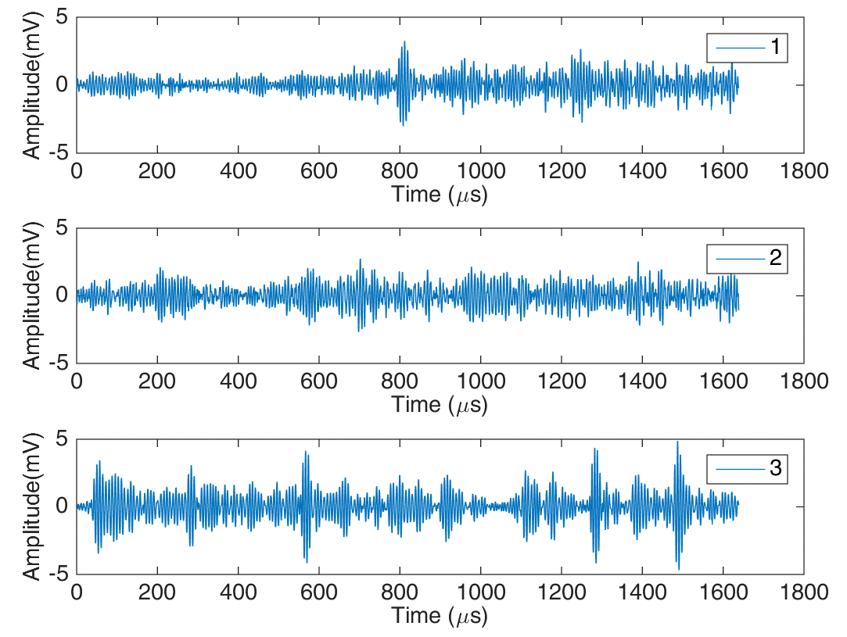  (a) | 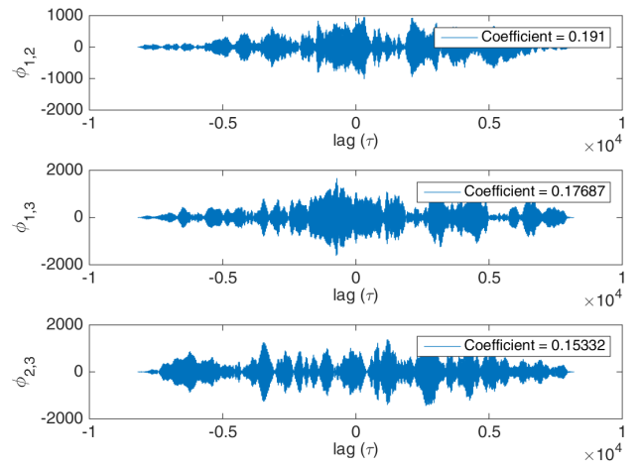  (b)
Figure 8: (a) Typical random signals recorded at sensor 1 – 3. (b) Low correlations of the random signals calculated for different combinations of signals.
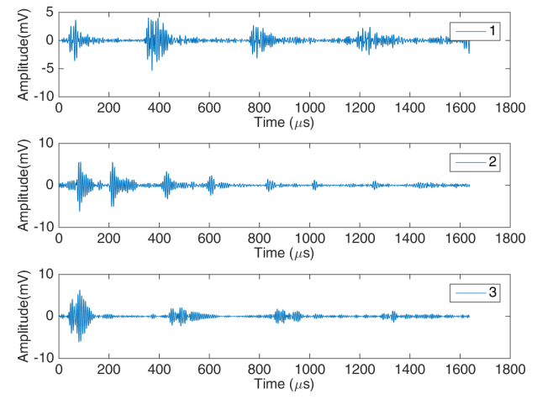  (a) | 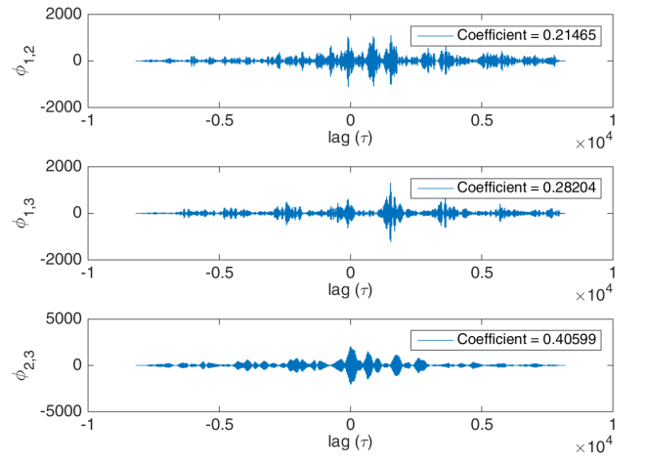  (b)
Figure 9: (a) Typical burst-like signals recorded by sensor 1 – 3. (b) High correlations of the burst-like signals calculated for different combinations of signals.
The weld joint is at the mid-point between sensors 1, 2 and 3, 4. The asymmetric sensor arrangement can make four combinations of isosceles triangular patterns i.e. 2-4-1, 4-1-3, 1-3-2 and 3-2-4, as illustrated in Figure 10. In contrast, the events located in Figure 7-a are based on all available sensors, and hence not in a triangular pattern. The maximum time of arrival $∆t_{max}$ limits the acquisition system to capture only the events generated near the weld area. Figure 10 shows the located events after limiting the time to 50$μs$ which covers the entire weld circumference. There are a number of located events recorded around the weld joint apart from the location of the failure at the 6 o’clock position (i.e. Figure 10-d), as a result of the applied cyclic stress around the pipe circumference. The located events (marked in green) were recorded repeatedly before the crack finally emerged on the pipe. The observation is consistent with the increase of AE energy towards the end of the test as shown in Figure 11. The gaps in Figure 11 imply some AE energy depicted in Figure 7-b could be generated outside the weld area.
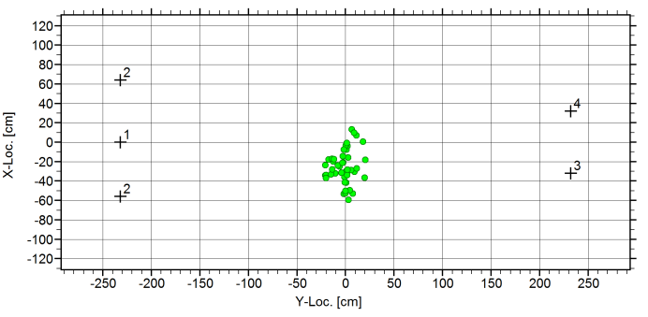  (a) 1-3-2 | 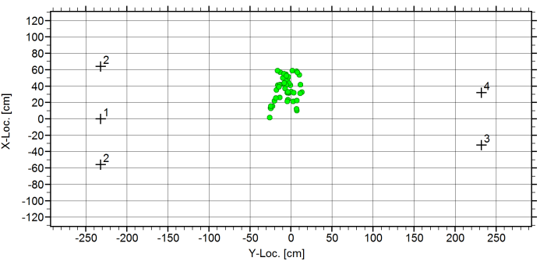  (b) 2-4-1
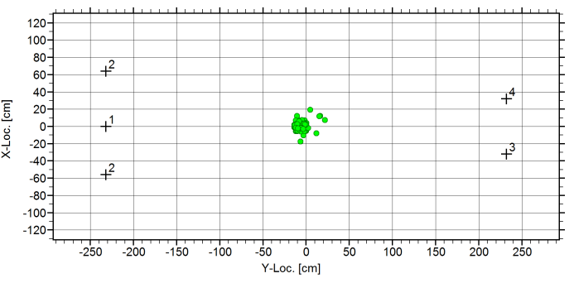  (c) 4-1-3 | 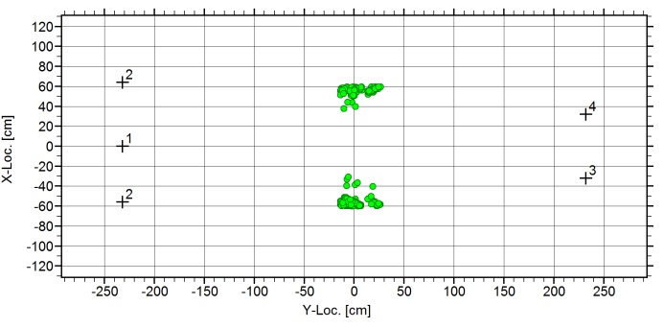  Failure location  (d) 3-2-4
Figure 10: Located acoustic emission events filtered by $∆t_{max}$. Sensor 2 is labelled twice which indicates a complete pipe revolution. The marked areas are the located events immediately before failure.
EC was estimated in 20 intervals of equal length of time. There is no rule on the selection of the number of intervals. For this assessment the selected number of intervals is considered sufficient given a clear distinction of successive events and that gaps are made in some intervals as illustrated in Figure 11.
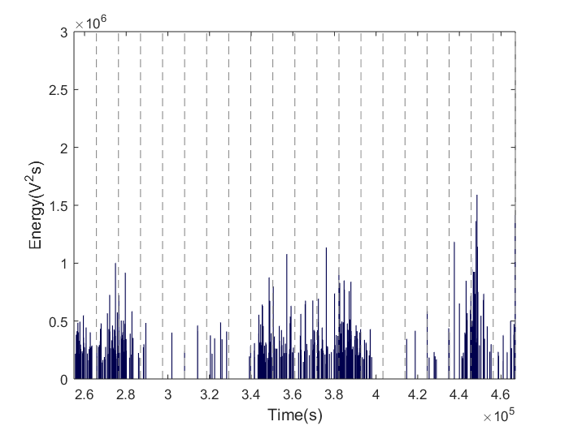
Figure 11: The acoustic energy obtained from the signals of the located events when $∆t_{max}$is used.

Bayesian estimation
Examples of the PLB signals are shown in Figure 12-a. A range of EC values were determined for various signal lengths and the distributions obtained are shown in a whisker plot (Figure 12-b). A larger signal length results in reduction of the mean values and variance.
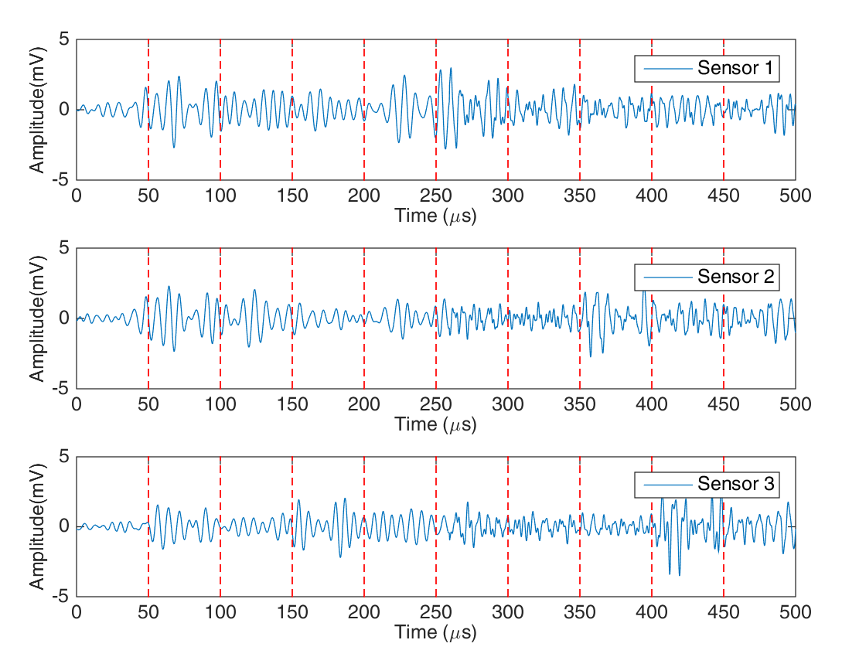 (a) | 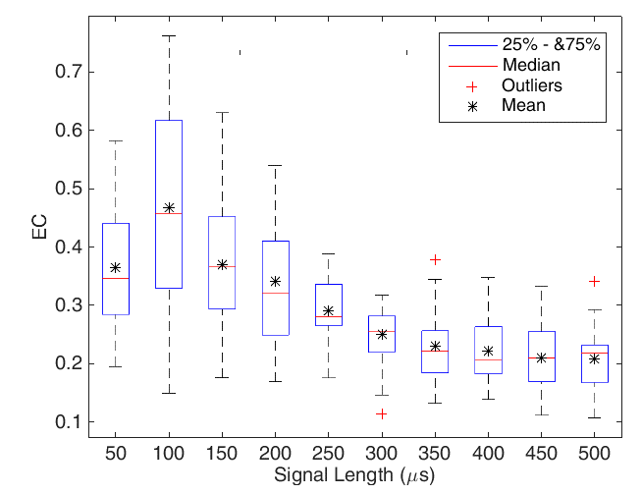  (b)
Figure 12: Distribution of cross correlation coefficients of various signal durations.
As can be seen from Figure 12-a, a larger signal length accommodates larger signal variations. Each signal length provides important information for Bayesian estimation, thus these distributions are assumed to provide an important reference for crack damage. The priors derived from the PLB tests are assumed to have normal distribution based on the distributions of EC for each signal length as shown Figure 12-b. A summary of these values is tabulated in Table 1.
Signal length ($μs)$ |  | $$\overline{EC}$$ |  | $$σ^{2}$$ |  | $$τ=\frac{1}{σ^{2}}$$
50 |  | 0.376 |  | 0.01075 |  | 93.05
100 |  | 0.502 |  | 0.02238 |  | 44.68
150 |  | 0.359 |  | 0.01239 |  | 80.71
200 |  | 0.323 |  | 0.01087 |  | 92.03
250 |  | 0.290 |  | 0.00291 |  | 343.25
300 |  | 0.251 |  | 0.00210 |  | 477.09
350 |  | 0.224 |  | 0.00314 |  | 318.28
400 |  | 0.217 |  | 0.00303 |  | 330.14
450 |  | 0.205 |  | 0.00312 |  | 320.88
500 |  | 0.204 |  | 0.00274 |  | 364.90
Table 1- The prior distribution
The 100$μs$ signal length has the largest spread of EC values with the highest mean. The arrival signals from each sensor for this duration are very similar as shown in Figure 12-a. However, the signals below 50$μs$ are of small magnitude within the pre-trigger duration and hence are not considered as the prior. Likewise, the means of the distributions above 300$μs$ converge to a single mean value as shown in Figure 12-b. Therefore the estimation was made for each signal length from 100$μs$ to 300$μs$. Bayesian estimation was carried out for the signals obtained from the located events of the resonance fatigue test. The 95% credible intervals of the estimated means from the posterior distributions are plotted with the AE burst energy in Figure 13.

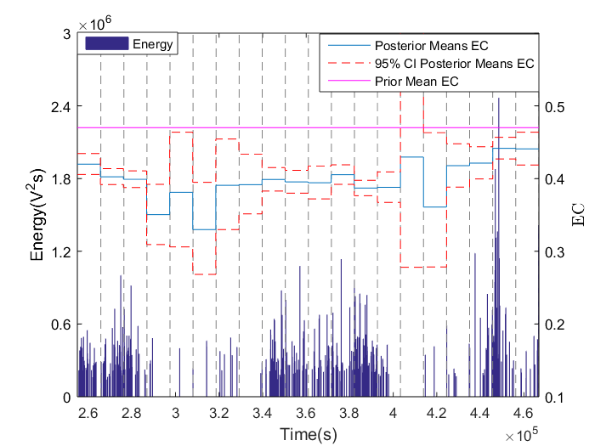  (a) | 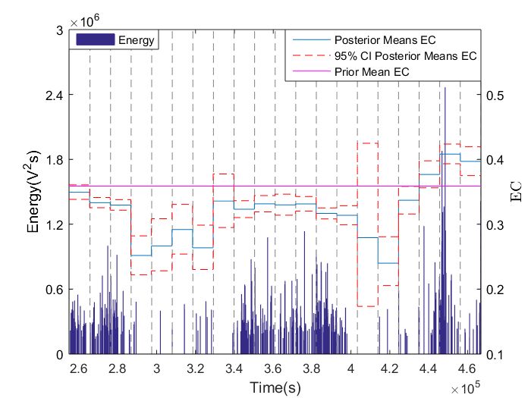  (b)
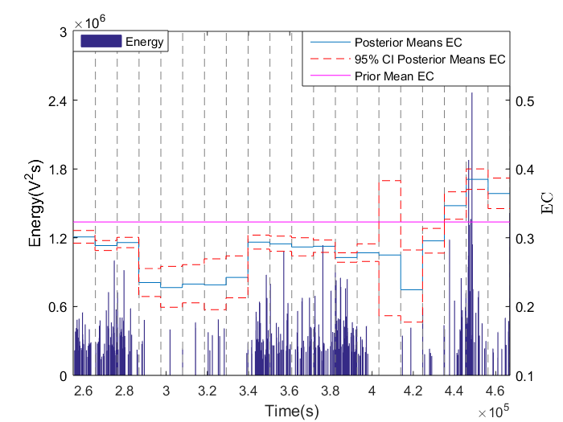  (c) | 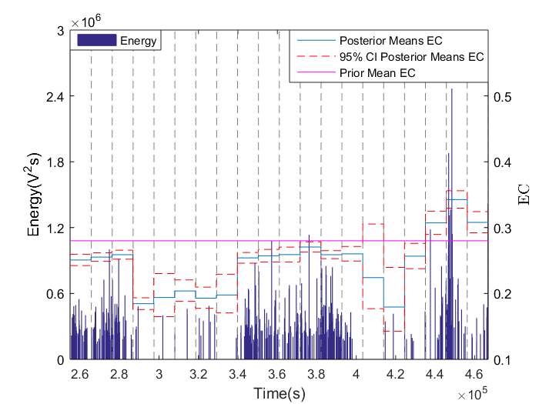  (d)
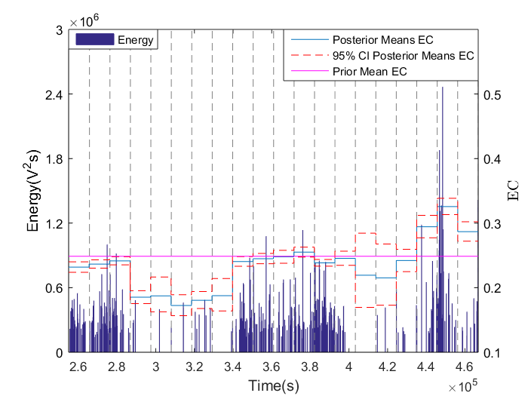
(e)
Figure 13: The estimated EC means with 95% credible intervals and the prior mean values from the PLB tests for various signal lengths (a) 100$μs$ (b) 150$μs$ (c) 200$μs$ (d) 250$μs$ (e) 300$μs$. The estimated ECs are plotted with the AE burst energy for comparisons. The highlighted red and green areas are the intervals where the majority of located events are away from the weld area.
Interesting observations can be seen from the estimated EC for different signal lengths. The estimation for$100μs$ signal length has a large EC variance particularly in the highlighted intervals, which is largely contributed by the variance from the prior distribution. Almost all of the estimated means are below the reference mean derived from the PLB tests. The reason is believed due to the fact that signals generated by PLB are not perfectly similar to the actual crack signals as shown in Figure 9-a and Figure 12-a. The distinction of the waves generated by the PLB on the pipe surface with respect to the actual cracks originally initiated within the weld is also noted. The similarity is more pronounced before the pipe failure since the sources are mainly near the surface. In these intervals the estimated EC for all signal lengths is higher compared to preceding intervals. For larger signal lengths, the estimated EC is lower for all intervals; the means of the highlighted (red) intervals in Figure 13 are consistently below the reference means, apart from the highlighted (green) intervals where uncertainties remain due to the large estimation of variance. The AE energy is mostly empty for these intervals, which implies that the low EC values are mainly events generated outside the weld area. The uncertainties of the located events can be justified by studying the 95% confidence level of the estimated means; for the estimated EC within the same intervals as when the AE energy was recorded using the filtering method (i.e. maximum time of arrival$∆t_{max}$), most of them are very close to the reference means which implies the located events are indeed related to damage.

Conclusions
In this work, Bayesian estimation of the effective coefficients (EC) derived from the cross correlation of AE signals was undertaken for a resonance fatigue test of a welded pipe. The premise of the Bayesian method to estimate credible EC is based on similarity of signals and makes use of the prior information from pencil lead break (PLB) tests to evaluate the uncertainties of the located events. A large number of data were generated during the test and errors in source localization were encountered. The acquired results did not produce good indications of damage evolution by studying the AE energy of the identified sources which were mostly generated by extraneous signals. The signals corresponding to these energies were quantified using Bayesian estimation. It was found that good correlation signals are most likely to be associated with cracks, and hence high EC values were estimated. The proposed method is able to evaluate the uncertainties of the located events. The method can thus potentially be used as an additional tool to increase confidence in source localization in AE testing and for monitoring crack growth in extreme conditions.

Acknowledgement
This publication was made possible by the sponsorship and support of Fatigue Integrated Management and Condition & Structural Monitoring sections at TWI, Brunel University London, and Majlis Amanah Rakyat (MARA). The work was enabled through, and undertaken at, the National Structural Integrity Research Centre (NSIRC).

References
[1] Health & Safety Executive, “Offshore Hydrocarbon Releases Statistics And Analysis,” Health & Safety Executive, 2003.
[2] Y.-H. Zhang and S. Maddox, “Development of fatigue testing of full-scale girth welded pipes under variable amplitude loading,” in ASME 2011 30th International Conference on Ocean, Offshore and Arctic Engineering, 2011, pp. 481–486.
[3] B. P. Michael Lowe, DISPERSE, 2.0.20a ed. Non-Destructive Testing Laboratory, Department of Mechanical Engineering, Imperial Colleage London, 2013.
[4] ASTM, “Standard for Leak Detection and Location using Surface-Mounted Acoustic Emission Sensors, E1211-02,” ASTM International, Book of Standards Vol. 03.03.
[5] ASTM, “Standard Practice for Continuous Monitoring of Acoustic Emission from Metal Pressure Boundaries, E1139-02,” ASTM International, Book of Standards Vol. 03.03.
[6] M. R. Gorman and W. H. Prosser, “AE source orientation by plate wave analysis,” J. Acoust. Soc. Am., vol. 90, 1991.
[7] E. P. Carden and P. Fanning, “Vibration based condition monitoring: a review,” Structural health monitoring, vol. 3, no. 4, pp. 355–377, 2004.
[8] S. W. Doebling, C. R. Farrar, M. B. Prime, and D. W. Shevits, “A summary review of vibration-based damage identification methods,” Shock and vibration digest, vol. 30, no. 2, pp. 91–105, 1998.
[9] W. Fan and P. Qiao, “Vibration-based damage identification methods: a review and comparative study,” Structural Health Monitoring, vol. 10, no. 1, pp. 83–111, 2011.
[10] H. Sohn, C. R. Farrar, F. M. Hemez, D. D. Shunk, D. W. Stinemates, B. R. Nadler, and J. J. Czarnecki, A review of structural health monitoring literature: 1996-2001. Los Alamos National Laboratory Los Alamos, NM, 2004.
[11] L. Qiao, A. Esmaeily, and H. G. Melhem, “Signal pattern recognition for damage diagnosis in structures,” Computer-Aided Civil and Infrastructure Engineering, vol. 27, no. 9, pp. 699–710, 2012.
[12] E. P. Carden and J. M. Brownjohn, “ARMA modelled time-series classification for structural health monitoring of civil infrastructure,” Mechanical systems and signal processing, vol. 22, no. 2, pp. 295–314, 2008.
[13] H. Sohn, J. A. Czarnecki, and C. R. Farrar, “Structural health monitoring using statistical process control,” Journal of Structural Engineering, vol. 126, no. 11, pp. 1356–1363, 2000.
[14] H. Sohn and C. R. Farrar, “Damage diagnosis using time series analysis of vibration signals,” Smart materials and structures, vol. 10, no. 3, p. 446, 2001.
[15] H. Sohn, K. Worden, and C. R. Farrar, “Statistical damage classification under changing environmental and operational conditions,” Journal of Intelligent Material Systems and Structures, vol. 13, no. 9, pp. 561–574, 2002.
[16] C. Huang, S. Hung, C. Lin, and W. Su, “A Wavelet-Based Approach to Identifying Structural Modal Parameters from Seismic Response and Free Vibration Data,” Computer-Aided Civil and Infrastructure Engineering, vol. 20, no. 6, pp. 408–423, 2005.
[17] J.-T. Kim, Y.-S. Ryu, H.-M. Cho, and N. Stubbs, “Damage identification in beam-type structures: frequency-based method vs mode-shape-based method,” Engineering structures, vol. 25, no. 1, pp. 57–67, 2003.
[18] J. B. Kosmatka and J. M. Ricles, “Damage detection in structures by modal vibration characterization,” Journal of Structural Engineering, vol. 125, no. 12, pp. 1384–1392, 1999.
[19] M. Shehadeh, J. Steel, and R. Reuben, “Acoustic emission source location for steel pipe and pipeline applications: the role of arrival time estimation,” Proceedings of the Institution of Mechanical Engineers, Part E: Journal of Process Mechanical Engineering, vol. 220, no. 2, pp. 121–133, 2006.
[20] S. M. Ziola and M. R. Gorman, “Source location in thin plates using cross-correlation,” The Journal of the Acoustical Society of America, vol. 90, no. 5, pp. 2551–2556, 1991.
[21] K. ONO, H. CHO, and M. Takuma, “THE ORIGIN OF CONTINUOUS EMISSIONS,” Journal of Acoustic Emission, vol. 23, p. 206, 2005.
[22] A. Rao, “Acoustic emission and signal analysis,” Defence Science Journal, vol. 40, no. 1, p. 55, 1990.
[23] J. L. Beck and S.-K. Au, “Bayesian updating of structural models and reliability using Markov chain Monte Carlo simulation,” Journal of Engineering Mechanics, vol. 128, no. 4, pp. 380–391, 2002.
[24] J. L. Beck and L. S. Katafygiotis, “Updating models and their uncertainties. I: Bayesian statistical framework,” Journal of Engineering Mechanics, vol. 124, no. 4, pp. 455–461, 1998.
[25] W. K. Hastings, “Monte Carlo sampling methods using Markov chains and their applications,” Biometrika, vol. 57, no. 1, pp. 97–109, 1970.
[26] N. Metropolis and S. Ulam, “The monte carlo method,” Journal of the American statistical association, vol. 44, pp. 335–341, 1949.
[27] D. J. Lunn, A. Thomas, N. Best, and D. Spiegelhalter, “WinBUGS-a Bayesian modelling framework: concepts, structure, and extensibility,” Statistics and computing, vol. 10, no. 4, pp. 325–337, 2000.
[28] S. Geman and D. Geman, “Stochastic relaxation, Gibbs distributions, and the Bayesian restoration of images,” Pattern Analysis and Machine Intelligence, IEEE Transactions on, no. 6, pp. 721–741, 1984.
[29] E. I. George and R. E. McCulloch, “Variable selection via Gibbs sampling,” Journal of the American Statistical Association, vol. 88, no. 423, pp. 881–889, 1993.
[30] M. F. Shamsudin, C. Mares, C. Johnston, G. Edwards, and T.-H. Gan, “Vibration and Acoustic Emission Monitoring of a Girth Weld during a Resonance Fatigue Test. In 24th International Congress on Sound and Vibration 23-27 July, 2017 London,” 2017.

