Experimental investigation of temperature distribution in non - heated and pre - heated hot mix asphalt patch repair
J. Byzyka, M. Rahman & D.A. Chamberlain
Brunel University, London, United Kingdom

ABSTRACT: This study focuses on the issue of hot mix asphalt patch repairs, the performance of which is greatly reduced by repair edge disintegration. This is caused by low interface temperatures during the repair operation which result in poor bonding between the fill material and the host pavement. Twelve shallow repairs comprising six non-heated and six pre-heated for 10 min 15 s with an experimental infrared heater have been investigated. Temperatures were measured at the repair interfaces during the laying and compaction of the fill mixture. The lowest temperatures were located at corners and vertical boundaries due to high thermal contact resistance in these interfaces. Comparing pre-heated with non-heated repairs, the temperatures at corners and at vertical faces increased in an average 10.85 ºC - 24.45 ºC and 34.97 ºC respectively. Such temperature increases are important for enhancing repair boundary fusion and interfacial bonding.

InTroduction
One of the major distresses in asphalt pavement is potholes. They can be locally developed and are created due to base or subgrade failure, poor drainage and poor workmanship (Lavin 2003, Thom 2008). Hot or cold mixture can be used as pothole filling, nevertheless, cold mixtures tend to be less durable than hot ones. Common compaction equipments are small and manually controlled rollers or vibrating plates (Thom 2008, Washington State Department of Transportation 2013). Sometimes, both rollers and plates are used to achieve the required density.
However, compaction of a thin layer of asphalt, such as that in most patching operations, has been always a struggle since there is not sufficient time available to compact the mix with temperatures reaching rapidly cessation levels (Thom 2008). Asphalt pre-compaction temperatures, wind velocity and environmental conditions at the time of the repair will affect this rapid decrease in temperature. Further, fast cooling is mainly observed in the edges of the repair due to cold underlying asphalt layer resulting in low dense interfaces and weak points prone to premature failure (Dong et al. 2014, Byzyka et al. 2017a).
Heating the underlying layer, prior to pothole filling and compaction, could possibly enhance the bonding between the cold host pavement and the new hot-fill mix and decrease early edge disintegration and repair failure. Infrared, microwave or induction heating systems are used for this purpose and studied by other researchers (Clyne et al. 2010, Uzarowski et al. 2011, Freeman & Epps 2012, Leininger 2015, Obaidi et al. 2016). However, temperatures in the repair interfaces of current patching practices have not been yet examined and correlated to repair failure. Defining patching temperatures will help to determine effective pothole heating procedures.
As a result, the objective of this research is to quantify the temperatures in the repair boundary during pothole filling and compaction of non-heated and pre-heated repairs repaired using infrared heat. The results will direct future research goals on improving the performance and longevity of patching as a result of pothole pre-heating with infrared heat.
In this study, non-heated potholes were repaired using common patching procedure. Whereas pre-heated potholes were repaired using an experimental infrared heater prior to pothole filling and compaction. The heater is presented in reference Byzyka et al. (2017b). Its main features include two plates that are capable of heating asphalt independently by radiating heat at different heat powers; an advanced controller; and infrared heat application at different heights, in motion or stationary above the asphalt surface.
The experiments were executed in a laboratory environment. Repair parameters such as pothole size, composition of asphalt mixtures and temperatures of pothole fill mixtures were kept the same to minimise their effect on the performed repairs. Non-heated and pre-heated repairs were performed as a pair in one slab for simultaneous comparison of interface temperatures between the repairs. The pothole cavities were artificially created. Therefore, the cutting, squaring up of the pothole excavation and its cleaning from water and debris that are usually performed in common patching was not essential.

EXPERIMENTS

Materials
In total, six slabs were built, and twelve potholes were repaired: six non-heated and six pre-heated repairs heated for 10 min 15 s applying radiative heat. Temperatures were measured at the corners, vertical and bottom repair interfaces. Table 1 shows the executed experimental program.
The test samples comprised of the host pavement and two pothole repairs. The host pavement was built with 20 mm dense bitumen macadam (DBM) mixture, granite aggregates and limestone filler. The bitumen used was 100/150 pen. The simulated potholes were repaired with 6 mm dense graded mixture (AC-6) and similar aggregate and filler types with the host pavement. Figure 1 presents the gradation curves of the asphalt mixtures.
The design of the described mixtures conforms to BS EN 13108 (British Standards Institution 2010) and the binder complies with the Manual of Contract Documents for Highways Works (2008). The preparation of the aggregates, filler and bitumen prior to mixing, the mixing of the asphalt, and the procedure followed to control asphalt temperatures conforms to BS EN 12697-35 (British Standards Institution 2016).

Construction of slabs
A steel mould 700 × 700 × 150 mm³ was used to build the slabs of this study with final dimensions 695 × 695 × 100 mm³ (Fig. 2). The slabs were built upside down, in twelve asphalt batches of 7.6 kg each and compacted in two lifts of 50 mm deep using a vibrating plate (Department of Transportation Roads, Standard Code of Practice, New Roads and Street Works Act 1991, 2010). The two lifts were bonded by pre-heating the compacted first lift with the described infrared heater in section 1 to an average surface temperature 110 ºC (± 10 ºC). The pre-heating time was 3 min and was applied prior to placement of the second lift. Each lift was compacted for 7 min.
Two artificial pothole excavations were designed per slab. The size of the excavations was 306 × 165 × 45 mm³. They were created using two steel pothole moulds prior to filling of the slab with asphalt mixture. The moulds, marked as A and B in Figure 2, indicate non-heated and pre-heated potholes repaired respectively. The moulds were removed from the slabs using the infrared heater after 19 hours of the construction of the slab.
Table 1. Slabs and their use in pothole repair.
 |  |  | Pothole A | Pothole B
Pothole size | Use of slab | Slab no. | Non-heated  repairs | 10 min 15 s pre-heated repair
300 mm × 160 mm × 45 mm | Measurement of temperatures at the corners and  vertical repair interfaces | S1 | ✓ | ✓
 |  | S2 | ✓ | ✓
 |  | S3 | ✓ | ✓
 | Measurement of temperatures at the corners and  bottom repair interfaces | S4 | ✓ | ✓
 |  | S5 | ✓ | ✓
 |  | S6 | ✓ | ✓

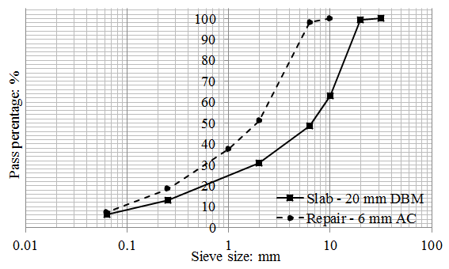
Figure 1. Gradation curves for asphalt mixtures.

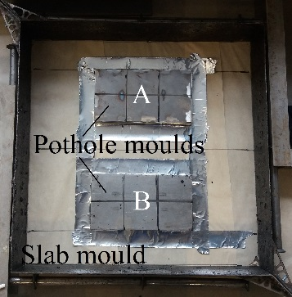
(a) | (b)
(c) | (d)

Figure 2. Slab and pothole repairs: (a) Moulds, (b) Constructed slab, (c) Demoulded slab and pothole excavations, (d) Final pothole repairs where A is a non-heated repair and B is a pre-heated repair.
During the construction of the slabs, aluminium tubes 4 mm in diameter were put at various locations inside the slabs. The tubes were later used to accommodate thermocouples for measurement of interface temperatures during the pothole repair operations. To measure the temperatures at locations along the vertical repair interfaces, the tubes were inserted in between the asphalt batches of the first lift of the slab. This was performed for slabs S1-S3 shown in Table 1. Their positions were targeted to be in the middle of the respective interfaces. Whereas, to measure the temperatures at the bottom of the repair, the tubes were placed at the top of the compacted first lift of the slab. This was performed for slabs S4-S6 shown in Table 1.

Non-heated pothole repairs
Six non-heated artificial potholes were repaired for this set of tests. Real-time temperatures were captured using eleven thermocouples of 0.5 ºC accuracy, four located at the corners, four at the vertical repair interfaces and three at the bottom of the repair. The thermocouples were inserted in the aluminium tubes prior to commencing the repair of the potholes. The temperatures were measured during the pouring and the compaction of the fill mix. The ambient temperature ranged from 17 ºC to 22 ºC and the starting temperature of the slabs, prior to patching, ranged from 17 ºC to 26 ºC.
To capture the temperatures in the vertical repair interfaces and corners, only the end of the thermocouples was exposed in the pothole cavity (thermocouples T1-T6, Fig. 3b). Whereas, to capture the temperatures at the bottom of the repair, the thermocouples were extended in the pothole cavity by 85 mm (thermocouples T7-T11, Fig. 3c). Three repetitions were executed for each temperature point measurement. The post-compaction locations of the tubes and thus the corresponding thermocouple locations are given in Table 2 and described in Figure 3.
The non-heated potholes were repaired as follows. Tack coat was applied in the pothole cavity 4 min prior to pothole filling to allow time for the tack coat to set. Then, hot mix asphalt was poured and evenly spread out. Right after, the mix was compacted for 6 min using a vibrating plate. The temperature of the fill mixes before and after compaction are presented in Figure 4.

Pre-heated pothole repairs using an experimental infrared heater
Six pre-heated artificial potholes were repaired. They were pre-heated, prior to patching, for 10 min and 15 s. Heat was applied in heating-cooling cycles (Fig. 5) using the infrared heater presented in Figure 6. The heat power of the heater was set to 6.6 kW (20 % of heater heat power) for which the temperature distribution on the heater plate is presented in reference Byzyka et al. (2017b). The interface temperatures were captured using the same type of thermocouples described in section 2.3. The test set up was also similar that of non-heated repairs.
The post-compaction locations of the thermocouples are given in Table 3 and described in Figure 3. The ambient temperature and the starting temperature of the slabs, prior to pre-heating and patching, were the same with the temperature levels given for the non-heated repairs in section 2.3. This happens because each slab consisted of a pair of artificial pothole excavations; one used for non-heated repair and one for pre-heated repair.
Pre-heated potholes were repaired as follows. The pothole cavity was positioned below the heater at an offset 230 mm. At the end of the pre-heating, the fill material was poured and compacted for 6 min. No tack coat was used for the repairs. The mixture temperatures prior to compaction are presented in Figure 4. The temperatures captured in the pothole cavity at the end of the pre-heating are shown in Figure 7.

vOLUMETRIC OF SLABS AND REPAIRS
Slabs S1 to S3 and their repairs were cored to evaluate physical and mechanical properties. Nine cores were obtained from each slab and three cores per pothole repair. Thereafter, bulk specific gravity and air voids content were calculated using Equation 1 (American Association of State Highway & Transportation Officials 2007), Equation 2 (American Association of State Highway & Transportation Officials 2005) and Equation 3 (Roberts et al. 1996).
$G_{mb}=\frac{A}{B-C}$ (1)
$G_{mm}=\frac{W_{T}}{\frac{W_{agg}}{G_{se}}+\frac{W_{AC}}{G_{b}}}$ (2)
$\% Air void=\left(1-\frac{G_{mb}}{G_{mm}}\right)100$ (3)

where G_{mb} = bulk specific gravity of compacted asphalt specimen; A = mass of dry specimen in air, g; B = mass of (saturated surface dry) SSD specimen in air, g; C = weight of specimen in water at 25 ± 1 ºC, g; G_{mm} = maximum theoretical specific gravity of asphalt mixture; W_{T} = total weight of mixture; Wagg = weight of aggregate; W_{AC} = weight of total bitumen content; G_{se} = effective specific gravity of aggregate; G_{b} = specific gravity of bitumen.

A: pothole A
B: pothole B
P₁: reference point for x₁ and x₂
P₂: reference point for x₃
P₃: reference point for x₄ and x₅
P₄: reference point for x₆
x₁: distance from P₁ along the side 1
x₂: distance from P₁ along the side 2
x₃: distance from P₂ along the side 3
x₄: distance from P₃ along the side 4
x₅: distance from P₃ along the side 5
x₆: distance from P₄ along the side 6
y: height from the bottom of the pothole cavity
T: thermocouple
 |  | (a)
Sides 1 & 4 |  | 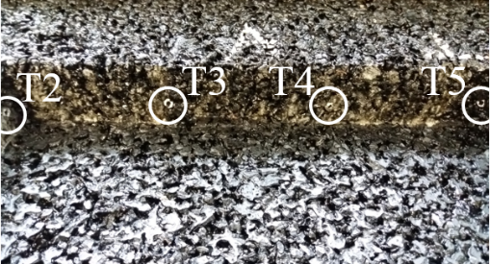  Sides 2 & 5 |  | 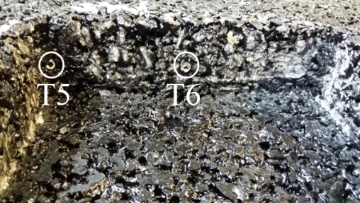  Sides 3 & 6
(b)
 | Side 2 – pothole A |  | 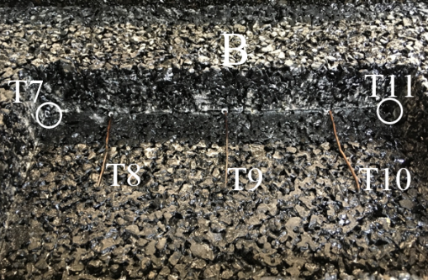  Side 5 – pothole B
(c)
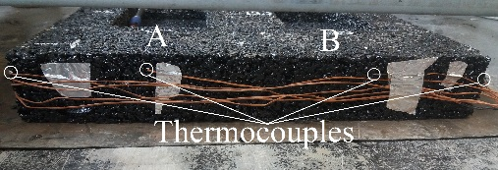  Sides 1 & 6 |  | 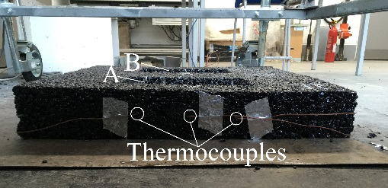  Sides 2 & 5 |  | 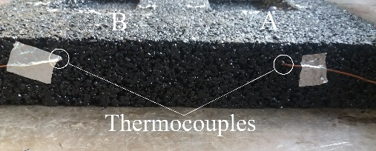  Sides 3 & 4
(d)
Figure 3. Test set up for temperature measurements in non-heated repair (completed for pothole A) and pre-heated repair (completed for pothole B): (a) Slab and pothole cavities: demonstrations of x and y positions given in Tables 2 and 3, (b) thermocouples in the vertical repair interfaces, (c) thermocouples in the bottom repair interface, (d) thermocouple routes outside potholes A and B, around the slab.

Table 2. Post-compaction thermocouple locations in the pothole excavation of non-heated repairs*.
 |  | Thermocouple no.
 |  | T1 |  |  | T2 |  |  | T3 |  |  | T4 |  |  | T5 |  |  | T6
Location: mm |  | x₁/x₂ | y |  | x₂ | y |  | x₂ | y |  | x₂ | y |  | x₂/x₃ | y |  | x₂/x₃ | y
 | Slab no.
Vertical repair interfaces | S1 | 85/0 | 15 |  | 0 | 20 |  | 100 | 14 |  | 200 | 14 |  | 305/0 | 20 |  | 0/90 | 21
 | S2 | 90/0 | 15 |  | 0 | 15 |  | 105 | 15 |  | 210 | 19 |  | 305/0 | 22 |  | 0/90 | 18
 | S3 | 90/0 | 18 |  | 0 | 24 |  | 105 | 12 |  | 210 | 17 |  | 305/0 | 20 |  | 0/88 | 20
 |  | T7 |  |  | T8 |  |  | T9 |  |  | T10 |  |  | T11
Bottom repair interface | S4 | 0/0 | 0 |  | 45 | 0 |  | 153 | 0 |  | 263 | 0 |  | 305/0 | 0
 | S5 | 0/0 | 0 |  | 55 | 0 |  | 155 | 0 |  | 260 | 0 |  | 305/0 | 0
 | S6 | 0/0 | 0 |  | 45 | 0 |  | 145 | 0 |  | 250 | 0 |  | 305/0 | 0
*For x₁, x₂ and x₃ the reference points are P₁ and P₂ respectively in Figure 3 - pothole A. The height (y) is measured from the bottom of the repair to the position of each thermocouple. The accuracy in the locations is ± 1 mm.
Table 3. Post-compaction thermocouple locations in the pothole excavation of 10 min 15 s pre-heated repairs**.
 |  | Thermocouple no.
 |  | T1 |  |  | T2 |  |  | T3 |  |  | T4 |  |  | T5 |  |  | T6
Location: mm |  | x₄/x₅ | y |  | x₅ | y |  | x₅ | y |  | x₅ | y |  | x₅/x₆ | y |  | x₅/x₆ | y
 | Slab no.
Vertical repair interfaces | S1 | 85/0 | 15 |  | 0 | 20 |  | 100 | 9 |  | 195 | 10 |  | 305/0 | 10 |  | 0/85 | 15
 | S2 | 82/0 | 23 |  | 0 | 15 |  | 105 | 15 |  | 210 | 19 |  | 305/0 | 23 |  | 0/85 | 26
 | S3 | 85/0 | 26 |  | 0 | 19 |  | 105 | 16 |  | 210 | 20 |  | 305/0 | 21 |  | 0/78 | 15
 |  | T7 |  |  | T8 |  |  | T9 |  |  | T10 |  |  | T11
Bottom repair interface | S4 | 0/0 | 0 |  | 47 | 0 |  | 150 | 0 |  | 259 | 0 |  | 305/0 | 0
 | S5 | 0/0 | 0 |  | 60 | 0 |  | 155 | 0 |  | 260 | 0 |  | 305/0 | 0
 | S6 | 0/0 | 0 |  | 58 | 0 |  | 160 | 0 |  | 250 | 0 |  | 305/0 | 0
**For x₃, x₄ and x₅ the reference points are P₃ and P₄ respectively in Figure 3 - pothole B. The height (y) is measured from the bottom of the repair to the position of each thermocouple. The accuracy in the locations is ± 1 mm.

RESULTS AND ANALYSIS

Volumetric
Table 4 presents the average air voids content of nine cores taken from slabs S1-S3 and three cores per corresponding repair. It was found, that the air voids of the slabs ranged from 12.23 % to 13.28 %, showing no significant variation. Although this level of air voids is considered high, this is a result that is expected when compacting with a vibrating plate (Thom 2008).
Lower air voids content was observed for the executed repairs. High variation in air voids content was found for non-heated repairs when compared against pre-heated repairs. The air voids of non-heated repairs ranged between 2.91 % and 6.70 % and of pre-heated repairs between 3.56 % and 5.86 %. It is not expected that pre-compaction mixture temperatures (Fig. 4) and compaction time affected the air voids variation in non-heated repairs. The air voids variation was attributed to the vibrating plated used to complete the compaction of the repairs. Further, the size of the vibrating plate 400 × 320 mm² in comparison with the small size of the repair 306 × 165 mm² also influenced the air voids content.
Figure 4. Pre- and post- compaction pothole fill temperatures.

Figure 5. Heating-cooling cycles of 10 min 15 s pre-heated pothole repairs (repair B).

Figure 6. Pothole - heater arrangement for pre-heated pothole repairs (repair B).

Figure 7. Temperature profile over time post-pre-heating.

Repair interface temperatures
The temperatures recorded at the repair interfaces are presented in Figure 8. The results presents temperature profile over time and are divided into eleven graphs; one graph per thermocouple with location given in Tables 2 and 3. For each thermocouple, the temperatures at the interfaces for non-heated repairs are reported together with temperatures for pre-heated repairs.
Signal noise of thermocouples captured during the tests is also presented. This was observed mainly during the compaction of pre-heated repairs and for thermocouples located at corners and vertical sides of the repairs. The disturbance of the thermocouples is attributed mainly to the softening of the asphalt during pre-heating and secondary to the aggregate reorientation and forces applied during compaction.
Between non-heated and pre-heated repairs, post-compaction temperatures in the vertical interfaces averaged 33.35 ºC and 57.11 ºC respectively (T1, T3, T4 and T6). Whereas, at the bottom of the repair (T8 - T11) temperatures averaged 63.39 ºC and 81.04 ºC for non-heated and pre-heated repairs respectively.
The lowest temperatures were observed at the corners of all executed repairs. Points located at the bottom corner of the repairs (T7 and T11), averaged 24.02 ºC for non-heated repairs and 30.91 ºC for pre-heated repairs respectively. There was a small increase in corner temperatures at higher points along the vertical side of the repairs, increasing from bottom to top. An average temperature 28.43 ºC was measured for non-heated repairs and 46.41 ºC for pre-heated repairs from thermocouples T2 and T5 located at corner mid-depth. The reason of low interface temperatures is described below.
When two solid bodies of different temperatures are in thermal contact, energy is transferred from the hotter to the cooler body. In the interface of these bodies, there is a temperature drop which is caused by surface roughness and non-flatness. In areas where there is a contact between the two surfaces, heat is transferred by conduction. In the void spaces of this interface, heat is transferred by convection and radiation. Thus, the actual contact area is significantly smaller than the apparent contact area. This contact limitation in the interface creates a thermal contact resistance (Janna 1999).
The inverse of thermal contact resistance is thermal contact conductance, equal to the conductivity of the material over thickness expressed in W / m² K. The higher the thermal conductance, the lower the thermal resistance at the interface. Thermal conductance is influenced by a number of factors. One of them is contact pressure. In the case of pothole repairs, when compaction force is applied, the pressure in the vertical interfaces of the repair is less than at the bottom of the repair. This increases the thermal resistance in the vertical interfaces which causes the cool boundary effect, with temperatures for non-heated repairs being at very low levels as shown in the experimental results (Fig. 8).
In pre-heated repairs the temperatures at the vertical interfaces improve because the contact spots increase, void gaps decrease, thermal contact resistance decreases, and more heat is being transferred due to conduction.

Table 4. Air voids content of slabs S1 to S3 and their respective repairs.
Slab no. | S1 | S2 | S3
Slab air voids content: % | 12.61 | 13.28 | 13.18
Repair A air voids content: % | 6.70 | 4.31 | 2.91
Repair B air voids content: % | 5.86 | 3.98 | 3.56

Ti: thermocouple no.
Si: slab no.
A: repair of pothole A
B: repair of pothole B
S1-A to S3-A: non-heated repairs – temperatures in vertical interfaces
S4-A to S6-A: non-heated repairs – temperatures in bottom interfaces
S1-B to S3-B: 10 min 15 s pre-heating – temperatures in vertical interfaces
S4-B to S6-B: 10 min 15 s pre-heating – temperatures in bottom interfaces

Figure 8. Temperature profile over time of non-heated and pre-heated repairs during pothole mix filling and its compaction.

SUMMARY AND CONCLUSIONS
The temperatures at the boundaries of non-heated and pre-heated repairs were experimentally investigated. Non-heated potholes were repaired using a conventional repair method whereas an experimental infrared heater, with capability of controlling heat application precisely, was used to heat pothole excavations of pre-heated repairs prior to filling and compaction. Temperatures were measured during the laying and compaction of the pothole fill mixes at eleven locations of the repair interfaces, using extractable thermocouples. The following conclusions are drawn from this investigation;
- Interfacial temperatures between fill material and host pavement were non-uniformly distributed.
- The lowest temperatures were recorded in vertical interfaces and at corners of repairs.
- Temperatures were similarly increased in repair interfaces with initial air and pavement temperatures ranging from 17 ºC to 22 ºC and from 17 ºC to 26 ºC respectively.
- Pothole pre-heating with infrared heat did not considerably increased the temperatures at corners of the repair. However, this figure improved in vertical interfaces along the length and width of the repairs.
- Comparing pre-heated repairs with non-heated repairs, the average temperatures at corners and at vertical faces increased by 10.85 ºC - 24.45 ºC and 34.97 ºC respectively.
- The low temperatures in the vertical interfaces of non-heated repairs was attributed to high thermal contact resistance in contrast with the bottom of the repair.
- The thermal contact resistance seemed to decrease in pre-heated repairs. This is due to higher actual contact spots in the repair interface, lower air voids and higher thermal contact conductance.
- Temperature increases in the interfaces of pre-heated repairs is expected to increase compaction effectiveness, interface bonding and patching longevity. However, future research must explore the assessment of such repairs.

Acknowledgements
The authors acknowledge the financial support of International Chem - Crete Corporation, Texas, USA, Engineering and Physcial Research Council (EPSRC), Epicuro Ltd and DAC Consulting (UK) Ltd, the support of Nynas UK AB and Conexpo (NI) Ltd for providing bitumen and aggregate respectively for this study, the support in laboratory work of Brunel University technical staff Neil Macfadyen and Simon Le Geyt and student researchers Albert Phillipson and Kamal Ahmad.

REFERENCES
American Association of State Highway & Transportation Officials 2005. Theoretical maximum specific gravity and density of hot mix. AASHTO T209-05.
American Association of State Highway & Transportation Officials 2007. Bulk specific gravity of compacted asphalt mixtures using saturated surface - dry specimens. AASHTO T166-07.
British Standards Institution 2010. Bituminous mixtures. BS EN 13108:2010.
British Standards Institution European Standard 2016. Bituminous mixtures. Test methods. Laboratory mixing. BS EN 12697-35:2016.
Byzyka, J., Chamberlain, D.A. & Rahman, M. 2017a. Thermal segregation of asphalt material in road repair, Journal of Traffic and Transportation Engineering 4(4): 360-371.
Byzyka, J., Chamberlain, D.A. & Rahman, M. 2017b. Development of advanced temperature distribution model in hot - mix asphalt patch repair, Proceedings of the Institution of Civil Engineers-Transport 1-11.
Clyne, T.R., Johnson, E.N. & Worel, B.J. 2010. Use of taconite aggregates in pavement applications. Minnesota Department of Transportation, Saint Paul, MN, USA, MN/RC.
Department of Transportation Roads, Standard Code of Practice, New Roads and Street Works Act 1991 (third ed., England) 2010. Specification for the Reinstatement of Openings in Highways.
Dong Q, Huang B & Zhao S 2014. Field and laboratory evaluation of winter season pavement pothole patching materials, International Journal of Pavement Engineering 15(4): 279–289.
Freeman, T.J. & Epps, J.A. 2012. HeatWurx Patching at Two Locations in San Antonio, Texas Transportation Institute. FHWA, Texas Department of Transportation, Austin, TX, USA.
Janna, W.S. (second ed.) 1999. Engineering heat transfer. Boca Raton, London, New York and Washington D.C: CRC Press.
Lavin, P. 2003. Asphalt pavements: a practical guide to design, production and maintenance for engineers and architects. London and New York: CRC Press.
Leininger, C.W. 2015. Optimization of the infrared asphalt repair process.
Manual of Contract Documents for Highway Works 2008. In Volume 1 Specification for Highway Works Series 900 Road Pavements - Bituminous Bound Materials.
Obaidi, H., Gomez-Meijide, B. & Garcia, A. 2017. A fast pothole repair method using asphalt tiles and induction heating. Construction and Building Materials 131: 592-599.
Roberts, F.L., Kandhal, P.S., Brown, E.R., Lee, D. & Kennedy, T.W. (second ed.) 1991. Hot mix asphalt materials, mixture design and construction. Lanham, Maryland: National Asphalt Pavement Association Education Foundation.
Thom, N. 2008. Principles of pavement engineering, London: ICE Publishing.
Uzarowski, L., Henderson, V., Henderson, M. & Kiesswetter, B. 2011. Innovative Infrared Crack Repair Method, 2011 Conference and exhibition of the Transportation Association of Canada. Transportation successes: Let’s build them. 2011 Congress et Exhibition de l'Association des Transports du Canada. Les Succes en Transports: Une Tremplin vers l'Avenir.
Washington State Department of Transportation 2013, WSDOT Maintenance Manual.

