Investigation of warm gas clean-up of biofuel flue and producer gas using electrostatic precipitator
Robertas Poškas^{1,4}*, Arūnas Sirvydas², Povilas Poškas³, Hussam Jouhara⁵, Nerijus Striūgas⁶, Nerijus Pedišius⁷, Vitas Valinčius⁸
¹⁻³Lithuanian Energy Institute, Nuclear Engineering Laboratory, 3 Breslaujos, Kaunas LT44403, Lithuania
⁴Kaunas University of Technology, Faculty of Mechanical Engineering and Design, Department of Thermal and Nuclear Energy, Studentu 56, Kaunas LT-51424, Lithuania
⁵Brunel University London, Institute of Energy Futures, College of Engineering, Design and Physical Sciences, UB8 3PH Uxbridge, United Kingdom
⁶Lithuanian Energy Institute, Laboratory of Combustion Processes, 3 Breslaujos, Kaunas LT44403, Lithuania
⁷Lithuanian Energy Institute, Laboratory of Heat Equipment Research and Testing, 3 Breslaujos, Kaunas LT44403, Lithuania
⁸Lithuanian Energy Institute, Plasma Processing Laboratory, 3 Breslaujos, Kaunas LT44403, Lithuania

*Corresponding author: E-mail address: Robertas.Poskas@lei.lt , Tel.: +370 37 401893. Full postal address: Lithuanian Energy Institute, Breslaujos str. 3, LT-44403 Kaunas, Lithuania

ABSTRACT
The use of biofuels has been increasing in Europe over recent years and the reason for that is an acceptable cost and the least negative impact on the environment. However, NO_{x} and emissions of fine particulates are important and in that respect biofuel is still at a disadvantage when compared with oil and natural gas-fired systems. Usually, the flue gas is filtered in multicyclones or fibre filters before discharge into the atmosphere. Yet, in the case of fine particulates, such filters do not show high effectiveness, thus electrostatic precipitators are used. In this comparative study on biofuel (wood pellets), the ESP collection efficiency was investigated for solid particles from a class 3 boiler (50 kW) and from a gasifier (100 kW). Although releases of solid particles from modern boilers are low, a combination of such a boiler with an electrostatic precipitator may reduce the release of particles to a minimum. The collection efficiency of the ESP obtained during the investigation with the flue gas was ~98-99%. There is a big difference in particle concentrations when comparing the systems with flue gas and producer gas. As the working conditions in the test section with the producer gas were more challenging, this leads to a lower efficiency for the electrostatic precipitator (~75 %). The obtained particle sizes and chemical composition of solid particles give better understanding of the problem under investigation.

Keywords: wood pellets, gasification, solid particles, particle dimensions, electrostatic precipitation, flue gas.

1. Introduction
During the last decades, biofuel has been increasingly used in many countries for various types of heating appliances. In the case of combustion of any liquid or solid fuel, particles are formed from the ash contained in the fuel. This is also the case for biofuels where the ash content may vary from a percent to more than ten percent by weight in the dry substance. Therefore, one of the main disadvantages of using biofuels in comparison with some other types of fuels (gaseous, liquid) is the emission of solid particles, levels of which especially increase in the ambient air during the heating season. The diameters of these particulates are usually in the range from 0.01 µm up to 100 µm [1, 2]. Solid particles can penetrate into the internal organs of humans and can cause serious illnesses [3].
It is well known that the main cleaning appliances of solid particles from the flue gases are fabric filters, cyclones, scrubbers, electrostatic precipitators (ESPs) or a combination of these (e.g. electro-cyclones, wet electrostatic precipitators, etc.) [4].
Traditional ESPs (tube type or plate type) are widely used in power plants at temperatures lower than 200 °C for removal of solid particles from flue gases. The ESP uses electrostatic forces to ionise the gas and at the same time to charge the particles in the gas stream. Charge builds on the particles and attracts them to collection electrodes [5]. Electrostatic precipitators are very effective in the case of fine or ultrafine particulate removal [5] and can achieve efficiencies of more than 99 %. The advantages of electrostatic precipitators also are the low aerodynamic resistance and high efficiency [6]. Therefore, electrostatic precipitators are one of the most commonly employed particulate control devices for collecting particulate emissions from boilers, incinerators and from many other industrial installations.
Producer gas generated during the gasification process among other impurities contains particulate matters as well. The diameters of these particulates are usually in the range from less than 1 µm to over 100 µm [7] and their concentrations can even exceed 1000 mg/m³ [8]. Therefore, it is necessary to clean the particulates from this gas as a combustion of such a gas in incinerators may cause malfunctioning of the injectors and corrosion/erosion of turbines, internal combustion engines, etc. As an option for cleaner producer gas generation ESPs could enhance gasification reactors [8].
In general, three types of syngas cleaning technologies, hot gas clean-up (T >300 °C), cold gas clean-up (T ~100 °C) and warm gas clean-up (T > ambient, but lower than for hot gas clean-up) are addressed in the literature [7].
The main techniques of hot syngas clean-up are the same as used for flue gases: inertial separation, barrier filtration and electrostatic precipitation.
As the concentrations of solid particles and temperatures of generated syngas are rather high (e.g. temperatures can be up to 800-950 °C), cyclones are usually used as the primary cleaning devices for syngas flowing from gasifiers. They also allow operation at high temperatures (up to 1000 °C).
For particulate cleaning from syngas fibres, granules or porous solids (i.e. “barriers”) can also be used. The collection efficiency of such types of filters is from about 99 % (e.g. in the case of granular filters) to about 99.5 % (in the case of ceramic candle, ceramic tube or metal barrier filters). The main disadvantage of such filters is the high pressure drop and low operational temperature (mainly for fibre filters). However, the metal barrier filters developed allowed operational temperatures of up to 1000 °C [9].
Significant efficiency has also been demonstrated by moving granular bed filters. In [10, 11], the collection efficiency achieved for a granular moving bed filter was more than 99 %.
Cold syngas clean-up is usually understood as a wet process [12]. Therefore, in this case cleaning devices such as wet scrubbers and wet ESPs are commonly used [7, 13, 14]. They can achieve relatively high collection efficiencies of solid particles – from at least 70 % to about 100%. The disadvantage of these devices is that they are rather complicated and during their operation, contaminated water is produced, which must be adequately treated [15].
Electrostatic precipitators as devices for hot syngas clean-up are not usually used at very high temperatures due to temperature effects on the main properties affecting ESP performance [12]. However, studies have been conducted with ESPs for high temperature syngas cleaning [15]. The collection of particles in syngas (flow rate of up to 5.7 m³/h) with a tube type electrostatic precipitator at temperatures of up to 1000 °C and pressure up to 1 MPa was analysed in [15]. The collection efficiency of solid particles obtained was almost 100 % at temperatures of about 500 °C. When the temperature was increased to 680 °C, the collection efficiency decreased to 96%. The increase of the syngas temperature also resulted in a decrease of the voltage of the corona discharge. The authors concluded, that the ESP can still be applied for syngas cleaning for temperatures up to 800 °C.
For warm syngas clean-up, in principle the methods of inertial separation, fibre filtration and ESP, which were discussed above, can be applied [16].
However, the publications related to investigations/operability of traditional ESPs for syngas cleaning are rather limited. The reviews of syngas cleaning methods [17] in general just state that the application of ESP for warm syngas clean-up is possible, however, no practical/experimental results are presented. In study [18], the collection efficiencies using wire-plate ESPs for solid particles from coal pyrolysis and in the flue gas from a coal-fired plant were compared. The collection efficiency of the ESP in the temperature range from 90 to 250 °C for both gases was found to be more than 95 %. At a higher temperature (~450 °C), the collection efficiency of the ESP decreased.
A literature review shows that warm syngas clean-up methods such as barrier filtration and inertial separation have been widely investigated and applied in practice. However, the practical application of the ESP for syngas clean-up is rather limited.
Hence, in order to expand the limited results available of ESP applications for producer gas cleaning, the aim of this study is to determine the collection efficiency of the traditional tube-type electrostatic precipitator operating on producer gas derived from a downdraft gasifier (100 kW nominal capacity) and then to compare it with the collection efficiency for solid particles from a European standard class 3 boiler (50 kW nominal capacity). Also, the study aims to provide some information on the characteristics of the solid particle sizes in the producer gas and their chemical composition.

2. Materials and Methods
2.1 Biofuel characteristics

During the experiments, wood pellets were used as fuel for gasification and incineration. Fuel component analysis was done using a Flash 2000 CHNS analyser [19]. The main characteristics of this fuel are presented in Table 1.
Table 1. The main characteristics of wood pellets used during experiments [19]
Component | wt.% (dry basis)
Carbon | 49.20
Hydrogen | 6.20
Oxygen | 44.06
Nitrogen | 0.08
Sulphur | 0.06
Chlorine | 0.02

The table above shows that carbon, oxygen and hydrogen comprise 99.46 %. There is also chlorine, sulphur and nitrogen in the fuel. During the analysis, other elements were not detected because their concentrations were below the equipment detection limit.

2.2 Experimental setup with boiler
A flue gas (including solid particulates) was generated by incinerating wood pellets in a commercial class 3 boiler. It is an automatic device with a nominal power of 50 kW and it can be used for the incineration of pellets, wood, coal, and cereals (Fig. 1).
Fig. 1. Schematic view of the experimental setup with the boiler.
The fuel and air supply for combustion were adjusted automatically based on the set power of the boiler. During the experiments, only pellets made from different kinds of wood were incinerated. The temperature of the flue gas exhausted from the boiler was about 150°C, and the chimney draft ~ 25 Pa (automatically maintained by the flue gas exhauster). Such a draft gives a flue gas velocity of approximately 1.9 m/s in the flue gas pipe of 180 mm diameter (flow rate ~180 m³/h).
From the boiler, the flue gas entered the ESP, where the solid particles were captured and then cleaned flue gas was exhausted into the atmosphere. The total height of the insulated flue gas pipe was about 15 m. The discharges of flue gas into the atmosphere are always at some distance from the boiler, and this section is the most important for measurement. Therefore, for particle measurements using an infrared particle sizer (IPS), the distance of ~8 m from the ESP was selected. The measurement results were further processed using a computer.
2.3 Experimental setup with gasifier
The main components of this experimental arrangement were the gasifier (nominal power 100 kW), the plasma unit, the cyclones, the gas cooler, the electrostatic precipitator and the boiler (Fig. 2).
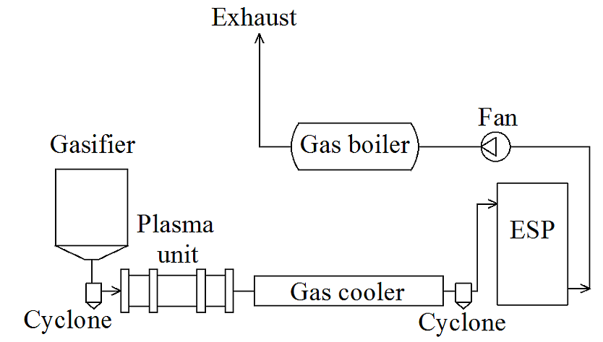

Fig. 2. Schematic view of the experimental setup with the gasifier.
The process of wood pellet gasification (as well as the generation of solid particles) took place in the downdraft gasifier. The producer gas (flow rate ~ 62 m³/h) with a temperature of about 550°C entered the cyclone (in order to reduce particle concentration), then the air plasma unit, which is needed for the neutralization of hazardous chemicals (dioxins, furans, etc. [20]). The processed hot producer gas at about 1100°C from the plasma unit was supplied to the water-cooled gas cooler, where the temperature of the gas was decreased, the gas was again cleaned in a cyclone and then the gas with a temperature of ~160°C entered the electrostatic precipitator. The cooled gas then flowed through the electrostatic precipitator where solid particles were captured from the gas flow. After passing through the ESP, the cleaned gas was transported by a fan to the gas boiler, and the flammable gas-air mixture was combusted. A more detailed description of the experimental setup is presented in [20].
The concentration of solid particles during these experiments was measured at the same time at positions before and after the ESP by applying the gravimetric method only.
2.4 Electrostatic precipitator
The same precipitator was used in the experiments with the boiler and the gasifier (see Fig. 3) and it was designed at the Lithuanian Energy Institute. Its frame is made from carbon steel bars. The inlet to the ESP is made in the upper part and the outlet is positioned in the lower part. Inside the frame, two parallel stainless steel pipes (i.e. collection electrodes) each with a diameter of 120 mm and a length of ~ 1000 mm are installed between two holding planes. A single nichrome wire (i.e. discharge electrode) of 0.2 mm diameter is stretched between the special holders inside the centre of each stainless steel pipe. The distance between the discharge electrodes is about 160 mm. The tension of the electrodes is ensured by stainless steel springs.
In order to avoid flue gas leakage between the holding planes and the collecting electrodes, the contact perimeters between them are sealed.
Fig. 3. Schematic cross-sectional view of the ESP used in the experiments.
During the experiments, each discharge electrode was connected to a separate high-voltage power supply unit (Glassman Series FR) with an adjustable output voltage in the range between 0–30 kV. So, in total two high-voltage supply units were used. A more detailed description of the ESP is presented in [21]. The experiments were carried out using the negative potential of the high-voltage power supply units.
To reveal the characteristics of the collection efficiency of the ESP, different numbers of collecting electrodes (1 or 2) were used. This allowed different flow velocities. When one collecting electrode was used, the other pipe with the electrode was closed using special plates, and flue gas could flow only via the open pipe.
The current-voltage characteristic for one ESP electrode is shown in Fig. 4 (high-voltage supply units used in the experiments had a feature enabling them to measure the current in an electrode depending on the voltage supplied).
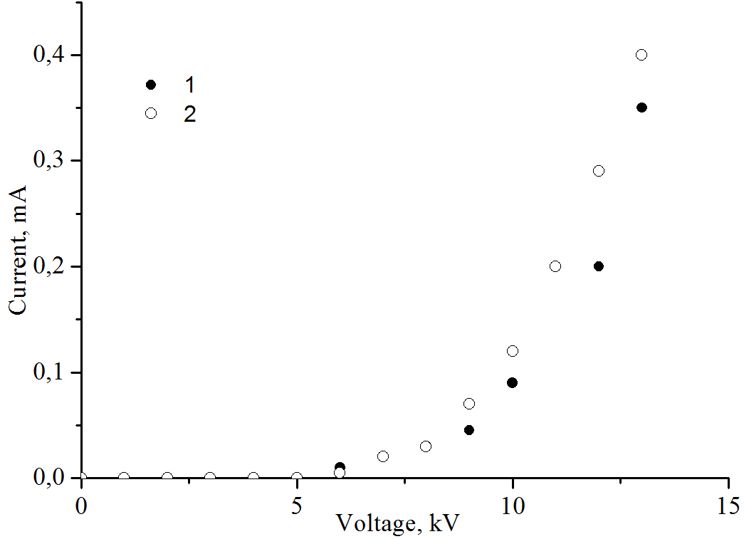
Fig. 4. Current-voltage characteristic of one ESP electrode: 1 – experimental data with the flue gas from the boiler; 2 – experimental data with the producer gas.
From Fig. 4 it is evident that for both flue gas from the boiler and producer gas, current is registered starting from a voltage of ~6 kV. This means that from this point the electrostatic discharge occurs, which ionizes the flue gas around the discharge electrode (i.e. creates a corona). Although the character of the experimental data is rather similar in both cases, the trend of the experimental data is slightly steeper for the producer gas than for flue gas from the boiler. This means that due to the characteristics of the producer gas (humidity, concentration of particles, etc.), the currents are higher at the same voltages in comparison with the flue gas.
2.5 Measurement techniques
The concentrations of particles during the experiments with the flue gas from the boiler were measured using the infrared particle sizer (IPS, made by “Kamika instruments”) and applying the gravimetric method. The IPS is an instrument for direct measurements of total particle concentration and concentration of particle fractions in flue gas channels. It is composed of a measuring head and an electronic computer-controlled measurement unit. An IPS sizer ensures only 1D measurements and it can measure particles in the range of 0.4–300 μm (this range is divided into four subranges). The measuring head of the device is also equipped with a special holder for the filter, which can be used for the determination of the concentration of solid particles by the gravimetric method. The IPS also measures flue gas temperature, concentration of solid particles, flue gas velocity and flow rate.
The distribution of particles by fraction in the producer gas was not measured using the IPS because the gas was rather hot, humid and “dirty”, and it could have fouled the optical system of the device. Therefore, for the producer gas only, the total concentrations of particles were measured before the inlet and after the outlet of the ESP using automatic isokinetic samplers Isostack Basic. In order to get information about the characteristics of solid particles in the case of gasification of wood pellets, the samples from the three parts of the experimental setup – from the cyclone downstream of the gasifier, from the cyclone upstream of the ESP and from the ESP were taken. Electron microscopic analyses of the solid particles collected from the experimental setup with the gasifier were performed using scanning electron microscope HITACHI S-3400N and for the elemental analysis the energy dispersive spectrometer BRUKER Quantax was used.
3. Results and Discussions
3.1 Concentrations of solid particles
The relative distribution of solid particles in the flue gas without the ESP is presented in Fig. 5.
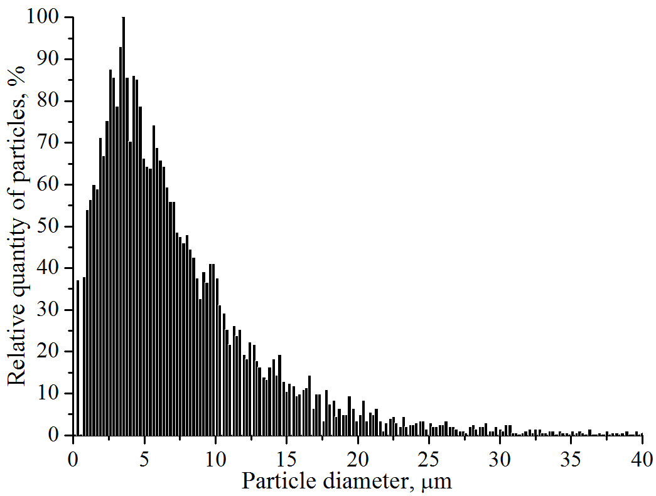
Fig. 5. Relative distribution of particles in flue gas without the ESP.
The Figure shows that the flue gas mainly contains solid particles with diameters from 0.3 to ~ 20 μm. The highest quantity of the particles in the distribution is at the diameter of about 2–6 μm. Similar results were obtained in [23] where it was determined that the peak diameters of coarse particles for different boiler types and powers in the case of biomass combustion are usually between 2–8 μm. So, the peak diameters of solid particles obtained in our case are typical for wood combustion.
Fig. 6 shows the variations in the concentrations of solid particles from measurements during steady-state experiments with producer gas and flue gas. Results obtained using the gravimetric method show that the initial concentration of solid particles in the producer gas measured after the cyclone installed before the ESP is rather high and is scattered in the range of ~140–220 mg/m³, while the average value is about 180 mg/m³.
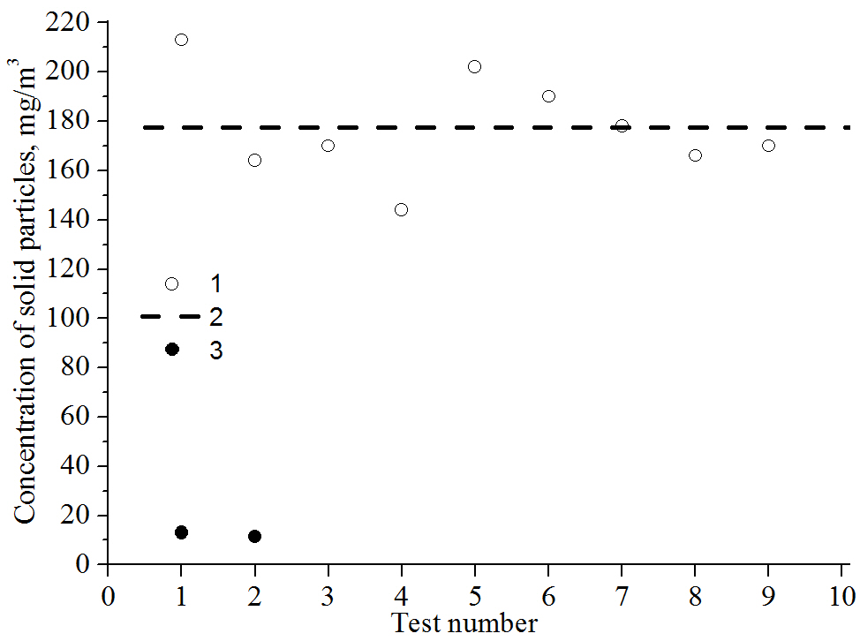
Fig. 6. Concentration of solid particles at the inlet to the ESP: 1 – in producer gas; 2 – average value in producer gas; 3 – in flue gas.
The concentration obtained for solid particles in the flue gas is rather low – about 13 mg/m³. Similar results were obtained in [22] where particle concentrations from modern 50 kW boilers fired by wood pellets vary in the range of ~11–40 mg/m³. Hence, particle concentrations in the flue gas are about fourteen times less than those in the producer gas. The limiting values for such a class of boiler are much higher (see EN303-5:2012).
3.2 Collection efficiency of the ESP
Usually in work related to ESP operation the ESP collection efficiency is given at a certain operating voltage [5, 24, etc.]. In our work, the effect of ESP operating conditions on the collection efficiency of different sized particles was assessed.
The distribution of solid particles in the flue gas depends on the operating voltage of the ESP, as shown in Fig. 7; the quantities are relative to the maximum in the data in Fig. 5 (without the ESP). When the voltage to the ESP was increased up to 2 kV or 4 kV, a slight decrease in the quantity of particles is observed. The decrease is clearly expressed in the particles of smaller diameters. When the ESP was operating at 6 kV a sharp decrease of particle quantity is obtained. The decrease in this case is expressed in the particles of diameters of a broader range, from ~2.5 µm to ~15 µm. A further increase of voltage to higher values resulted in a slight but gradual decrease in particle quantity.

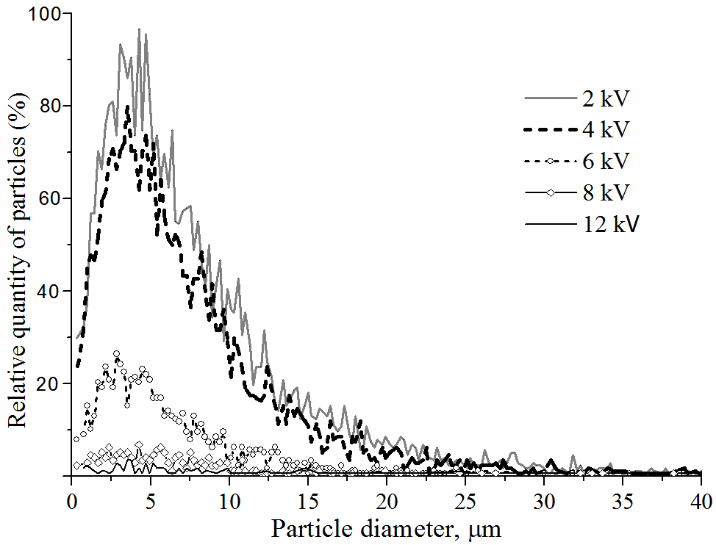
Fig. 7. Relative distribution of particles in flue gas with different voltages supplied to the ESP.
From the results presented in Fig. 7 it can be concluded that the “worst” collection is for the particles with the smallest diameters. This is a known problem [25, 26]. In the work [25], although the total collection efficiency of the ESP was almost 100 %, for particles in the size range between 0.1 - 2 µm the collection efficiency was about 96-97%. In order to collect small diameter particles some improvements of the ESP have to be made, such as the use of dual electrostatic precipitators [27] or particle traps [28].
The total collection efficiency E_{Ti} presented in Fig. 8 was calculated using the equation:
$E_{\text{Ti}}=\left(1−{C_{i}}/{C_{o}}\right)⋅\text{100}$ (1)
where C_{o} is the concentration of the particles obtained without the ESP; C_{i} means the concentration of the particles obtained with the ESP at a certain voltage.
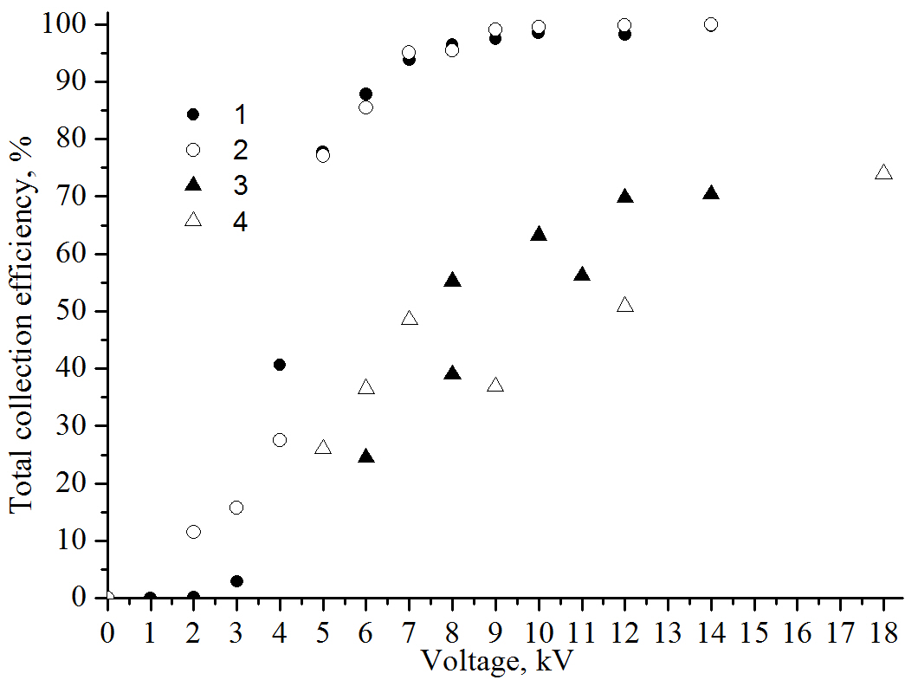
Fig. 8. Total collection efficiency of particles with the applied voltage to the ESP for a different number of collection electrodes: 1 – one collection electrode (flue gas); 2 – two collection electrodes (flue gas); 3 – one collection electrode (producer gas); 4 – two collection electrodes (producer gas).
The results with the flue gas show that in the region of voltages up to 6 kV (corona discharge registered), the collection efficiency just slightly depends on the number of collection electrodes used.
For the voltage equal to or higher than 6 kV, the collection efficiency sharply increases and does not depend on the number of collecting electrodes used. The collection efficiency increases from about 75% at 6 kV to about 98–99% at 14 kV. A further increase of the voltage does not give any tangible increase in the total collection efficiency.
Although the initial concentration of solid particles in the flue gas was not very high (see Fig. 6), the results obtained confirm that for flue gas cleaning electrostatic precipitators are rather efficient devices allowing very high collection efficiencies to be obtained. In investigation [25] it was also demonstrated that ESP can successfully deal even with very high concentrations. When the initial concentration of solid particles from biomass combustion was in the range of 510-1400 mg/m³, the total concentration at ESP outlet obtained decreased to 2.3 - 6.4 mg/m³, thus the collection efficiency was ~99.2 - 99.8 %. The highest concentration of 6.4 mg/m³ represents about 50 % of the concentration, which was obtained from our boiler (13 mg/m³, see Fig. 6) operating without ESP. Thus, this means, that the resultant concentrations in the cleaned flue gas obtained in [25] are due to the smallest particles.
For the case with the producer gas, the dependency on the number of collection electrodes is not evidently expressed over the whole range of the applied voltages (5–18 kV) either. Due to variations of the initial concentration of solid particles (Fig. 6), the collection efficiency in the case of one or two collecting electrodes is slightly scattered. With the increase in voltage, the collection efficiency gradually increases, and there is no sudden increase in the efficiency as was observed for the flue gas. For the producer gas, the highest efficiency reached is only about 75% at a voltage of 18 kV. A further increase in the voltage does not increase the collection efficiency. In [18] the collection efficiency of the ESP used for cleaning gas from coal pyrolysis was almost equal to 94 %. Special powder was used to condition solid particles existing in the syngas and this allowed the collection efficiency to increase to about 99 %. Thus, the study reveals that for syngas the collection efficiencies of ESPs are usually reduced.
In order to get a similar collection efficiency of the ESP as in the case with the flue gas, for producer gas cleaning longer electrodes in the ESP than are used in this investigation are necessary.
3.3 Solid particles from setup with gasifier
In the case of the gasification of wood pellets, samples of solid particles were collected from the three parts of the experimental setup (in the cyclone downstream of gasifier, in the cyclone upstream of the ESP and in the ESP) and then they were dried. Imaging with the scanning electron microscope was performed using a 15.0 kV accelerating voltage. The results are presented in Fig. 9.

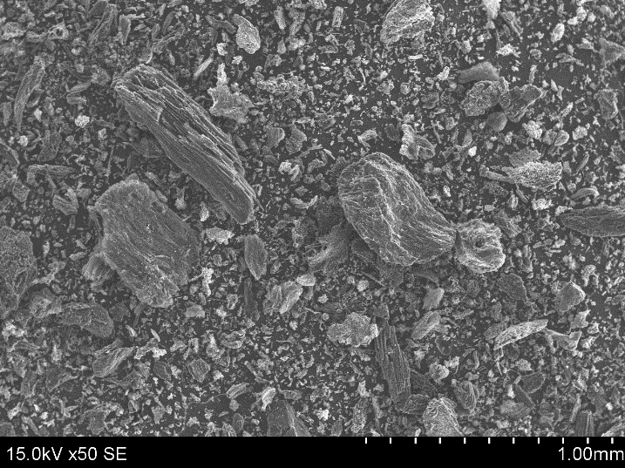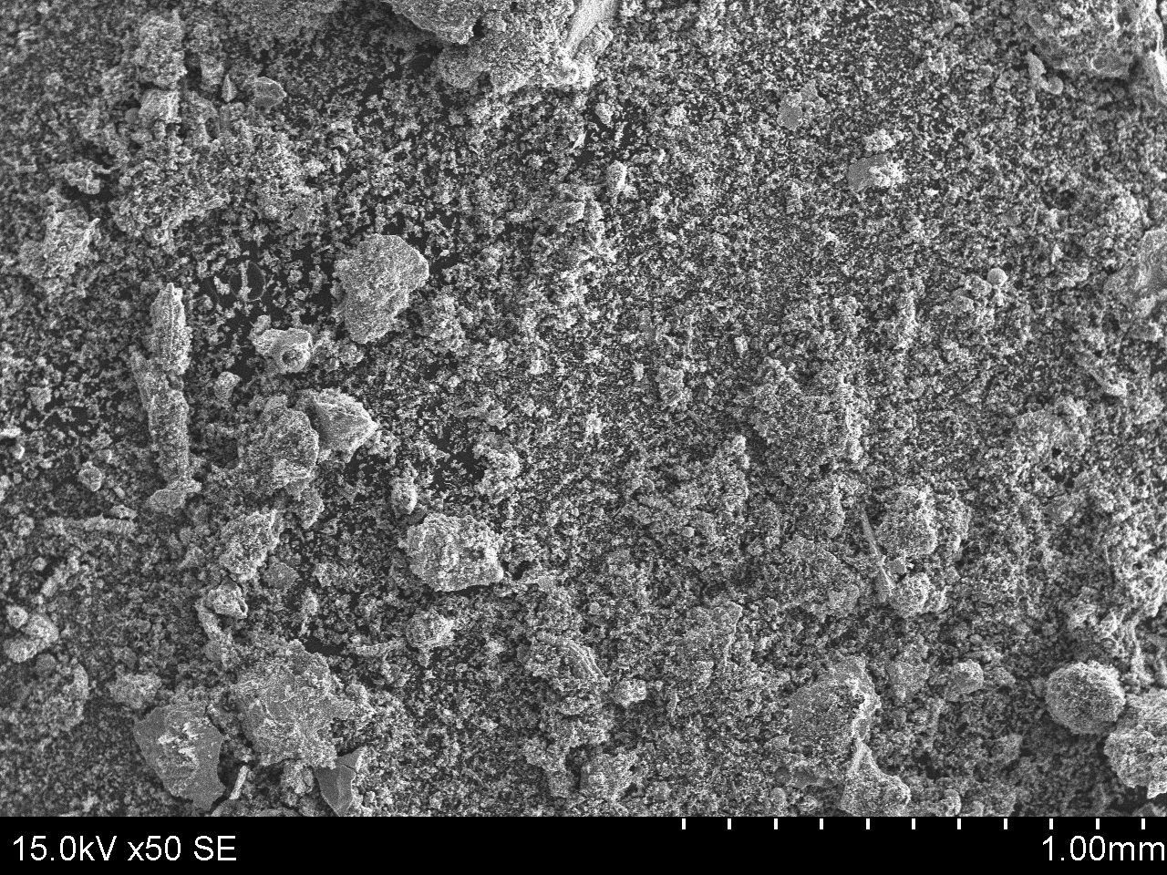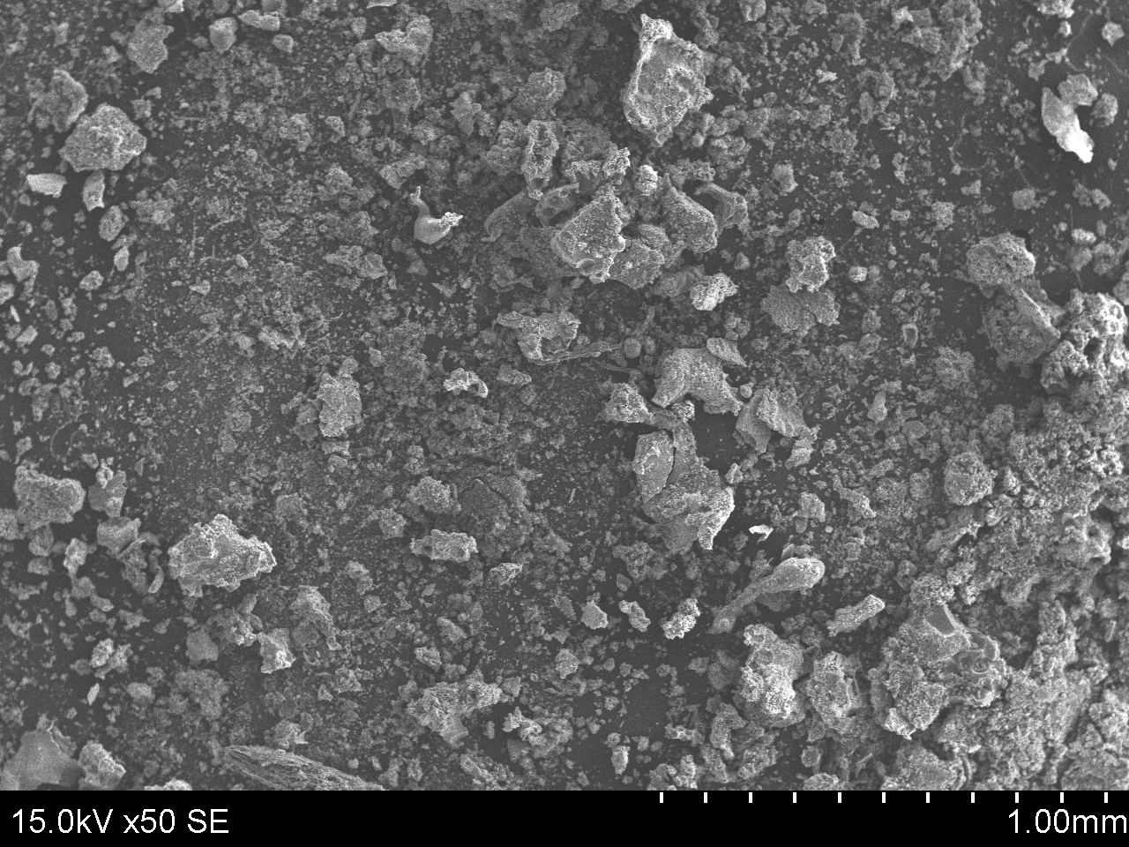
a
b
c
Fig. 9.: Images of solid particles at the same magnification: a – in the cyclone downstream of gasifier, b – in the cyclone upstream of ESP, c – in the ESP

The particle sizes from the gasified wood pellets were found to be between 4 and 400 μm, between 1.8 and 390 μm and between 3.9 and 375 μm in the in cyclone downstream of the gasifier, in the cyclone upstream of the ESP and in the ESP, respectively. As we can see, the sizes of the particles in these three collection points are very similar, with a small decrease of the particle size in the second cyclone and ESP.
The elemental composition of the samples from the same three parts of the experimental setup are presented in Table 2 and Fig. 10.
Table 2. Chemical composition of the solid particles from different places of experimental setup in case of gasification of wood pellets
Element,  mean wt.% | Cyclone downstream of gasifier | Cyclone upstream of ESP | ESP
Oxygen | 20.28 | 24.61 | 29.73
Carbon | 68.42 | 23.78 | 25.59
Zinc | n.d. | 1.87 | n.d.
Iron | 1.85 | 32.20 | 26.86
Calcium | 7.17 | 5.50 | 8.76
Potassium | 0.87 | 1.35 | 1.70
Sulphur | 0.08 | 2.26 | 1.86
Phosphorus | 0.04 | 0.245 | 0.26
Silicon | 0.11 | 1.15 | 0.25
Aluminium | 0.075 | 0.88 | 0.28
Magnesium | 0.47 | 0.94 | 075
Chlorine | 0.14 | 1.67 | 0.44
Sodium | 0.02 | 0.25 | 0.24
Zirconium | 0.14 | n.d. | n.d.
Copper | n.d. | 1.88 | 1.68
Manganese | 0.89 | 0.85 | 1.44
Titanium | 0.23 | 0.54 | 0.23
Nickel | n.d. | 0.34 | n.d.
Chromium | n.d. | 0.31 | n.d.

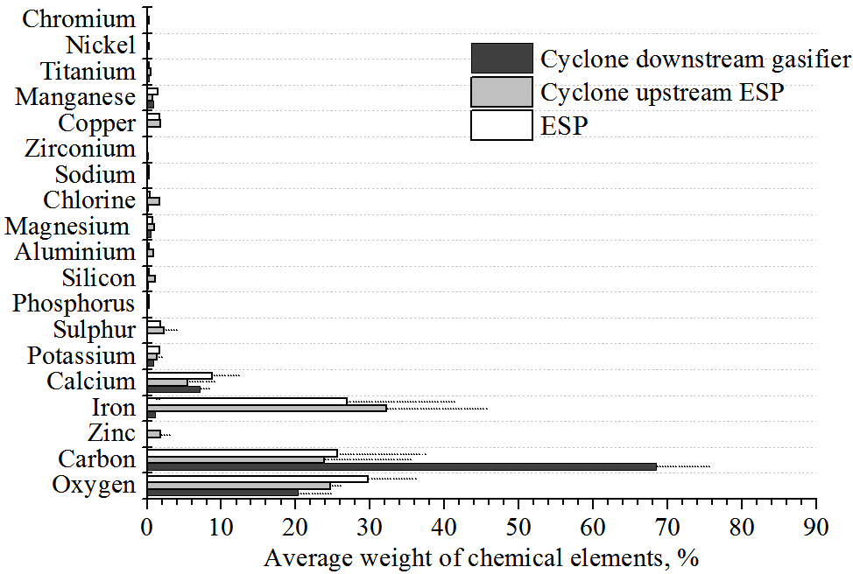

Fig. 10.: Average values of chemical element mass weights of solid particle samples from cyclone downstream of gasifier, from cyclone upstream of ESP and from ESP (dotted lines indicate standard deviation; if dotted lines are not indicated, this means that standard deviation is less than 1 %).

In Fig. 10 for the particles from the cyclones relatively high amounts of various carbon oxides (oxygen 20.3±4.3%, carbon 68.1±8.3%) can be seen along with metals such as zinc, iron and some negligible amounts of aluminium, copper, zirconium and others which were not determined in the initial composition of the fuel shown in Table 1.
4. Conclusions
The investigation focuses on the practical application of a tube-type electrostatic precipitator for particulate removal from a biofuel flue of a class 3 boiler and from a producer gas. The analysis has shown that the gasification process generates particles, which are larger than those obtained during incineration of the same type of wood pellets. The initial concentration of solid particles in the producer gas is much higher than in the flue gas as well. Due to this, the performance of producer gas cleaning using ESP was reduced and a maximum total collection efficiency of about 75% was reached, while for the flue gas it was in the range of 98–99%. The character of the ESP collection performance for both gases was also found to be different. For the flue gas there was a sharp increase with voltage, while for the producer gas the increase observed was only gradual. The results obtained suggest that in order to achieve collection efficiencies of particles in the producer gas close to those in the flue gas modification of the ESP is needed with longer collection electrodes. Results from an investigation of particle size and chemical composition in flue gas and in producer gas are presented and these give a better understanding of the problem under investigation.
References
- V. Schmatloch, S. Rausch. Design and characterisation of an electrostatic precipitator for small heating appliances. Journal of Electrostatics 63, 85-100 (2005).
- J. Tonkonogij, N. Pedišius, A. Stankevičius, A. Tonkonogovas. Investigation of particulate matter emission from low- and middle-capacity boilers fired with solid biofuel. Power engineering 61, 119-130, (2016) (in Lithuanian).
- J.T. Zelikoff, L.C. Chen, M. Cohen, K. Fang, T. Gordon, Y. Li, C. Nadziejko, R.B. Schlesinger. Effects of inhaled ambient particulate matter on pulmonary antimicrobial immune defense. Inhallation Toxicology, 15, 131-150 (2003).
- R. Singh, A. Shukla. A review on methods of flue gas cleaning from combustion of biomass. Renewable and Sustainable Energy Reviews, 29, 854-864 (2014).
- K.L. Parker, Applied electrostatic precipitation (Springer, Netherlands, 1997).
- A.A. Varonos, J.S. Anagnostopoulos, G.C. Bergeles. Prediction of the cleaning efficiency of an electrostatic precipitator. Journal of Electrostatics, 55, 111-133 (2002).
- P.J. Woolcock, R. C. Brown. A review of cleaning technologies for biomass-derived syngas. Biomass and bioenergy 52, 54-84 (2013).
- P. Raman, N.K. Ram, R. Gupta. A dual downdraft gasifier system to produce cleaner gas for power generation: Design, development and performance analysis. Energy 54, 302-314 (2013).
- I. Schildermans, J. Baeyens Reviewing the growing potential of porous sintered metal filters. Czech Society of Chemical Engineering, Prague, Czech Republic (2006).
- J. Smid, S.S. Hsiau, C.Y. Peng, H.T. Lee. Hot gas cleanup: new designs for moving bed filters, Filtration+Separation, 42, 36-39 (2005).
- Y-S. Chen, Y-P. Chyou, S-C. Li. Hot gas clean-up technology of dust particulates with a moving granular bed filter. Applied Thermal Engineering 74, 146-155 (2014).
- J.P.K. Seville. Gas cleaning in demanding applications. 1st edition. 1997. Science Springer + Business Media Dordrecht. 307 p.
- A.G. Bhave, D.K. Vyas, J.B. Patel. A wet packed bed scrubber-based producer gas cooling–cleaning system. Technical note. Renewable Energy 33, 1716–1720 (2008).
- S.V.B. van Paasen, L.P.L.M. Rabou, R. Bär. Tar removal with a wet electrostatic precipitator (ESP); a parametric study. The 2nd World Conference and Technology Exhibition on Biomass for Energy, Industry and Climate Protection” in Rome, Italy, 10-14 May 2004.
- A. Villot, Y. Gonthier, E. Gonze, A. Bernis, S. Ravel, M. Grateau, J. Guillaudeau. Separation of particles from syngas at high-temperatures with an electrostatic precipitator. Separation and Purification Technology, 92, 181-190 (2012).
- A. Bologa, H.-R. Paur, H. Seifert, Th. Wascher, K. Woletz. 2009. Novel wet electrostatic precipitator for collection of fine aerosol. Journal of Electrostatics 67, 150–153.
- Prabhansu, M.K. Karmakar, P. Chandra, P.K. Chatterjee. A review on the fuel gas cleaning technologies in gasification process. J. Environ. Chem. Eng. 3, 689–702 (2015).
- C. Zheng, Z. Shen, Q. Chang, Q. Su, X. Zhu, X Gao. Experimental study on electrostatic precipitation of lLow-resistivity high-carbon fly ash at high temperature. Energy&Fuels, 31, 6266–6273 (2017).
- N. Striugas, K. Zakarauskas, A. Dziugys, R. Navakas, R Paulauskas. 2014. An evaluation of performance of automatically operated multi-fuel downdraft gasifier for energy production. Applied Thermal Engineering 73, 1151-1159.
- Z. Kavaliauskas, V. Valincius, G. Stravinskas, M. Milieska, N. Striugas. 2015. The investigation of solid slag obtained by neutralization of sewage sludge. Journal of the Air & Waste Management 65, 1292-1296.
- R. Poškas, A. Sirvydas, P. Poškas, V. Šimonis, J. Jankauskas. Investigation of the ESP cleaning efficiency of the flue gases in the wide range of Re numbers. Mechanika 23, 47-54 (2017).
- N. Pedisius, M. Praspaliauskas, M. Valantinavicius, T. Vonzodas, V. Zaleskas, E. Lemanas, D. Cepauskienė. Study of biofuel properties, efficiency and pollution parameters of small and medium capacity boilers fired with this fuel. Power engineering 62, 268-281 (2016) (in Lithuanian)
- C Ehrlich, G. Noll, W.-D. Kalkoff, G. Baumbach, A. Dreiseidler. Emissions from industrial plants - Results from measurement programmes in Germany. Atmospheric environment 41, 6236–6254 (2007).
- A Bologa, H.R. Paur, T. Ulbricht, K. Woletz, 2010. Particle emissions from small scale wood combustion devices and their control by electrostatic precipitation. Chemical engineering transactions 22, 119–124 (2010).
- T. Lind, J. Hokkinen, J. K. Jokiniemi. Electrostatic precipitator collection efficiency and trace element emissions from co-combustion of biomass and recovered fuel in fluidized-bed combustion. Enviromental science & technology 37, 2842-2846.
- O. Sippula, J. Hokkinen, H. Puustinen, P. Yli-Pirilä, J, Jokiniemi. Particle emissions from small wood-fired district heating units. Energy&Fuels 23, 2974–2982 (2009).
- J. Pettersson, M. Strand, L. Lin. Charging- and removal efficiency of an ESP in a 250 kW biomass boiler. Proceedings of the XII International Conference on Electrostatic Precipitation, ICESP Nürnberg (2011).
- V. Schmatloch, S. Rausch. Design and characterisation of an electrostatic precipitator for small heating appliances, Journal of Electrostatics 63, 85–100 (2005).

