Acoustic cavitation measurements and modeling in liquid aluminum
Iakovos Tzanakis
Faculty of Technology, Design and Environment, Oxford Brookes University, Oxford, OX33 1HX, UK
Department of Materials, University of Oxford, Oxford, OX1 3PH, United Kingdom
E-mail: itzanakis@brookes.ac.uk

Gerard Serge Bruno Lebon
Brunel Centre for Advanced Solidification Technology (BCAST), Brunel University London, Uxbridge, UB8 3PH, UK Computational Science and Engineering Group, University of Greenwich, 30 Park Row, London SE10 9LS, UK
E-mail: bruno.lebon@brunel.ac.uk

Tungky Subroto
Brunel Centre for Advanced Solidification Technology (BCAST), Brunel University London, Uxbridge, UB8 3PH, UK
E-mail: tungky.subroto@brunel.ac.uk

Dmitry Eskin
Brunel Centre for Advanced Solidification Technology (BCAST), Brunel University London, Uxbridge, UB8 3PH, UK
Tomsk State University, Tomsk, 634050, Russia
E-mail: dmitry.eskin@brunel.ac.uk

Koulis Pericleous
Computational Science and Engineering Group, University of Greenwich, 30 Park Row, London SE10 9LS, UK
E-mail: K.Pericleous@greenwich.ac.uk

Abstract

The quantification of acoustic pressures in liquid metals is of paramount interest for the optimization of ultrasonic melt treatment (UST) of large volumes. Until recently, the measurements of acoustic pressure and cavitation intensity in a melt were cumbersome and unreliable due to the high temperatures and the lack of suitable instruments. These difficulties imposed strict limitations on the experimental and numerical investigation of cavitation and bubble dynamics within liquid metals.

In recent years, our group used a unique calibrated high temperature cavitometer to measure cavitation activity and acoustic pressures in liquid aluminum. Phenomena such as acoustic attenuation, shielding, and cavitation intensity have been studied. These measurements were also used to validate a non-linear acoustic numerical model applicable to flow in bubbly liquids subject to acoustic cavitation. Both experimental and numerical characterization of the acoustic and flow fields provides a powerful tool to optimize cavitation processing in liquid metals.

Keywords: Acoustic pressure, cavitation intensity, ultrasonic melt processing, aluminum

Introduction

Ultrasonic cavitation melt treatment (UST) of melts near their liquidus temperature significantly improves the quality and integrity of alloys, assuring enhanced mechanical and physical properties [1–2]. Observed beneficial effects of the treatment include the release of dissolved gases from the liquid phase (degassing) leading to porosity reduction [3], improved wetting and activation of inclusions by cleaning the solid-liquid interface (sono-capilarity) promoting heterogeneous nucleation and filtration [4], more uniform and finer equiaxed structure of the as-cast alloy by fragmentation of primary crystals and dendrites and their subsequent distribution in the volume [5–6], reduction of segregation and agglomeration due to acoustic streaming [1] and large acoustic pressures from bubble collapse [7]. These property improvements are attributed to acoustic cavitation [8] and acoustic streaming [1]. Acoustic cavitation is the formation, expansion, pulsation and implosion of bubbles and other pre-existing cavities in the bulk liquid generating extreme local temperatures (>10000 K) [9], hydrodynamic pressures and shock waves (GPa range) [10–11] and cooling rates (>10¹¹ K/s) [12] and results in the development of acoustic streaming and secondary flows.

The transfer of this promising ultrasonic technology to the industry has been impeded by difficulties in scaling up the treatment to large volumes of melt, as is required by industrial processes such as continuous casting. A fundamental understanding of the multi-scale behavior in the sonicated melt and the actual nature of the grain refinement mechanisms is required to facilitate the transfer of this technology so that the casting industry may benefit from UST. Current efforts are concentrated on 1) understanding the interaction between cavitation field and acoustic streaming with the melt flow and the suspended solid/liquid phases, and 2) achieving high efficiency in processing large melt volumes using cleverly designed flow arrangements including baffles, optimized melt flows, and different positions of the sonotrode along a launder [13–14]. The success of this operation requires the understanding of the multi-scale phenomena that are involved in cavitation and in-depth knowledge of the underlying physical mechanisms of UST, supported by adequate and validated numerical modeling. A key parameter for such a technological step up is the characterization of cavitation activity in a melt volume that helps to distinguish different regimes of acoustic cavitation and consequently measure acoustic pressures at particular frequencies.

The characterization of cavitation activity in liquid aluminum, as exemplified by Komarov et al. [15], has been the subject of few studies [1]. However, results were presented in a qualitative manner in relative electrical units (mV) and not in the physically meaningful units of pressure (Pa). As a result, the reported data cannot be applied for quantitative analysis, and development and validation of numerical models. To fill this gap in melt treatment research, an advanced high-temperature cavitometer was calibrated at particular low frequencies (kHz), related to the driving frequency and further harmonics of the ultrasonic source, and high frequencies (MHz), related to cavitation emissions; calibration at these frequency ranges enable direct acoustic pressure measurements inside the melt [16]. This tool enabled the characterization of the acoustic spectra and pressure fields in aluminum and water, demonstrating also that water is a good physical analogue to aluminum for cavitation studies [17]. The effect of melt temperature, ultrasound input power and location of the ultrasound source on acoustic pressures have been quantified in liquid aluminum [18]. In this work using our established experimental and numerical methodology in measuring and quantifying acoustic pressures [7, 19–20], we highlight the effect of the resonance size of an experimental vessel on the development of cavitation activity in the aluminium melt. The proposed work is another stepping stone towards the optimization of flow management in UST.

Methodology

A high performance cylindrical ceramic (SiAlON) sonotrode with a tip diameter of 48 mm and length 460 mm attached to a 1 kW piezoelectric transducer treated liquid aluminum at a frequency of 20 kHz. The input power was constant at 70 %, corresponding to a peak-to-peak amplitude of 33 μm (the power delivered to the melt was 275 W) able to generate cavitation into the melt [20]. The ceramic sonotrode was submerged 20 mm below the free surface. The tip was preheated before aluminum treatment. A K-type thermocouple was used to continuously monitor the melt temperature. There was no controlled atmosphere during experiments. The material properties of liquid aluminum can be found in [17].

Experiments were performed in two rectangular domains of different sizes separated by a solid partition wall as shown in Figure 1. A wavelength size tank (225 mm in length) was deployed to match the wavelength of sound in liquid aluminum at an operating frequency of 20 kHz. A non-wavelength size tank (145 mm in length) was chosen to verify whether setting one dimension of the experimental tank to differ from the wavelength of soundwave had an effect on the acoustic resonance and hence on the cavitation activity and pressure field along the liquid domain. Thus, to investigate the effect of resonance across the fluid domain, measurements of acoustic emissions were taken at several points: i) below the sonotrode (with cavitometer positioned at an angle of 45°) ii) at the side wall and iii) at distance of 45 mm from the sonotrode axis (with cavitometer vertically positioned), as illustrated by Figure 2. The sonotrode was placed in the center of both rectangular tanks. The melt temperature was continuously monitored with a K-type thermocouple and maintained in the range of 680±15 °C for all the experiments.

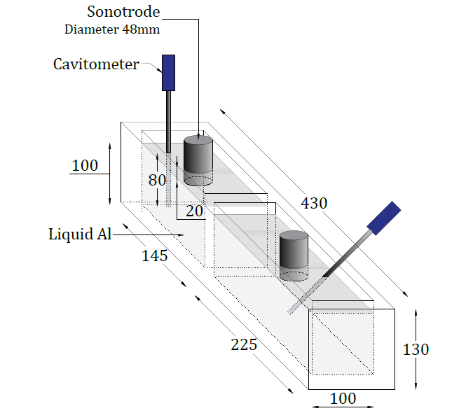

Figure 1: Schematic of the experimental setup showing different used settings for acoustic measurements

A calibrated cavitometer captured the cavitation activity inside the liquid bulk: a full account of the cavitometer design and performance was given elsewhere [15]. The cavitometer consisted of a cylindrical tungsten probe (diameter 4 mm), had a spatial resolution of 50±10 mm, and could capture frequencies up to 10 MHz. The probe tip was submerged 80±5 mm below the sonotrode. An external digital oscilloscope (Picoscope series 4424) collected the voltage response of the probe from 60 individual readings in samples of 2 ms, each with a resolution of 0.150 kHz. The data was acquired when there was no change in the average value of the minimum voltages and a steady state condition was achieved. The pressure conversion process followed the methodology described in [17]. The measurements in the 225 mm tank are supported by a numerical simulation using a non-linear acoustic model [21].

Results and Discussion

Figures 2 and 3 show the root mean square (RMS) and maximum pressures measured in each tank at the measuring locations given in Figures 2a and 3a. In both cases, the highest cavitation pressure was measured under the sonotrode, with the rest of the locations providing lower cavitation pressure regime with symmetric values. In particular, in the resonance size tank (Fig. 2, 225 mm in length) maximum acoustic pressure peaks were in the range of 10 MPa with largest RMS pressures (representing the average of largest RMS acoustic pressure measured from 60 individual waveforms) being at 1.5 MPa. For the non-resonance tank (145 mm in length), the maximum acoustic pressure reached 2.5 MPa with the maximum RMS pressure measured at 450 kPa. It is apparent that the effect of the tank resonance size is significant, amplifying the RMS pressure field within the cavitation zone by 3 times with the maximum pressures being 4 times larger. Moreover, these pressures are adequate to generate a large number of cavitation bubbles within liquid aluminum as numerically predicted by [20] and experimentally captured and analysed using X-ray radiation in [22]. Additionally, Figures 2 and 3 indicate the borders of the cavitation zone with an exponential pressure drop as we migrate from the cavitation zone. Results are in good agreement with [7, 19] and confirm that cavitation treatment in liquid aluminium should take place inside the cavitation zone where the highest acoustic pressures are registered.

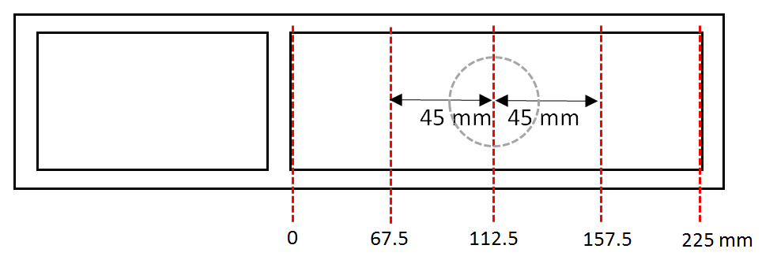
a
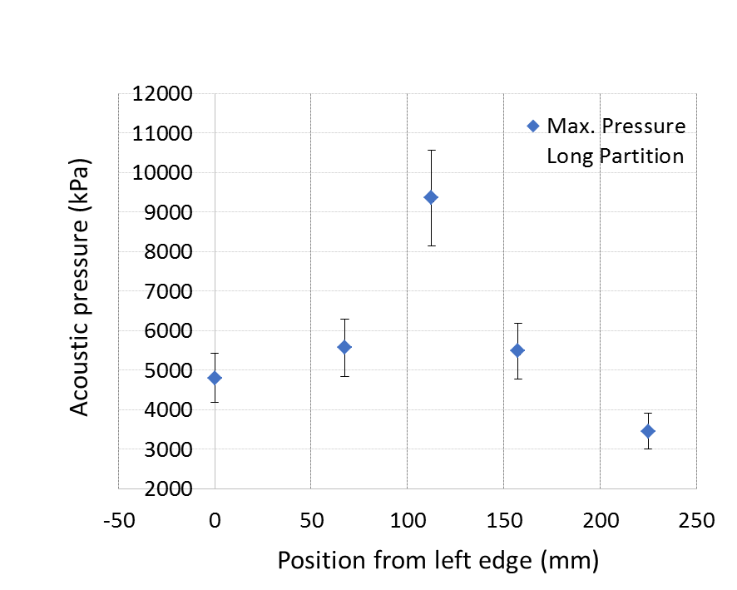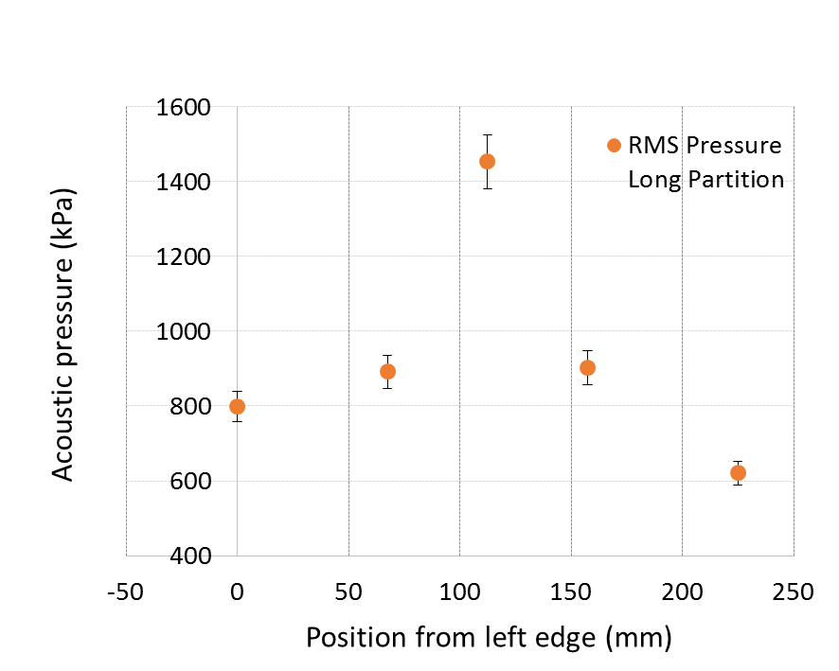
c
b
Figure 2: Resonance tank (225 mm in length): a) Locations of acoustic pressure measurements and position of the sonotrode indicated by the dashed lines and with the dashed circle respectively, b) Maximum pressures and c) RMS pressures recorded for the specific locations as shown in (a) with the sonotrode power set at 70%

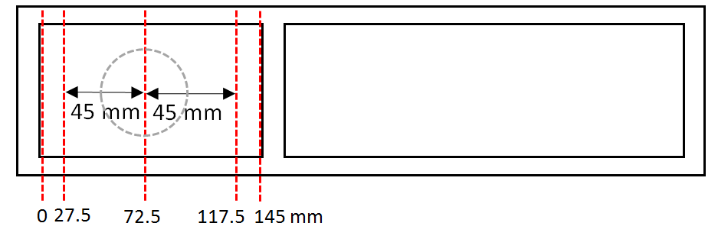
a
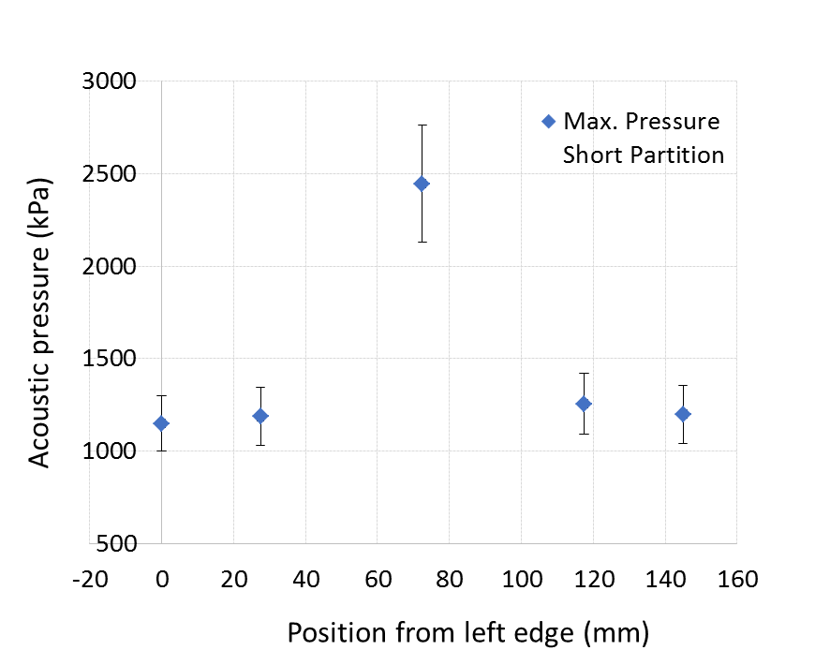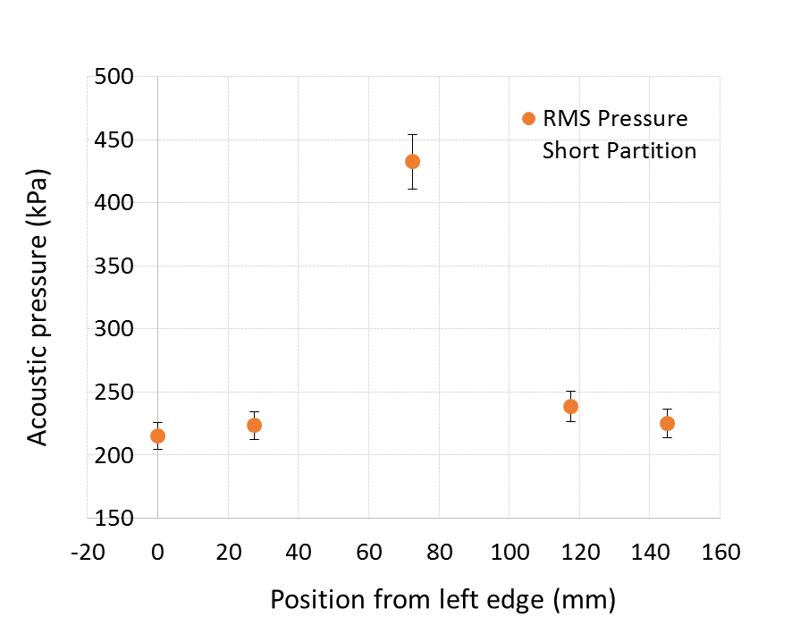
c
b

Figure 3: Resonance tank (145 mm in length): a) Locations of acoustic pressure measurements and position of the sonotrode indicated by the dashed lines and with the dashed circle respectively, b) Maximum pressures and c) RMS pressures recorded for the specific locations as shown in (a) with the sonotrode power set at 70%

Similarly, the resulting RMS pressures in the other two measuring locations, side and at 45 mm from the source as illustrated by Figures 2a and 3a, were in the order of 600 kPa to 1 MPa for the resonance tank and 200–250 kPa for the non-resonance tank with maximum pressures in the range of 4–6 MPa and 1–3 MPa respectively. Liquid aluminum in the tank with the resonance length 225 mm seemed to have a much higher acoustic RMS pressure under the sonotrode, in the range of about 230% as compared with the non-resonance tank (145 mm) whereas at the same distance from the sonotrode (45 mm) as well as near the side walls, this percentage was 260%. A plausible explanation lies in the fact that the 225 mm tank has a dimension that is closer to the resonance length of liquid aluminum when sonicated at 20 kHz compared to the 145 mm tank. This resonance match promoted the formation of standing waves that gave rise to a larger pressure field.

This observation improves our understanding of the development of cavitation acoustic pressures across the whole fluid domain when a tank with resonance geometrical features is utilized while at the same time it can be used for further development and validation of numerical models to simulate comprehensively the UST. Results are also in a very good agreement with the recent numerical work of Lebon et al. [20] where a comparison between a resonant and non-resonant experimental tank in sonicated water showed that the size of the tank plays an important role in the cavitation development as it can significantly increase the acoustic pressure field.

A non-linear sound propagation model was used to predict the cavitation pressures inside the tank, as shown in Figure 4. Figure 4a denotes the positions of the nodes across the tank plane. Two rows of five pressure nodes were predicted, with the strongest node located at the tank bottom under the sonotrode. The pressure profile is plotted along the lines y = -75 mm, y = -80 mm and y = -85 mm, corresponding to the range of experimental data acquisition (Fig. 4b). The predicted values compare well with the measured pressures, suggesting that the non-linear model is an adequate tool to study acoustic cavitation in liquid aluminum.

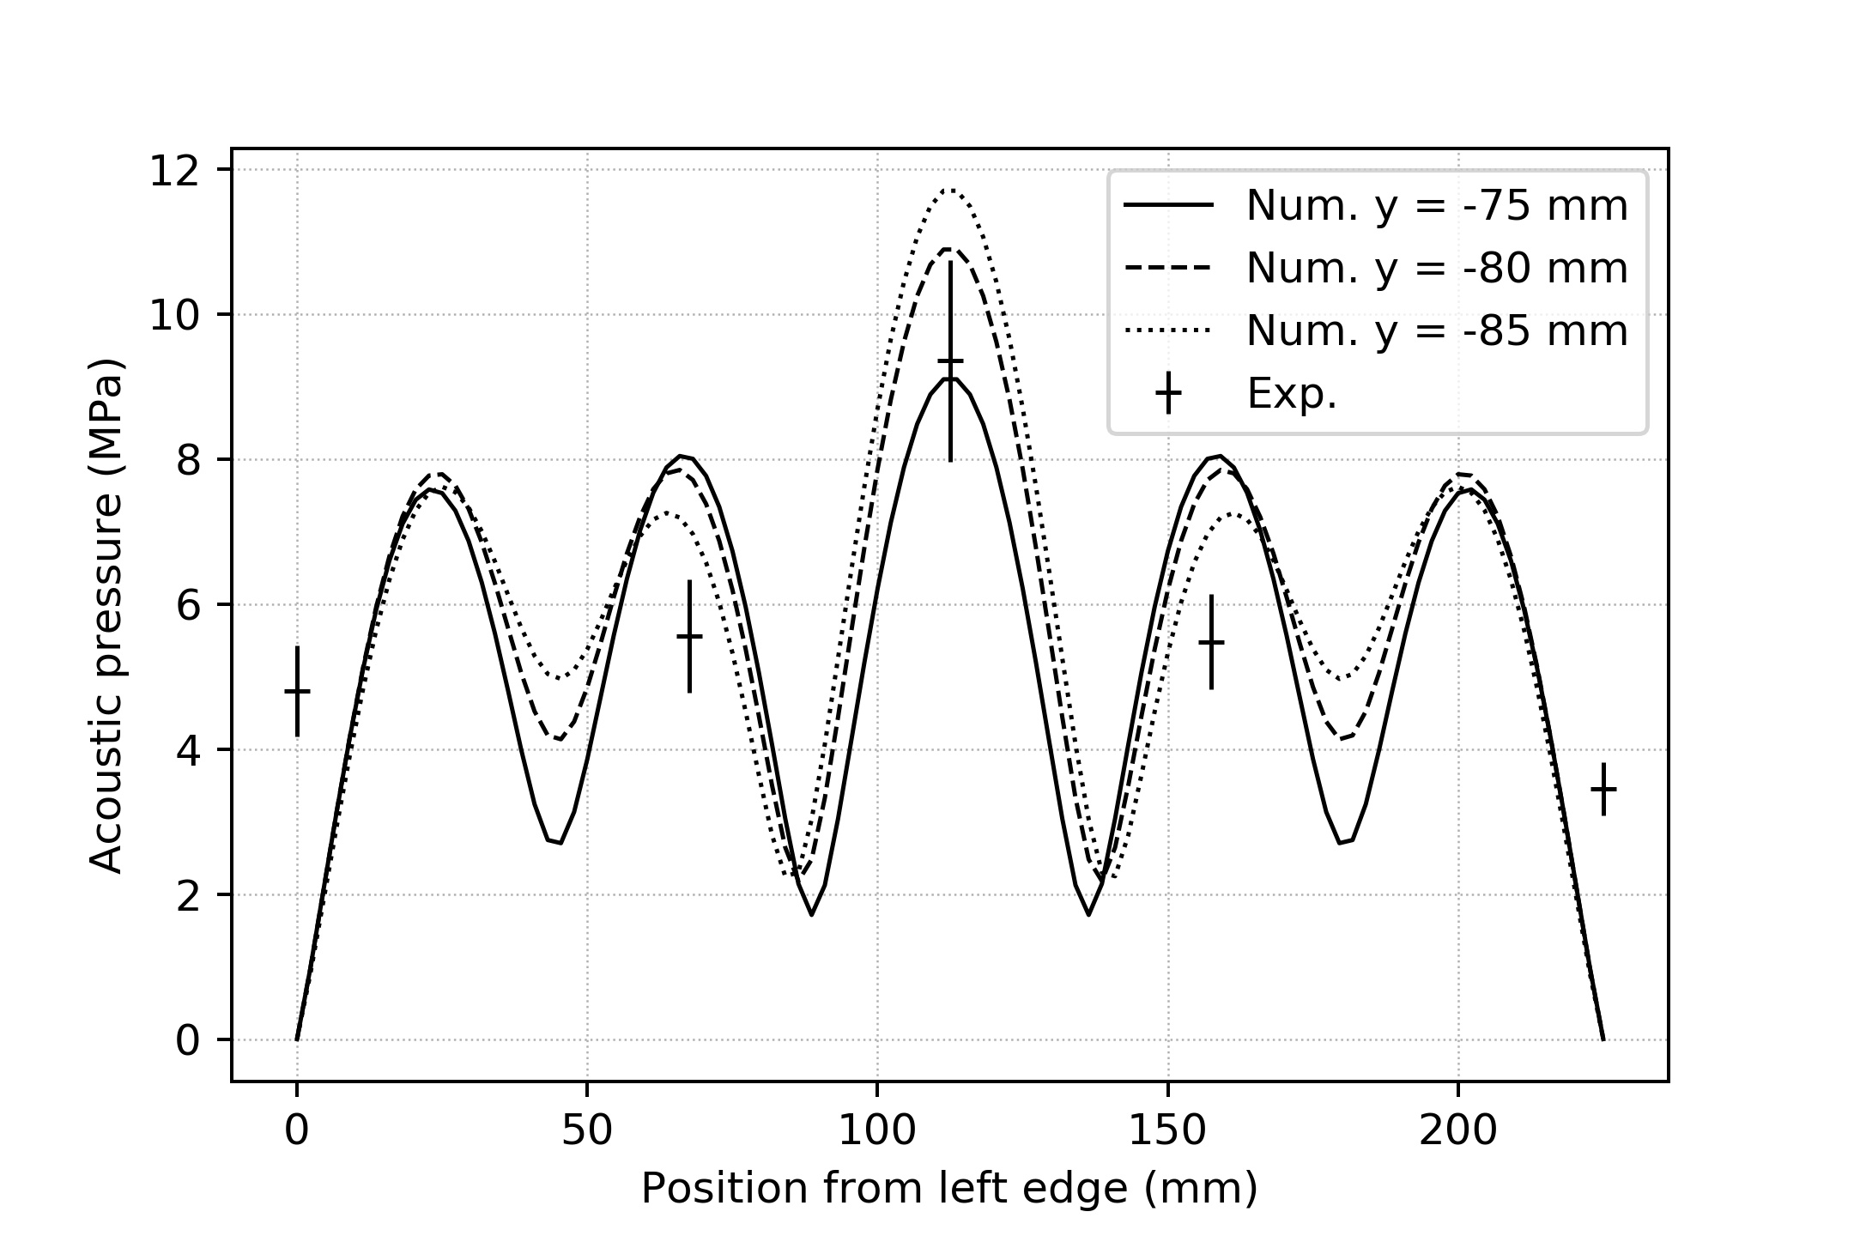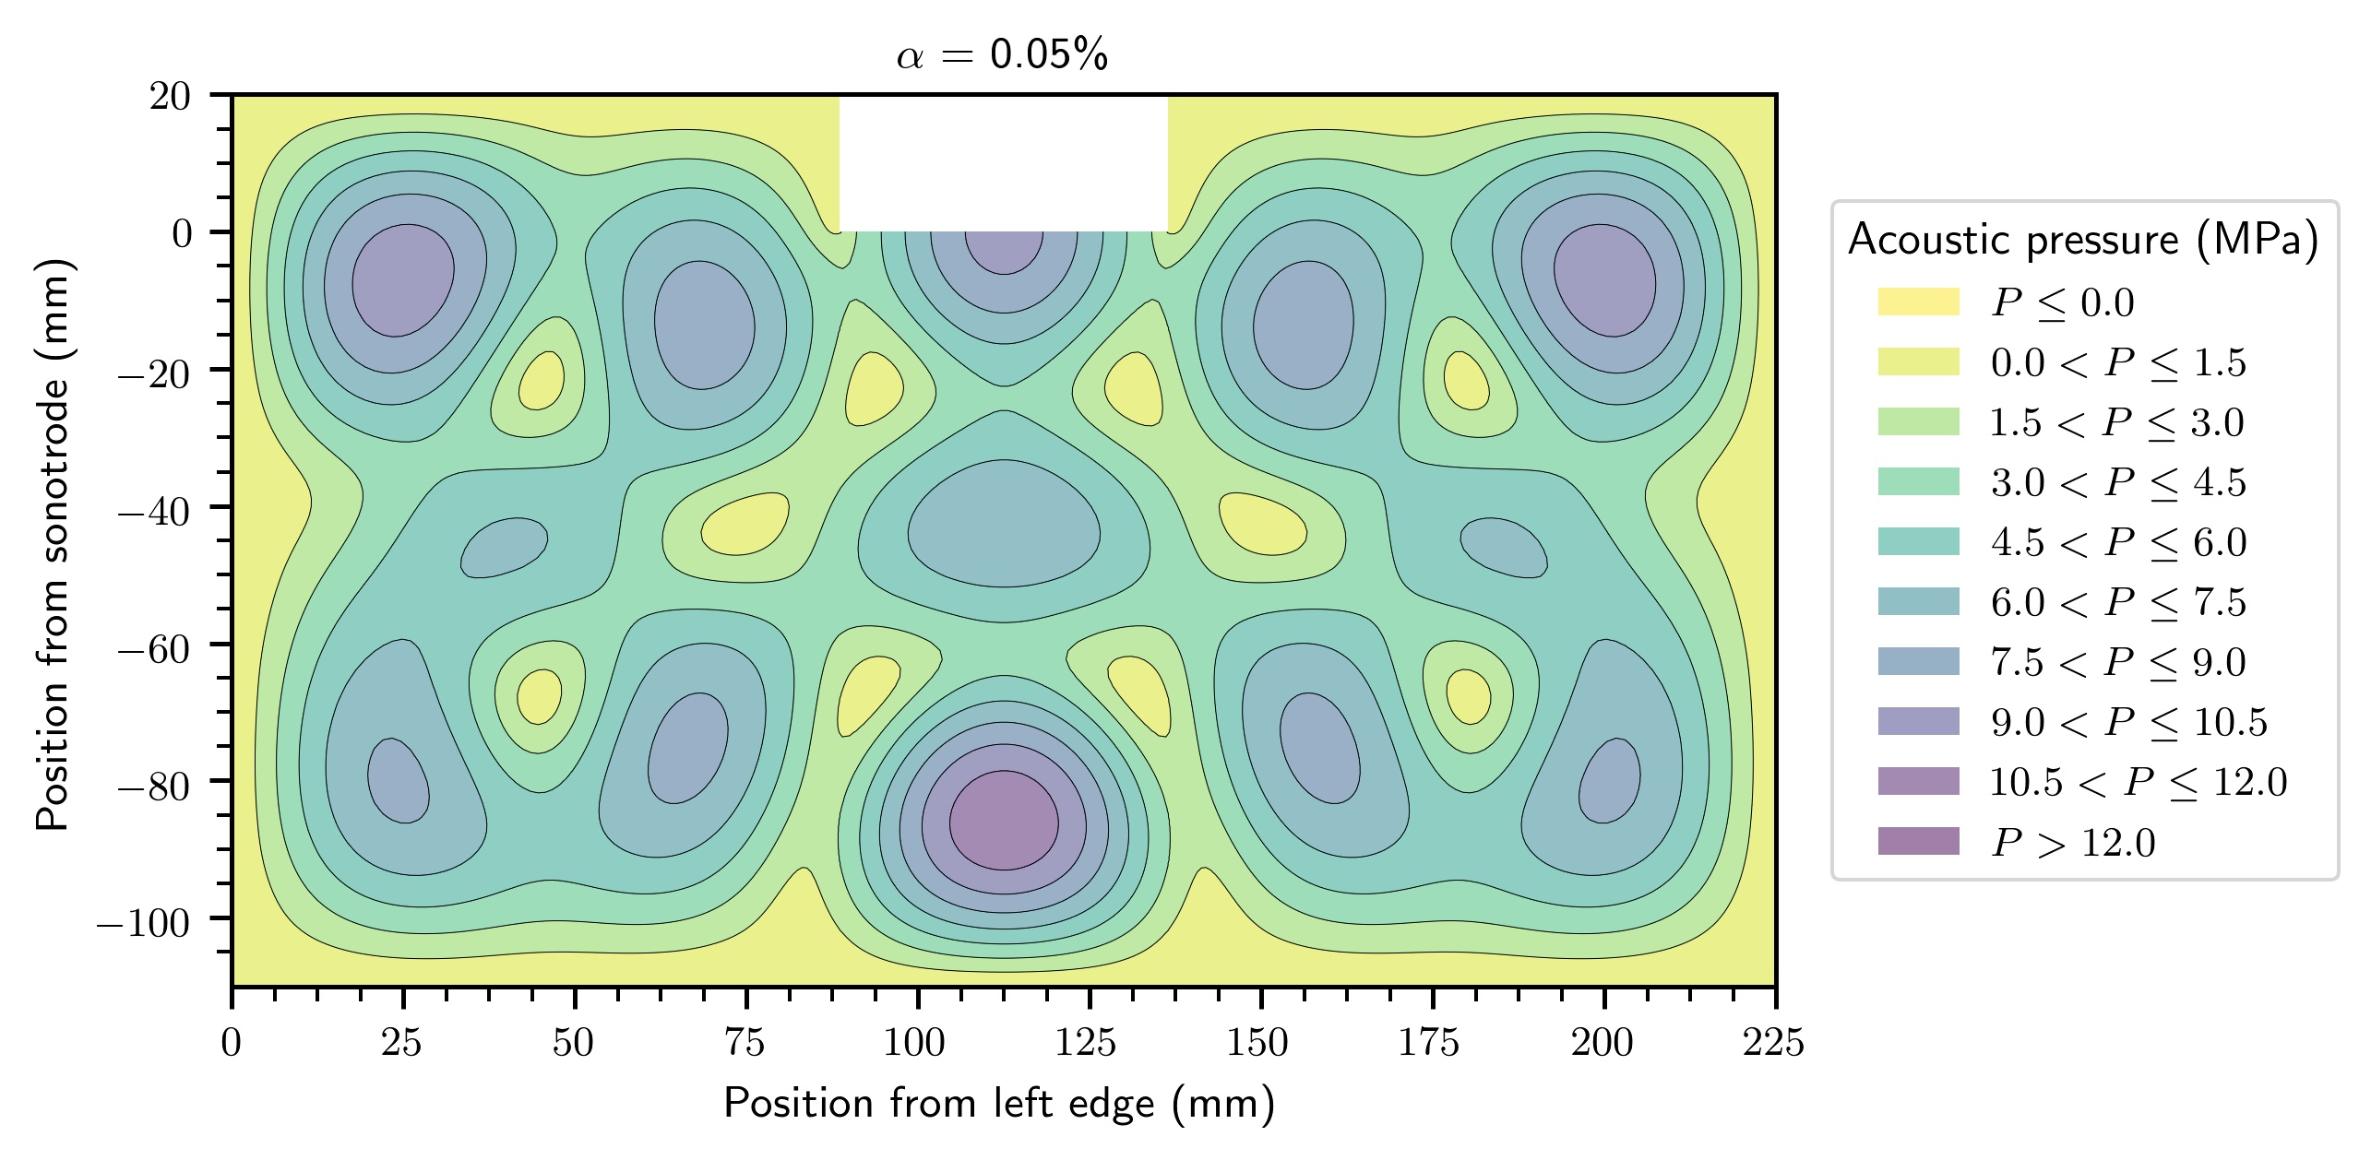
sonotrode

Figure 4: Predicted acoustic pressure in the 225 mm tank. (a) Contours of pressure in the plane of the tank and (b) acoustic pressure plots between 75 mm and 80 mm below the sonotrode level, corresponding to the position of the cavitometer during the experiments (as shown in Fig. 1).

Conclusions

In this study, the effect of resonance length in the development of cavitation intensity was investigated. Comparison between the different length scales of the experimental tank showed that cavitation development is affected by the vessel size and the resonance mode, giving rise to higher acoustic pressures under resonance conditions.

Specifically, liquid aluminum in the tank with a resonance length of 225 mm shows a much higher acoustic pressure under the sonotrode (about 230% compared with the non-resonance tank of 145 mm), with the other measurement locations indicating similar amplification of cavitation intensity, up to 260%. This result reveals that the optimum geometrical features of an experimental tank are located in the range of the resonance size where it is likely that standing waves will be more pronounced.

The numerically predicted pressure values are in good agreement with the measured pressure values and in the range of up to 10 MPa suggesting that the non-linear numerical model is a powerful tool for melt flow optimization.

We have shown in this paper that the resonance size plays an important role in the cavitation development as it can significantly increase the acoustic pressure field in a sonicated melt. This work paves the way to the optimization and better control of UST which is crucial for up-scaling and industrial implementation.

Acknowledgments:

Financial support from the UK Engineering and Physical Sciences Research Council (EPSRC) through grants UltraMelt2 (EP/R011001/1, EP/R011044/1, and EP/R011095/1) and LiME Hub (EP/N007638/1) is gratefully acknowledged.

References:

- G.I. Eskin, D.G. Eskin “Ultrasonic Treatment of Light Alloy Melts” Second Edition, CRC Press, 2015.
- D.G. Eskin, I. Tzanakis, F. Wang, G.S.B. Lebon, K. Pericleous, P.D. Lee, T. Connolley, J. Mi, Fundamental studies of ultrasonic melt processing, in: Proc. 6th Decenn. Int. Conf. Solidif. Process., Old Windsor, UK, 2017: pp. 546–549
- D.G. Eskin, K. Al-Helal, I. Tzanakis, “Application of a plate sonotrode to ultrasonic degassing of aluminum melt”, J. Mater. Process. Technol. 222 (2015) 148–154.
- I. Tzanakis, W.W. Xu, D.G. Eskin, P.D. Lee, N. Kotsovinos, “In situ observation and analysis of ultrasonic capillary effect in molten”, Ultrason. Sonochem. 27 (2015) 72–80.
- T.V. Atamanenko, D.G. Eskin, L. Zhang, L. Katgerman, “Criteria of grain refinement induced by ultrasonicmelt treatment of aluminum alloys containing Zr and Ti”, Metall. Mater. Trans. A 41A (2010) 2056–2066.
- F. Wang, I. Tzanakis, D. Eskin, J. Mi, T. Connolley “In situ observation of ultrasonic cavitation-induced fragmentation of the primary crystals formed in Al alloys” Ultrasonics - Sonochemistry 39 (2017) 66–76
- I. Tzanakis, G.S.B. Lebon, D.G. Eskin, K.A. Pericleous “Characterisation of the ultrasonic acoustic spectrum and pressure field in aluminium melt with an advanced cavitometer” Journal of Materials Processing Technology 229 (2016) 582–586
- E. Neppiras. “Acoustic cavitation series: part one: Acoustic cavitation: an introduction”, Ultrasonics 22 (1984) 25-28.
- D.J. Flannigan, K.S. Suslick, “Plasma formation and temperature measurement during single-bubble cavitation”. Nature 434 (2005) 52–55.
- I. Tzanakis, D.G. Eskin, A. Georgoulas, D. Fytanidis, “Incubation pit analysis and calculation of the hydrodynamic impact pressure from the implosion of an acoustic cavitation bubble”, Ultrason. Sonochem. 21 (2014) 866–878.
- A. Phillipp, W. Lauterborn, “Cavitation erosion by single laser-produced bubbles” J. Fluid Mech. (1998), vol. 361, pp. 75-116
- A. Gedanken, “Using sonochemistry for the fabrication of nanomaterials.” Ultrason. Sonochem. 11 (2004) 47–55
- I. Tzanakis, G.S.B. Lebon, D.G. Eskin, K.A. Pericleous “Optimization of the Ultrasonic Processing in a Melt Flow” Light Metals 2016, chapter 141
- G.S.B. Lebon, I. Tzanakis, D.G. Eskin, K.A. Pericleous WA High-Order Acoustic Cavitation Model for the Treatment of a Moving Liquid Metal Volume” In: Nastac L. et al. (eds) CFD Modeling and Simulation in Materials Processing 2016. The Minerals, Metals & Materials Series. Springer, Cham
- S. Komarov, K. Oda, Y. Ishiwata, N. Dezhkunov. Characterization of acoustic cavitation in water and molten aluminum alloy, Ultrasonics Sonochemistry 20 (2013) 754-761.
- I. Tzanakis, M. Hodnett, G.S.B. Lebon, N. Dezhkunov, D.G. Eskin. Calibration and performance assessment of an innovative high-temperature cavitometer, Sensors and Actuators A: Physical 240 (2016) 57-69
- I. Tzanakis, G.S.B. Lebon, D.G. Eskin, K.A. Pericleous, Characterizing the cavitation development and acoustic spectrum in various liquids, Ultrason. Sonochem. 34 (2017) 651–662
- I. Tzanakis, G.S.B. Lebon, D.G. Eskin, K. Pericleous. Investigation of the factors influencing cavitation intensity during the ultrasonic treatment of molten aluminium, Materials and Design 90 (2016) 979-983
- G.S.B. Lebon, I. Tzanakis, G. Djambazov, K. Pericleous, D.G. Eskin, Numerical modelling of ultrasonic waves in a bubbly Newtonian liquid using a high-order acoustic cavitation model, Ultrason. Sonochem. 37 (2017) 660–668. doi:10.1016/j.ultsonch.2017.02.031.
- G.S.B. Lebon, I. Tzanakis, K. Pericleous, D. Eskin, Experimental and numerical investigation of acoustic pressures in different liquids, Ultrason. Sonochem. 42 (2018) 411–421. doi:10.1016/j.ultsonch.2017.12.002
- O. Louisnard, A simple model of ultrasound propagation in a cavitating liquid. Part I: Theory, nonlinear attenuation and traveling wave generation, Ultrason. Sonochem. 19 (2012) 56–65. doi:10.1016/j.ultsonch.2011.06.007
- W.W. Xu, I. Tzanakis, P. Srirangam, S. Terzi, W. Mirihanage, D.G. Eskin, A.J. Bodey, P. Lee, Synchrotron quantification of ultrasound cavitation and bubble dynamics in Al–10Cu melts, Ultrason. Sonochem. 31 (2016) 355–361.

