The Role of Gasoline Price Expectations in Transmitting Gasoline Price Shocks

to Inflation and Real Activity

Christina Anderl
Bank of England

Guglielmo Maria Caporale
Brunel University of London

Revised, July 2026

Abstract
This paper argues that gasoline price fluctuations affect inflation through changes in consumer expectations about future energy costs. More precisely, we use data from the US Michigan Survey of Consumers and estimate a Structural VAR model to show that long-run gasoline price expectations are an important transmission channel through which gasoline price shocks are propagated to both inflation and real economic activity. These findings suggest that monitoring consumer energy price expectations offers policymakers an early warning signal for inflationary pressure, which is a useful tool in addition to broader inflation anchoring. As energy market volatility intensifies in an era of geopolitical uncertainty and green transition, understanding this channel becomes increasingly important for monetary policy.
Keywords: Gasoline price expectations; inflation expectations; anchoring; transmission channel; counterfactual analysis; Structural VAR
JEL Classification: C32, E31, E52, Q43

Corresponding author: Professor Guglielmo Maria Caporale, Department of Economics, Finance and Accounting, Brunel University of London, Uxbridge, UB8 3PH, UK. Email: Guglielmo-Maria.Caporale@brunel.ac.uk; https://orcid.org/0000-0002-0144-4135

The views expressed in this paper are those of the authors and do not represent those of the Bank of England.
We thank the editor and the two anonymous reviewers for their helpful comments.

Introduction
Gasoline is one of the most visible and frequently purchased goods in modern economies, making its price extremely important for how consumers form views about the cost of living more broadly: when gasoline prices rise, households immediately notice. How consumers expect gasoline prices to behave in the future matters as much as how they actually behave today, since their expectations influence wage demands, spending decisions, and ultimately the inflation dynamics that central banks try to control. Anchoring inflation expectations, whose aim is to keep public beliefs about future price increases close to the central bank target, is a cornerstone of modern monetary policy. When expectations are not anchored, price and wage-setting can generate self-fulfilling inflationary spirals that are costly and difficult to reverse. A large body of research has studied whether headline inflation expectations from household, firm, and professional forecaster surveys are well-anchored, and a broad consensus has emerged that they have been in the US since the global financial crisis of 2008 (Strohsal et al., 2016; Buono and Formai, 2018; Grishchenko et al., 2019). Yet how economic agents actually form inflation expectations, and whether survey responses reflect the beliefs that genuinely drive their behaviour, remains an open question (Coibion et al., 2020a; Kumar et al., 2015).

A critical but rather underexplored issue concerns expectations about individual components of consumer prices. The Michigan Survey of Consumers, one of the most widely used and carefully studied surveys of household expectations, asks respondents not only about their general outlook for inflation over the next one or five years, but also, in a separate question, specifically about gasoline prices. This distinction matters. Gasoline prices affect the cost of numerous goods and services and consumers become aware of them repeatedly, whether at the pump, on road signs, or in daily conversation. Therefore, they have a large influence on how consumers think about inflation more broadly. If gasoline price expectations, rather than realised gasoline price changes, are an important channel through which energy shocks spread to the rest of the economy, then monitoring and understanding them becomes a policy priority.

Figure 1. Time Series Plots
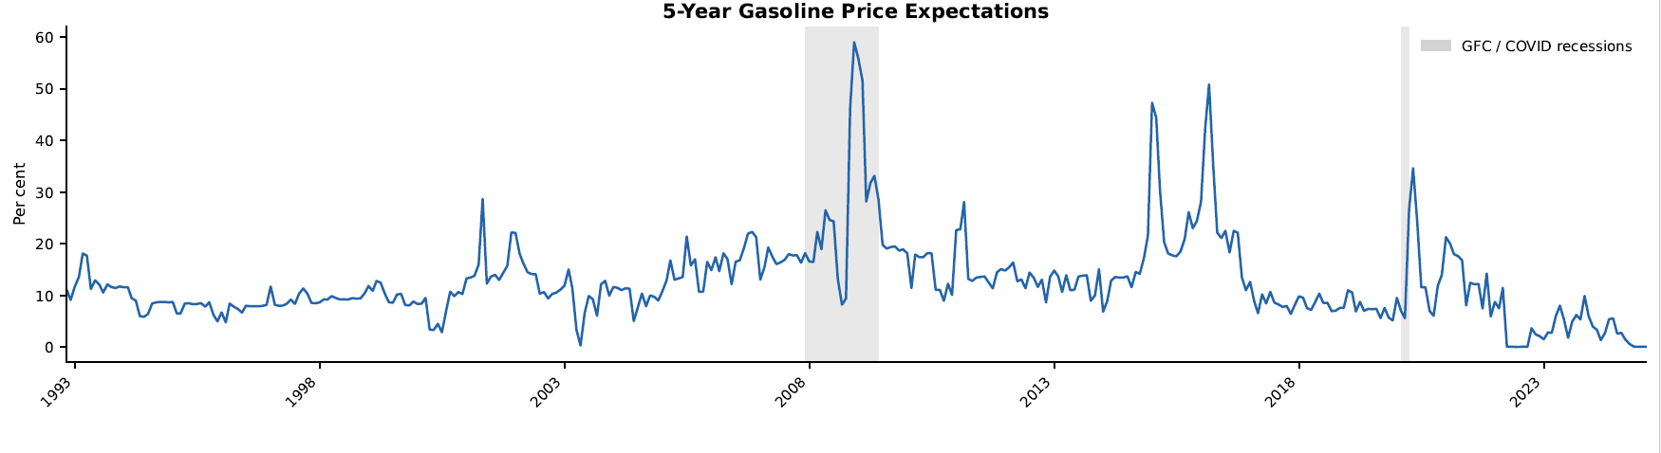
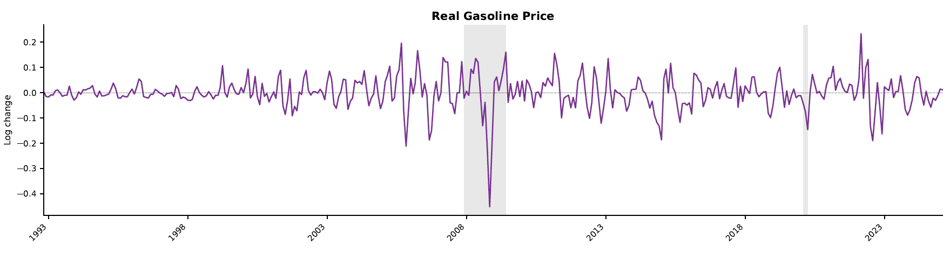
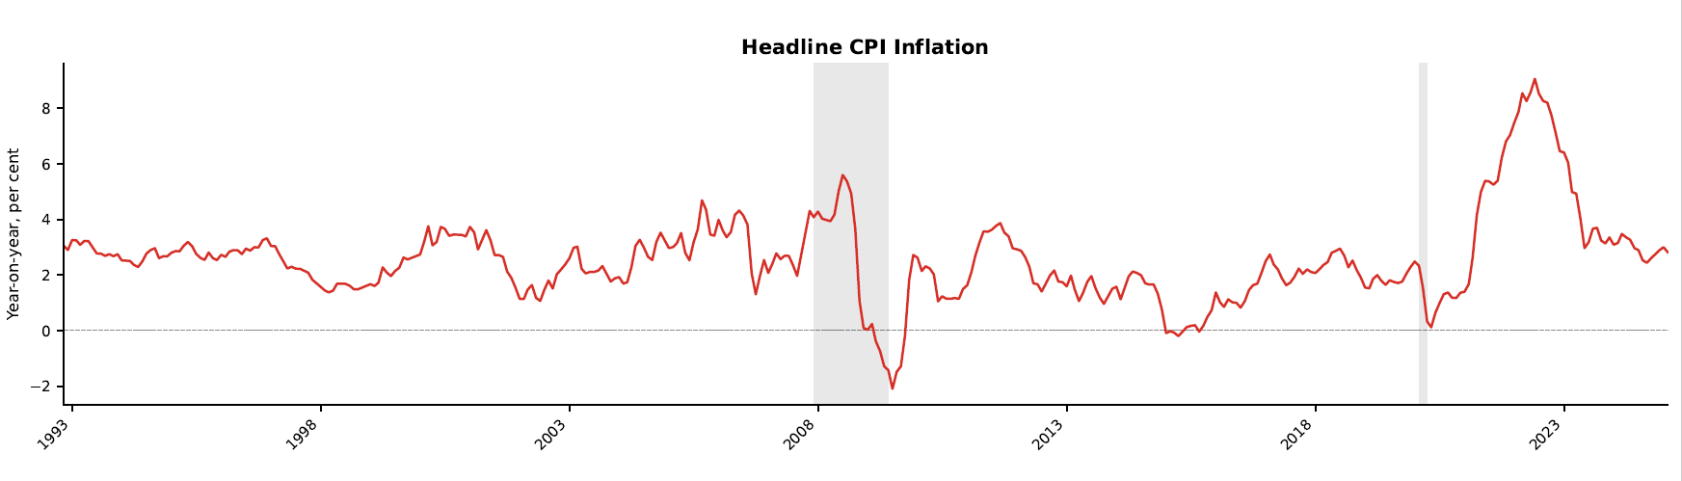
Notes: Time series plots with NBER recession bars.

Figure 1, which shows monthly 5-year gasoline price expectations, real gasoline price, and headline CPI inflation over the period from November 1992 to February 2025 (see section 4 for further details of the data) lends support to this idea. Five-year gasoline price expectations display substantial volatility, with a full-sample mean of around 13% and a standard deviation of over 8 percentage points, and movements that closely shadow major energy market events. They increased during the global financial crisis, reaching nearly 60% in late 2008, before collapsing as prices reversed, and rose again, more moderately, during the Covid-19 period. By mid-2022, expectations had fallen back to near zero, consistently with the sharp reversal in gasoline prices at that time. Real gasoline price growth follows a similar pattern with large negative swings in late 2008 and early 2020 and a sharp positive spike in early 2022 as a result of the Russian invasion of Ukraine. Headline inflation follows these energy price cycles closely; it fell to its sample minimum of −2.1% during the global financial crisis as energy prices collapsed, and rose to its sample maximum of over 9% in mid-2022, which is its highest value in the sample and well above the Fed's 2% target. Crucially, the impact of gasoline price expectations on the other series appears not to be contemporaneous: expectations lead prices in several instances, suggesting that they do not simply mirror current conditions. This motivates a formal structural investigation of whether gasoline price expectations act as an active transmission channel that propagates the effects of gasoline price shocks on inflation and real activity beyond their direct impact.

This is precisely the issue we investigate in the present study. Using the Michigan Survey's five-year gasoline price expectations data, we ask whether consumers' forward-looking beliefs about energy costs act as a transmission channel for gasoline price shocks and propagate their effects to wider inflation and real economic activity. To answer this question, we estimate a Structural Vector Autoregressive (SVAR) model for the US and conduct counterfactual analysis to separate the direct effects of gasoline price shocks from the second-round effects that operate through the expectations channel. Our approach builds on a growing literature examining how energy price shocks are transmitted to inflation through expectations, including recent work on natural gas in the euro area which shows that the expectations channel can generate large and asymmetric propagation effects beyond what commodity prices alone would predict (Boeck and Zörner, 2025).

Our findings have important policy implications. In an era of recurrent energy price volatility driven by geopolitical disruptions, the green energy transition, and shifting global supply chains, understanding how commodity-specific expectations feed into aggregate inflation is crucial for policymakers. If gasoline price expectations propagate inflationary pressures even when headline expectations appear anchored, then the standard measure of central bank credibility may be giving an incomplete signal. Monitoring narrower, commodity-specific expectations could offer policymakers an early warning system that complements conventional measures and provides insights directly relevant for inflation targeting frameworks.

The remainder of this paper is organised as follows: Section 2 reviews the literature on the anchoring of inflation expectations and their role as a transmission channel; Section 3 introduces the modelling framework; Section 4 describes the data and presents the empirical results; Section 5 offers some concluding remarks.

Literature Review
There is an extensive literature examining the anchoring of inflation expectations and how it can be measured. For instance, Kumar et al. (2015) consider five different definitions of anchoring, including distance from the target and disagreement amongst participants, and using firm survey data for New Zealand reach the conclusion that expectations are not anchored, regardless of the chosen definition. Strohsal and Winkelmann (2015) assess the degree of anchoring on the basis of the mean reversion of inflation expectations and report heterogeneities across countries. Other approaches are news-based and define anchored expectations as the absence of movements in inflation expectations in response to news (see, for instance, Gürkaynak et al., 2010) – such studies generally find support for anchoring in credible inflation targeting environments. Using a time-varying parameter model, Strohsal et al. (2016) find that expectations in the US were de-anchored during the global financial crisis of 2008 but have been firmly anchored since then. Similar evidence is provided by Buono and Formai (2018), who test movements between short- and long-term expectations and provide evidence for anchored US inflation expectations after the financial crisis of 2008. Finally, Grishchenko et al. (2019) account for time-varying uncertainty around survey-based inflation expectations, and again confirm that expectations in the US have been anchored since the financial crisis of 2008.

A related strand of the literature focuses on the importance of inflation expectations for the transmission of economic shocks. For instance, Bems et al. (2021) show that consumer prices respond more strongly and persistently to terms-of-trade shocks when expectations are poorly anchored than when they are well anchored. Falck et al. (2021) find that contractionary US monetary policy shocks affect positively (negatively) inflation and inflation expectations during periods of high (low) disagreement about future inflation between survey participants. Diegel and Nautz (2021) report that long-term inflation expectations in the US respond to monetary policy shocks and play an important role in the stabilisation of inflation and unemployment. Recently, there has also been much interest in investigating the response of expectations to energy price shocks. According to Güntner and Linsbauer (2018), inflation expectations represent one of the main transmission channels of oil supply and demand shocks to the US economy. Hammoudeh and Reboredo (2018) find that oil price shocks have a stronger effect on inflation expectations when oil prices are above 67 US dollars per barrel. Using a structural VAR model of the US economy, Geiger and Scharler (2019) show that oil market shocks increasing the price of crude oil also raise consumer inflation and unemployment expectations. Kumar et al. (2021) show that uncertainty shocks behave as demand shocks with contractionary output effects in the US, but as supply shocks with inflationary effects in emerging economies. This asymmetry appears to be linked to differences between countries in the correlation between uncertainty and oil price shocks. This result is directly relevant for the present paper. It implies that the same gasoline price shock may propagate very differently depending on the economic regime in which it occurs, motivating our regime-dependent framework. On the supply side of the oil market, Kumar and Mallick (2024) use a forecast-error-variance identification to show that in the post-crisis period, oil supply shocks have emerged as the primary driver of short-run oil price increases, while demand shocks have lost their long-run effect. This structural shift matters for interpreting how gasoline price expectations respond to different types of underlying shocks.

In addition to oil price shocks, gasoline price shocks have also been examined for their impact on consumer expectations and spending decisions. In particular, Edelstein and Kilian (2009) report that, although consumption expenditure does respond to gasoline price shocks, the latter cannot be considered the most important determinant of real consumption growth in the US. In the case of the euro area Clerides et al. (2022) find that consumer sentiment deteriorates in response to gasoline price shocks, but less so in response to crude oil price or demand shocks. In the context of a structural VAR model, Kilian and Zhou (2022a) show that cumulative gasoline price shocks account for over 40% of the movements in 1-year headline consumer inflation expectations in the US. Focusing on long-term expectations, Kilian and Zhou (2022b) conclude that these are not affected by gasoline price shocks. Vatsa et al. (2025) investigate the response of 1-year US headline and gasoline price expectations to gasoline price shocks and find that the response of headline inflation expectations is more persistent than that of gasoline price expectations. However, this literature does not examine the extent to which gasoline price expectations transmit gasoline price shocks to other economic aggregates, which is the focus of the present paper. The empirical approach used for this purpose is outlined in the following section.

Empirical Framework

3.1 The structural VAR model
In the first instance we estimate a linear structural VAR model of the following form:

$$\begin{aligned}A_{0}y_{t}=c_{0}+\sum_{i=1}^{p}{A_{i}y_{t-i}+ε_{t}}\#\left(1\right)\end{aligned}$$

where $y_{t}$ is a $(n×1)$ vector of endogenous variables, $A_{0}$ is a $(n×n)$ matrix of contemporaneous coefficients, $c_{0}$ is a $(n×1)$ vector of constants, $A_{i}$ is a $(n×n)$ matrix of autoregressive coefficients and $ε_{t}$ is a $(n×1)$ vector of serially uncorrelated structural innovations. Initially, the variables included are 5-year gasoline price inflation expectations, headline inflation, a measure of economic activity (specifically, real industrial production growth), the real price of gasoline and the shadow rate.

The choice of variables is guided by a parsimonious representation of the key channels through which gasoline price shocks are propagated to the wider macroeconomy, while remaining consistent with the existing empirical literature on energy prices and inflation. Each variable plays a distinct and non-redundant role in the system. The real price of gasoline is the primary shock variable of interest. It directly captures the price signal that households observe at the pump and respond to when forming expectations, and it is the standard measure used in the gasoline-inflation expectations literature (Kilian and Zhou, 2022a, 2022b; Edelstein and Kilian, 2009). We later replace it with the real price of oil as a robustness check, allowing us to assess whether the transmission mechanism operates similarly at a higher level of the energy supply chain. The two prices are closely related but not identical, since retail gasoline prices reflect refinery margins, taxes and distribution costs in addition to crude oil costs, making them more directly relevant to consumer price formation. Five-year gasoline price inflation expectations from the Michigan Survey of Consumers are the central variable of interest in this paper. Unlike one-year expectations, which respond mechanically to current price changes, five-year expectations are more informative about whether consumers perceive gasoline price movements as persistent and whether those beliefs feed into longer-term wage and price-setting behaviour. Including this variable rather than headline inflation expectations allows us to isolate the specific role of commodity-level forward-looking beliefs, which has not been examined in existing VAR-based studies of energy price transmission. Headline CPI inflation captures the aggregate price-level outcome that central banks monitor and that is ultimately affected by both the direct cost-push effect of gasoline prices and their indirect second-round effects via expectations. Including inflation alongside gasoline price expectations allows the model to distinguish between the direct pass-through of gasoline prices to the CPI and the amplification that occurs through the expectations channel, which is precisely the counterfactual exercise we conduct later. Real industrial production growth is used as the measure of real economic activity, following the established convention in the SVAR literature on oil and energy price shocks (Kilian, 2009; Güntner and Linsbauer, 2018; Geiger and Scharler, 2019). It captures the demand-side contraction that typically accompanies energy price increases and allows us to assess whether gasoline price expectations transmit shocks to real activity as well as to prices. Finally, the shadow rate (Wu and Xia, 2016) replaces the conventional federal funds rate as the measure of monetary policy stance. This is essential for a sample that spans the zero lower bound period after 2008, during which the federal funds rate was constrained at the effective lower bound.

The lag length is set to 12 months to account for long and variable lags in the transmission of energy price shocks (Hamilton and Herrera, 2004). To achieve identification we use zero and sign restrictions. These are preferable to a Cholesky identification scheme when dealing with both inflation and inflation expectations due to their endogeneity and the general ambiguity regarding their ordering (Coibion et al., 2020b; Casoli et al., 2024). By contrast, when imposing zero and sign restrictions one does not have to determine a priori the exogeneity status of the variables. The reduced form model is then the following:

$$\begin{aligned}y_{t}=A_{0}^{-1}c_{0}+\sum_{i=1}^{p}{{A_{0}^{-1}A}_{i}y_{t-i}+u_{t}}\#\left(2\right)\end{aligned}$$

where the reduced form errors are $u_{t}=A_{0}^{-1}ε_{t}$ with impact matrix $A_{0}^{-1}$. We impose the following set of restrictions:

$$\begin{aligned}u_{t}=\left[\begin{aligned}{gasexp}_{t} \\ \inf_{t} \\ {act}_{t} \\ \begin{matrix}gas_{t}\end{matrix} \\ {sr}_{t}\end{aligned}\right]=\left[\begin{aligned}\begin{matrix}+ & 0 & 0 & + & * \\ * & + & + & + & - \\ * & - & + & - & - \\ * & + & + & + & - \\ 0 & * & + & + & +\end{matrix}\end{aligned}\right]×\left[\begin{aligned}\begin{matrix}gasoline price expectations shock\end{matrix} \\ aggregate supply shock \\ aggregate demand shock \\ gasoline price shock \\ monetary policy shock\end{aligned}\right]\#\left(3\right)\end{aligned}$$

where $+$ is a positive restriction, $-$ is a negative restriction, $0$ is a zero restriction and $*$ indicates that no restriction has been imposed. The gasoline price expectations shock is restricted to raise expectations only, with the shadow rate response set to zero. The latter reflects the institutional reality that central banks monitor aggregate inflation and real activity, not commodity-specific consumer sentiment at monthly frequency. The timing restriction, such that gasoline price expectations do not respond contemporaneously to domestic macroeconomic variables (inflation, output) but do respond to gasoline prices, follows directly from the information structure of the Michigan Survey (Geiger and Scharler, 2019). Gasoline prices are observable in real time at the pump, whereas CPI releases and industrial production data are published with a lag, so that expectations are updated in response to energy price signals before responding to broader macroeconomic news. From an economic point of view, the gasoline price expectations shock captures an autonomous shift in consumers' forward-looking beliefs not immediately attributable to observable changes in spot prices, inflation, or real activity. This can be interpreted as a sentiment or salience shock, consistently with evidence that household inflation expectations are disproportionately sensitive to gasoline price signals (Coibion and Gorodnichenko, 2015; Binder, 2018). Because the gasoline price expectations shock and the gasoline price shock by construction enter the system as separate structural disturbances by construction, the former is best understood as an autonomous innovation to consumers’ expectations rather than as partly reflecting the contemporaneously identified gasoline price shock. We acknowledge that this shock may nonetheless remain partially composite, potentially conflating genuine expectational errors, salience effects, and news about future gasoline-market conditions, where such ‘news’ refers to consumers’ forward-looking beliefs about future developments in the gasoline market rather than to the gasoline price shock identified elsewhere in the system; this is an inherent limitation in common with the broader literature on energy price shocks and inflation expectations (Geiger and Scharler, 2019; Güntner and Linsbauer, 2018).

The sign restrictions on the aggregate supply and demand shocks follow the conventional theoretical priors in Blanchard and Quah (1989), which are adopted extensively in the oil price literature (Kilian, 2009; Baumeister and Peersman, 2013). A negative supply shock raises inflation and gasoline prices while contracting real activity, whereas the Fed’s response is left unrestricted given its dual mandate. A positive demand shock raises inflation, gasoline prices and real activity, with the shadow rate increasing in response. The gasoline price shock raises spot prices, gasoline price expectations, and headline inflation, with real activity falling and the shadow rate rising. This shock should be understood as a composite disturbance to the retail gasoline price, influenced by refinery constraints, taxes, distribution costs, and global oil market forces, rather than a structurally decomposed shock in the tradition of Kilian (2009). This is a deliberate choice, since our interest lies in how gasoline price expectations transmit price movements to inflation and real activity, regardless of the underlying source of those movements, consistently with the strand of the literature that also treats retail gasoline prices as a single variable (Kilian and Zhou, 2022a, 2022b; Edelstein and Kilian, 2009). As a robustness exercise in Appendix B, we instrument the gasoline price shock using daily movements in the full term structure of gasoline futures prices on EIA announcement days (Inoue and Rossi, 2021; Kilian, 2024), which provides a more supply-side and inventory-driven interpretation of the identified shock. Finally, a contractionary monetary policy shock raises the shadow rate, with gasoline prices, inflation and real activity all falling; the response of gasoline price expectations is left unrestricted.

The model is estimated using Bayesian methods, specifically a Normal-Inverse-Wishart prior and the algorithm by Arias et al. (2018). The hyperparameters are set as follows: the autoregressive prior mean is 0.8, the overall tightness parameter λ₁ is set to 10,000, reflecting a relatively diffuse prior that lets the data speak and the lag decay parameter λ₂ is 0.5. The Gibbs sampler is run for 1,000 iterations with a burn-in of 500 draws, and inference is based on the remaining 500 retained draws.

To improve identification of the gasoline price shock beyond sign restrictions alone, we impose two relative size restrictions on the impact impulse responses following Caldara et al. (2019). Specifically, we require that the gasoline price shock moves the real gasoline price by more than it moves headline CPI inflation, and by more than it moves gasoline price expectations, when responses are expressed in units of each variable's residual standard deviation. From an economic point of view, the first restriction represents a pass-through elasticity below unity from gasoline prices to consumer prices, consistently with the empirical estimates of Kilian and Zhou (2022a). The second reflects the plausible prior that a contemporaneous gasoline price shock changes the actual price by more than it changes forward-looking survey expectations within the same month. These restrictions are imposed at horizon zero only. As a further robustness check, we complement the sign and zero restrictions with narrative sign restrictions following Antolín-Díaz and Rubio-Ramírez (2018). We impose two restrictions anchored to well-documented historical episodes. First, we require that the structural gasoline price shock be positive in July and August 2008, the months surrounding the peak of the pre-financial crisis commodity price surge, which is attributed to a large positive energy price disturbance in the empirical literature. Second, we require that the gasoline price shock be the dominant contributor to the historical decomposition of the real gasoline price in March 2022, the month in which gasoline prices spiked following Russia's invasion of Ukraine. Both restrictions are of the type studied by Antolín-Díaz and Rubio-Ramírez (2018), who show that even a single narrative restriction can substantially improve inference in set-identified SVARs.

3.2 Counterfactual analysis and robustness
To assess the role of gasoline price inflation expectations as a transmission channel for gasoline price and other types of shocks to the wider economy we conduct a counterfactual exercise. Counterfactual analysis is useful to separate the direct effects of a shock from the second-round effects, which take place through the inflation expectations, or in our case gasoline price expectations, channel. The counterfactual works as follows. For a given shock, for instance a gasoline price shock, the response of the corresponding expectations to the shock is set to be zero. In practice, this requires creating a sequence of gasoline price expectations shocks that offset the response of gasoline price expectations to the shock of interest at all response horizons. This offsetting shock sequence ${\tilde{ε}}_{t+h}^{gasexp}$ takes the following form:

$$\begin{aligned}{\tilde{ε}}_{t+h}^{gasexp}=-\frac{1}{θ_{h}^{gasexp,gasexp}}\left(θ_{h}^{gas,gasexp}ε_{t}^{gas}+\sum_{j=0}^{h-1}{θ_{j}^{gasexp,gasexp}}\right)\#\left(4\right)\end{aligned}$$

where $θ_{h}^{gas,gasexp}$ is the impulse response of gasoline price expectations to the gasoline price shock, $θ_{h}^{gasexp,gasexp}$ is the response of gasoline price expectations to the gasoline price expectations shock, and $ε_{t}^{gas}$ is the gasoline price shock. The counterfactual shock in period $h$ depends on the gasoline price shock itself and on the counterfactual gasoline price expectations in all periods up until $h-1$. The counterfactual impulse responses of the other variables in the model to the gasoline price shock are then:

$$\begin{aligned}{\tilde{θ}}_{h}^{gas,i}=θ_{h}^{gas,i}ε_{t}^{gas}+\sum_{j=0}^{h}{θ_{h}^{gasexp,i}}{\tilde{ε}}_{t+h-j}^{gasexp}\#\left(5\right)\end{aligned}$$

where $θ_{h}^{gas,i}$ is the standard impulse response of variable $i$ to the gasoline price shock at response horizon $h$, and ${\tilde{θ}}_{h}^{gas,i}$ is the counterfactual response. The term $\sum_{j=0}^{h}{θ_{h}^{gasexp,i}}{\tilde{ε}}_{t+h-j}^{gasexp}$ offsets the part of the gasoline price shock that is transmitted to variable $i$ through gasoline price expectations. This approach is common in the counterfactual literature; further details can be found, for instance, in Wong (2015) or Diegel and Nautz (2021).

Further, we carry out robustness checks by using different measures for inflation and economic activity in the model. Specifically, we also estimate the SVAR model using personal consumption expenditure (PCE) inflation instead of consumer price (CPI) inflation. Moreover, we introduce the output gap and the unemployment rate instead of real industrial production growth as alternative measures of economic activity.

As an extension we also conduct an analysis of regime-dependence in the transmission with respect to the state of inflation expectations anchoring using nonlinear local projections. Its description and the related results can be found in Appendix B.

Data and Empirical Results

4.1 Data description
We use monthly series from November 1992 until February 2025, most of which are obtained from the Federal Reserve Economic Data (FRED) of the Federal Reserve Bank of St. Louis. Gasoline spot prices are the city average of regular unleaded US gasoline retail prices while the crude oil price is WTI. Both gasoline and crude oil prices are divided by CPI to obtain real prices and then expressed as yearly growth rates. For the inflation series we obtain headline CPI and PCE series. Industrial production is converted to its real annual growth rate. The unemployment rate is the total seasonally adjusted series. Finally, the Wu-Xia shadow rate is transformed to month-on-month changes. The log futures gasoline price data are the HU1 to HU12 series until October 2005 and the XB1 to XB12 series afterwards. They are obtained from Bloomberg and include all horizons from 1 to 12 months. The daily announcements and releases used to construct the instrument are obtained from the EIA. They contain all EIA Weekly Petroleum Status Report releases and all monthly EIA Short-term Energy Outlook releases during our sample period. We also include announcements related to gasoline market trends, refining industry news, petroleum taxation and subsidy changes and crude oil capacity information. All together they sum up to a total of 2,580 releases over the sample period.

Inflation expectations are obtained from the Michigan Survey of Consumers. The survey asks around 500 households each month about their inflation expectations, including those related to gasoline prices. The survey questions related to gasoline prices are worded as follows: “About how many cents per gallon do you think gasoline prices will (increase/decrease) during the next twelve months compared to now?” and “About how many cents per gallon do you think gasoline prices will (increase/decrease) during the next five years compared to now?”. Since the raw series obtained from these questions are expressed in cents per gallon, they need to be transformed to represent expected gasoline price inflation according to the approach by Binder (2018), namely by dividing the expected increase in cents per gallon by the US regular conventional gas price to obtain the gasoline price inflation expectations measure. We use the 5-year median gasoline price expectations series, which is available since November 1992. We also obtain headline inflation expectations for the 5-year horizon from the survey to create the anchoring dummy variables.

4.2 Transmission through the gasoline price expectations channel
This section discusses the results from the linear Structural VAR model. Throughout, it should be borne in mind that, as discussed in Section 3.1, the identified gasoline price shock is a broad, composite disturbance to the retail gasoline price rather than a structurally decomposed energy-market shock. The impulse responses and counterfactual results reported below should therefore be interpreted as the economy’s reaction to this composite disturbance, rather than to any single, narrowly defined source of gasoline price movements. Figure 2 presents the results for the model with headline CPI and real output growth. The solid blue line is the actual response and the solid orange line the counterfactual one. The second-round effects correspond to the difference between the two lines. In response to a gasoline price shock, gasoline price expectations initially increase, then fall before reaching a second peak after around seven months. Inflation increases initially by less when the gasoline price expectations channel is open, and reaches a peak after around three months, when gasoline price expectations have already fallen again. Output growth falls more severely due to the second-round effects, initially and again after five months. The shadow rate increases by a slightly larger amount when gasoline price expectations are allowed to respond to the gasoline price shock. In response to a contractionary monetary policy shock, gasoline price expectations fall, and so do inflation and output growth. In both cases the contraction is stronger due to the gasoline price expectations response to the monetary policy shock.

While gasoline price expectations do not respond initially to a supply shock (which is consistent with the fact that the expectations are surveyed before information for inflation and real activity becomes available), they fall for two months afterwards. Inflation increases more strongly due to second-round effects, despite the negative response of gasoline price expectations to the negative supply shock. Output growth contracts by a larger amount and has a more pronounced upward trajectory in the counterfactual case. The response of gasoline price expectations to a demand shock is very similar to that of a supply shock but with a larger magnitude. A possible reason why gasoline price expectations fall in response to these two shocks might be that consumers expect them to be short-lived or that there will be a monetary tightening in response (Geiger and Scharler, 2019). Since the gasoline price expectations series used represents longer term (5-year ahead) views, this suggests that the supply and demand shocks are expected to affect gasoline prices only temporarily. In the case of a negative supply shock, individuals might anticipate a reduction in the use of energy for production and personal consumption due to lower activity, which would reduce expected price increases for gasoline, but not necessarily for other goods. There could also be a wealth effect, specifically the expectations of falling gasoline prices might encourage increased consumer spending on other goods and services which would lead to higher inflation.

Figure 3 presents the results with the unemployment rate as a different activity measure included in the model. The initial impact is larger, i.e. unemployment increases more due to the second-round effects and remains high over the entire horizon. Appendix A presents additional results using PCE instead of CPI inflation and crude oil prices instead of gasoline prices. The differences in either case are only marginal compared to the baseline models with CPI inflation and gasoline prices.

Figure 2. Results in the model with real output growth
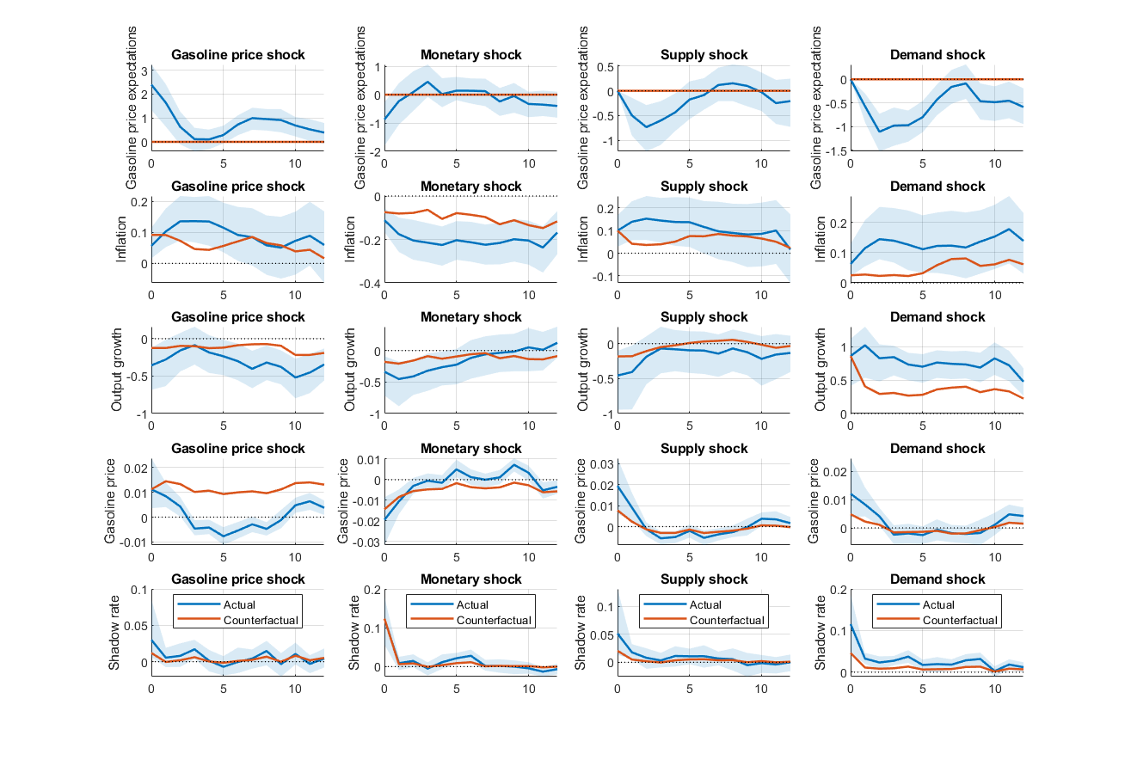
Notes: Impulse responses to a one standard deviation shock. The solid blue line shows the median response while the shaded blue area represents the 90% error bands. The solid orange line is the counterfactual response. All responses are in percentage points.

Figure 4 reports the historical decomposition for the model with real output growth. The results suggest that gasoline price expectations shocks are the single largest contributor to fluctuations in gasoline price expectations themselves, accounting for roughly 28% of their total variance over the sample, followed by gasoline price shocks (17%) and demand shocks (8%). For headline inflation, monetary policy shocks explain the largest share of variance (19%), with gasoline price expectations shocks (14%) and demand shocks (12%) also playing a meaningful role, while gasoline price shocks contribute comparatively less (6%). For real output growth, demand shocks dominate overwhelmingly (44%), with gasoline price and monetary policy shocks each contributing around 8%. The decomposition is consistent with our second-round transmission mechanism during key historical episodes. During the global financial crisis of 2008-09, gasoline price shocks had a strong positive contribution to gasoline price expectations, which in turn contributed positively to headline inflation, suggesting that the energy price increase during that period was propagated to inflation not only directly but also through the expectations channel. A similar pattern is visible during the post-Covid inflationary episode of 2021-23, where gasoline price shocks made a positive contribution to expectations throughout the period, and the expectations shock in turn contributed positively to headline inflation. For real output, the gasoline price shock contribution turns negative in both episodes, consistently with the view that higher gasoline prices depress real activity both directly and indirectly through the dampening effect of higher energy price expectations on consumer spending. Taken together, the historical decomposition supports our central argument that gasoline price shocks do not operate in isolation, but instead their transmission to inflation and output is propagated by the expectations channel.

Figure 3. Results in the model with the unemployment rate
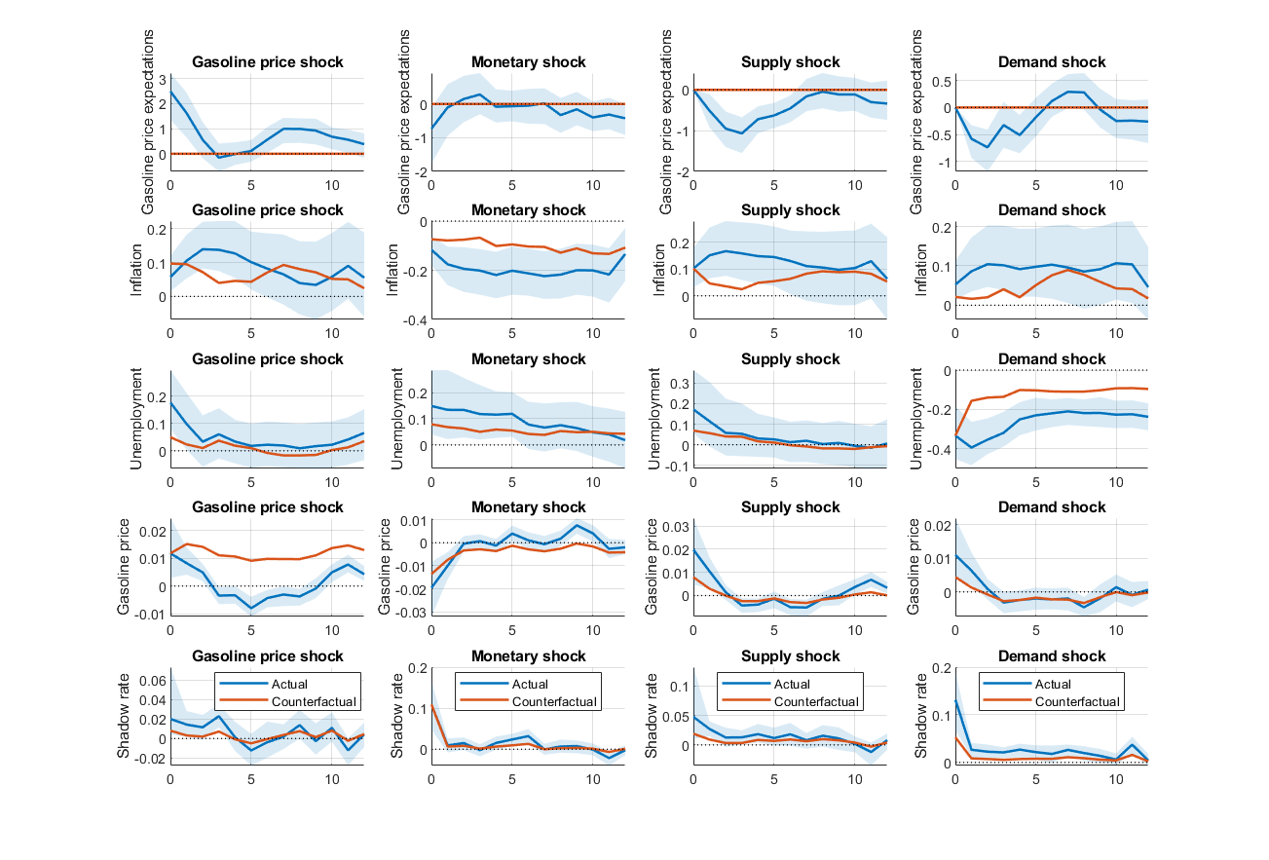
Notes: Impulse responses to a one standard deviation shock. The solid blue line shows the median response while the shaded blue area represents the 90% error bands. The solid orange line is the counterfactual response. All responses are in percentage points.

Figure 4. Historical Decomposition
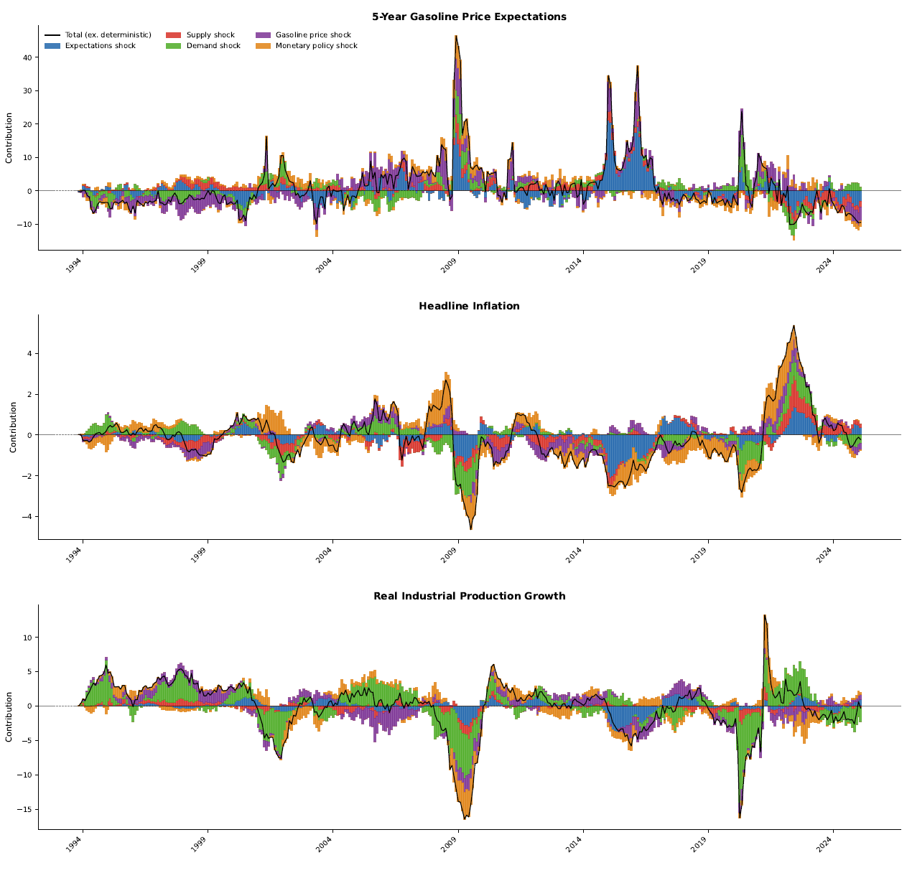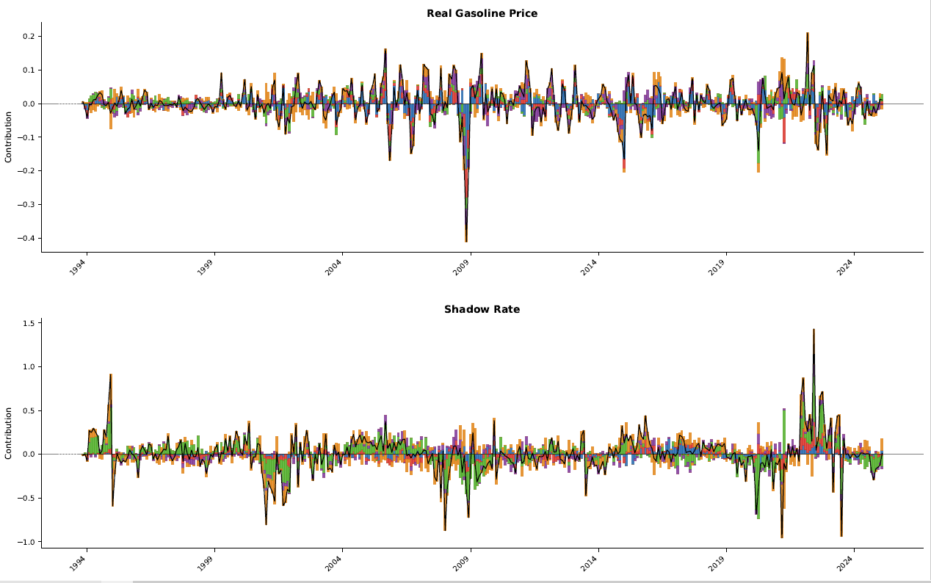
Notes: Historical decomposition with shock contributions as deviations from the deterministic baseline.
The additional results using nonlinear local projection reported in Appendix B suggest that gasoline price expectations propagate gasoline price shocks to inflation even when headline inflation expectations are anchored.

As a robustness check, Figures 5 and 6 show the results obtained under the relative size and narrative restrictions respectively. They confirm that the main findings are not an artefact of the baseline identification. The most notable quantitative differences arise for the gasoline price shock. Both restricted models produce a considerably smaller contemporaneous response of gasoline price expectations, suggesting that the baseline slightly overstates the immediate pass-through to consumer expectations. The response of inflation to the gasoline price shock is, by contrast, virtually unchanged, with impact medians of 0.04, 0.05, and 0.06 respectively. Overall, the additional restrictions do not affect the core conclusions of the paper.

Figure 5. Main results with size restrictions
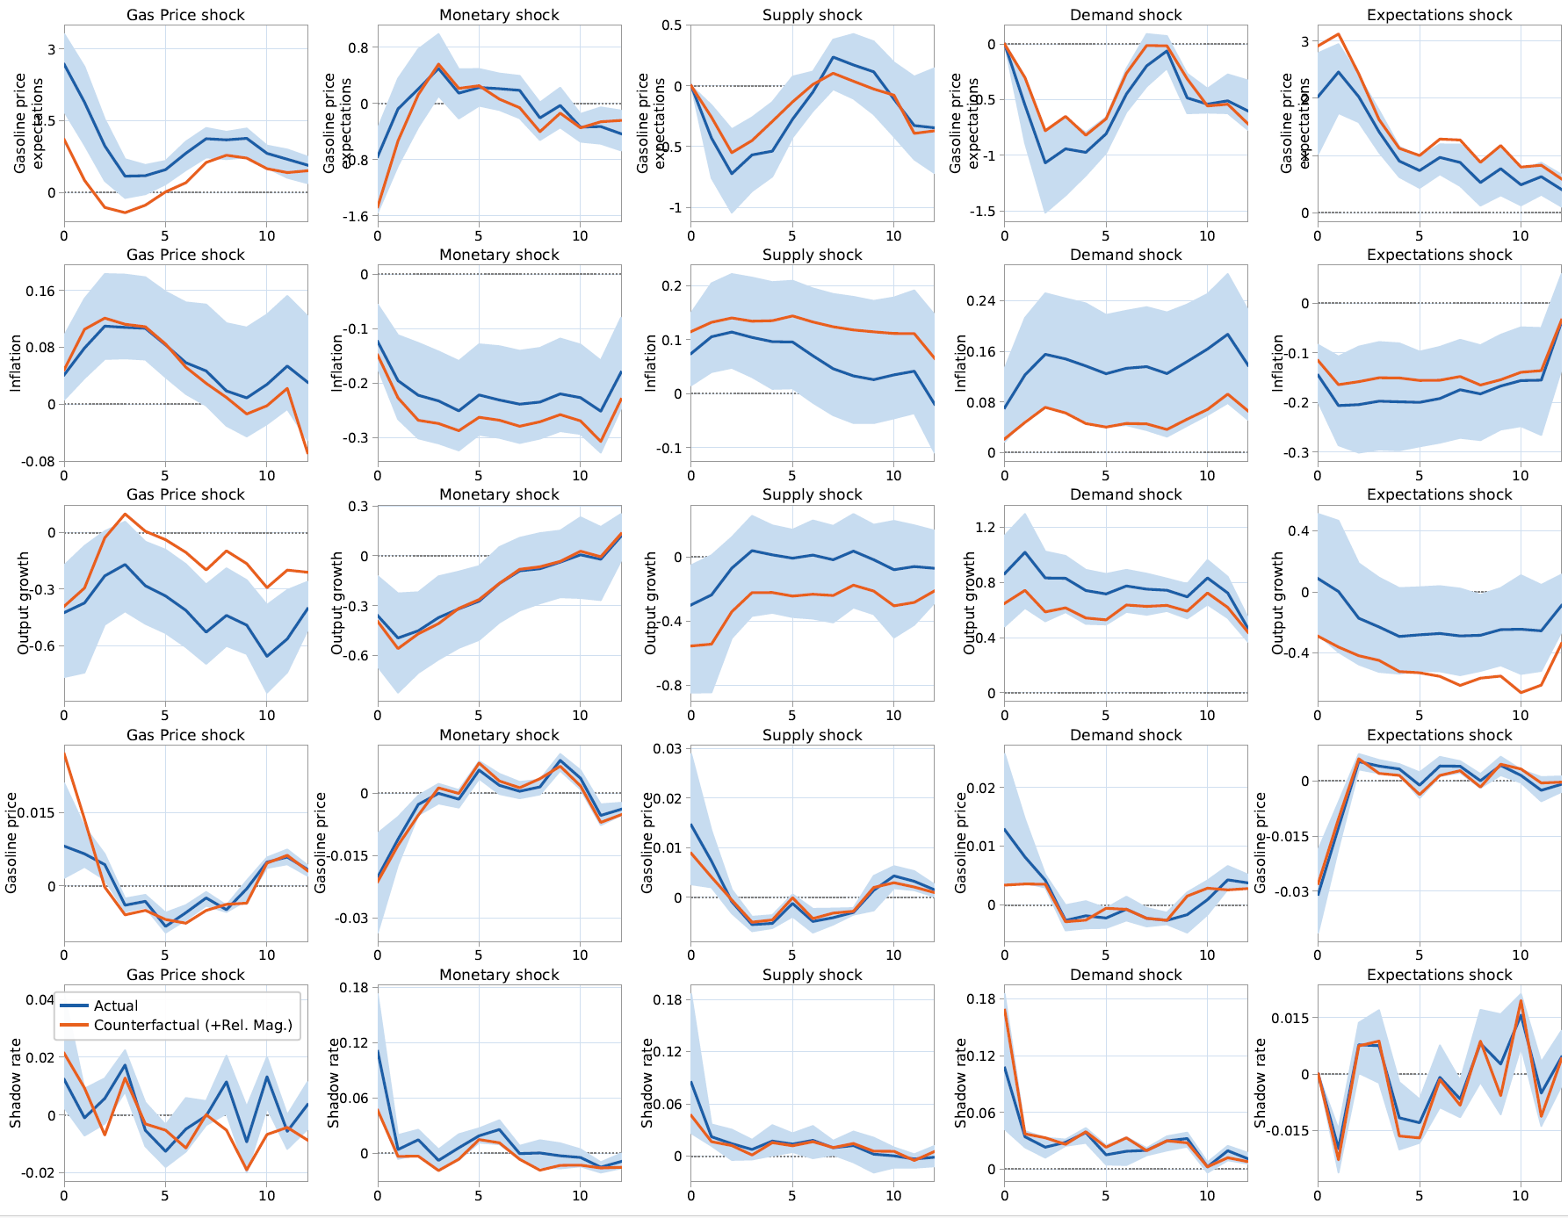
Notes: Impulse responses to a one standard deviation shock. The solid blue line shows the median response while the shaded blue area represents the 90% error bands. The solid orange line is the counterfactual response. All responses are in percentage points.

Figure 6. Main results with narrative restrictions
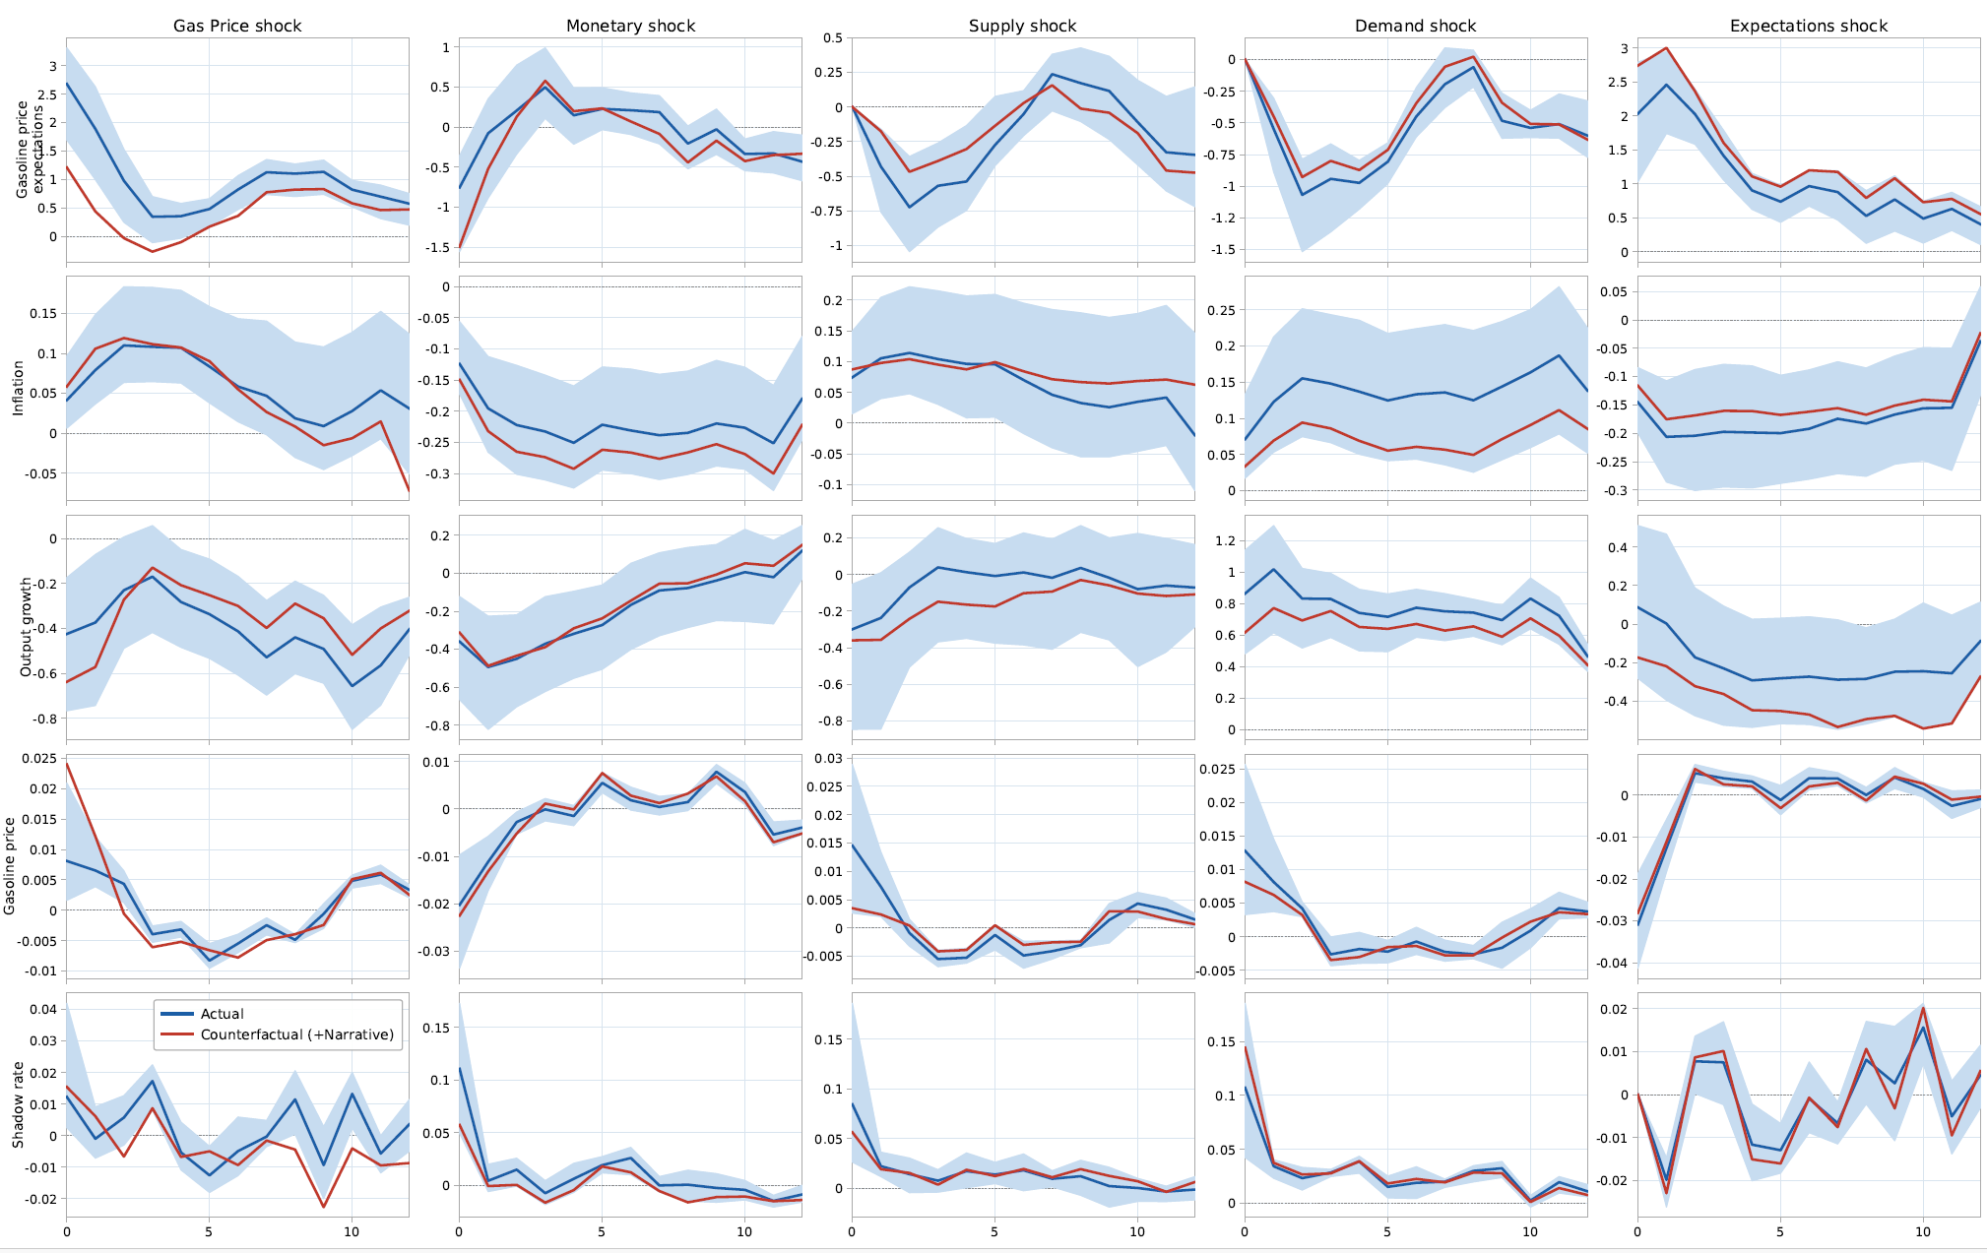
Notes: Impulse responses to a one standard deviation shock. The solid blue line shows the median response while the shaded blue area represents the 90% error bands. The solid orange line is the counterfactual response. All responses are in percentage points.

Conclusions
This paper investigates the role of gasoline price expectations as a transmission channel for economic shocks. Using 5-year gasoline price expectations data from the Michigan Survey of Consumers in a Structural VAR model of the US economy, we conduct a counterfactual analysis to isolate the second-round effects of gasoline price and other shocks on macroeconomic aggregates through the gasoline price expectations channel. Nonlinear local projections examining regime-dependence in the transmission of gasoline price shocks are also provided in the appendix as supplementary evidence, using four different definitions of anchoring based on whether headline inflation expectations are anchored or not. It should be emphasised that the identified gasoline price shock is a broad, composite disturbance to the retail gasoline price rather than a structurally decomposed energy-market shock, and its estimated effects should be interpreted accordingly.

The main findings can be summarised as follows. First, the results from the Structural VAR model and counterfactual analysis show that gasoline price expectations transmit economic shocks to inflation and economic activity. They also provide evidence of large second-round effects, especially in the case of real output growth and unemployment; thus they contribute to the growing literature on this topic (Wong, 2015; Diegel and Nautz, 2021) by showing that such effects are sizeable even in the case of disaggregate price expectations. Second, it appears that gasoline price expectations propagate gasoline price shocks to inflation even when headline inflation expectations are anchored. This represents a novel result for the literature on anchoring, which is primarily concerned with headline inflation expectations and has so far neglected disaggregate price expectations (Kumar et al., 2015, Strohsal and Winkelmann, 2015; Grishchenko et al., 2019). The appendix results further confirm this finding in a nonlinear local projection framework. For four different definitions of anchoring, gasoline price shocks continue to be transmitted through expectations even in anchored regimes, though the second-round effects are less persistent than in unanchored ones, and their strength varies somewhat depending on the anchoring definition employed.

These findings have important implications for policymakers. Specifically, the assumption of well-anchored long-term inflation expectations often made by central banks might need to be reconsidered given the fact that second-round effects can also occur through disaggregate price expectations. In addition, policymakers and academics should reflect further on the various definitions of anchoring and the extent to which they are useful in capturing a state of the economy where shocks are not propagated by either aggregate or disaggregate expectations. In this respect, a better understanding of the extent to which gasoline price expectations more accurately reflect consumers’ true beliefs about future prices and inform their decision-making would be useful. Lastly, central banks might want to consider survey expectations for additional disaggregate prices, such as food prices, as beliefs about them might differ substantially from those concerning aggregate headline prices. Future research could examine the relative importance of other disaggregate prices in the expectations formation and as a transmission channel in comparison to headline inflation expectations.

References
Antolín-Díaz, J. and Rubio-Ramírez, J.F., 2018. Narrative sign restrictions for SVARs. American Economic Review, 108(10), pp.2802-2829.
Arias, J.E., Rubio‐Ramírez, J.F. and Waggoner, D.F., 2018. Inference based on structural vector autoregressions identified with sign and zero restrictions: Theory and applications. Econometrica, 86(2), pp.685-720.
Baumeister, C. and Peersman, G., 2013. Time-varying effects of oil supply shocks on the US economy. American Economic Journal: Macroeconomics, 5(4), pp.1-28.
Bems, R., Caselli, F., Grigoli, F. and Gruss, B., 2021. Expectations' anchoring and inflation persistence. Journal of International Economics, 132, p.103516.
Binder, C.C., 2018. Inflation expectations and the price at the pump. Journal of Macroeconomics, 58, pp.1-18.
Blanchard, O.J. and Quah, D., 1989. The dynamic effects of aggregate demand and supply disturbances. American Economic Review, 79(4), pp.655-673.
Boeck, M. and Zörner, T.O., 2025. Natural gas prices, inflation expectations, and the pass-through to euro area inflation. Energy Economics, 141, p.108061.
Buono, I. and Formai, S., 2018. New evidence on the evolution of the anchoring of inflation expectations. Journal of Macroeconomics, 57, pp.39-54.
Caldara, D., Cavallo, M. and Iacoviello, M., 2019. Oil price elasticities and oil price fluctuations. Journal of Monetary Economics, 103, pp.1-20.
Casoli, C., Manera, M. and Valenti, D., 2024. Energy shocks in the Euro area: disentangling the pass-through from oil and gas prices to inflation. Journal of International Money and Finance, 147, p.103154.
Clerides, S., Krokida, S.I., Lambertides, N. and Tsouknidis, D., 2022. What matters for consumer sentiment in the euro area? World crude oil price or retail gasoline price?. Energy Economics, 105, p.105743.
Coibion, O. and Gorodnichenko, Y., 2015. Is the Phillips curve alive and well after all? Inflation expectations and the missing disinflation. American Economic Journal: Macroeconomics, 7(1), pp.197-232.
Coibion, O., Gorodnichenko, Y., Kumar, S. and Pedemonte, M., 2020a. Inflation expectations as a policy tool?. Journal of International Economics, 124, p.103297.
Coibion, O., Gorodnichenko, Y. and Ropele, T., 2020b. Inflation expectations and firm decisions: New causal evidence. The Quarterly Journal of Economics, 135(1), pp.165-219.
Diegel, M. and Nautz, D., 2021. Long-term inflation expectations and the transmission of monetary policy shocks: Evidence from a SVAR analysis. Journal of Economic Dynamics and Control, 130, p.104192.
Edelstein, P. and Kilian, L., 2009. How sensitive are consumer expenditures to retail energy prices?. Journal of Monetary Economics, 56(6), pp.766-779.
Falck, E., Hoffmann, M. and Hürtgen, P., 2021. Disagreement about inflation expectations and monetary policy transmission. Journal of Monetary Economics, 118, pp.15-31.
Geiger, M. and Scharler, J., 2019. How do consumers assess the macroeconomic effects of oil price fluctuations? Evidence from US survey data. Journal of Macroeconomics, 62, p.103134.
Grishchenko, O., Mouabbi, S. and Renne, J.P., 2019. Measuring inflation anchoring and uncertainty: A US and euro area comparison. Journal of Money, Credit and Banking, 51(5), pp.1053-1096.
Güntner, J.H. and Linsbauer, K., 2018. The effects of oil supply and demand shocks on US consumer sentiment. Journal of Money, Credit and Banking, 50(7), pp.1617-1644.
Gürkaynak, R.S., Levin, A. and Swanson, E., 2010. Does inflation targeting anchor long-run inflation expectations? Evidence from the US, UK, and Sweden. Journal of the European Economic Association, 8(6), pp.1208-1242.
Hamilton, J.D. and Herrera, A.M., 2004. Comment: oil shocks and aggregate macroeconomic behavior: the role of monetary policy. Journal of Money, Credit and Banking, pp.265-286.
Hammoudeh, S. and Reboredo, J.C., 2018. Oil price dynamics and market-based inflation expectations. Energy Economics, 75, pp.484-491.
Inoue, A. and Rossi, B., 2021. A new approach to measuring economic policy shocks, with an application to conventional and unconventional monetary policy. Quantitative Economics, 12(4), pp.1085-1138.
Jordà, O., 2007. Joint inference and counterfactual experimentation for impulse response functions by local projections, Working Paper no. 06-24), University of California, Department of Economics, Davis, CA.
Känzig, D.R., 2021. The macroeconomic effects of oil supply news: Evidence from OPEC announcements. American Economic Review, 111(4), pp.1092-1125.
Kilian, L., 2009. Not all oil price shocks are alike: Disentangling demand and supply shocks in the crude oil market. American Economic Review, 99(3), pp.1053-1069.
Kilian, L., 2024. How to construct monthly VAR proxies based on daily surprises in futures markets. Journal of Economic Dynamics and Control, 168, p.104966.
Kilian, L. and Zhou, X., 2022a. Oil prices, gasoline prices, and inflation expectations. Journal of Applied Econometrics, 37(5), pp.867-881.
Kilian, L. and Zhou, X., 2022b. The impact of rising oil prices on US inflation and inflation expectations in 2020–23. Energy Economics, 113, p.106228.
Kumar, S., Afrouzi, H., Coibion, O. and Gorodnichenko, Y., 2015. Inflation targeting does not anchor inflation expectations: Evidence from firms in New Zealand. Brookings Papers on Economic Activity, 2015(2), pp.151-225.
Kumar, A. and Mallick, S., 2024. Oil price dynamics in times of uncertainty: Revisiting the role of demand and supply shocks. Energy Economics, 129, p.107152.
Kumar, A., Mallick, S. and Sinha, A., 2021. Is uncertainty the same everywhere? Advanced versus emerging economies. Economic Modelling, 101, p.105524.
Staiger, D. and Stock, J., 1997. Instrumental Variables Regression with Weak Instruments. Econometrica, 65(3), pp.557-586.
Strohsal, T., Melnick, R. and Nautz, D., 2016. The time-varying degree of inflation expectations anchoring. Journal of Macroeconomics, 48, pp.62-71.
Strohsal, T. and Winkelmann, L., 2015. Assessing the anchoring of inflation expectations. Journal of International Money and Finance, 50, pp.33-48.
Vatsa, P., Pino, G. and Clements, A., 2025. Gasoline prices, gasoline price expectations, and inflation expectations in the United States. Energy Economics, p.108508.
Wong, B., 2015. Do inflation expectations propagate the inflationary impact of real oil price shocks?: Evidence from the Michigan survey. Journal of Money, Credit and Banking, 47(8), pp.1673-1689.
Wu, J.C. and Xia, F.D., 2016. Measuring the macroeconomic impact of monetary policy at the zero lower bound. Journal of Money, Credit and Banking, 48(2-3), pp.253-291.

Appendix A. Additional results for the linear model

Figure A1. Results in the model with PCE inflation and real output growth
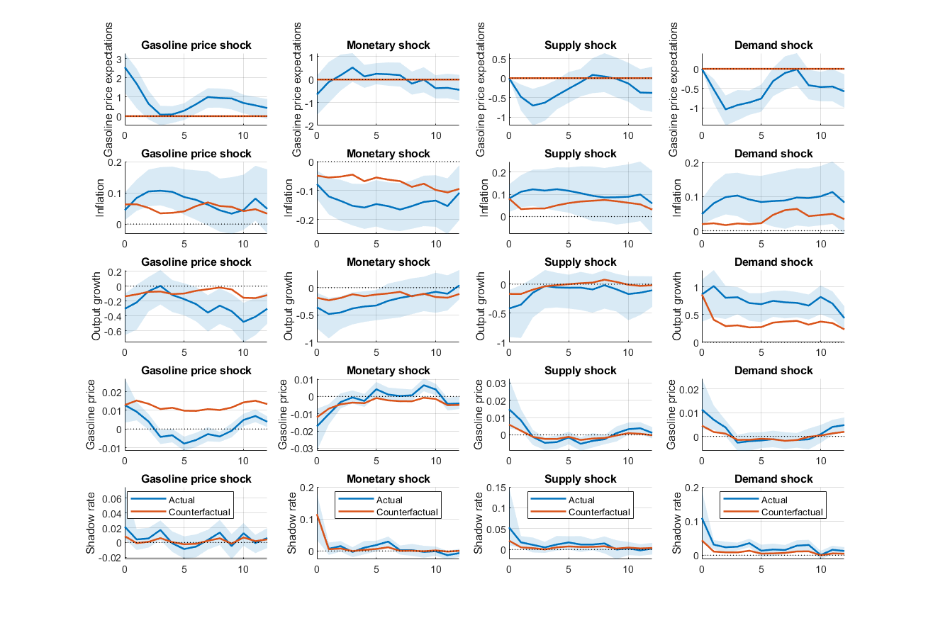
Notes: Impulse responses to a one standard deviation shock. The solid blue line shows the median response while the shaded blue area represents the 90% error bands. The solid orange line is the counterfactual response. All responses are in percentage points.

Figure A2. Results in the model with PCE inflation and the unemployment rate
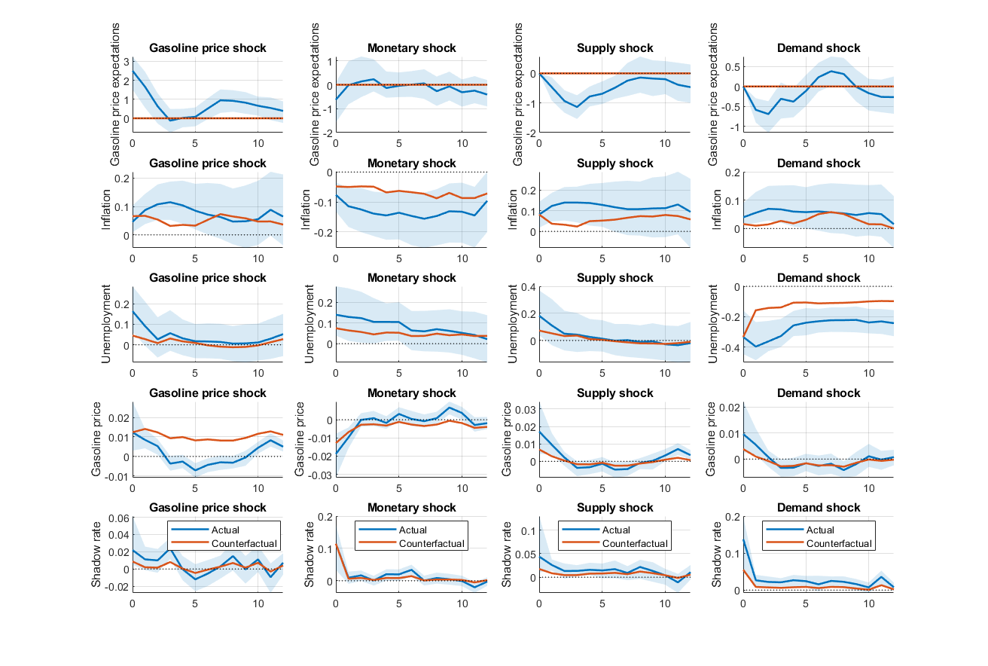
Notes: Impulse responses to a one standard deviation shock. The solid blue line shows the median response while the shaded blue area represents the 90% error bands. The solid orange line is the counterfactual response. All responses are in percentage points.

Figure A3. Results in the model with crude oil prices and real output growth
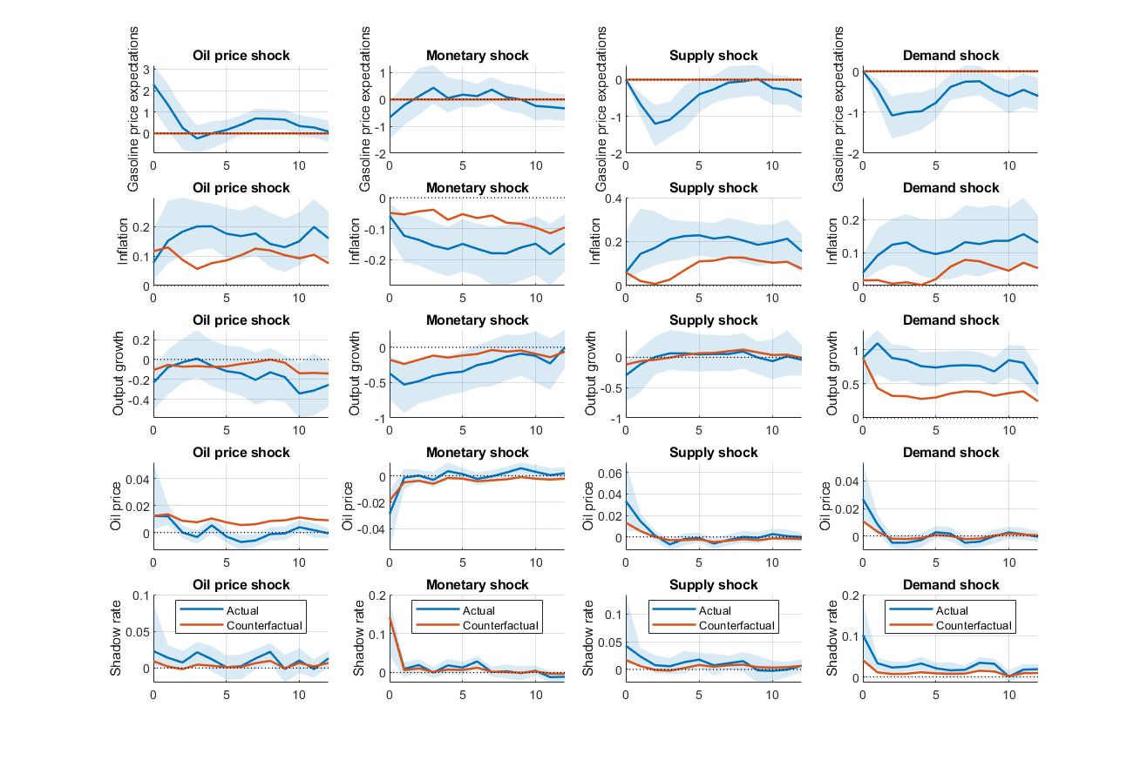
Notes: Impulse responses to a one standard deviation shock. The solid blue line shows the median response while the shaded blue area represents the 90% error bands. The solid orange line is the counterfactual response. All responses are in percentage points.

Figure A4. Results in the model with crude oil prices and the unemployment rate
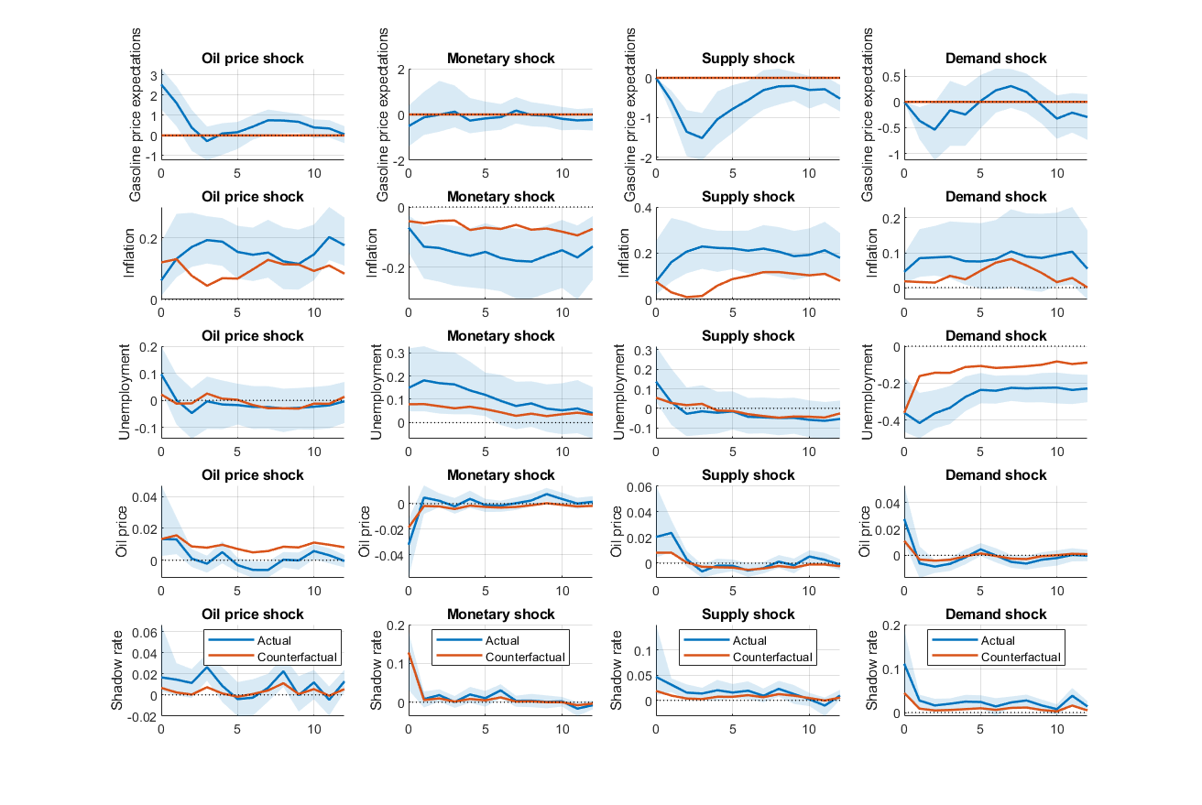
Notes: Impulse responses to a one standard deviation shock. The solid blue line shows the median response while the shaded blue area represents the 90% error bands. The solid orange line is the counterfactual response. All responses are in percentage points.

Appendix B. Nonlinear local projections

The extent to which gasoline price expectations propagate the effects of gasoline price shocks on the economy matters in general, and even more when headline inflation expectations are anchored. To investigate this issue we use nonlinear local projections, since these can more easily incorporate regime-dependence than structural VAR models, which makes them an attractive choice for nonlinear analysis. The model takes the following form:

$$\begin{aligned}y_{j,t+h}=α_{h}^{j}+β_{h,0}^{j}s_{t}^{0}+β_{h,1}^{j}s_{t}^{1}+δ_{h}^{j}X_{t}+ε_{j,t+h}\#\left(B1\right)\end{aligned}$$

where $y_{j,t+h}$ is the outcome of the local projection of variable $j$ at horizon $h$ to the gasoline price shock $s_{t}$ which is identified by an instrument $Z_{t}$, $X_{t}$ is a vector of control variables, $β_{h,0}$ indicates the effect in regime 0, and $β_{h,1}$ in regime 1. The regimes are determined by a binary dummy variable $D_{t}$, which specifies whether long-term headline inflation expectations are anchored or not. Given the lack of a general consensus on the most appropriate measure of anchored inflation expectations, we consider four different definitions of anchored inflation as in Kumar et al. (2015), namely: (i) average expectations should be close to the inflation target; (ii) there should be little dispersion of expectations across individual survey participants; (iii) individual respondents should show little uncertainty about their expectations; (iv) forecast revisions should be small. In each case, the dummy takes a value of 1 if headline inflation expectations are anchored and a value of 0 if they are not. For the first definition of anchoring, this means that the dummy takes a value of 1 when 5-year headline inflation expectations fall within a 200-basis point range around the inflation target of 2%, and a value of 0 when they fall outside this range. For the second definition, the dummy takes a value of 1 (0) if the individual agents’ beliefs are within (outside) a one standard deviation range of the average belief of all participants. For the third definition, the dummy takes a value of 0 (1) if an individual participant’s expectations lie within (outside) a one standard deviation band of their average. For the fourth definition, the dummy takes a value of 0 (1) if the individual respondents’ forecast revisions at any point in time are larger (smaller) than their average forecast revision. As in the linear VAR model case, we also conduct a counterfactual analysis within the nonlinear local projections framework following the process outlined by Jordà (2007). The counterfactual now works differently than in the structural VAR case. Specifically, the model is the following:

$$\begin{aligned}y_{j,t+h}=α_{h}^{j}+β_{h,0}^{j}s_{t}^{0}+β_{h,1}^{j}s_{t}^{1}+γ_{h,0}^{j}y_{gasexp,t+h}^{0}+γ_{h,1}^{j}y_{gasexp,t+h}^{1}+δ_{h}^{j}X_{t}+ε_{j,t+h}\#\left(B2\right)\end{aligned}$$

where $y_{gasexp,t+h}^{i}=β_{h,i}^{gasexp}∙s_{t}^{i}$ for $i=\{0,1\}$, which shows the response of gasoline price expectations to the gasoline price shock in each regime and for each response horizon. In the counterfactual, this response is set to zero.

For the nonlinear local projections we focus only on the transmission of a gasoline price shock. To identify the single gasoline price shock, we use an instrumental variable approach. A suitable instrument is required to be relevant and exogenous, namely it should be correlated with the endogenous regressor but uncorrelated with the error term. Following a similar approach to the crude oil surprise literature, we construct a high-frequency instrument as monthly aggregates of daily movements in gasoline futures prices around announcements and releases by the EIA (US Energy Information Administration). As in Inoue and Rossi (2021), we represent the movements in gasoline futures prices as functional shocks defined as shifts in the entire gasoline futures price term structure on an announcement day. For this purpose we consider movements in all maturities from one month to twelve months, and use the Diebold-Li term structure model to estimate the level, slope and curvature parameters. This approach is adapted from Känzig (2021), who constructs a high-frequency instrument for oil supply news shocks by extracting the first principal component of futures price surprises across maturities of 1 to 12 months around OPEC announcement windows. We apply the same aggregation logic to gasoline futures, following Kilian (2024) in weighting daily surprises within the month according to their timing. We acknowledge that this methodology was originally developed to identify oil supply news shocks rather than gasoline price shocks, and that the two are conceptually distinct. Oil supply news shocks are structural disturbances to crude oil production expectations, whereas the shock we seek to identify is a broader disturbance to the retail gasoline price. Unlike OPEC announcement-based instruments, our instrument does not restrict identification to a particular type of supply shock, which is better suited to our broader research question concerning the transmission of gasoline price movements regardless of their origin. We carry out a weak instrument test to test instrument suitability, specifically a first-stage F-statistic (Staiger and Stock, 1997).

Figure B1 displays the three Diebold-Li factors extracted from gasoline futures over the sample period (1993–2025). The level factor (β₁), which captures the long-run price of gasoline, is broadly stationary around zero but exhibits pronounced spikes coinciding with major oil market disruptions, most notably the 2008 commodity price surge, the 2014–16 oil price collapse (negative), and the 2022 Russia–Ukraine shock. As shown in Figure B2, the level factor tracks the log change in gasoline prices closely over time (r = 0.427), with both series moving sharply in the same direction during each of these episodes, providing visual confirmation of instrument relevance. The slope factor (β₂), reflecting the spread between short- and long-dated futures, shows similar episodic behaviour but with somewhat greater high-frequency volatility, turning sharply negative during the 2008–09 financial crisis as near-term futures collapsed faster than long-dated contracts. The curvature factor (β₃) is the most volatile of the three, with the widest range from -125 to +104 log-points, capturing transitory medium-term distortions in the futures curve; it spikes sharply in both directions around major supply events but mean-reverts quickly, consistently with its interpretation as a short-lived hump in the term structure. All three factors display heteroscedasticity, with notably larger swings during the 2008–09 and 2020–22 periods, reflecting the heightened uncertainty in energy markets during those episodes. Taken together, the three factors constitute a strong instrument set: a first-stage F-statistic of 56.93 confirms that the Diebold-Li factors are strongly correlated with the endogenous gasoline price variable, while their near-zero correlations with gasoline price expectations support the exclusion restrictions.

Figure B1. Instrument series over time
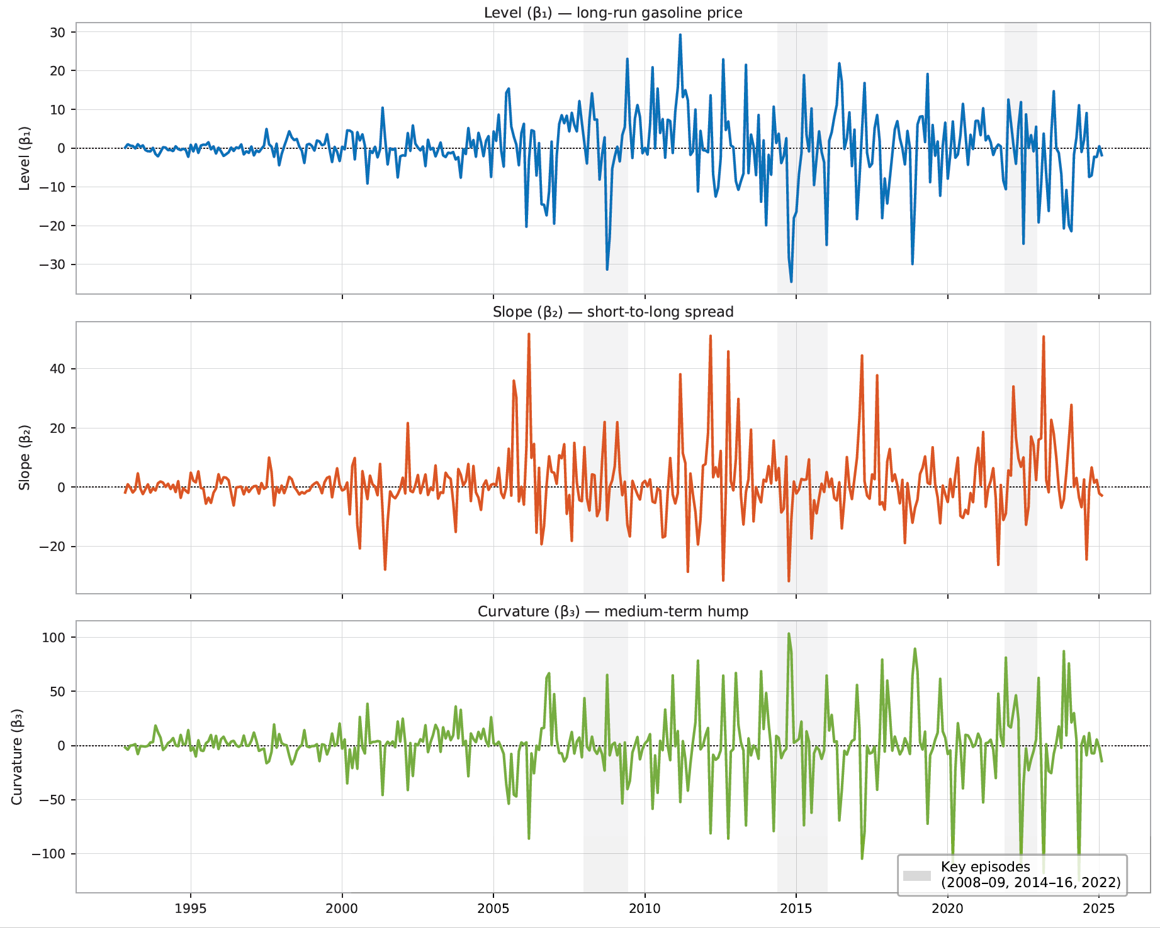
Notes: Instrument series over time.

Figure B2. Level Factor and Gasoline Prices over Time
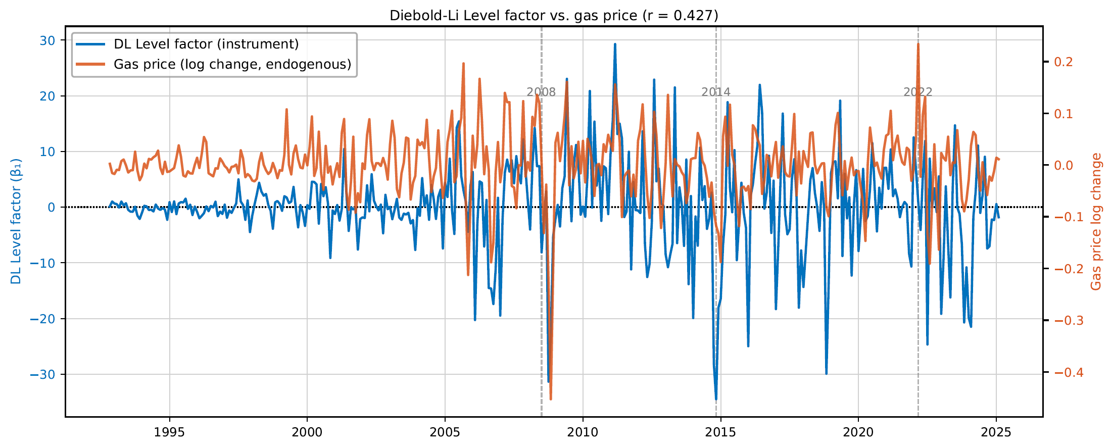
Notes: Level factor and gasoline prices over time.

Figure B3. Nonlinear local projection results with regime dummy 1
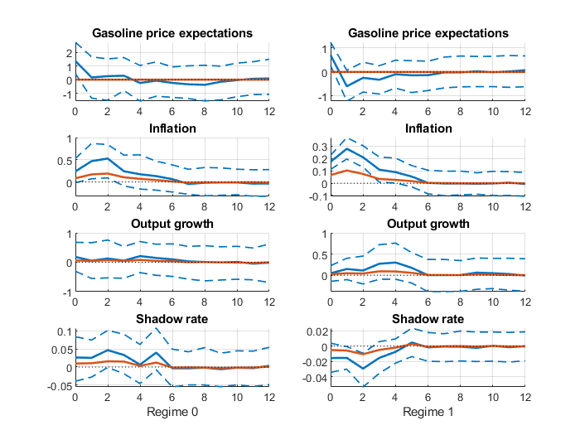
Notes: Responses to a gasoline price shock. The solid blue line shows the median response while the dashed blue lines indicate the 90% bootstrapped confidence intervals. The solid orange line is the counterfactual response. All responses are in percentage points.

Figure B3 shows the results in the model with the first regime dummy, which indicates the deviation of headline inflation expectations from the 2% target. The response of gasoline price expectations to the gasoline price shock is only short-lived and even turns briefly negative after the initial impact in the anchored regime, consistently with findings by Vatsa et al. (2025). The response of inflation to the shock and the strong second-round effects are equally large in both regimes. However, these effects only last for six months before dying out completely. This is good news for the Fed in terms of persistence and can help gauge the duration of short-term inflationary pressures arising from these second-round effects. The results are similar in the model with the second regime dummy, which is based on the dispersion of individual agents’ beliefs. Despite a smaller response of gasoline price expectations to the gasoline price shock, second-round effects on inflation still exist in the anchored regime, but they are also smaller. This suggests that the size of gasoline price expectations changes after a gasoline price shock matters for agents’ decision-making and the impact of the transmission to inflation. The results are also similar in the case of the model with the third regime dummy, which shows the uncertainty around individual forecasts. Finally, they are slightly different for the fourth model, which defines the regimes according to the size of agents’ forecast revisions. In this case, it seems that inflation responds more strongly to the gasoline price shock in the anchored regime (when forecast revisions are small), but second-round effects appear to still be present in both regimes.

Figure B4. Nonlinear local projection results with regime dummy 2
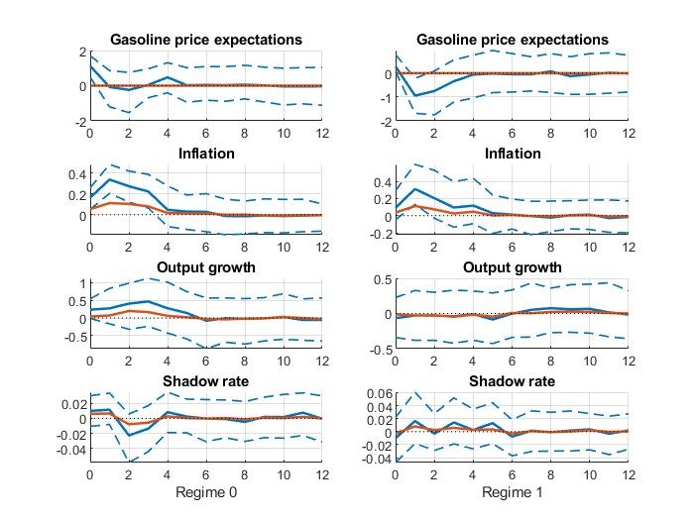
Notes: Responses to a gasoline price shock. The solid blue line shows the median response while the dashed blue lines indicate the 90% bootstrapped confidence intervals. The solid orange line is the counterfactual response. All responses are in percentage points.

Concerning the definitions of anchoring, it appears that for definitions (ii) and (iii), which relate to individual agents’ beliefs and how they deviate from their own and all agents’ average beliefs, the second-round effects are smaller in the anchored regime. This suggests that the entire distribution of gasoline price expectations might be relevant to capture accurately the transmission channel. In the case of forecast revisions, however, the transmission is stronger when these are small. Forecast revisions tend to be small (large) when little (a lot of) new information becomes available that causes agents to revise their expectations. This can also mean that the error made in the previous agents’ forecast was small (large). In the absence of significant new information or economic developments, agents might be more likely to act on their expectations than when unforeseen information or events require large revisions in expectations, which can carry additional uncertainty that keeps agents from acting on them. Similarly, individuals might be quicker to act on their expectations when they perceive to have made small forecast errors rather than large ones.

Figure B5. Nonlinear local projection results with regime dummy 3
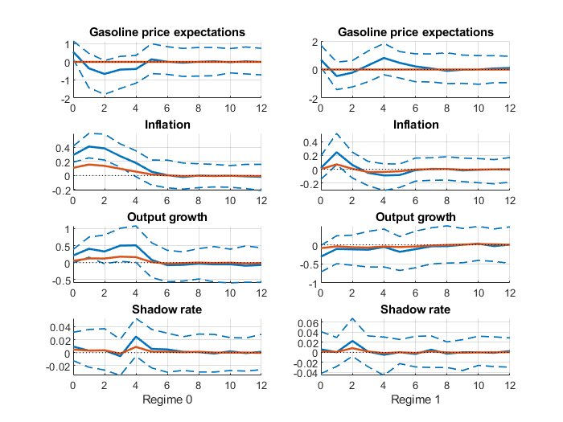
Notes: Responses to a gasoline price shock. The solid blue line shows the median response while the dashed blue lines indicate the 90% bootstrapped confidence intervals. The solid orange line is the counterfactual response. All responses are in percentage points.

Figure B6. Nonlinear local projection results with regime dummy 4
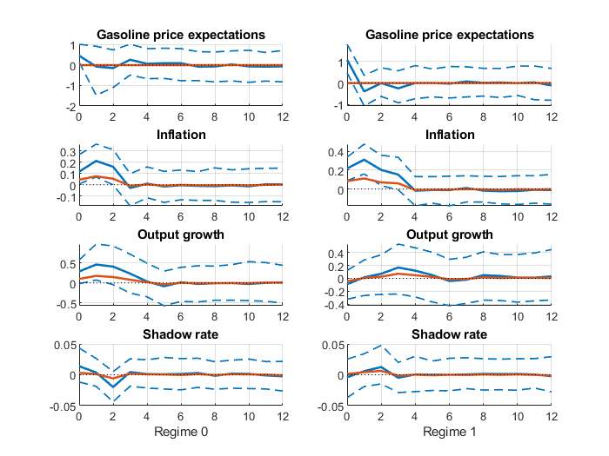
Notes: Responses to a gasoline price shock. The solid blue line shows the median response while the dashed blue lines indicate the 90% bootstrapped confidence intervals. The solid orange line is the counterfactual response. All responses are in percentage points.

While the restrictions on the responses are the same whether one uses economic activity or the output gap, they need to be reversed when using the unemployment rate instead. Specifically, the latter is assumed to respond positively to a gasoline price shock, a contractionary monetary policy shock and an aggregate supply shock, but negatively to an aggregate demand shock.
This is the earliest date for which gasoline price expectations are available.
The 1-year median series is only available continuously since October 2005, which would substantially reduce our sample size.
Kumar et al. (2015) propose a fifth definition which states that there should be little to no co-movement between short- and long-run expectations. However, under this definition there would be an insufficient number of observations for the dummy variable in regime 0 to estimate the model.
When using a 100-basis point range, the number of observations in regime 1 is insufficient for the model to be estimated.

