Designing accessible ICT products and services – The
VERITAS accessibility testing platform

Fotios Spyridonis
Brunel University
Uxbridge, UK
+44(0)1895 265503
Fotios.Spyridonis@brunel.ac.uk
Panagiotis Moschonas
Informatics & Telematics Institute, Centre of Research & Technology
Greece
+30(2311) 257733
moschona@iti.gr
Katerina Touliou
Hellenic Institute of Transport, Centre of Research & Technology
Greece
+30(2310) 498267
touliouk@certh.gr
Athanasios Tsakiris
Informatics & Telematics Institute, Centre of Research & Technology
Greece
+30(2311) 257748
atsakir@iti.gr
Gheorghita Ghinea
Brunel University
Uxbridge, UK
+44 (0)1895 266033
George.Ghinea@brunel.ac.uk

ABSTRACT
Among the key components of designing accessible products and services for disabled users is accessibility testing and support. The VERITAS FP7 project has developed a platform that consists of several tools that provide automatic simulation feedback and reporting for built-in accessibility support at all stages of ICT product development. In this explorative pilot study, we evaluated the usability and technology acceptance of using three of these tools in the design of accessible GUI-based ICT products in five application domains. A sample of 80 designers/developers (12 female; 68 male) evaluated the three tools by filling in the standard SUS and TAM questionnaires. Results revealed good usability and technology acceptance for all three tools as a novel accessibility testing method. The VERITAS platform can offer an intuitive solution in accessibility design and can ensure that ICT products are designed for all.
Categories and Subject Descriptors
D.2.2 Design Tools and Techniques; H5 Information Interfaces and Presentation; H.5.2 User Interfaces
General Terms
Design, Human Factors
Keywords
Accessibility testing; virtual user; simulation and modelling; disabled users; usability evaluation

INTRODUCTION
It is estimated that up to 15% of the European Union population has a type of disability such as a hearing, visual, speech, cognitive, or motor impairment [3]. People with disabilities are often faced with significant challenges to independently participate in various aspects of daily life. Inaccessible applications, services, goods, or infrastructures are largely considered in the European Disability Action Plan [16] as the essential disabling barriers to full and equal participation in many aspects of daily life. Removing these barriers, therefore, will significantly improve the quality of life of people with disabilities.
Traditionally, developers have relied on existing development tools and packaged solutions and on a range of principles, guidelines and standards for accessibility design. Despite the increasing importance of accessibility over the last years, the latter still do not provide explicit guidelines to developers on how to sufficiently adopt them during design and development, whereas the former in most cases give little assistance to develop accessible ICT solutions.
The VERITAS (Virtual and Augmented Environments and Realistic User Interactions To Achieve Embedded Accessibility Designs) project aims at developing a novel platform of tools for accessibility support and to ensure that future products and services are being systematically designed for people with the aforementioned types of disabilities. The goal is to introduce simulation-based testing into five important industrial domains: (i) automotive, (ii) smart living spaces, (iii) workspace, (iv) infotainment and games, and (v) healthcare.

RELATED WORK

Permission to make digital or hard copies of all or part of this work for personal or classroom use is granted without fee provided that copies are not made or distributed for profit or commercial advantage and that copies bear this notice and the full citation on the first page. Copyrights for components of this work owned by others than ACM must be honored. Abstracting with credit is permitted. To copy otherwise, or republish, to post on servers or to redistribute to lists, requires prior specific permission and/or a fee. Request permissions from Permissions@acm.org.
AVI' 14, May 27 - 29 2014, Como, Italy
Copyright 2014 ACM 978-1-4503-2775-6/14/05…$15.00.
http://dx.doi.org/10.1145/2598153.2598191

In response to the need for progress, there have been sporadic, but limited, attempts to support automated accessibility testing and design. Different approaches have been proposed in the literature, varying from the use of ‘personas’ [4] [13] in the design of user interfaces for disabled people to the development of full design tools.
Several such tools are already in use in the five targeted application areas. In the automotive industry, the RAMSIS human modelling tool [10] is currently used in the design of automobiles, while CATIA is a leading commercial software suite for human modelling with applications in the design of automotive parts [14] and car aesthetics [17]. Both tools can analyze how the manikins will interact with objects in the virtual environment, as well as determine operator comfort and performance in the context of a new design.
Recent work within the smart living spaces industry has been largely based on developments in Virtual Reality (VR). Such a study by [2] assessed accessibility evaluation by immersing the designer in the virtual world of a mechanical system. The HabiTest software tool [12] used the first approach of user immersion where the user controls a virtual wheelchair and uses a haptic device to interact with objects within a given interior building space.
The concept of simulating working environments has drawn the interest of researchers a decade ago. One of the first tools presented in the literature is the Deneb/ERGO software tool [11] that used early 3D simulation and modeling technologies in order to rapidly prototype human motion within an area and study for related ergonomics. In [6] the authors present a prototype for adapting workspaces to the people with physical disabilities. The prototype was found to be useful in designing and testing several alternatives at an early stage and making modifications throughout the planning process.
In the infotainment and games industry researchers have investigated the possibility of extending massive 3D game environments to be easily accessible to visually impaired people [18]. In [9] the authors constructed a system based on a game of pong to produce highly motivating rehabilitation for persons with arms partially paralyzed from a stroke. In [7] the authors present algorithms for inferring a user's cognitive performance using monitoring data from computer games, which are then used to classify significant performance changes and to adapt computer interfaces with tailored hints and assistance, when needed.
All of the above examples, however, demonstrate that related work in the area of accessibility design shares the lack of explicit support for automated accessibility evaluation, a feature that the VERITAS platform aims to address. Developers are therefore still not able to systematically test their developments in terms of their accessibility, and struggle under total absence of structured guidance, support, and tools.

THE VERITAS CONCEPT AND TOOLS
The VERITAS simulation platform comprises of several tools, which provide automatic simulation feedback and reporting for guideline compliance and quality of service.

The tools for GUI accessibility testing
The VERITAS graphical user interface (GUI) accessibility assessment is passed through three phases: a) user modelling, b) application scenario definition and, c) simulation of the virtual user actions. User modelling has been based on data gathered from the medical bibliography and through the VERITAS Multisensorial Platform, which was especially constructed for this purpose [8]. This process resulted into a database of several profiles, where each profile contains the generic specification of an impairment group, e.g. people with cataract, etc. The remaining two phases are addressed through the three tools described next.

VERITAS user model generator
The above information is handled by the VERITAS User Model Generator tool or VerGen (hereforth referred to as T1), with which the designer selects what impairments the virtual test-user model will have. T1 can be used to define the severity of the impairment or even combine two or three impairments to one model. The tool exports a Virtual User Model (VUM), which contains the specification of an indicative virtual user selected from a population percentile, with one or many impairments of that severity.

VERITAS GUI simulation editor
Having created the VUM, the designer must then define the application scenario. The respective tool for defining the interaction tasks to be performed on a given GUI is the VERITAS GUI Simulation Editor tool or VerSEd-GUI (hereforth referred to as T2). Using T2, a series of GUI interaction tasks can be defined by capturing the developer’s actions on the specified GUI, e.g. mouse clicks, etc. and then defining the success/failure conditions for each.

VERITAS GUI simulation viewer
The simulation phase takes place using the VERITAS GUI Simulation Viewer tool or VerSim-GUI (hereforth referred to as T3) that can be used for evaluating the accessibility of a GUI. In T3, the VUM, as well as the application scenario are loaded and simulated. In this phase, motor, vision, hearing and cognitive emulation can reproduce the impaired user’s behavior. During the simulation, the designer is able to spot any flaws of the designed GUI components. A detailed report is presented by the tool when the simulation is over. This workflow is presented in Figure 1.

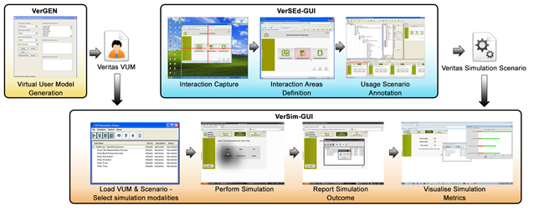
Figure 1. VERITAS GUI Accessibility Assessment Workflow

Example scenario of use
In a typical scenario of use, an educational game developer wants to develop an accessible game for disabled users. After designing a first prototype using existing design tools and guidelines, the developer then uses T1, where s/he selects the appropriate types of virtual user models, and then performs a simulated execution of the draft game prototype using T2 and T3. Information about the quality of the interaction, content accessibility difficulties and other assessment information are explicitly reported to the developer with respect to the target end users. The developer only compiles a draft version of the game when s/he has been able to address all issues identified by the VERITAS platform. Once the above step is finalized, then the game will be tested by gamers with different disabilities to undertake a final assessment.

PILOT EVALUATION PROTOCOL
To evaluate the three tools in practice, an explorative pilot study was carried out focusing on testing their usability and acceptance in the context of the five targeted application domains.

Recruitment and training
A convenience sample of 80 (mean age 32.6 ±6.92; range 23-58 years) designers/developers participated in the pilot tests across five different countries. Twelve (mean age 31.3±5.53) were female and 68 were (mean age 32.8±7.15) male users. All had some experience in using design tools and applications in their respective area of work. Recruitment was through the VERITAS partners representing the targeted application domains.

Data collection and protocol
Informed consent was obtained from each participant of the pilot tests. Each participant was then asked to fill in a typical demographic questionnaire before beginning with the main pilot test. The evaluation of the tools began with the presentation of T2 to the user, a written description of the considered scenario, and a list of tasks to be performed autonomously. After the pilot test, each user had to fill in a System Usability Scale (SUS) [1] and a Technology Acceptance Model (TAM) [5] questionnaire, which are well-established methods in measuring perceptions of usability and acceptance of an examined technology. The protocol was similarly applied to the evaluation of the remaining T1 and T3 tools, and all participants were able to complete it. The tests were administered by two evaluators and took place from June 2013 – November 2013. Each test lasted approximately 1.5-2 hours.

RESULTS AND KEY FINDINGS
The consolidated data analysis from all pilot sites that conducted the pilot tests is presented next, which was based on previous work by [15].

Usability per application area
The SUS usability scores reached good levels for all five application areas, with all scoring above the 68 score average [15] and typically ranging between 75-83% (Figure 2). The usability of the VERITAS tools in these areas was therefore between “B” and “A” [15] (see 15 for more information on the grading).
The highest mean usability scores were achieved in the workspace (83%) and healthcare (82%) application areas, and were accordingly classified in the top 10% of scores of the usability percentile reaching the grade “A”. This means that the three VERITAS tools are a toolkit that professional designers and developers would recommend to their friends or colleagues to use.

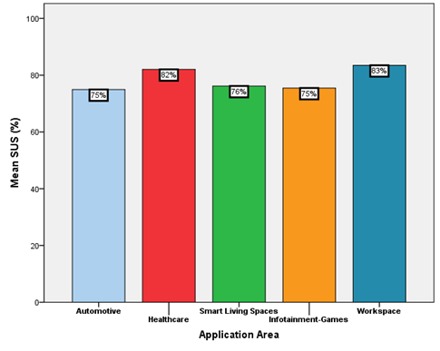
Figure 2. Mean SUS scores per application area
The mean usability scores for the remaining three application areas were quite similar (automotive 75%; smart living spaces 76%; infotainment-games 75%) and were accordingly graded as “B”. It is therefore evident from the respective Figure 2 that the usability of the three VERITAS tools was good for all five application areas.

Usability per VERITAS tool
Analysis of the mean usability scores per VERITAS tool was performed using the same principle. The findings revealed that the mean SUS scores per tool were above the 70% usability percentile (Figure 3). Specifically, the highest mean SUS scores were found for T1 and T3 (79% and 79%, respectively), graded therefore as “B” for their usability. The lowest mean SUS score was reported for T2 (75%); however, it still scored above the average 70%. This finding was anticipated as T2 was considered to be the tool with the lowest learnability, as compared to the rest of the tools, mainly because of the high number and complexity of the integrated functionalities.

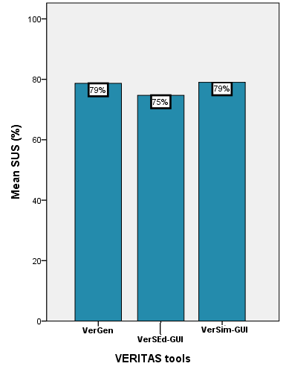
Figure 3. Mean SUS scores per VERITAS tool

Technology acceptance per application area
Most TAM mean scores were above 6 and are therefore considered as high across all five application areas (Figure 4). The highest scores were found in the automotive area with a notably higher mean “Intention of Use” (6.1±0.35) and mean “Attitude towards Use” (6.36±0.21) for all three VERITAS tools.

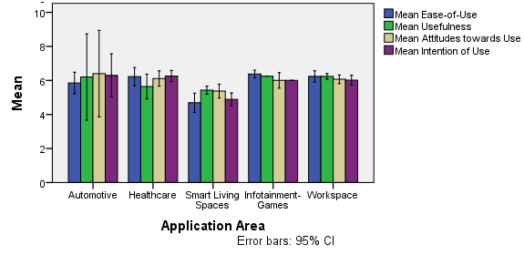
Figure 4. Mean TAM scores per application area
On the other hand, the lowest mean scores were found in the smart living spaces area. The mean “Ease-of-use” of the three tools is similarly high in most areas, with the highest scores found in the healthcare and infotainment-games domains. Accordingly, the mean “Usefulness” of the tools was rated as high in three out of the five areas (automotive; infotainment-games; workspace). Overall, the findings from the TAM score analysis demonstrate that the positive rating of the acceptance of the three tools is consistent with the usability findings from the SUS questionnaire.

CONCLUSIONS AND FUTURE WORK
This paper presented results from pilot tests that were carried out to evaluate the usability and technology acceptance of three novel tools by designers and/or developers in the design process of accessible GUI-based ICT products in five application areas.
The outcomes of the pilot tests revealed interesting and promising indications on the attitude of users towards the usability and acceptance of the three tools, while they also enabled us to identify further improvements. Participants in all five application areas reported good levels of usability for all three tools, with the findings showing a mean usability score difference that lies predominantly in the difficulty of the VERITAS tools as defined by their use, content and complexity.
Specifically, T1 and T3 were reported to be quite easy to use across all five targeted domains, while T2 was rated as slightly more difficult. This could highlight the importance of learning effects and experience, and the effect they could have on usability when complex and multi-level and purpose tools are being evaluated. It is important to note that T3 was rated as an easy to use tool, something that is particularly encouraging when considering that simulation-based testing is in the core of the VERITAS outcomes.
Designers and developers in all five application areas showed good technology acceptance of the three novel VERITAS tools and revealed that the tools can have an impact and improve their design activities. In fact, participants from all five domains reported that the three tools could be quite useful in designing more accessible ICT products, while a good agreement was also noticed towards their positive intention to use them.
All these findings were taken into consideration and suggested potential avenues for future work. In fact, we have already implemented some of the suggestions, which we plan to address into an improved version of the tools. Furthermore, a plan is in place to perform additional empirical validation of the new version.

ACKNOWLEDGMENTS
We gratefully acknowledge support from the EU project VERITAS (FP7 - 247765).

REFERENCES
[1] Brooke, J. 1996. SUS: a "quick and dirty" usability scale. In P. W. Jordan, B. Thomas, B. A. Weerdmeester, & A. L. McClelland. Usability Evaluation in Industry. London: Taylor and Francis.
[2] Chedmail, P., Maille, B., and Ramstein, E. 2002. Accessibility and ergonomics study with virtual reality, a state of the art. Mec Ind. 3, 2, 147-152. DOI= http://dx.doi.org/10.1016/S1296-2139 (02)01151-X
[3] COCOM04-08. 2004. Technical report from the inclusive communications (INCOM) subgroup. European Commission, Brussels, Belgium.
[4] Cooper, A. 1999. The Inmates Are Running the Asylum. Macmillan Publishing Company, New York.
[5] Davis, FD. 1989. Perceived Usefulness, Perceived Ease of Use, and User Acceptance of Information Technology. MIS Quart. 13, 3, 319-340. DOI= 10.2307/249008
[6] Eriksson, J., Johansson, and G.I., Akselsson, K.R. 1995. A planning tool prototype for environment adaptations. IEEE Trans Rehabil Eng. 3, 3, 283 – 287. DOI= 10.1109/86.413201
[7] Jimison, H., Pavel, M., McKanna, J., and Pavel, J. 2004. Unobtrusive monitoring of computer interactions to detect cognitive status in elders. IEEE Trans Inform Tech Biomed. 8, 3, 248-252. DOI= 10.1109/TITB.2004.835539
[8] Kaklanis, N., Moschonas, P., Moustakas, K., and Tzovaras, D. 2012. Virtual user models for the elderly and disabled for automatic simulated accessibility and ergonomy evaluation of designs. Univ Access Inform Soc, 12, 4, 403-425. DOI= 10.1007/s10209-012-0281-0
[9] Leder, R.S. et al. 2001. Computer game motivating rehabilitation with objective measures of improvement in motor function. In Proceedings of the 23rd Annual EMBC International Conference (Istanbul, Turkey, October 25-28, 2001). DOI= 10.1109/IEMBS.2001.1020459
[10] Meulen, PVD., and Seidl, A. 2007. RAMSIS-The Leading Cad Tool for Ergonomic Analysis of Vehicles. In Proceedings of the 12th International Conference on Human-Computer Interaction (Beijing, China, July 22-27, 2007).
[11] Nayar, N. 1995. Deneb/ERGO-a simulation based human factors tool. In Proceeding of the Winter Simulation Conference (Virginia, USA, December 3-6, 1995). DOI=10.1109/WSC.1995.478769
[12] Palmon, O., Oxman, R., Shahar, M., and Weiss, PL. Virtual environments as an aid to the design and evaluation of home and work settings for people with physical disabilities. In Proceedings of the 5th International Conference on Disability, Virtual Reality & Associated Technologies (Oxford, UK, September 20-22, 2004). DOI= 10.1007/1- 4020-3698-1_13
[13] Picking, R., Robinet, A., Grout, V., McGinn, J., Roy, A., Ellis, S., and Oram, D. 2009. A Case Study Using a Methodological Approach to Developing User Interfaces for Elderly and Disabled People. Comput J 53, 6, 842-859. DOI= http://dx.doi.org/10.1093/comjnl/bxp089.
[14] Prasanna Kumar, V., and Prakasan, K. 2006. Computer aided optical design of reflectors in automotive headlights. J Auto Eng, 220, 4, 415-424. DOI= 10.1243/09544070JAUTO86
[15] Sauro, J. 2011. A practical guide to the System Usability Scale: Background, benchmarks, & best practices. Denver, CO: Measuring Usability LLC.
[16] SEC (2007)1548. 2007. Situation of disabled people in the European Union: the European Action Plan 2008-2009. European Commission, Brussels, Belgium.
[17] Vignesh, R., Suganthan, R., and Prakasan, K. 2007. Development of CAD models from sketches: A case study for automotive applications. J Auto Eng, 221: 41-47.
[18] White, GR., Fitzpatrick, G., and McAllister, G. 2008. Toward accessible 3D virtual environments for the blind and visually impaired. In Proceedings of the 3rd international Conference on Digital interactive Media in Entertainment and Arts (Athens, Greece, September 10-12, 2008)

